A MINI PRORJECT REPORT ON DIGITAL ASSET TRADING WEBSITE

# CrypteX website

Submitted By

|  |  |
| --- | --- |
| **Name of Student** | **PRN Number** |
| Harshal C. Rabade  Rohit D. Wankhade  Yash Y. Sahu | 2010121245036  2010121245030  2010121245036 |
|  |  |
|  |  |
|  |  |
|  |  |
|  |  |

Under the guidance of

### PROF. S.A.Vaghare

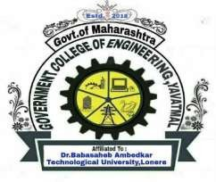

**DEPARTMENT OF COMPUTER ENGINEERING GOVERNMENT COLLEGE OF ENGINEERING, YAVATMAL**

**2022-2023**

### CERTIFICATE

### This is to certify that the Digital asset trading website report entitled

### “PROJECT ON CRYPTEX WEBSITE”

is a bonafide work and it is submitted to the Government College of Engineering, Yavatmal SUBMITTED BY:

|  |  |
| --- | --- |
| **Name of Student** | **PRN Number** |
| Harshal C. Rabade  Rohit D. Wankhade  Yash Y. Sahu | 2010121245036  2010121245030  2010121245036 |
|  |  |
|  |  |

The report has been approved as it satisfies the academic requirements in respect of mini project work prescribed for the course.

Prof.

**(S.A.Vaghare)**

Department of Computer Engineering Government College of Engineering, Yavatmal

Prof. Chetan Andhare

**(Head of the Department)**

Department of Computer Engineering Government College of Engineering,

Yavatmal

### Dr. P. M. Khodke

(Principal)

Government College of Engineering, Yavatmal

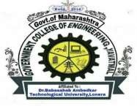

**DEPARTMENT OF COMPUTER ENGINEERING GOVERNMENT COLLEGE OF ENGINEERING, YAVATMAL**

## 2022-2023

### DEPARTMENT OF COMPUTER ENGINEERING GOVERNMENT COLLEGE OF ENGINEERING YAVATMAL



This is to certify that the seminar report entitled

# “PRORJECT NAME HERE”

SUBMITTED BY:

|  |  |
| --- | --- |
| **Name of Student** | **PRN Number** |
| Harshal C. Rabade  Rohit D. Wankhade  Yash Y. Sahu | 2010121245036  2010121245030  2010121245036 |

in the partial fulfillment of the award of B. Tech in COMPUTER ENGINEERING. This mini project report is the reward of the work carried out by them under our Guidance and supervision during the year 2022-2023

### PROF.

(S.A.Vaghare)

Department of Computer Engineering Government College of Engineering, Yavatmal

Internal Examiner External Examiner