RepoPilot AI
Agentic GitHub Developer Platform
A high-quality flagship AI project blueprint for a fresher portfolio, resume, and practical daily use
Project thesis
Build a production-grade system that turns GitHub issues into structured implementation plans, creates safe branches and draft pull requests, generates tests, runs CI/security checks, summarizes failures, and requires human approval before merge.

Prepared as a portfolio-ready project specification and implementation plan

Contents
- Executive brief and resume positioning
- Product concept and daily-use workflows
- System architecture and recommended tech stack
- Implementation plan by module
- Feature backlog: MVP, advanced, and elite version
- Agent design, workflow, and GitHub commands
- Data model, APIs, and repository structure
- Security model and quality gates
- Evaluation benchmark and success metrics
- Build timeline and delivery milestones
- Portfolio packaging, resume bullets, and final recommendations
- References and source notes
Note: This is a static contents list designed to render consistently across Word, LibreOffice, and Google Docs import.

1. Executive brief and resume positioning
Flagship project: RepoPilot AI is not a chatbot. It is an agentic software-development platform that demonstrates practical AI engineering: GitHub Apps, LLM orchestration, codebase RAG, CI/CD, security scanning, human-in-the-loop approval, evaluation, and dashboard product design.
Resume headline
RepoPilot AI: Production-grade agentic GitHub workflow that converts issues into tested, reviewed, security-scanned pull requests using LLM agents, GitHub Actions, CodeQL, codebase RAG, Docker sandboxing, and human-in-the-loop approval.

Why this project stands out for a fresher
Common fresher AI project | Weakness | How RepoPilot AI is stronger
PDF chatbot / basic RAG app | Saturated and often shallow. | Applies RAG to a codebase and produces real engineering artifacts.
Simple LangChain agent | Often lacks validation, security, or deployment. | Uses stateful planning, approval gates, CI, tests, and audit logs.
Resume screener / sentiment app | Generic and hard to connect to production AI roles. | Directly maps to agentic AI, LLMOps, platform engineering, and developer productivity.
Code generator script | Unsafe and difficult to trust. | Creates draft PRs with test evidence, risk scoring, and human review.

What recruiters and interviewers should infer
- You can build a practical agentic AI system rather than a demo prompt wrapper.
- You understand GitHub-native software delivery: issues, branches, PRs, reviews, CI, Actions, and security gates.
- You can design reliable LLM workflows with planning, retrieval, tool use, state transitions, retries, and human approvals.
- You think about production concerns: testing, observability, cost, security, auditability, and evaluation.

2. Product concept and daily-use workflows
Product behavior: A user opens a GitHub issue. RepoPilot AI reads the issue, understands the repository, asks clarifying questions if needed, proposes a plan, waits for approval, creates a safe branch, modifies code in a sandbox, adds tests, runs CI/security checks, opens a draft PR, and supports review comments.

Primary users and use cases
User | Daily use case | Value delivered
Fresher developer | Use it on personal projects to triage issues, create PRs, run tests, and improve code quality. | Portfolio proof and productivity boost.
Small team | Automate repetitive engineering tasks while keeping human review. | More output without sacrificing safety.
Open-source maintainer | Triage issues, generate reproduction steps, improve docs, and propose safe PRs. | Less maintainer burden.
Startup engineering team | Automate low-risk backlog items and CI failure analysis. | Faster iteration with auditability.

Daily-use workflows to include
Workflow | What the user sees | Why it matters
Morning repo summary | Open issues, agent-ready items, failing PRs, blocked tasks, recommended next actions. | Makes the tool useful every day.
Issue grooming | Auto-labels issues and asks clarifying questions before planning. | Prevents low-quality agent attempts.
PR review help | Diff summary, risk notes, reviewer checklist, test evidence. | Saves reviewer time.
CI debugging | Plain-English explanation of failed logs and suggested fix. | Useful even when coding agent fails.
Release notes | Changelog entries from merged PRs. | Practical for teams and open-source repos.
Documentation maintenance | Detects when code changes require README/API docs updates. | Improves production readiness.

3. System architecture and recommended tech stack
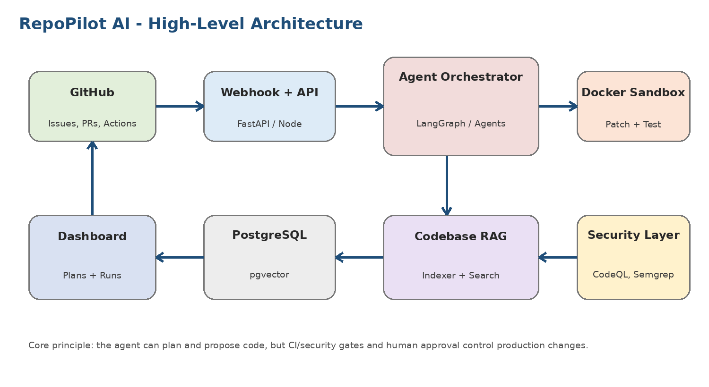
Architecture principle: the agent may plan and propose code, but production-quality checks decide whether the change is trustworthy. Human approval remains mandatory for code-changing and high-risk actions.

Recommended technology stack
Layer | Recommended tools | Why this choice helps you stand out
Frontend | Next.js, React, Tailwind, shadcn/ui | Professional dashboard, quick UI iteration, strong portfolio presentation.
Backend API | FastAPI or NestJS | FastAPI is excellent for Python AI workflows; NestJS is strong for TypeScript-first teams.
Agent orchestration | LangGraph, OpenAI Agents SDK, or CrewAI | Shows stateful agent design, tool use, retries, and human approval gates.
LLM layer | OpenAI / Anthropic / Gemini plus optional local fallback | Demonstrates model routing, cost control, and vendor-aware architecture.
GitHub integration | GitHub App, Webhooks, REST/GraphQL API | More professional and secure than a personal-access-token script.
Storage | PostgreSQL + pgvector | Stores agent runs, plans, embeddings, issue state, audit logs, and evaluation metrics.
Queue/workers | Redis + Celery/RQ/BullMQ | Handles indexing, agent runs, CI analysis, and long-running tasks asynchronously.
Sandbox | Docker containers | Isolates code editing, tests, command execution, and dependency installation.
CI/CD | GitHub Actions | Proves real deployment and validation workflow knowledge.
Security | CodeQL, Semgrep, Gitleaks/TruffleHog, dependency audit | Differentiates the project from ordinary AI demos.
Observability | Langfuse/Phoenix, OpenTelemetry, Sentry | Adds traces, costs, model calls, errors, and production debugging evidence.
Deployment | Docker Compose + cloud deployment | Makes the project self-hostable and practically usable by others.

4. Implementation plan by module
Build the system as independent modules so each part can be demoed, tested, and discussed in interviews. The table below is the execution blueprint.
# | Module | What to build | Resume/interview signal
1 | GitHub App foundation | Install app, verify webhook signatures, connect repositories, store installation IDs, display repo list. | Security-aware integration; stronger than scripts using personal tokens.
2 | Issue intake and smart triage | Classify issues, score risk/complexity, detect missing information, generate acceptance criteria, auto-label issues. | Shows product thinking and prevents blind agent execution.
3 | Codebase RAG and repo indexing | Scan files, parse dependencies, chunk code, embed symbols/docs/tests, store in pgvector, incrementally re-index changed files. | Demonstrates LLM retrieval over code, not just PDFs.
4 | Planning agent | Generate implementation plan, touched files, test plan, risks, rollback notes, and approval request. | Shows structured agentic reasoning and human-in-the-loop design.
5 | Sandboxed implementation | Create branch, run commands in Docker, apply patches, format, run focused tests, capture logs. | Proves safety and practical engineering discipline.
6 | Test agent | Add unit/regression/API tests, detect test gaps, compare coverage, confirm real test logs. | Moves project beyond code generation into verified engineering output.
7 | Security agent | Prompt-injection scan, secret scanning, dependency audit, CodeQL/Semgrep, high-risk file detection. | Critical differentiator for AI-agent safety.
8 | Draft PR generator | Open draft PR with summary, checklist, test results, risk score, rollback note, and linked issue. | Creates immediately useful daily workflow.
9 | CI failure debugger | Listen to failed GitHub Actions, summarize root cause, suggest fix, ask approval before patching. | Useful to teams daily and excellent for demos.
10 | Dashboard and audit logs | Show runs, traces, plans, CI status, security gates, cost, approval history, and action audit trail. | Makes the project look like a real product, not a notebook demo.

Module-level implementation details

GitHub App foundation
- Create GitHub App with minimal permissions.
- Implement webhook endpoint and signature verification.
- Store installation/repository metadata.
- Display connected repositories in dashboard.
Quality bar: do not use personal access tokens as the primary integration model.

Issue intake and triage
- Parse title/body/comments/labels.
- Classify task type and complexity.
- Generate acceptance criteria.
- Ask clarifying questions when requirements are vague.
Quality bar: the agent should refuse broad tasks and suggest smaller issues.

Codebase RAG
- Scan repository tree and ignore irrelevant files.
- Chunk code by functions/classes/routes/configs.
- Store embeddings and metadata in pgvector.
- Retrieve files with citations for planning.
Quality bar: show exactly which files were used as context.

Planning engine
- Generate file-level plan, test plan, risks, rollback notes.
- Display plan in dashboard.
- Comment on GitHub with approval command.
- Block implementation until approved.
Quality bar: every plan should include acceptance criteria and validation steps.

Sandboxed implementation
- Checkout branch in Docker workspace.
- Apply patch-based edits.
- Run allowed commands only.
- Capture logs and stop after limited retries.
Quality bar: never execute arbitrary shell commands from issue text.

Tests and CI
- Generate unit/regression/API tests.
- Run focused tests locally.
- Trigger GitHub Actions.
- Summarize CI status and failures.
Quality bar: never claim tests passed without actual logs.

Security layer
- Run prompt-injection scan, secret scan, dependency audit, CodeQL/Semgrep.
- Flag high-risk files.
- Require human approval for risky changes.
Quality bar: high-risk PRs remain draft until reviewed.

PR and review loop
- Create branch and draft PR.
- Write summary/checklist/risk/test evidence.
- Respond to slash commands.
- Support revise/explain/fix-ci/add-tests.
Quality bar: PRs should be small, reviewable, and linked to the original issue.

5. Feature backlog: MVP, advanced, and elite version
Recommended scope control
Do not attempt the full elite version immediately. Build an impressive MVP first, then add security, evaluation, and product polish. A working, measured system is stronger than an unfinished mega-project.

Version | Feature | Description | Why it matters
MVP | GitHub App + webhooks | Connect repo, receive issues/comments/workflow events, verify webhook signatures. | Required for professional GitHub integration.
MVP | Issue triage | Classify bug/feature/docs/refactor/test/security, add labels, request missing info. | Makes project useful before code generation.
MVP | Repo indexing | Code chunking, embeddings, symbol/file search, docs ingestion, incremental updates. | Core to high-quality coding-agent behavior.
MVP | Plan approval | Generate plan and wait for /repopilot approve before editing code. | Human-in-the-loop safety gate.
MVP | Draft PR creation | Create branch, commit changes, open draft PR with evidence checklist. | Visible, resume-friendly outcome.
Advanced | Test generation | Create regression/unit/API tests and run them before PR readiness. | Proves code quality.
Advanced | CI failure summarizer | Parse GitHub Actions logs and propose likely fix. | Daily-use feature for developers.
Advanced | Security scanning | Run CodeQL/Semgrep/secret scanning/dependency audit. | High-quality production signal.
Advanced | Review commands | Support /repopilot revise, explain, fix-ci, add-tests, stop. | Makes it interactive inside GitHub.
Advanced | Cost and trace tracking | Track tokens, model, runtime, cost, and action trace per run. | Shows LLMOps maturity.
Elite | Benchmark suite | Create 30 issue tasks and measure PR success, CI pass rate, cost, and human revisions. | Turns demo into measurable engineering project.
Elite | Multi-model comparison | Run same tasks using different models and compare outcome quality/cost. | Great for AI evaluation interviews.
Elite | Agent replay | Replay every agent decision and tool call in dashboard. | Excellent transparency feature.
Elite | Policy engine | Rules for high-risk files, max changed files/lines, blocked commands, approval gates. | Enterprise-grade governance.
Elite | Self-hosted mode | Docker Compose deployment with setup wizard and docs. | Makes it usable by others daily.

6. Agent design, workflow, and GitHub commands
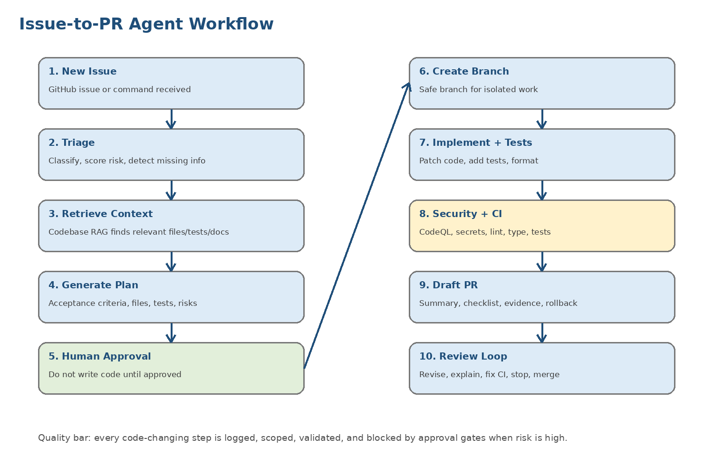

Specialized agents
Agent | Responsibility | Output
Triage Agent | Reads the issue, classifies task type, detects missing info, applies labels. | Structured issue JSON, labels, clarification comment.
Codebase Research Agent | Retrieves relevant files, tests, docs, routes, dependencies, and symbols. | Context bundle with file citations.
Planning Agent | Creates implementation plan, acceptance criteria, risk score, rollback plan. | Plan awaiting approval.
Implementation Agent | Applies small patches inside a sandbox and follows existing conventions. | Code changes and commit draft.
Test Agent | Adds/updates tests and validates real test logs. | Test files, coverage delta, validation evidence.
Security Agent | Checks prompt injection, secrets, dependencies, dangerous files, and CodeQL/Semgrep results. | Security gate report.
CI Debugger Agent | Summarizes failed GitHub Actions logs and proposes a fix. | Failure diagnosis + suggested patch.
PR Writer Agent | Creates PR title, summary, checklist, risk notes, and reviewer instructions. | Draft PR body.
Human Approval Controller | Blocks code changes, high-risk actions, and merge decisions until approved. | Approval/denial decision and audit log.

GitHub comment commands
Command | Purpose
/repopilot plan | Generate or refresh a plan for the issue.
/repopilot approve | Approve the current plan and allow branch/code generation.
/repopilot reject | Reject the plan and stop the current run.
/repopilot revise-plan | Ask the planner to produce a smaller or safer plan.
/repopilot implement | Begin implementation after approval.
/repopilot add-tests | Add or improve tests for the PR.
/repopilot explain | Explain a file, diff, design decision, or test result.
/repopilot fix-ci | Analyze failed CI and suggest or apply an approved fix.
/repopilot security-review | Run or re-run security-focused review.
/repopilot stop | Cancel an active agent run.
Example command sequence
Example issue comment flow:
/repopilot plan
/repopilot approve
/repopilot implement
/repopilot fix-ci
/repopilot explain
/repopilot add-tests

7. Data model, APIs, and repository structure

Recommended monorepo structure
repopilot-ai/
apps/
web/ # Next.js dashboard
api/ # FastAPI or NestJS backend
agents/ # Triage, planner, implementer, tester, security agents
workers/ # Queue workers for indexing, agent runs, CI analysis
packages/
github-client/ # GitHub REST/GraphQL helper
repo-indexer/ # Code chunking, embeddings, symbol extraction
evals/ # Benchmark issues and scoring tools
infra/ # Docker, deployment, IaC
docs/ # Architecture, security model, evaluation report
.github/workflows/ # CI, security, coverage, Docker build
docker-compose.yml

Core database entities
Entity | Stores | Key fields
users | GitHub user/account details. | id, github_user_id, username, email
installations | GitHub App installations and permissions. | github_installation_id, account_name, permissions
repositories | Connected repo metadata and indexing state. | owner, name, default_branch, last_indexed_sha
issues | Issue classification and task state. | issue_number, type, complexity, risk_score, status
agent_runs | Every agent execution. | status, model_used, total_tokens, total_cost, started_at
plans | Generated plans and approval state. | plan_json, approval_status, approved_by
code_chunks | Code/doc chunks for retrieval. | file_path, symbol_name, chunk_text, embedding
pull_requests | PR metadata and CI/security state. | pr_number, branch_name, ci_status, risk_score
security_findings | Tool findings and risk status. | tool, severity, description, status
audit_logs | Every action taken by the agent or user. | actor, action, metadata, created_at

Suggested API surface
Endpoint | Purpose
POST /webhooks/github | Receive and verify GitHub webhook events.
GET /repos | List connected repositories.
POST /repos/{id}/index | Trigger repository indexing.
POST /repos/{id}/search-context | Retrieve relevant code/docs/tests for an issue.
POST /issues/{id}/triage | Run classification and missing-information detection.
POST /issues/{id}/plan | Generate implementation plan.
POST /plans/{id}/approve | Approve plan and allow implementation.
POST /agent-runs/{id}/stop | Cancel current run.
GET /agent-runs/{id} | View trace, logs, costs, plan, and outputs.
GET /pull-requests/{id}/security | View security gate results.

8. Security model and quality gates
Security priority: Agentic GitHub workflows introduce unique risks because issue text, PR comments, CI logs, and user-generated content can become model input. Treat all external content as untrusted and constrain the agent with policies, approvals, and scans.
Threat | Mitigation
Prompt injection in issues/comments | Treat GitHub issue body, comments, PR text, and CI logs as untrusted input. Scan for instructions that attempt to override system/tool policies.
Secret exfiltration | Block commands that print environment variables or read .env files. Run Gitleaks/TruffleHog before PR creation.
Unsafe workflow modification | Require human approval for any change to .github/workflows, deployment config, Dockerfiles, or permissions.
Supply-chain risk | Audit dependency additions and require approval for new packages or version bumps.
Dangerous shell command | Use an allowlist of safe commands. Block curl|bash, wget|bash, rm -rf, printenv, and arbitrary shell execution.
Hallucinated validation | Trust only actual CI/test logs. The PR cannot claim tests passed unless logs confirm it.
Oversized PRs | Limit changed files/lines by default and split large work into smaller issues.
Over-permissioned GitHub token | Use GitHub App installation tokens with minimum required permissions.

Command policy example
allowed_commands:
- npm test
- npm run lint
- pytest
- ruff check
- mypy
- pnpm test
- go test ./...
blocked_commands:
- rm -rf
- curl | bash
- wget | bash
- printenv
- cat .env
require_approval_for:
- .github/workflows/*
- auth/*
- payments/*
- Dockerfile
- deployment/*
- secrets/*
limits:
max_files_without_approval: 5
max_lines_changed_without_approval: 300
max_retries: 2

Definition of done
Gate | Requirement
Functional gate | Issue triage, planning, approval, branch creation, and draft PR flow works end to end.
Testing gate | PR includes tests where relevant and shows real test logs.
CI gate | GitHub Actions status is visible and summarized.
Security gate | Secret scan, dependency audit, and static analysis are included.
Human gate | No code-changing action without approval.
Audit gate | Every agent action is logged with timestamp and actor.
Cost gate | Tokens, runtime, and estimated cost are tracked per run.
Documentation gate | README, architecture, setup, security model, and limitations are complete.
Evaluation gate | Benchmark report includes real numbers, failures, and learnings.

9. Evaluation benchmark and success metrics
Why evaluation matters: Most AI portfolios show a successful demo. A standout project should prove performance across multiple tasks, include failures, and present honest metrics. This makes the project credible in technical interviews.

Benchmark design
Task category | Number of issues | Example task
Documentation updates | 5 | Update API docs after route change.
Unit test additions | 5 | Add tests for edge cases in a service function.
Small bug fixes | 5 | Fix pagination or validation bug with regression test.
Refactors | 5 | Split large function without changing behavior.
API features | 5 | Add endpoint with validation and tests.
Security-related tasks | 5 | Add rate limiting or improve auth error handling.

Metrics to track
Metric | Target | How to measure
Issue triage accuracy | 85%+ | Manually compare classification and missing-info detection against expected labels.
Plan approval rate | 70%+ | Percentage of generated plans accepted without major revision.
PR creation success rate | 70%+ | How often the agent reaches a draft PR after approved plan.
First-run CI pass rate | 60%+ | How often CI passes on the first agent-created PR.
CI pass after one revision | 80%+ | How often the agent can fix one CI failure after approval.
Critical security findings introduced | 0 | No secrets, critical vulnerabilities, or unsafe workflow permission changes.
Average files changed | < 5 for simple tasks | Shows scoped changes and reviewer-friendly PRs.
Average cost per task | Track actual value | Demonstrates cost awareness and production thinking.
Human edits required | Track actual value | Shows practical usefulness and remaining limitations.
Reviewer satisfaction | 4/5 target | Ask peers to review sample PRs and score clarity/usefulness.
Important integrity rule
Do not fake benchmark numbers. Publish actual results, including failures and limitations. Honest evaluation is more impressive than perfect but unverifiable claims.

10. Build timeline and delivery milestones

8-week impressive MVP plan
Week | Build focus
Week 1 | Project spec, repo setup, GitHub App, webhook signature verification, dashboard skeleton.
Week 2 | Issue triage, classification JSON, labels, clarification questions, connected repo page.
Week 3 | Repository indexing, code chunking, embeddings, file/symbol search, context citation.
Week 4 | Planning agent, acceptance criteria, risk scoring, approval workflow.
Week 5 | Branch creation, patch application, draft PR generation, PR template.
Week 6 | Test generation, GitHub Actions integration, CI status tracking, failure summarizer.
Week 7 | Security scanning, prompt-injection checks, command allowlist, audit logs.
Week 8 | Evaluation benchmark, deployment, README polish, demo video, portfolio case study.

12-week elite version extension
Weeks | Build focus
Weeks 1-2 | GitHub App, webhook system, dashboard skeleton, repo connection flow.
Weeks 3-4 | Repository indexing, RAG, issue triage, labels, context citation.
Weeks 5-6 | Planning and implementation agents, approval workflow, branch/PR automation.
Week 7 | Test generation and CI debugger.
Week 8 | Security layer, prompt-injection defense, command allowlist.
Week 9 | Review comment loop and slash-command interface.
Week 10 | Metrics dashboard, cost tracking, traces, audit logs.
Week 11 | Benchmark suite and evaluation report.
Week 12 | Deployment, documentation, demo video, portfolio case study, resume bullets.

11. Portfolio packaging, resume bullets, and final recommendations

Portfolio deliverables
Deliverable | What it should include
GitHub repo | Clean README, architecture diagram, setup guide, demo GIF/video, security model, evaluation results.
Live demo | Hosted dashboard with a demo repository and recorded issue-to-PR workflow.
Demo repository | A realistic FastAPI/Next.js app with issues that RepoPilot solves.
Evaluation report | 30-issue benchmark with honest metrics, screenshots, failures, and learnings.
Resume bullets | Outcome-focused bullets with technologies, metrics, safety controls, and deployment details.
LinkedIn post/thread | Explain why safe agentic coding workflows need CI, security, human approval, and evaluation.

Resume bullets after completion
- Built RepoPilot AI, an agentic GitHub developer platform that converts issues into human-approved, tested, security-scanned pull requests using GitHub Apps, FastAPI, LangGraph, PostgreSQL/pgvector, Docker, and GitHub Actions.
- Implemented codebase RAG over repository files, issue triage, multi-agent planning, branch/PR automation, CI log analysis, test generation, risk scoring, and PR review summaries.
- Designed security controls for agentic workflows, including prompt-injection detection, command allowlisting, secret scanning, CodeQL/Semgrep integration, audit logs, and mandatory human approval for high-risk changes.
- Created a benchmark suite of 30 GitHub issues to evaluate PR success rate, CI pass rate, test coverage delta, average files changed, human revision rate, and token cost per task.

Final recommendations
- Start with an end-to-end MVP before adding elite features. A finished system with measured results beats an over-scoped unfinished project.
- Make the demo repository realistic. Use a FastAPI/Next.js task-management app with authentication, tests, API docs, CI, and security scans.
- Prioritize safety and evaluation. These are the areas where most fresher AI projects are weak, so they are your best differentiation points.
- Record a 3-5 minute demo video showing a GitHub issue becoming a draft PR with tests, security checks, and human approval.
- Turn the project into a case study page with architecture, workflow, screenshots, metrics, failures, and lessons learned.
Highest-impact version
An open-source, self-hostable GitHub App that uses agentic AI to triage issues, generate implementation plans, create draft PRs, run tests/security checks, summarize CI failures, and support human-approved review workflows.

12. References and source notes
The following sources informed the market context, GitHub agentic AI direction, and security/evaluation emphasis. Treat these as background references; the implementation plan is intentionally practical and portfolio-focused.
Source | Link
GitHub Copilot coding agent | Open source
GitHub Agent HQ workflows | Open source
Agentic PR review outcomes | Open source
Agentic PR CI/CD reliability | Open source
Workflow injection risks | Open source

