Smart Agriculture with Predictive Solutions using Deep Learning

|  |  |  |
| --- | --- | --- |
| *Shrividya S Toutam UG Student Department of DIC*  *G H Raisoni College of Engineering* [*shrividya.toutam.ds@ghrce.raisoni.net*](mailto:shrividya.toutam.ds@ghrce.raisoni.net) | *Harshal G Samantsinghar UG Student*  *Department of DIC*  *G H Raisoni College of Engineering* [*harshal.samantsinghar.ds@ghrce.raisoni.net*](mailto:harshal.samantsinghar.ds@ghrce.raisoni.net) | *Raghav S Chintalwar UG Student Department of DIC*  *G H Raisoni College of Engineering* [*raghav.chintalwar.ds@ghrce.raisoni.net*](mailto:raghav.chintalwar.ds@ghrce.raisoni.net) |
| *Prof. Kailash Dewangan Assistant Professor*  *Department of Data Science, CSE (IoT) & CSE (Cyber Security)*  *G H Raisoni College of Engineering*  [kailash.dewangan@raisoni.net](mailto:kailash.dewangan@raisoni.net) | *Prof. Nekita Chauhan Morris Head of Department*  *Department of Data Science, CSE (IoT) & CSE (Cyber Security)*  *G H Raisoni College of Engineering*  [hoddic.ghrce@raisoni.net](mailto:hoddic.ghrce@raisoni.net) |  |

# Abstract - Many economies are built on agriculture, which is essential for maintaining livelihoods and guaranteeing food security. However, selecting the correct crops, maintaining soil fertility, and fending off plant diseases present significant challenges for farmers. To address these issues, an online platform has been developed those leverages deep learning (DL) and machine learning (ML) methods to provide farmers with personalized advice. The platform consists of three essential components: a fertilizer recommendation system driven by a rule-based algorithm that offers advice on ideal NPK values to improve soil fertility; a crop recommendation system that employs the Random Forest algorithm to recommend the best crops based on variables such as temperature, humidity, pH, and nutrient levels, with Random Forest identified as the most accurate algorithm, achieving an accuracy of 99.35%; and a plant disease detection system that uses ResNet to detect diseases from photos of plant leaves. By presenting the analysis findings through a user-friendly web interface, the platform enables farmers to make more informed decisions and enhance agricultural productivity.

# Keywords— Precision Agriculture, Smart Farming, Machine Learning, Deep Learning, Plant Disease, Crop Recommendation

1. **INTRODUCTION**

Agriculture, or farming as it is more often known, is the practice of tilling soil and raising animals. It significantly affects the economics of a country. Numerous food products and raw materials are produced by agriculture [1]. Raw materials like cotton and jute are utilized by industries to create a wide range of everyday commodities [2]. Conventional agricultural techniques were employed to cultivate the crops. Conventional farming accounts for most farming activities worldwide [3].

Although agricultural scientists and technologists have made

great strides, farmers still face numerous challenges in their quest to maximize crop yield while minimizing resource input and environmental effect [4]. The absence of timely and accurate information on crucial subjects like crop selection, maintaining soil fertility, and disease diagnosis is the most serious of these challenges [5]. The absence of precise and up-to-date information seriously impairs farmers' ability to make educated decisions [6]. If farmers do not have access to large amounts of data and analytical tools, they may find it challenging to identify which crops are most suited for production given the existing soil conditions, climate variables, and market demand [7].

Automation, robotics, electronics, and sensors are examples of digital technology that is used in precision agriculture. This technology aims to increase profitability and make better decisions [8,9]. In order to optimize productivity, generate income, and enhance yield quality, this agricultural management system provides a comprehensive way to regulate the seasonal and geographical variation of crops and soil [10]. Precision agriculture benefits from advanced technology like artificial intelligence, data mining, the IoT and Data Science [11].

The project's main goal is to develop an online platform that combines machine learning (ML) and deep learning (DL) techniques to give farmers customized guidance in three important areas. Initially, the project aims to develop prediction algorithms that could offer tailored crop recommendations based on soil data. The development of algorithms intended expressly to recommend fertilizers for different soil types and crops is the second objective of the thesis. Thirdly, the project aims to identify and detect agricultural diseases by applying a DL-based method like ResNet utilizing images of leaves. Finally, the project wants to create a simple and easy-to-use online interface that makes it easier for farmers and the platform to communicate with each other. The system showed an accuracy of 99.35%.

The following is the arrangement of the remaining sections: A thorough review of previous research on the subject is given in Section 2, along with a list of the gaps that this study attempts

to fill. The research strategy, techniques, and research protocols for data collection and analysis are discussed in Section 3. Section 4 provides a thorough analysis of the data as well as the study's findings. Section 5 presents the primary findings, their consequences, and suggestions for additional research. The future scope of the research is described in Section 6. The relevant sources are all included in Section 7.

1. **LITERATURE REVIEW**

The study proposes a novel method for employing fuzzy logic modelling to provide real-time crop recommendations based on assessments of soil quality. Subsequently, this device employs fuzzy logic model to analyze the sensor data and produce a list of appropriate crops [1].

The main objective of the study is to effectively use ResNet50 to classify plant diseases. With the use of 38 diseases dataset, pre-trained weights, data augmentation, and deep learning, the model classified plants with an accuracy of 96.49% [3].

This study uses image processing techniques to identify bacterial blight in pomegranate plants. To accurately diagnose plant illnesses, one must do the following steps: image collection, segmentation, feature extraction, and classification [4]. The study aims to enhance early detection and management of pomegranate plant diseases by utilizing these methodologies.

The research report offers a technique for accurately identifying cotton plant diseases and recommending the fertilizer. It utilized the cotton plant dataset to perform a thorough computational examination of eight state-of-the-art object identification techniques and seven state-of-the-art classification algorithms [5].

The use of deep learning methods, particularly Convolutional Neural Networks (CNNs), is described in this paper [8] for accurate pest and agricultural disease identification in crops. It provides an automated diagnosis paradigm by precisely identifying pests and illnesses on crop leaves using deep learning.

Based on the YOLOv2 approach, the research presents an integrated system for identifying prevalent physiological problems in tomato fruit. By differentiating between tomatoes in good health and those with common illnesses, this method hopes to increase tomato yield. The results of the experiment verify the effectiveness of the suggested method; the tomato fruit identification network YOLOv2 achieved a mean average precision (mAP) of 97.24%. [9].

The research on leaf disease identification uses a neural network classifier in conjunction with image processing techniques to precisely identify agricultural leaf diseases, specifically leaf spot. Getting images, segmenting them with K-means clustering, extracting pertinent features, and classifying

diseases using a neural network classifier are all steps in the process. With 95% and 80% of the target spot and bacterial leaf spot of cotton leaf diseases correctly identified, respectively, the study's results show high accuracy rates [10].

To estimate crop yield based on various data, the research uses machine learning methods such as AdaBoost and the Random Forest approach to account for soil conditions when recommending fertilizer. By offering precise crop production forecasts and individualized fertilizer recommendations, this combined strategy seeks to improve agricultural practices [12].

To generate crop recommendations, the research use the Light GBM Machine Learning Algorithm to assess environmental variables and datasets [13]. It considers quantifiable information such as soil nutrient content, rainfall, humidity, pH, and temperature. The goal of the study is to provide tailored, data-driven crop recommendations by using these variables.

The research suggests a hybrid feature selection strategy that combines filter and wrapper techniques to get the best characteristics for a crop recommendation model [15]. Once validated, these selected features are utilized to construct artificial neural networks and decision tree models. To verify the effectiveness, evaluation metrics such as Mean Absolute Error (MAE), Root Mean Squared Error (RMSE), Mean Squared Error (MSE), and R-squared (R2) are used.

Using machine learning techniques, the study created a crop and fertilizer recommendation system that offers farmers individualized advice based on soil features and environmental parameters [18]. To provide customized recommendations, the program considered crop history, soil properties, climate, and fertilizer usage habits. The initiative sought to improve agricultural practices in India by providing information on crop choices and planting on an intuitive website.

Four types of fertilizers were suggested for usage as part of the technique, which comprised utilizing a fuzzy logic-based program to recommend soil fertilizers based on input parameters and fuzzy rules [19].

During the reproductive growth cycle, winter wheat steadily loses nitrogen content. Integrating the critical nitrogen concentration curve and hyperspectral data is beneficial in creating nitrogen fertilizer recommendations [20].

# Table 1: Comparative Analysis

|  |  |  |  |  |
| --- | --- | --- | --- | --- |
| Sr. No | Reference No. | Year of Publication | Advantages | Limitations |
| 1. | [3] | 2024 | With the use of 38 diseases dataset, pre-trained weights, data augmentation, and deep learning, the model uses ResNet50 to classify plant diseases with 96.49% accuracy. | There is still need for improvement in the current methods for classifying and detecting plant diseases, which calls for more study and development. |
| 2. | [17] | 2024 | Among plant disease identification tests, the updated AlexNet deep learning model outperformed the VGG16 and VGG19 models with the greatest testing accuracy of 96.63%. | Lack of information on validation methods. |
| 3. | [5] | 2024 | Utilizing the cotton plant dataset to perform a thorough computational examination of eight state-of-the-art object identification techniques and seven state-of-the-art classification algorithms. | The study assessed several algorithms, but it was unable to determine which was the "best" one, indicating that more research may be required. |
| 4. | [18] | 2023 | Using machine learning techniques, the study created a crop and fertilizer recommendation system that offers farmers individualized advice. | Not addressing all potential factors, suggesting the need for further research |
| 5. | [14] | 2023 | This study proposes a Crop Recommendation System that uses Random Forest and Decision Trees to assist farmers in selecting which crops to plant. | Challenges in sustaining soil fertility and replenishing essential nutrients. |
| 6. | [13] | 2022 | Using data sets, environmental factors, and soil nutrient content measurement as a basis, the study recommended crops. | The limitations of the study include potential resource loss in quality prediction and the need for improvement in accuracy and dependability of the system. |
| 7. | [12] | 2022 | The study utilizes AdaBoost and Random Forest for crop yield prediction and recommends fertilizers based on soil conditions. | Need for exactness in analyzing crop production. |
| 8. | [15] | 2022 | To collect ideal features for constructing a crop recommendation model, the methodology employs a hybrid feature selection strategy that combines filter and wrapper techniques. | Current hybrid feature extraction procedures have limitations in assessment measures and the number of characteristic features processed |
| 9. | [11] | 2022 | Support vector machine performed better among other algorithms in fertilizer prediction. | Lack of validation methods for ML models. |
| 10. | [7] | 2021 | Image acquisition, feature extraction, K- means clustering image segmentation, and a neural network (NN) classifier are all part of the process. | The study only focuses on the detection of leaf spot diseases and does not cover a broader range of plant diseases. |

|  |  |  |  |  |
| --- | --- | --- | --- | --- |
| 11. | [20] | 2021 | The N content of winter wheat progressively decreased over the period of reproductive development. | Validating the N recommendation model in various environmental circumstances may require additional research.  . |
| 12. | [16] | 2021 | To deliver precise crop recommendations, the system makes use of Machine Learning techniques like Naive Bayes Algorithm, K-Nearest, Decision Trees, Support Vector Machine, and Neural Networks. | Limited to specific characteristics like soil type, rainfall, season. |
| 13. | [9] | 2021 | The suggested approach proved successful in distinguishing between tomato fruits in good health and those with common physiological conditions. | Limited generalizability to other fruits and vegetables. |
| 14. | [4] | 2021 | Tensor flow is used by the CNN model to attain 96% accuracy over 8 epochs. | The need for quick, less costly, and precise methods for disease detection on plant leaves. |
| 15. | [19] | 2020 | The research aims to develop an application based on fuzzy logic that can recommend four different types of fertilizers for usage in soil. | Excessive fertilizer can harm crop development. |
| 16. | [8] | 2020 | Using deep learning algorithms can improve the accuracy of disease and pest detection on leaves and other crop sections. | Although the study offers a strategy for identifying pests and agricultural diseases, it might not fully address all possible drawbacks with the strategies used today. |
| 17. | [6] | 2020 | To identify the leaf portion that is impacted, the clustering method is used. | Lack of validation or comparison with existing methods. |
| 18. | [10] | 2019 | The study achieved high accuracies in classifying different types of leaf diseases using ANN and K-means Clustering with accuracies ranging from 80% to 100%. | The study does not discuss the scalability or practical implementation of the proposed system in real-world agricultural settings. |
| 19. | [2] | 2019 | Applying machine learning and data mining techniques to optimize fertilizer use and forecast crop yield. | Dependence on diverse soil parameters and weather aspects for growth. |
| 20. | [1] | 2019 | Created a crop recommending device using sensors to detect soil quality for building a fuzzy logic model for crop classification. | Lack of consideration for crop recommendation based on soil state. |

We developed a comprehensive web-based application using the Flask framework to solve the various issues farmers encounter with crop selection, fertilizer application, and disease management. We used the Random Forest algorithm for crop recommendation, taking use of its ensemble learning capabilities to assess soil and climate data and recommend the best crops for particular areas. We used a rule-based algorithm in the field of fertilizer recommendation to give accurate guidance on the kind and quantity of fertilizers needed, depending on the nutrient profile of the soil and the particular crop requirements. In order to quickly diagnose plant diseases from uploaded photographs, we integrated the ResNet deep learning architecture, which is well-known for its high accuracy in image recognition tasks. The goal of these technology advancements is to increase agricultural output.

1. **METHODOLOGY**

Fig. 1 proposes the three modules of this work: Plant disease detection, Fertilizer advice, and Crop recommendation. The internet application developed using the Flask framework is the suggested project.

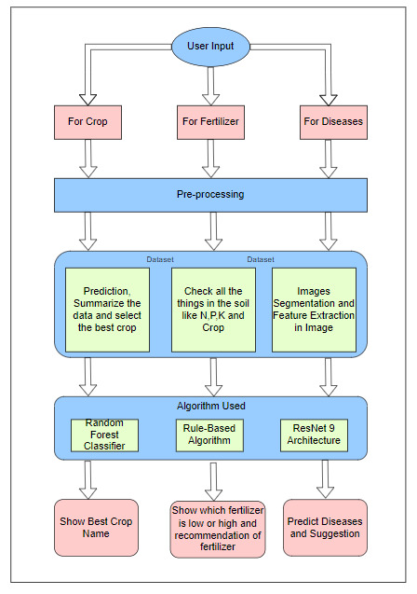

Figure 1. System Block Diagram

* 1. Crop Recommendation System

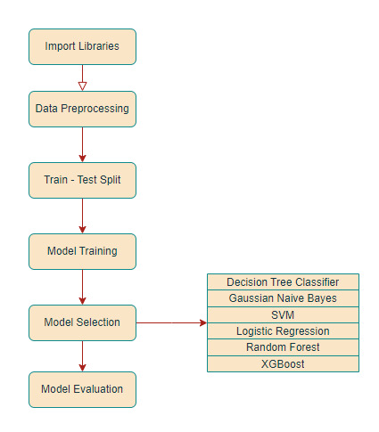

Figure 2. Crop Recommendation System Flowchart

The process of suggesting appropriate crops for a specific site depending on several variables is illustrated in this flowchart.

1. Input Data**:** The system begins by obtaining information from the user, such as:

* Soil Properties: They could include the amounts of potassium (K), phosphorus (P), and nitrogen (N). These are frequently referred to as NPK values.
* Climate Data: They consist of variables like humidity, precipitation, and temperature.

1. Data Preprocessing**:** Categorical variables like state or city may be numerically encoded, and any missing values in the gathered data are likely to be handled. To make sure every feature contributes equally to the model, scaling or normalization of numerical features (such as temperature and rainfall) may also be used.
2. Splitting**:** The data is then divided into two sets: a training set and a testing set. The training set is used to construct the recommendation model, and the testing set is used to evaluate the model's performance on untested data.
3. Training**:** In this case, different Machine learning algorithms are trained for categorization using the training data. The flowchart makes special mention of the training classifiers for XgBoost, Support Vector Machines, Random Forest, Logistic Regression, Naive Bayes, and Decision Tree.
4. Model Selection**:** Here, the flowchart diverges from a machine learning procedure in order to concentrate on crop suggestion. Here, the system evaluates how well the trained models perform against each other, most likely using metrics such as F1 score on the testing set, accuracy, precision, and recall. Based on this comparison, the flowchart shows that Random Forest is the model with the highest accuracy for crop recommendation.
5. Crop Recommendation**:** The system uses the selected Random Forest model to estimate the best crop under the given conditions based on fresh user input data (probably includes the same criteria as step 1).
6. Output**:** After analyzing the input data, the system shows the crop that is suggested for the user's farm.
   1. Fertilizer Recommendation System

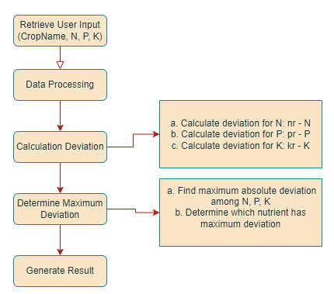

Figure 3. Fertilizer Recommendation System Flowchart

The technique for recommending fertilizers based on crop and NPK values is illustrated in the flowchart. It follows a rule- based methodology. The steps involved are broken down as follows:

1. Retrieve User Input: The first thing the system does is collect user input, which includes:

* Crop Name: The kind of crop the user plans to cultivate.
* NPK Values: These stand for the amounts of potassium (K), phosphorus (P), and nitrogen (N) in the user's soil.

1. Data Processing:

Calculate Deviation for NPK**:** In this stage, the difference between the actual NPK values that the user submitted (N, P, and K) and the recommended NPK values for the designated crop (nr, pr, and kr) is calculated. The following formulae are employed:

The formulas used are:

* + Deviation for N: nr – N
  + Deviation for P: pr – P
  + Deviation for K: kr - K

1. Determine Maximum Deviation:

* Find Maximum Absolute Deviation This phase determines which of the estimated deviations for N, P, and K has the biggest absolute deviation (distance from zero).
* Determine Nutrient with Maximum Deviation: The nutrient (N, P, or K) with the largest variation determined in the preceding stage is then determined by the system.

1. Retrieve User Input: The method makes a fertilizer recommendation that is likely to treat the shortfall based on the nutrient with the highest variance. For example, the system may suggest a high-nitrogen fertilizer if the largest deviation is detected in the nitrogen (N) value.
   1. Disease Detection System

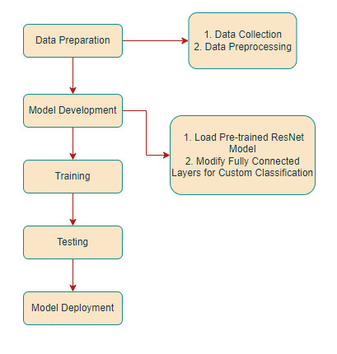

Figure 4. Disease Detection System Flowchart

A disease diagnosis system based on input image data is illustrated in the flowchart, which makes use of a pre-trained Resnet model. The procedures are broken down as follows:

1. Collect Data: This step requires the collection of a large dataset of images showing examples of both healthy and diseased plants.
2. Data Preprocessing**:** This could entail cropping images to a standard size, changing contrast and brightness, or using certain methods to bring out traits associated with the disease.
3. Load Pre-trained ResNet Model: The system employs a pre-trained ResNet model. Impressive results have been obtained with the convolutional neural network (CNN) architecture called ResNet in several image categorization tasks. Use of a pre-trained model and the advantages of its learned characteristics can help the system save training time as compared to starting from scratch with a new model.
4. Modify Fully Connected Layers for Custom Classification**:** New fully linked layers are probably going to replace the final levels created for the first classification task, however, the pre-trained ResNet model's fundamental layers remain. The set of disease pictures is used to train these additional layers to identify the particular plant illnesses that are of interest.
5. Training: The enhanced ResNet model is then trained using the acquired illness image dataset. Before the model can differentiate between various illnesses and between healthy and diseased plants, it needs to learn to identify patterns and features in the images.
6. Testing: Another testing dataset is used to assess the model's performance once it has been trained. This aids in evaluating the model's generalization ability, or its capacity to correctly categorize novel, unseen images.
7. Output**:** The system is prepared for deployment when it reaches an acceptable performance level. Next, users can upload additional plant images, which the system will analyze using the trained model to determine whether and what kind of disease is likely to be present.
8. **RESULT AND DISCUSSION**
   1. Dataset

# Table 2: Dataset

The dataset depicted in the image is one that recommends crops. It has several characteristics that can be utilized to forecast which crop would do best when planted in a specific area.

The dataset's features are as follows:

* NPK: This probably alludes to the proportion of these three nutrients—nitrogen, phosphorus, and potassium—in the soil, which are necessary for plant growth.
* temperature: This is the Fahrenheit temperature.
* Humidity: Denotes the degree of humidity expressed in Fahrenheit.
* pH: This is the soil's pH, which indicates basic or acidic properties.
* Rainfall: The millimeters per hour of rainfall is indicated here.
* Label: Given the other characteristics, this crop is suggested. For the first five rows in the photograph, the label reads "rice," and for the final five rows, it reads "coffee.".
  1. Visualization

The homepage of the AgroTech online application, which helps farmers make data-driven decisions about their crops, is shown in Fig. 5. AgroTech has the potential to raise farm profitability, output, and sustainability of the environment.



Figure 5. Homepage

As shown in Fig. 6, our crop recommendation system asks users for information on temperature, humidity, pH, average rainfall, and Potassium (K) and Phosphorus (P) values. The system then recommends a crop that is most likely to succeed in those conditions based on that data.

|  |  |  |  |  |  |  |  |  |
| --- | --- | --- | --- | --- | --- | --- | --- | --- |
|  | **N** | **P** | **K** | **temperature** | **humidity** | **pH** | **rainfall** | **label** |
| 0 | 73 | 55 | 42 | 20.879744 | 82.002744 | 6.502985 | 202.935536 | rice |
| 1 | 100 | 43 | 44 | 21.770462 | 80.319644 | 7.038096 | 226.655537 | rice |
| 2 | 91 | 46 | 41 | 23.004459 | 82.320763 | 7.840207 | 2630964248 | rice |
| 3 | 67 | 40 | 43 | 26.491096 | 80.158363 | 6.980401 | 242.864034 | rice |
| 4 | 60 | 60 | 42 | 20.130175 | 81.604873 | 7.628473 | 262.717340 | rice |
| … | … | … | … | … | … | … | … | … |
| 2295 | 88 | 33 | 32 | 26.774637 | 66.413269 | 6.780064 | 177.774507 | coffee |
| 2296 | 98 | 23 | 35 | 27.417112 | 56.636362 | 6.086922 | 127.924610 | coffee |
| 2297 | 84 | 27 | 28 | 24.131797 | 67.225123 | 6.362608 | 173.322839 | coffee |
| 2298 | 113 | 33 | 35 | 26.272418 | 52.127394 | 6.758793 | 127.175293 | coffee |
| 2299 | 90 | 29 | 34 | 23.603016 | 60.396475 | 6.779833 | 140.937041 | coffee |

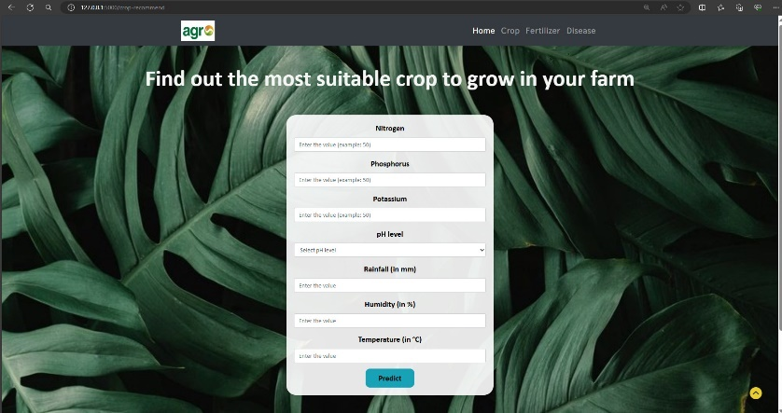

Figure 6. User Interface for Crop Recommendation System

Next, a crop that is appropriate for the growing conditions is suggested based on the user data. Based on the information users supply, the algorithm suggests crops for them to produce. Here, it recommends growing chickpeas on your farm using the Random Forest Algorithm.

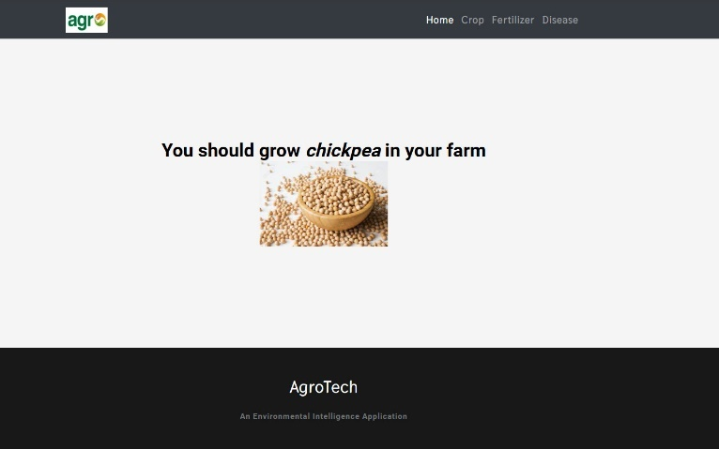 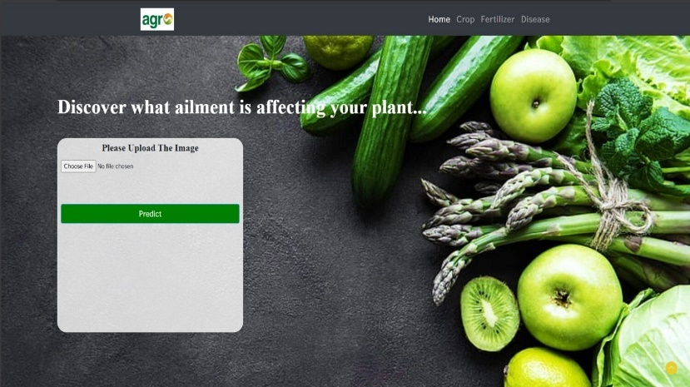

Figure 7. Crop Recommendation System

Our fertilizer recommendation system (Fig. 8) provides NPK values for the crop the user chooses to plant. The macronutrients NPK, which are essential for plant growth, are used. The device can suggest fertilizers specifically designed to treat any potential nutritional deficiencies in the user's soil by gathering this data.

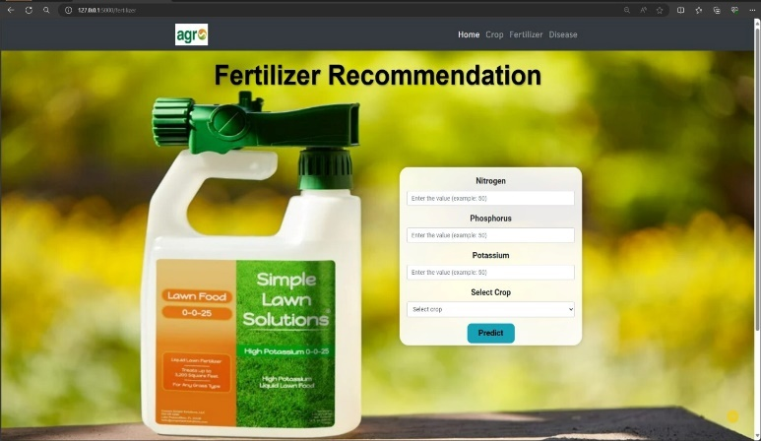

Figure 8. User Interface for Fertilizer Recommendation System

User input on the factors influencing fertilizer requirements is gathered by our fertilizer suggestion system. By gathering data, it may identify nutritional inadequacies and use Rule-Based algorithms to support the best possible plant growth.

Figure 9. Fertilizer Recommendation System

Users can contribute images of their plants through a web interface that we are using for our crop disease detection study. Next, the system uses ResNet to analyze the submitted photos to identify possible diseases.

Figure 10. User Interface for Disease Detection System

Once a user uploads an image, the system shows the ailment the plant has.

Figure 11. Disease Detection System

* 1. Evaluation

1. Accuracy-The most fundamental indicator is accuracy, which shows the total percentage of accurate predictions your system makes. True positive and true negative cases are both considered.

Accuracy = (TP + TN) / Total No. of Samples

1. Precision- Precision highlights the positive forecasts by calculating the percentage of your system's positive predictions that materialize. It assists you in determining how well your system handles false positives.

Precision = TP / (TP + FP)

1. Recall - Recall quantifies the proportion of true positive cases that your system accurately identifies. It aids in evaluating the degree to which your system avoids false negatives.

Recall = TP / (TP + FN)

1. F1-Score – A harmonic mean that finds a balance between recall and precision is the F1-Score. It provides a single indicator to account for both elements, which makes it particularly useful in scenarios where the cost of false positives and false negatives may be equally large.

F1-Score = 2 * (Precision * Recall) / (Precision + Recall)

1. Specificity – The percentage of real negative cases that your system accurately detects is measured by specificity. It provides you with an indicator of how well your system avoids false positives.

Specificity = TN / (TN + FP)

The goal of this effort was to identify the optimal model for crop dataset crop recommendation prediction. Random Forest is the most accurate model for crop suggestion in the comparison table, with an incredible accuracy score of 0.9935.

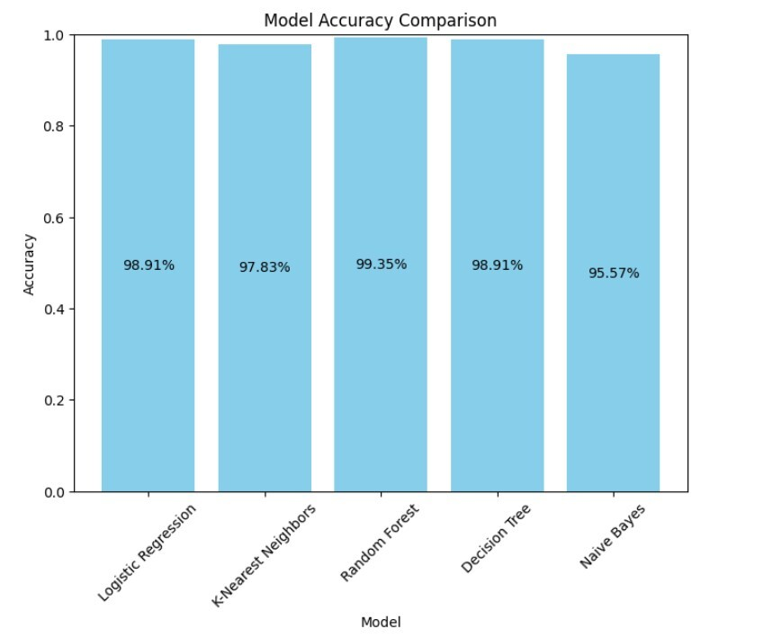

Figure 12. Accuracy Comparison Chart

1. **CONCLUSION**

In conclusion, by developing a web-based application for crop disease, fertilizer, and yield prediction, our research study offers a novel solution to the issues encountered in contemporary agriculture. Farmers will gain practical knowledge from it to increase productivity and sustainability. By utilizing multispectral imaging methods and larger datasets for training models, the platform can offer more precise diagnostic and treatment suggestions for crop diseases. This agricultural web tool will eventually use satellite imagery and real-time IoT sensor data to increase recommendation accuracy. Creating a smartphone application will make farming more accessible, especially for those who live in rural areas. The goal of adding multilingual support is to appeal to a worldwide audience.

1. **FUTURE SCOPE**

The project's future objectives include broadening the database's coverage of crops, soil kinds, and climates to improve the recommendations' accuracy and usefulness. The accuracy of crop and fertilizer recommendations can be further improved by integrating real-time data from IoT devices and satellite photography. In order to forecast the long-term effects of farming methods on soil health and crop productivity, sophisticated machine learning algorithms could be implemented. The technology will become more widely available to farmers worldwide with the addition of multilingual support and a mobile application interface.

1. **REFERENCES**
2. C. O. Martinez-Ojeda, T. M. Amado and J. C. Dela Cruz, "In Field Prssoximal Soil Sensing For Real Time Crop Recommendation Using Fuzzy Logic Model," 2019 International Symposium on Multimedia and Communication Technology (ISMAC), Quezon City, Philippines, 2019, pp. 1-5, doi: 10.1109/ISMAC.2019.8836160.
3. S. Bhanumathi, M. Vineeth and N. Rohit, "Crop Yield Prediction and Efficient use of Fertilizers," 2019 International Conference on Communication and Signal Processing (ICCSP), Chennai, India, 2019, pp. 0769-0773, doi: 10.1109/ICCSP.2019.8698087.
4. M. Kumar, A. Arora, A. Deb and A. L. Yadav, "Deep Learning for Accurate Plant Disease Classification Using ResNet50: A Comprehensive Approach," 2024 International Conference on Computational Intelligence and Computing Applications (ICCICA), Samalkha, India, 2024, pp. 125-130, doi: 10.1109/ICCICA60014.2024.10584860.
5. V. Suma, R. A. Shetty, R. F. Tated, S. Rohan and T. S. Pujar, "CNN based Leaf Disease Identification and Remedy Recommendation System," 2019 3rd International conference on Electronics, Communication and Aerospace Technology (ICECA), Coimbatore, India, 2019, pp. 395-399, doi: 10.1109/ICECA.2019.8821872.
6. M. S. Ram, D. M. Kumar, S. S. Manikanta and S. Mahira, "Deep Learning based Cotton Plant Pest Detection and Fertilizer Recommendation System," 2024 3rd International Conference on Applied Artificial Intelligence and Computing (ICAAIC), Salem, India, 2024, pp. 656-663, doi: 10.1109/ICAAIC60222.2024.10574915.
7. R. Indumathi., N. Saagari., V. Thejuswini. and R. Swarnareka., "Leaf Disease Detection and Fertilizer Suggestion," 2019 IEEE International Conference on System, Computation, Automation and Networking (ICSCAN), Pondicherry, India, 2019, pp. 1-7, doi: 10.1109/ICSCAN.2019.8878781.
8. U. Shruthi, V. Nagaveni and B. K. Raghavendra, "A Review on Machine Learning Classification Techniques for Plant Disease Detection," 2019 5th International Conference on Advanced Computing & Communication Systems (ICACCS), Coimbatore, India, 2019, pp. 281-284, doi: 10.1109/ICACCS.2019.8728415.
9. P. P. Patel and D. B. Vaghela, "Crop Diseases and Pests Detection Using Convolutional Neural Network," 2019 IEEE International Conference on Electrical, Computer and CommunicationTechnologies (ICECCT), Coimbatore, India, 2019, pp. 1-4, doi: 10.1109/ICECCT.2019.8869510.
10. J. Zhao and J. Qu, "A Detection Method for Tomato Fruit Common Physiological Diseases Based on YOLOv2," 2019 10th International Conference on Information Technology in Medicine and Education (ITME), Qingdao, China, 2019, pp. 559-563, doi: 10.1109/ITME.2019.00132.
11. .C. U. Kumari, S. Jeevan Prasad and G. Mounika, "Leaf Disease Detection: Feature Extraction with K-means clustering and Classification with ANN," 2019 3rd International Conference on Computing Methodologies and Communication (ICCMC), Erode, India, 2019, pp. 1095-1098, doi: 10.1109/ICCMC.2019.8819750.
12. A. Agarwal, S. Ahmad and A. Pandey, "Crop Recommendation Based on Soil Properties: A Comprehensive Analysis," 2023 14th International Conference on Computing Communication and Networking Technologies (ICCCNT), Delhi, India, 2023, pp. 1-6, doi: 10.1109/ICCCNT56998.2023.10307999.
13. S. J. R, H. D and P. B, "A Machine Learning-based Approach for Crop Yield Prediction and Fertilizer Recommendation," 2022 6th International Conference on Trends in Electronics and Informatics (ICOEI), Tirunelveli, India, 2022, pp. 1330-1334, doi: 10.1109/ICOEI53556.2022.9777230.
14. R. Jaichandran, T. M. Krishna, S. H. Arigela, R. Raman, N. Dharani and A. Kumar, "Light GBM Algorithm based Crop Recommendation by Weather Detection and Acquired Soil Nutrients," 2022 International Conference on Power, Energy, Control and Transmission Systems (ICPECTS), Chennai, India, 2022, pp. 1-5, doi: 10.1109/ICPECTS56089.2022.10047765
15. D. Balakrishnan, A. P. Kumar, K. Sai Kiran Reddy, R. R. Kumar, K. Aadith and S. Madhan, "Agricultural Crop Recommendation System," 2023 3rd International Conference on Intelligent Technologies (CONIT), Hubli, India, 2023, pp. 1-5, doi: 10.1109/CONIT59222.2023.10205756.
16. M. J and I. M, "Hybrid filter and wrapper methodsbased feature selection for crop recommendation," 2022 International Conference on Electronic Systems and Intelligent Computing (ICESIC), Chennai, India, 2022, pp. 247-252, doi: 10.1109/ICESIC53714.2022.9783542.
17. P. Parameswari, N. Rajathi and K. J. Harshanaa, "Machine Learning Approaches for Crop Recommendation," 2021 International Conference on Advancements in Electrical, Electronics, Communication, Computing and Automation (ICAECA), Coimbatore, India, 2021, pp. 1-5, doi: 10.1109/ICAECA52838.2021.9675480.
18. P. Dey, T. Mahmud, S. R. Nahar, M. S. Hossain and K. Andersson, "Plant Disease Detection in Precision Agriculture: Deep Learning Approaches," 2024 2nd International Conference on Intelligent Data Communication Technologies and Internet of Things (IDCIoT), Bengaluru, India, 2024, pp. 661-667, doi: 10.1109/IDCIoT59759.2024.10467525.
19. S. Iniyan, M. S. Raja, R. Srinivasan, C. Santhanakrishnan and A. Srinivasan, "Crop and Fertilizer Recommendation System Applying Machine Learning Classifiers," 2023 International Conference on Emerging Research in Computational Science (ICERCS), Coimbatore, India, 2023, pp. 1-6, doi: 10.1109/ICERCS57948.2023.10433972.
20. J. J. I. Haban, J. C. V. Puno, A. A. Bandala, R. Kerwin Billones, E. P. Dadios and E. Sybingco, "Soil Fertilizer Recommendation System using Fuzzy Logic," 2020 IEEE REGION 10 CONFERENCE (TENCON), Osaka, Japan, 2020, pp. 1171-1175, doi: 10.1109/TENCON50793.2020.9293780.
21. Y. Zhao, Z. Li, J. Wang, W. Yang, D. Duan and X. Xu, "Recommendations for Nitrogen Fertilizer in Winter wheat Based on Nitrogen Nutrition Index," 2019 8th International Conference on Agro-Geoinformatics (Agro-Geoinformatics), Istanbul, Turkey, 2019, pp. 1-4, doi: 10.1109/Agro-Geoinformatics.2019.8820439.