**Abstract**

Crafting User-Centric Login, Signup, and Verification Experiences.

In the dynamic landscape of digital interaction, our commitment to an exceptional user experience is evident in the meticulous design of our login, signup, forget password, and OTP verification pages. The login page introduces a dynamic mouseover effect on the login button, utilizing color changes to subtly enhance user interaction. This, coupled with an elegant background gradient and a delicate box shadow, results in an interface that is not only functional but also aesthetically pleasing.

The signup page goes beyond mere functionality, seamlessly integrating form shake effects and red border indicators to guide users effectively through the completion of all required fields. The incorporation of password matching checks and a confirmation alert post-signup ensures a smooth and positive interaction, while the inclusion of a strategically placed login link facilitates effortless navigation between functionalities.

Within the forget password page, a shaking effect and red border indicators elegantly handle empty email fields. A well-thought-out transition to the OTP entry page ensures a user-friendly password recovery process, providing a logical and reassuring sequence.

The OTP verification page, designed with efficiency in mind, boasts features such as seamless navigation, numeric input restrictions, and intelligent button activation. This approach aims not only for a secure verification process but also for one that is devoid of friction, ensuring a seamless user journey.

Beyond the functional aspects, the overarching design philosophy prioritizes aesthetics, leveraging attractive gradients to elevate visual appeal. Responsiveness is not merely a consideration but a priority, guaranteeing an optimal user experience across an array of devices and screen sizes. CSS is employed as a tool for creative expression, experimenting with styles, fonts, and spacing to create visually engaging interfaces that captivate and retain user attention.

Form validation on the signup page adds yet another layer of user-friendly functionality, providing clear and concise error messages for invalid inputs. This meticulous approach to design and functionality is aimed at creating an immersive, error-resistant, and visually captivating experience for users accessing the platform.

**Login Page**

**Features**

**1.Mouseover Enhancements for the Login Button**

The login button undergoes a dynamic visual transformation upon mouse hover, providing an engaging and interactive experience. This subtle yet effective feature uses colour change to signal interactivity, enhancing the overall user experience.

**2.Dynamic Form Shake Effect for Empty Fields**

**a. Empty Email and Password Fields**

When attempting to submit the login form with empty email and password fields, a dynamic shaking effect is applied to the entire form. This visual cue directs the user's attention to the areas requiring input, prompting them to fill in the necessary information before proceeding.

**b. Empty Password Field**

In case the password field is left empty during a login attempt, a targeted shaking effect is specifically applied to the password input field. This ensures that users are promptly notified of the missing password input, encouraging them to provide the required information.

**3.Notification for Successful Login**

An alert message promptly notifies users upon successful authentication, serving as confirmation and reassurance regarding the accuracy of their credentials. This immediate feedback enhances the user experience by providing clear information on the login status.

**4.Aesthetic Design Elements: Background Gradient and Box Shadow**

The login page is visually enhanced with a gradient background spanning the entire body, contributing to an aesthetically pleasing design. Additionally, a subtle box shadow applied to the login form creates depth and separation from the background, adding a touch of elegance to the overall login page aesthetics.

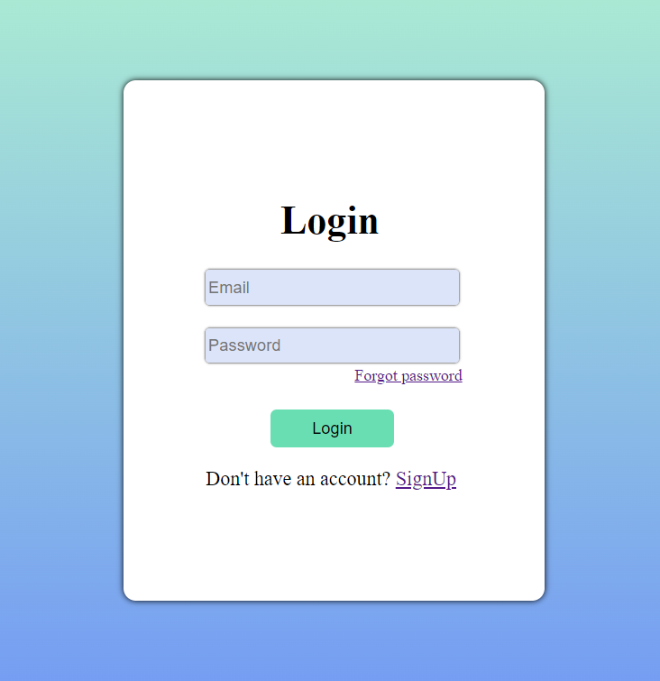

*By integrating these features, the login page aims to deliver a user-friendly and visually engaging experience, ensuring a seamless and aesthetically pleasing login process.*

**Sign-Up Page**

**Features**

**1.Interactive Form Shake Effect and Red Border Indicators**

**a. All Fields Empty**

Attempting to submit the sign-up form with all field’s empty triggers a form-shaking effect and red border indicators on all input fields. This provides a clear visual indication of missing information, prompting users to complete all required fields before proceeding.

**b. Any One Field Empty**

If any one of the three fields (email, password, or confirm password) is left empty during sign-up, a targeted shaking effect and red border on the specific empty field guide users to input the necessary information.

**2.Password Matching Check**

The sign-up page includes a password matching check, ensuring entered passwords match the confirmation password. A shaking effect and red border on the confirm password field visually notify users of any password mismatch, prompting them to verify the entered information.

**3.Confirmation Alert for Successful Sign-Up**

Upon successfully completing the sign-up process, a pop-up alert message confirms the user's successful registration. This immediate feedback ensures users are informed of their sign-up status, fostering a positive interaction with the platform.

**4.Convenient Login Link**

The sign-up form incorporates a direct link to the login page, facilitating easy navigation between login and sign-up functionalities. This feature enhances user convenience for those with existing accounts or those exploring additional platform features.

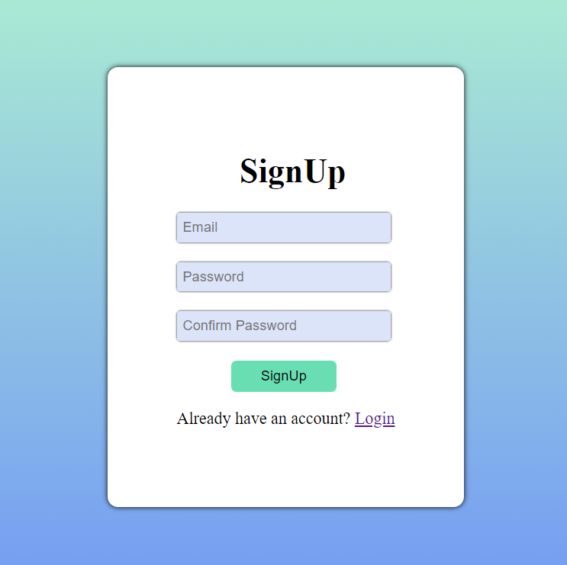

*By including these features, the sign-up page aims to provide a comprehensive and user-friendly experience, combining visual cues, error feedback, and navigation links for an effective sign-up process.*

**Forget Password Page**

**Features**

**1.Effective Handling of Empty Email Field**

**a. Email Field Empty**

Initiating the password recovery process with an empty email field triggers a shaking effect and red border on the email field. This visual feedback prompts users to enter a valid email address before proceeding with password recovery.

**2.Smooth Transition to OTP Entry Page**

After successfully entering a valid email address and clicking the "Send OTP" button, users are seamlessly redirected to the OTP entry page. This step-by-step approach enhances the user experience, guiding them through a logical sequence starting with email verification.

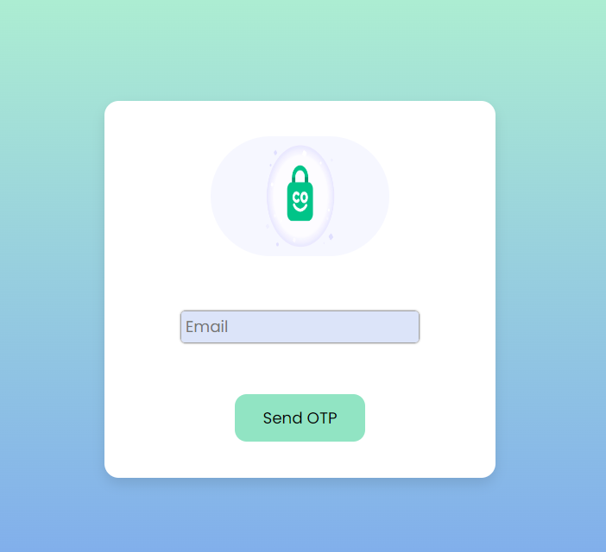

*By incorporating these features, the forget password page ensures clear feedback on the email field's status and facilitates a smooth transition to the OTP entry page, simplifying the password recovery process and reducing potential errors or confusion.*

**OTP Verification Page**

**Features**

**1.Efficient Navigation Between OTP Input Fields**

The OTP verification page is designed with four dedicated input fields, allowing users to seamlessly navigate between them. Automatic focus shifting to the next input field upon digit entry and returning to the previous field when removing a digit ensures a quick and efficient entry process.

**2.Numeric Input Restriction for Accuracy**

To enhance data accuracy, the input fields exclusively accept numeric values during OTP entry. This restriction prevents users from entering non-numeric characters, reducing the likelihood of errors in the verification process.

**3.Intelligent Button Activation on Complete OTP Entry**

The verification page features a button, labelled "Verify" or a similar term, which remains inactive until all four OTP input fields contain numeric values. This design ensures users can only attempt verification once all necessary information is provided, preventing premature or incomplete attempts.

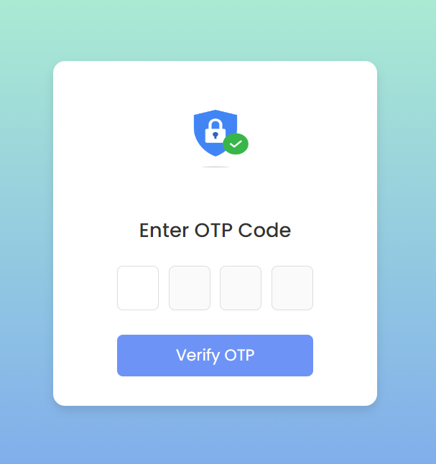

*By integrating these features, the OTP verification page aims to streamline the user experience, promoting efficiency and error resistance. Automatic navigation, numeric input restriction, and intelligent button activation collectively contribute to a seamless and secure OTP verification process.*