1.open AWS select all services after that click on EC2

2. Click on instance

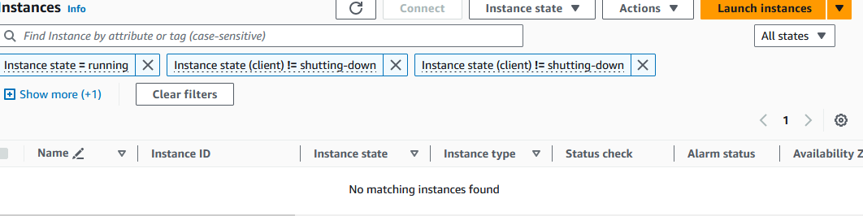

3.Create instance click on launch instance

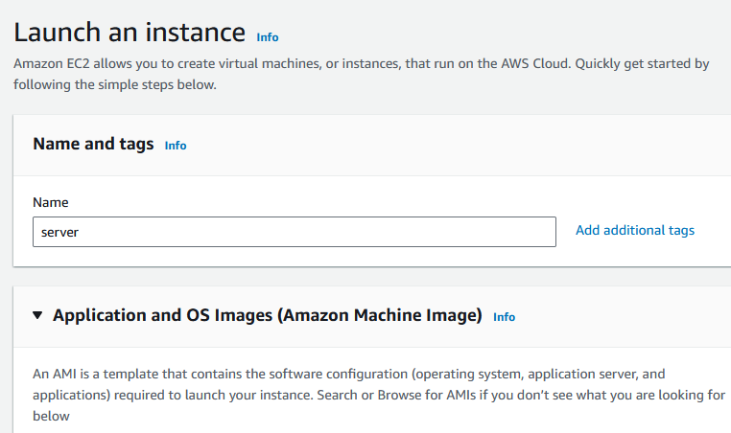

4. Select AMI as a Ubuntu after that add key pair

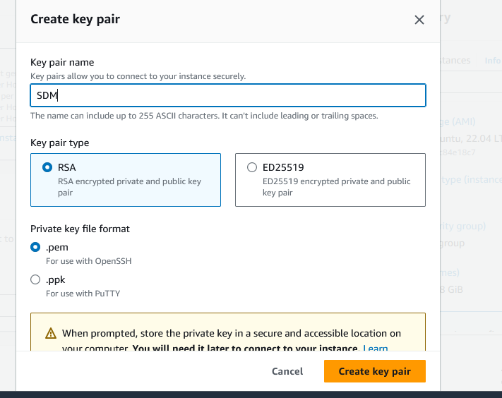

5. click launch instance

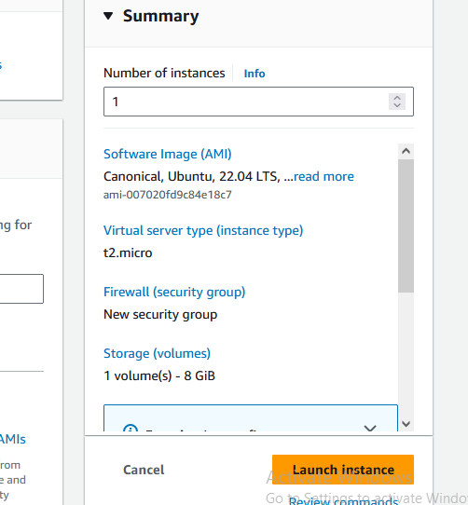

6. click on connect instance

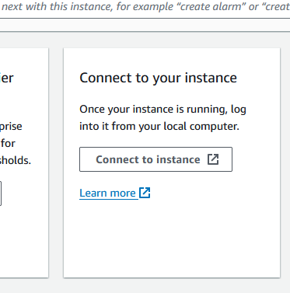

7.click on connect

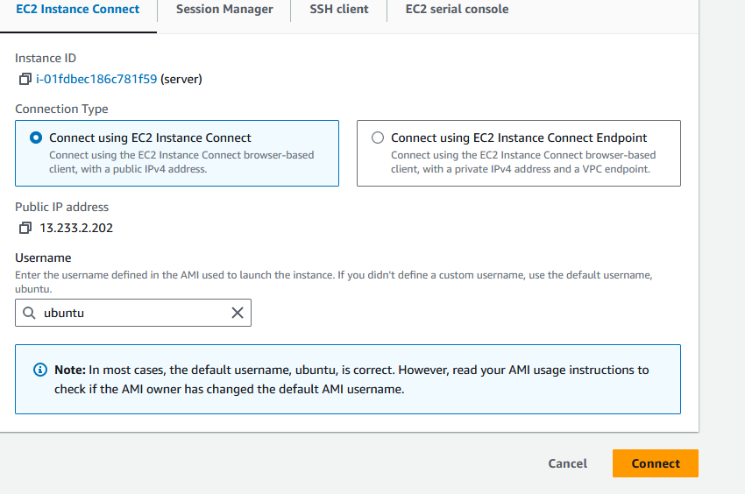

8.Select security group click on link change inbound rule

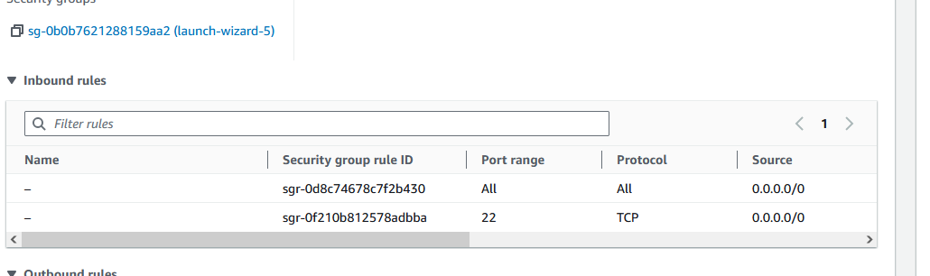

Click on edit inbound rules

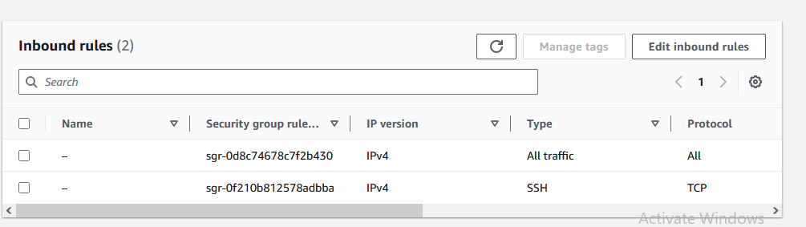

Click on add rules and select all traffic and select IPv4

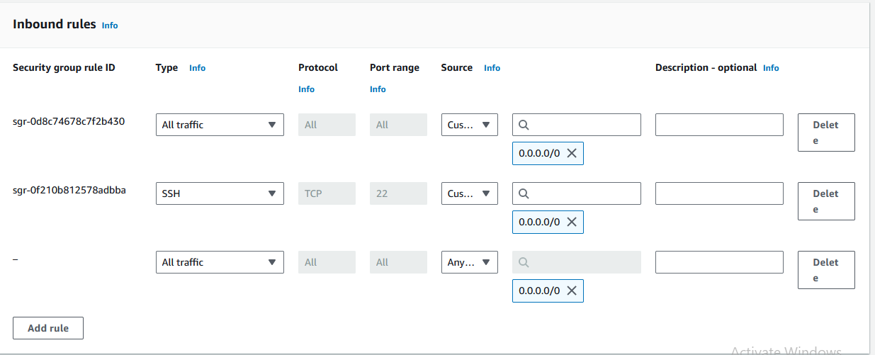

9.Linux shell is open

-- mkdir TFL

--ls

--git –version

--cd TFL

--git clone <https://github.com/RaviTambade/tflstore.git>

--git tflstore

--Ls

--node –v

--sudo apt update

--sudo apt install nodejs

--node –v

--sudo apt install npm

--npm install

--node server.js

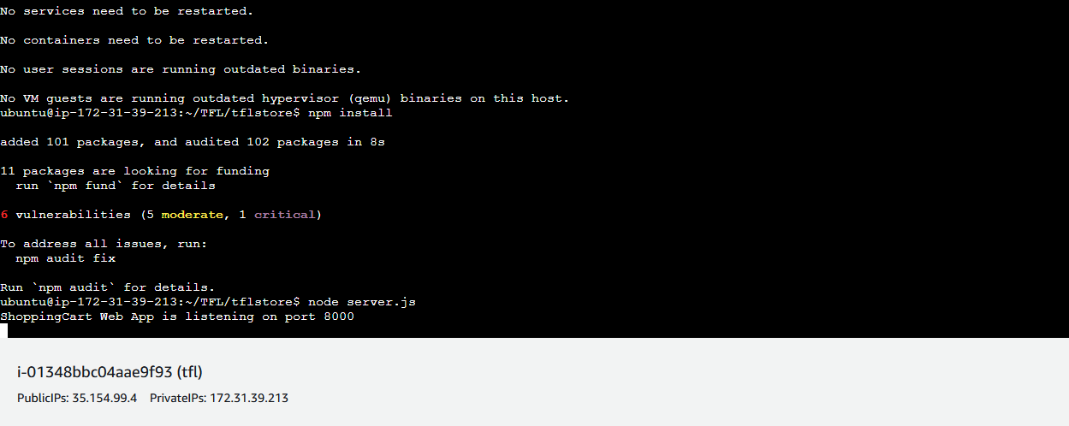

**Q. Building and deploying webapps as contanarized application**

Steps

1.login aws console

2.Create EC2 instance with Ubuntu os image

connection----SSH---auth---Credential—ppk files---open putty

clear

sudo apt update

clear

docker –v

sudo apt install docker.io

docker –v

sudo systemctl status docker

Q

Sudo docker ps

Sudo docker images

Sudo docker pull hello-world

Sudo docker images

Sudo docker pull nginx

Sudo docker images

Sudo docker run hello-world

Sudo docker ps

Sudo docker images

Sudo docker run –name tflserver –d –p 8080:80 nginx

Sudo docker ps

Git clone path

Ls

Cd tflstore

Sudo docker images

Sudo docker build –t tflimage .

Sudo docker images

Sudo docker run –name vijaysales –d –p 8000:8000 tflimages

Sudo docker ps

