ANALYSIS OF REVISED GRAPHS CHECKING AWARENESS LEVELS BY ATTRIBUTES AND OVERALL AS WELL

- Overall distribution of Awareness Based on final normalized score
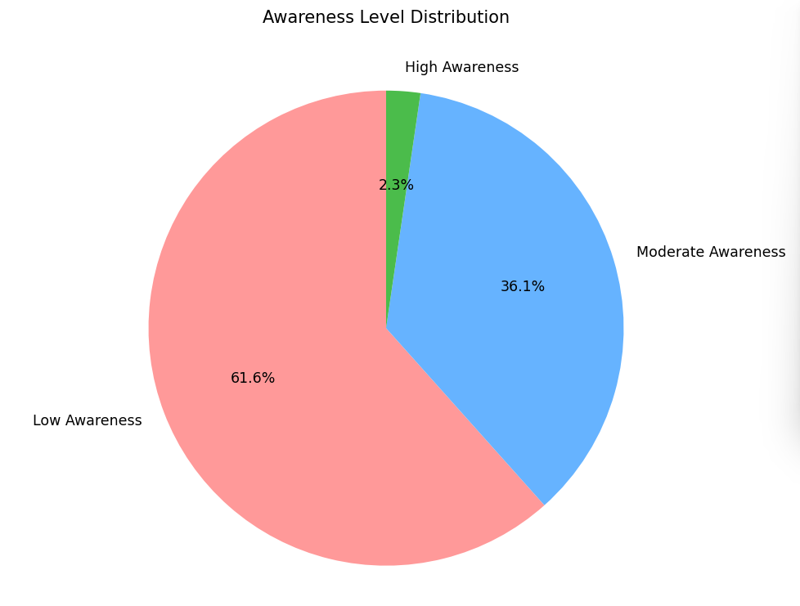
Thresholds: Low = score between 0 and 6
Moderate = score between 6 and 8.5
High = score greater than 8.5
For a candidate to have high awareness, they should be completely prepared to deal with a real time stroke types emergency. That involves the complete and accurate knowledge of what stroke is, what are the symptoms, the risk factors, and nature of action to be taken ranging from timing to specialist to place to contact. Hence the threshold for anyone to be labelled as “highly aware” is kept strictly more than 8.5.
A score between 0 to 6 is treated as a user having fragmented or incomplete understanding of what stroke is and its severity. Hence a user having less than 60% knowledge knows some facts but not enough to act in a case of emergency and they are labelled as individuals with “low awareness”.
Thus, we can observe that only 2.3% of the total respondents of the survey are properly equipped to identify, and deal with a stroke like situation in real life while 36.1% respondents know some measures to be taken but still need proper education to actually make a change. This means a huge majority i.e. 61.6% of the respondents are not aware enough to even identify symptoms of stroke and even if they do because of their incomplete knowledge they won’t be able to act accordingly.

- Awareness Level Distribution – Advice
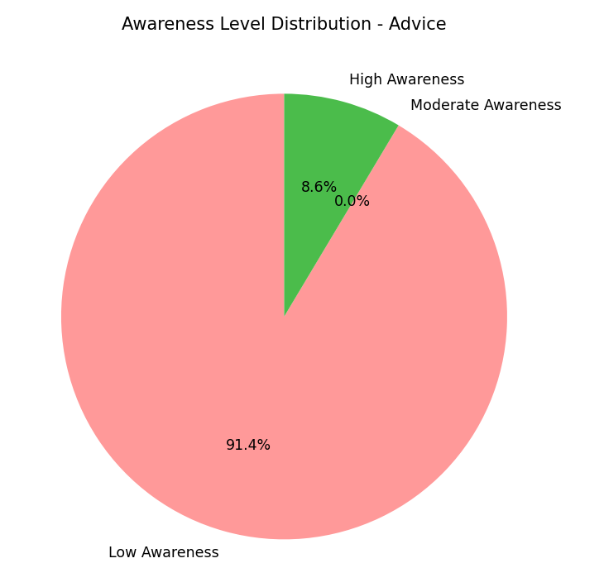
Meaning: Low = vague, incorrect, non-actionable advice
Moderate = partially appropriate advice
High = immediate emergency care and hospitalization
This pie chart shows the awareness levels of respondents on the vagueness level of the advice they give when asked. An overwhelming 91.4% of respondents fall under low awareness, with only 8.6% demonstrating high awareness. Moderate awareness is almost absent, indicating that advice tends to be either clearly appropriate or largely ineffective. This reflects a serious gap in actionable knowledge. Even when individuals may recognize symptoms or risks, they often fail to translate this awareness into correct advice, which could result in harmful delays during real-life situations.

- Awareness Level Distribution – First Contact
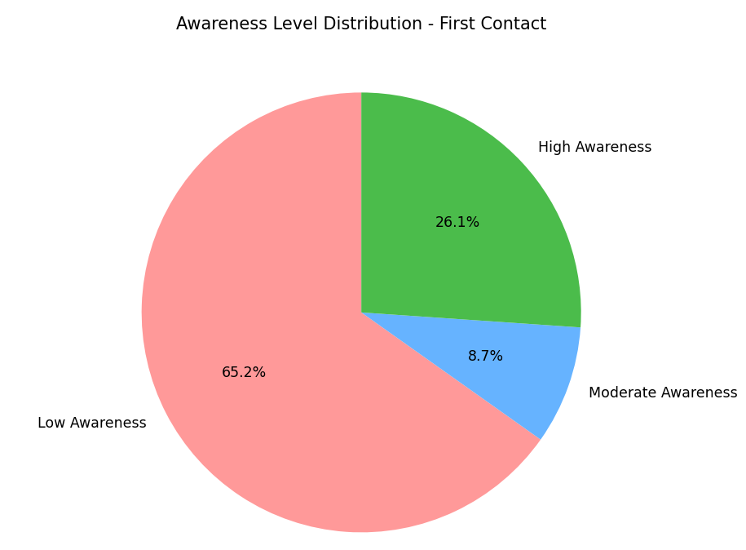
Meaning: High = emergency services, immediate hospital care
Moderate = hospital (no emergency services specified)
Low = other inputs
The majority of respondents i.e. 65.2% of the total respondents fall under low awareness, indicating uncertainty or misinformation about whom to contact first during a stroke event. A small proportion of 8.7% shows moderate awareness, while only a limited segment of 26.1% of the total respondents demonstrates correct understanding of emergency response pathways. This highlights a critical gap between symptom recognition and action. Even when symptoms are identified, lack of clarity about the correct first contact may result in delayed treatment, undermining the benefits of early detection.

- Awareness Level Distribution – Urgency
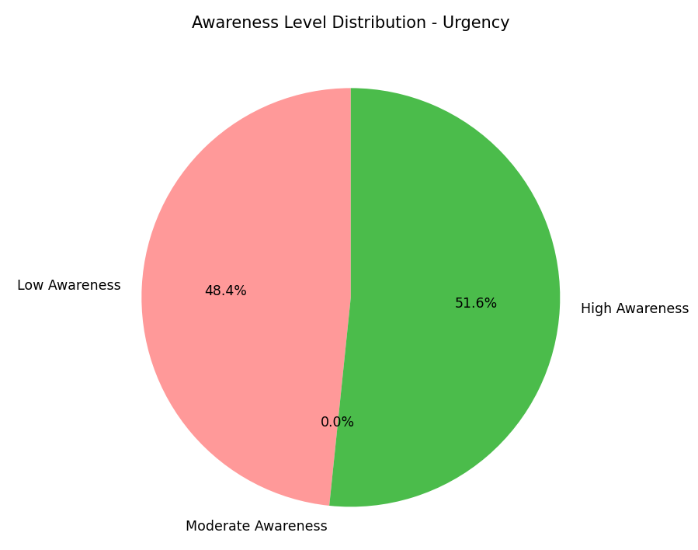
Meaning: High = immediate attention required
Moderate = delayed / non urgent responses
Low = no immediate attention required
The realization of level of urgency is extremely important as this can make or break the treatment plan of the patient. The distribution shows nearly equal proportions of low and high awareness (48.4% and 51.6% respectively), with negligible representation in the moderate category. This suggests that respondents tend to either understand the urgency of stroke clearly or significantly underestimate it. Urgency perception appears polarized. While many respondents understand the critical nature of stroke, a substantial number still fail to recognize the time-sensitive aspect, which could lead to dangerous delays in care.

- Awareness Level Distribution – Location
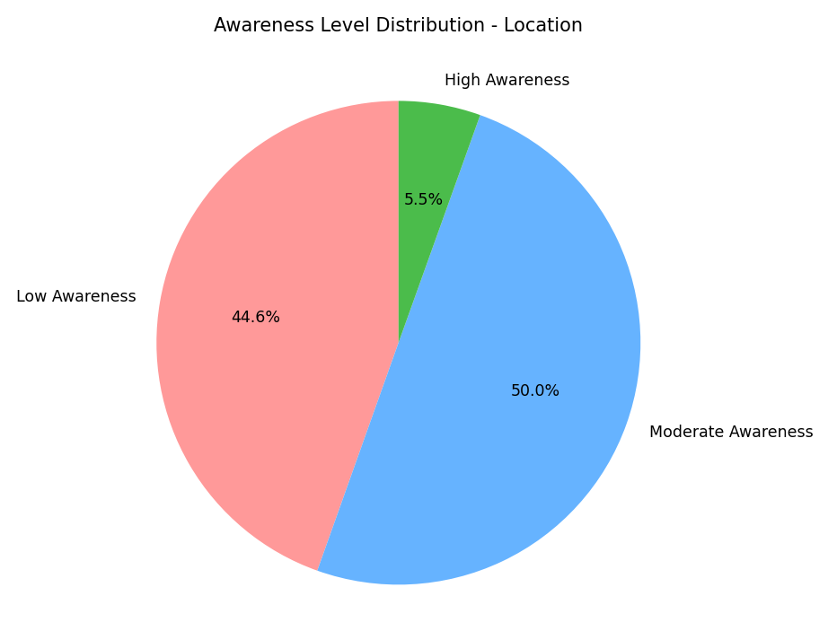
Meaning: High = emergency department, neurological facilities
Moderate = hospital care
Low = no hospital-based treatment
This pie chart shows the awareness levels of respondents with respect to the correct location to go when a case of stroke occurs. High awareness is linked to the emergency department or neurological facilities as this shows that the respondent realizes that an emergency situation like that of a stroke needs urgent care and that the patient needs that care from neurological facilities. Moderate awareness is linked to hospital care as this shows that the respondents do realize the need of treatment in hospitals but not actually the fully accurate department to consult. According to the pie chart, 50% of the total respondents fall into the moderate-awareness category, indicating general knowledge that stroke requires hospital care but limited understanding of the need for specialized or emergency treatment. High awareness is only found in 5.5% of the total respondents which emphasises the need for better awareness and understanding. This suggests partial awareness regarding treatment location. The section of low awareness with 44.6% of the total respondents shows that while respondents know stroke requires medical attention, many lack clarity on the urgency and specialization required, potentially contributing to treatment delays.

- Distribution of awareness of symptoms:
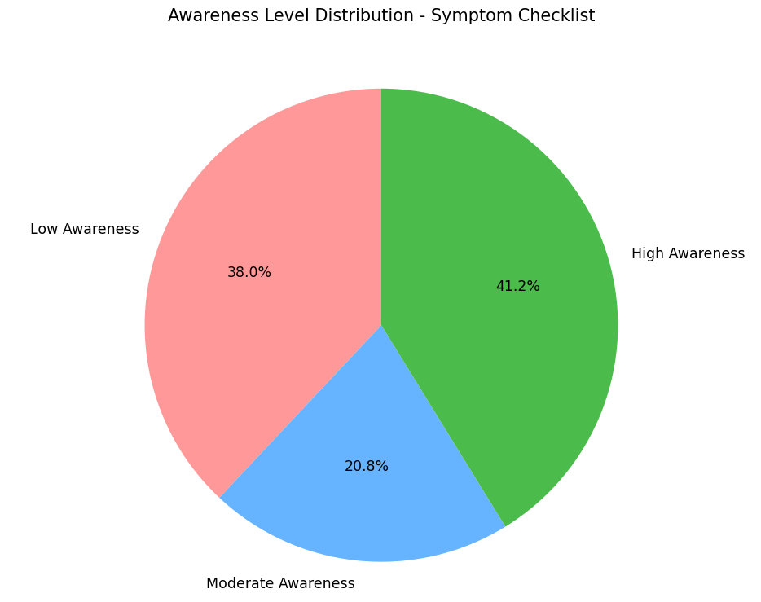
Meaning: Low = symptom awareness score less than 6
Moderate = symptom awareness score between 6 and 8.3
High = symptom awareness score more than 8.3
In the above pie chart, 41.2% of the total respondents fall under high awareness, indicating that many individuals are familiar with common stroke symptoms. However, a similarly 38% of the respondents are in the low-awareness group suggesting that symptom recognition is still inconsistent across the population. The moderate-awareness group (20.8%) represents respondents with partial knowledge, likely aware of one or two symptoms but lacking a complete understanding. This distribution suggests that symptom-based awareness campaigns have had some impact, but their reach is uneven. While some individuals are well-informed, a significant portion still lacks sufficient knowledge to reliably recognize stroke symptoms, which could lead to delayed medical response.

- Distribution of Awareness Level with respect to the familiarity to word “stroke”:
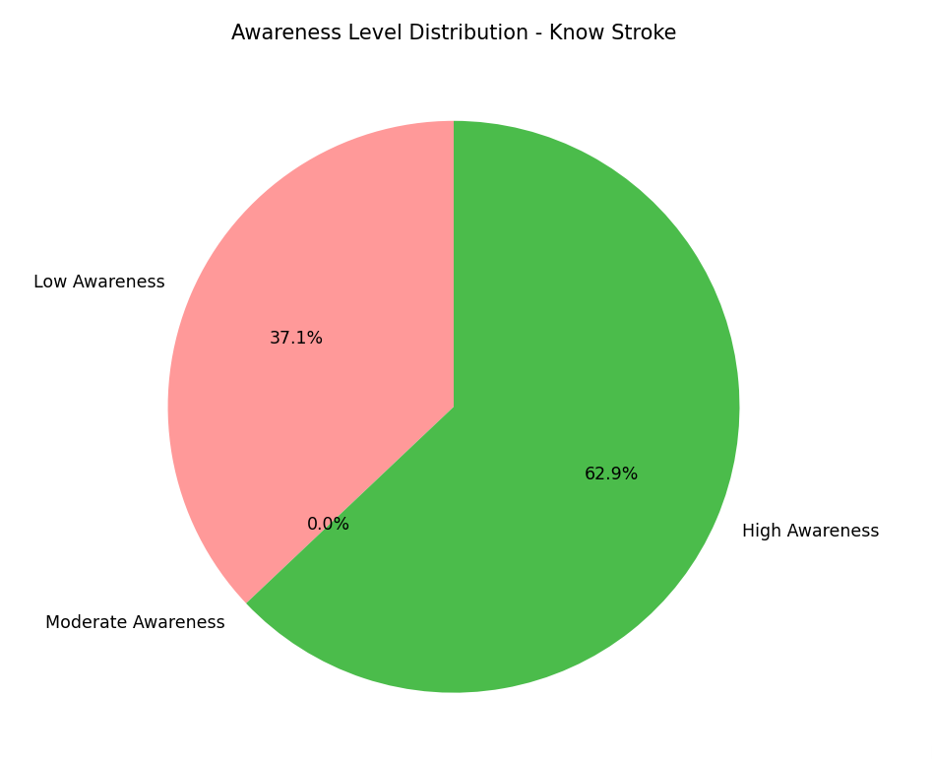
Meaning: Low = No
High = Yes
The asked question was binary in nature simply asking a respondent if they are aware about the term “stroke”. While 62.9% of respondents said yes, 37.1% respondents were still present who were not even familiar or aware of the term. This further emphasises the need for better education. This can also be contrasted with the overall awareness graph where one can easily see the difference between respondents claiming awareness about stroke, and how aware they actually are.

- Awareness Level Distribution – Risk Factors
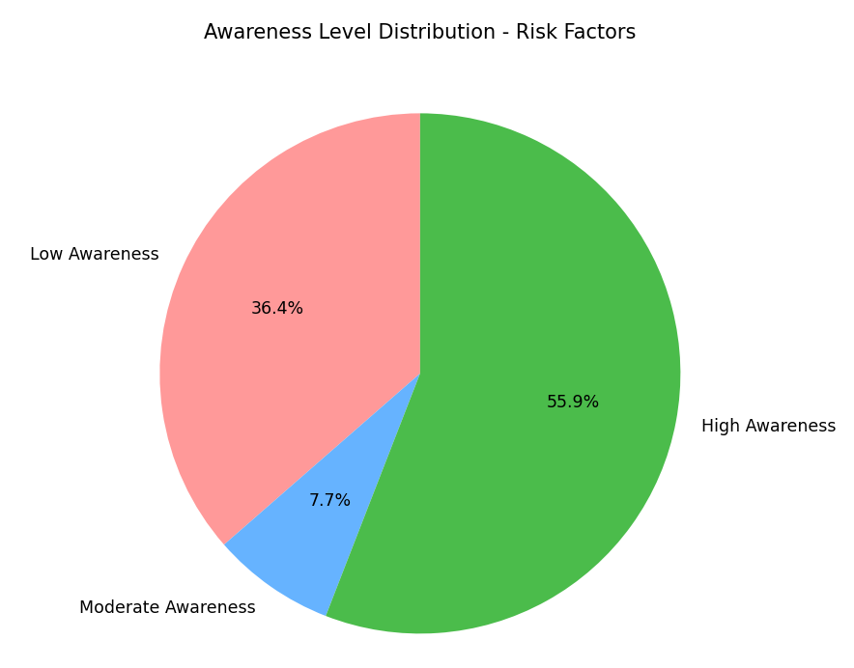
Meaning: High = hypertension, diabetes, smoking, age
Moderate = recognized some of the above-mentioned factors
Low = no factors recognized
More than half of the respondents i.e. 55.9% of the total respondents fall under high awareness, indicating relatively strong understanding of stroke risk factors. However, a significant low-awareness group remains (36.4%), showing that knowledge is not universal. Preventive awareness appears better developed than emergency-response awareness. While many respondents understand long-term risks, this knowledge does not necessarily translate into appropriate action during an actual stroke event.
- Distribution of awareness about the correct specialist to be consulted:
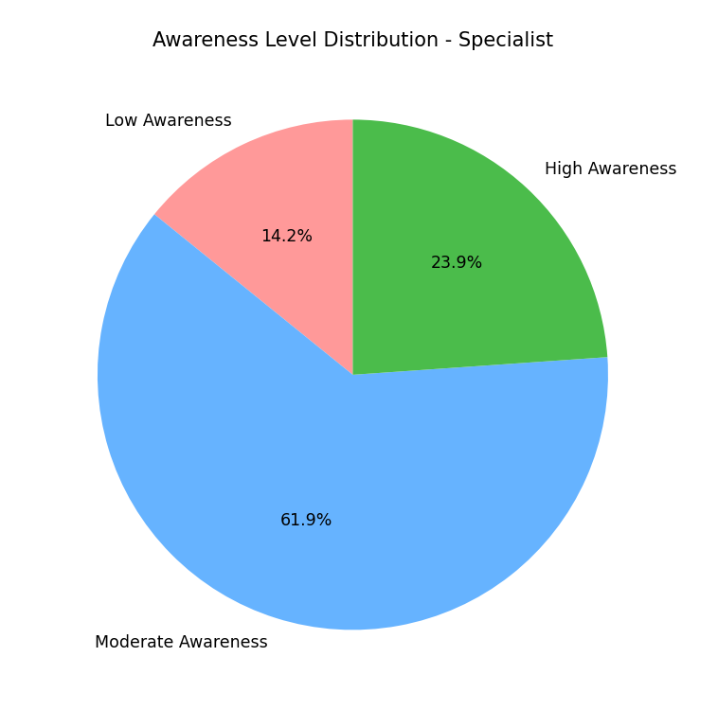
Meaning: High = neurologists
Moderate = physician
Low = all other inputs
The above graph shows that 23.9% of the total respondents knew that the ideal specialist to be consulted in a case of a stroke are neurologists. These people can accurately identify the symptoms of stroke and can make the correlation of symptoms and brain. According to this graph 61.9% of the total respondents don’t exactly know who to consult in the case of a stroke but consult a physician that can guide them further in the pathway. However, 14.2% of the respondents consult other specialists such as orthopaedics, or ENTs that only treat the symptom at best not the cause. This leads to delay in proper diagnosis and loss of time. This might be because of the inability to link the symptom to stroke and wanting to treat it without seeking the cause.

- Distribution of awareness of how soon a specialist should be consulted after first symptom
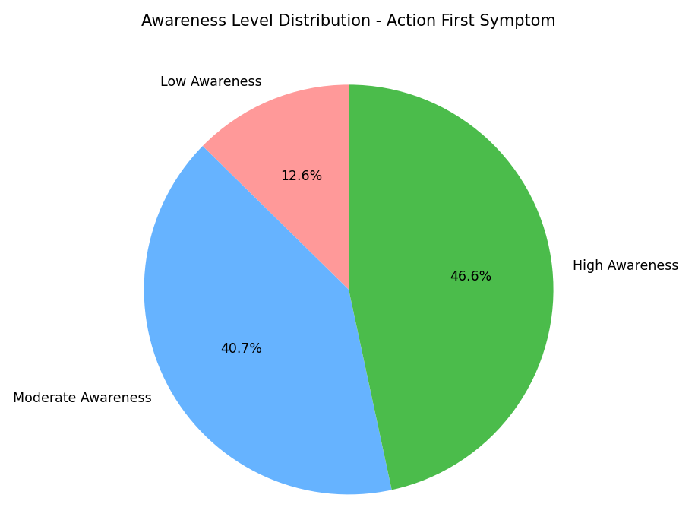
Meaning: High = within an hour, immediately
Moderate = within a day, within 24 hours, within a few hours
Low = anything more than that
In the above graph we see that 46.6% of the respondents are aware about the severity and importance of fast treatment on recognizing symptoms of stroke making them highly aware. On the other hand, 12.6% of the respondents choose to ignore or take action dangerously late that decreases the chance of treatment. That leaves 40.7% respondents as moderately aware as they choose the time of consultation to be on the same day but not exactly in the very limited time frame that exists. This means that a patient can still be saved but that would need several specialized operations, and monitoring needs.
This shows that if a person knows and can identify stroke when it happens, and know where to go, they are highly likely to consult a specialist if not in an hour (ideally), but at least on the same day.

