**Q1. Develop web page to display logged in time and current time.**

WebForm1.aspx.cs

using System;

using System.Collections.Generic;

using System.Linq;

using System.Web;

using System.Web.UI;

using System.Web.UI.WebControls;

namespace WebApplication1

{

public partial class WebForm1 : System.Web.UI.Page

{

protected void Page_Load(object sender, EventArgs e)

{

if (!IsPostBack)

{

Literal1.Text = System.DateTime.Now.ToString();

}

}

protected void Button1_Click1(object sender, EventArgs e)

{

Literal2.Text = System.DateTime.Now.ToString();

}

protected void Button2_Click(object sender, EventArgs e)

{

Response.End();

}

}

}

**Output –**

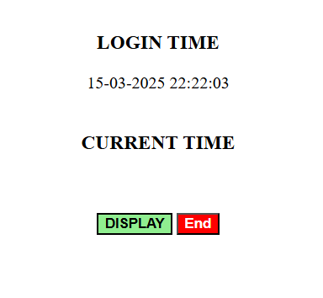

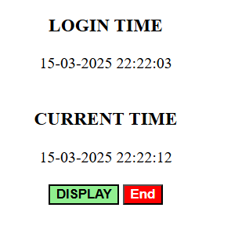

**Q2. Create web application to demonstrate View State, Session State and application state.**

WebForm1.aspx.cs

using System;

using System.Web;

using System.Web.UI;

using System.Web.UI.WebControls;

namespace WebApplication2

{

public partial class WebForm1 : System.Web.UI.Page

{

protected void Page_Load(object sender, EventArgs e)

{

if (!IsPostBack) // Ensuring data loads only once

{

// Load ViewState Data

if (ViewState["MyViewState"] != null)

{

lblViewState.Text = "View State Saved: " + ViewState["MyViewState"].ToString();

}

// Load Session Data

if (Session["MySession"] != null)

{

lblSessionState.Text = "Session Data: " + Session["MySession"].ToString();

}

// Load Application Data

if (Application["MyApplication"] != null)

{

lblApplicationState.Text = "Application State Saved: " + Application["MyApplication"].ToString();

}

}

}

// Save ViewState Data

protected void btnViewState_Click(object sender, EventArgs e)

{

ViewState["MyViewState"] = txtViewState.Text;

lblViewState.Text = "View State Saved: " + txtViewState.Text;

}

// Save Session Data

protected void btnSessionState_Click(object sender, EventArgs e)

{

Session["MySession"] = txtSessionState.Text;

lblSessionState.Text = "Session Data: " + txtSessionState.Text;

}

// Save Application Data

protected void btnApplicationState_Click(object sender, EventArgs e)

{

Application["MyApplication"] = txtApplicationState.Text;

lblApplicationState.Text = "Application State Saved: " + txtApplicationState.Text;

}

}

}

**Output –**

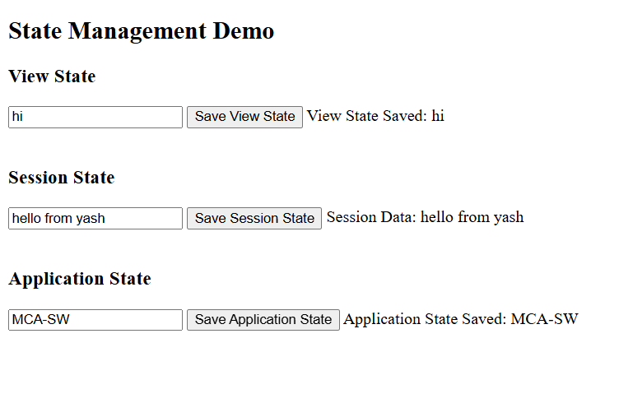

**Q3. Create web pages using server controls- Textbox, List Controls, Calendar, Imagebutton, Linkbutton.**

1. **Textbox –**
2. using System;
3. using System.Collections.Generic;
4. using System.Linq;
5. using System.Web;
6. using System.Web.UI;
7. using System.Web.UI.WebControls;
8. namespace WebApplication3
9. {
10. public partial class WebForm1 : System.Web.UI.Page
11. {
12. protected void Page_Load(object sender, EventArgs e)
13. {
14. }
15. protected void btnCheck_Click(object sender, EventArgs e)
16. {
17. if (txtPassword.Text == txtRePassword.Text)
18. {
19. lblMessage.Text = "Password Matched";
20. lblMessage.CssClass = "success-text";
21. }
22. else
23. {
24. lblMessage.Text = "Password Doesn't Match!";
25. lblMessage.CssClass = "error-text";
26. }
27. }
28. }
29. }

**Output –**

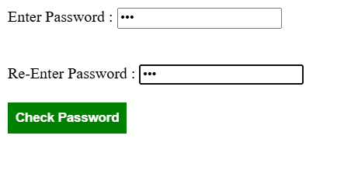

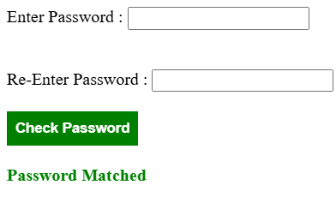

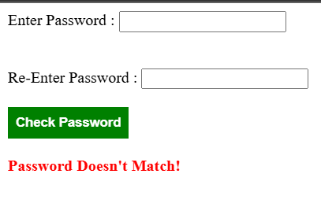

**2. List Controls –**

using System;

using System.Web.UI;

using System.Web.UI.WebControls;

namespace WebApplication

{

public partial class ListControls : System.Web.UI.Page

{

protected void Page_Load(object sender, EventArgs e)

{

if (!IsPostBack)

{

lblMessage.Text = "";

}

}

protected void btnSubmit_Click(object sender, EventArgs e)

{

string country = ddlCountry.SelectedValue;

string gender = rblGender.SelectedValue;

string skills = "";

foreach (ListItem item in chkSkills.Items)

{

if (item.Selected)

{

skills += item.Text + ", ";

}

}

skills = skills.TrimEnd(',', ' ');

string cities = "";

foreach (ListItem item in lstCities.Items)

{

if (item.Selected)

{

cities += item.Text + ", ";

}

}

cities = cities.TrimEnd(',', ' ');

lblMessage.Text = string.Format(

"Country: {0}<br/> Gender: {1}<br/> Skills: {2}<br/> Cities: {3}",

country, gender, skills, cities);

}

}

}

**Output –**

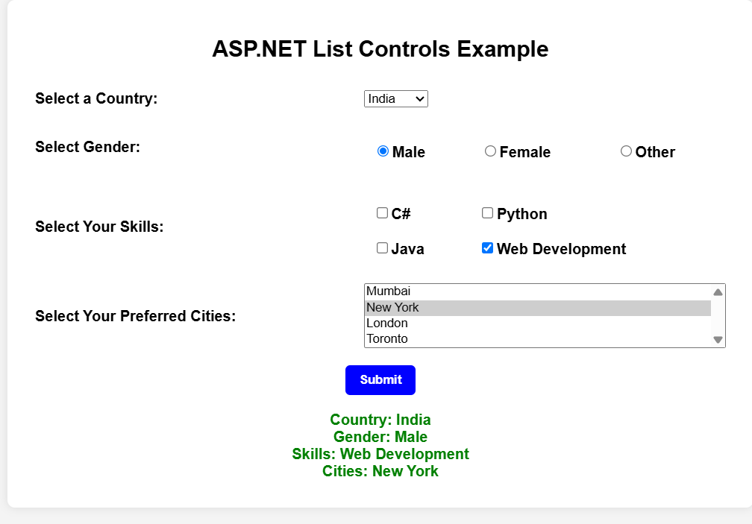

**3. Calendar –**

using System;

using System.Web.UI;

namespace WebApplication

{

public partial class WebForm1 : System.Web.UI.Page

{

protected void Page_Load(object sender, EventArgs e)

{

if (!IsPostBack)

{

Label1.Text = "Please select a date.";

}

}

protected void Calendar1_SelectionChanged(object sender, EventArgs e)

{

// Update TextBox with selected date

TextBox1.Text = Calendar1.SelectedDate.ToShortDateString();

}

protected void Button1_Click(object sender, EventArgs e)

{

// Display selected date

Label1.Text = "You have selected: " + Calendar1.SelectedDate.ToLongDateString();

}

}

}

**Output –**

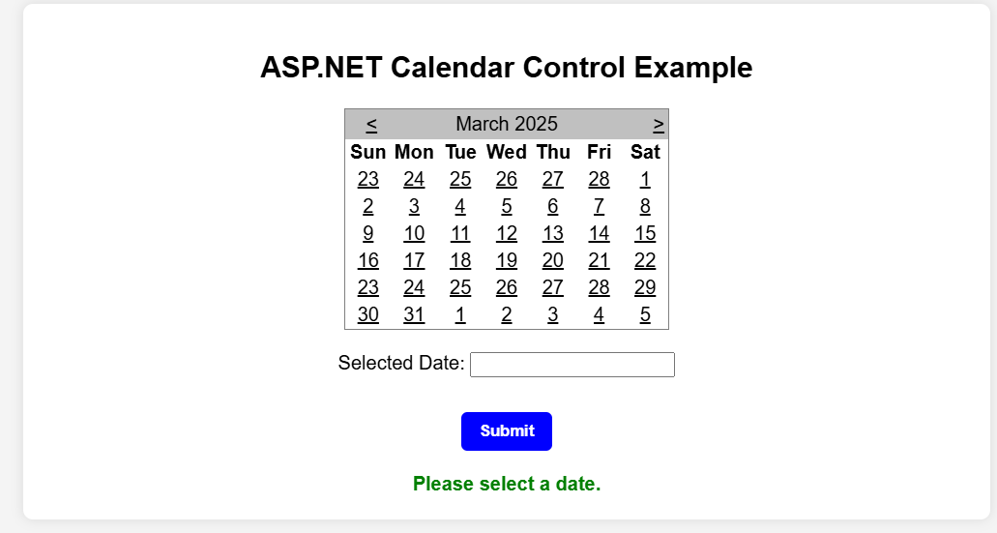

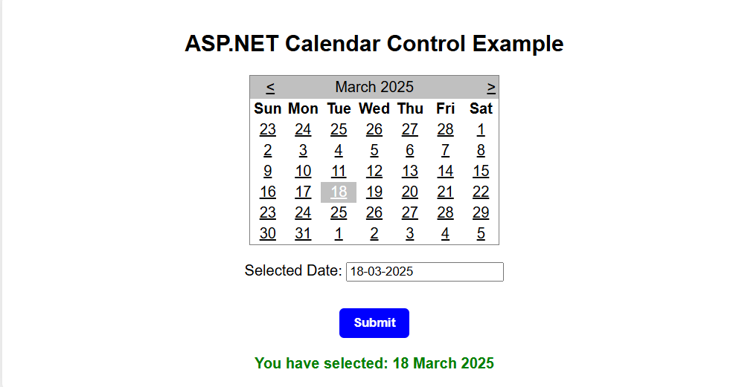

**4. Imagebutton –**

using System;

using System.Web.UI;

namespace WebApplication

{

public partial class WebForm1 : System.Web.UI.Page

{

protected void Page_Load(object sender, EventArgs e)

{

if (!IsPostBack)

{

Label1.Text = "Click the image button!";

}

}

protected void ImageButton1_Click(object sender, EventArgs e)

{

// Display message when image button is clicked

Label1.Text = "ImageButton clicked! Action performed.";

}

}

}

**Output –**

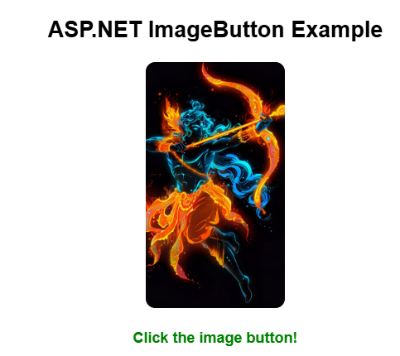

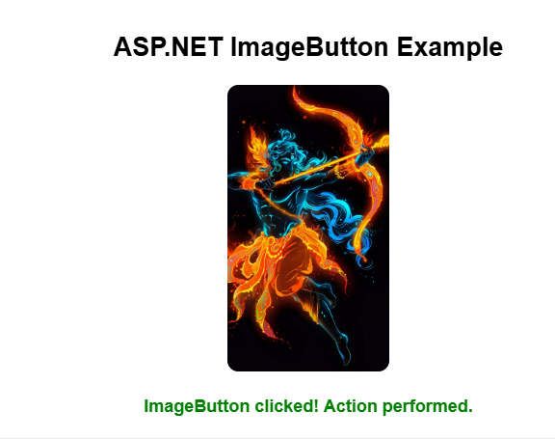

**5. Linkbutton –**

using System;

using System.Web.UI;

namespace WebApplication

{

public partial class WebForm1 : System.Web.UI.Page

{

protected void Page_Load(object sender, EventArgs e)

{

if (!IsPostBack)

{

Label1.Text = "Click the LinkButton to see the message.";

}

}

protected void LinkButton1_Click(object sender, EventArgs e)

{

// Display a message when LinkButton is clicked

Label1.Text = "You clicked the LinkButton!";

}

}

}

**Output –**





**Q.4 Create web page to display Kolhapur map using Image map controls with different hotpots.**

<%@ Page Language="C#" AutoEventWireup="true" CodeBehind="KolhapurMap.aspx.cs"

Inherits="AspExp.KolhapurMap" %>

<!DOCTYPEhtml>

<html xmlns="http://www.w3.org/1999/xhtml">

<head runat="server">

<title>Kolhapur Map</title>

<style>

body {

font-family: Arial, sans-serif;

text-align: center;

margin: 20px;

}

img {

max-width: 100%;

height: auto;

}

.info {

margin-top: 10px;

font-size: 1.2em;

}

</style>

</head>

<body>

<form id="form1" runat="server">

<div>

<h1>Kolhapur Map</h1>

<img src="Images/kolhapur-city-map.jpg" usemap="#kolhapurmap" alt="Kolhapur

Map" />

<map name="kolhapurmap">

<area

shape="rect"

coords="34,44,270,350"

href="https://en.wikipedia.org/wiki/Kolhapur" alt="Kolhapur City" title="Kolhapur City" />

<area

shape="circle"

coords="400,200,30"

href="https://en.wikipedia.org/wiki/Rankala_Lake" alt="Rankala Lake" title="Rankala Lake" />

<area

shape="poly"

coords="300,100,350,150,300,200"

href="https://en.wikipedia.org/wiki/Mahalakshmi_Temple,_Kolhapur" alt="Mahalakshmi Temple"

title="Mahalakshmi Temple" />

</map>

<div class="info">

<p>Click on the hotspots to learn more about different places in Kolhapur!</p>

</div>

</div>

</form></body></html>

**Output –**

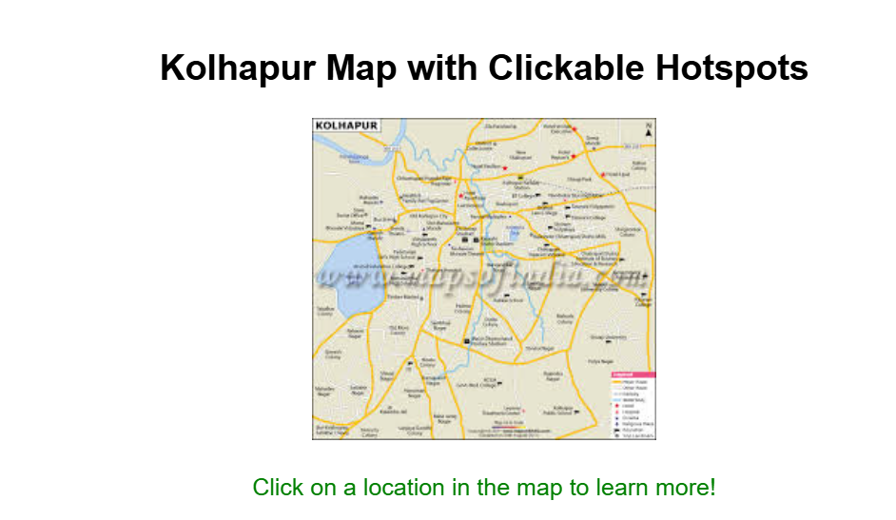

**Q.5 Create a webpage to demonstrate Dropdown and ListBoxm (Perform Add,Remove,Edit and Transfer items Operations)**

using System;

using System.Web.UI;

using System.Web.UI.WebControls;

namespace WebApplication

{

public partial class WebForm1 : System.Web.UI.Page

{

protected void Page_Load(object sender, EventArgs e)

{

if (!IsPostBack)

{

ddlItems.Items.Add("MCA-SW");

ddlItems.Items.Add("MCA");

ddlItems.Items.Add("B-Tech");

ddlItems.Items.Add("BCA");

lstItems.Items.Add("Apple");

lstItems.Items.Add("Banana");

lstItems.Items.Add("Mango");

lstItems.Items.Add("Orange");

}

}

protected void btnAdd_Click(object sender, EventArgs e)

{

if (!string.IsNullOrEmpty(txtNewItem.Text))

{

lstItems.Items.Add(txtNewItem.Text);

txtNewItem.Text = "";

lblMessage.Text = "Item added successfully!";

}

else

{

lblMessage.Text = "Enter an item before adding.";

}

}

protected void btnRemove_Click(object sender, EventArgs e)

{

if (lstItems.SelectedItem != null)

{

lstItems.Items.Remove(lstItems.SelectedItem);

lblMessage.Text = "Item removed successfully!";

}

else

{

lblMessage.Text = "Please select an item to remove.";

}

}

protected void btnEdit_Click(object sender, EventArgs e)

{

if (lstItems.SelectedItem != null && !string.IsNullOrEmpty(txtNewItem.Text))

{

lstItems.SelectedItem.Text = txtNewItem.Text;

lblMessage.Text = "Item updated successfully!";

}

else

{

lblMessage.Text = "Select an item and enter a new name to edit.";

}

}

}

}

**Output –**

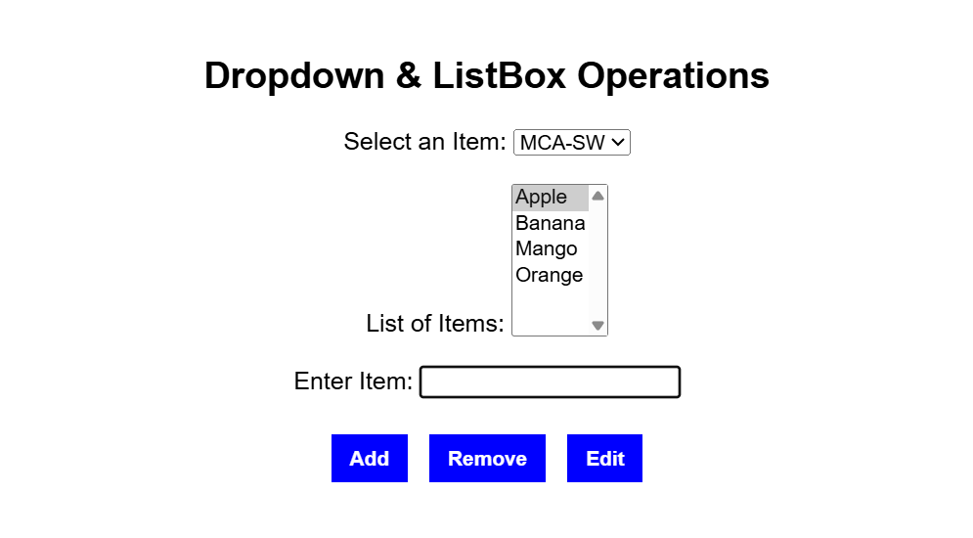

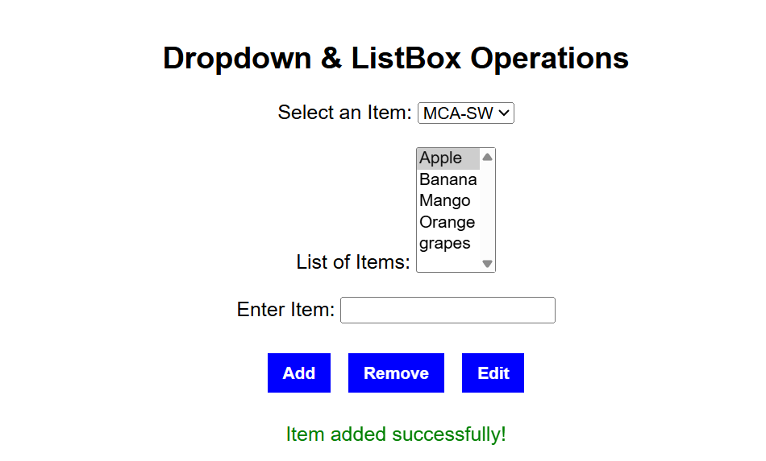

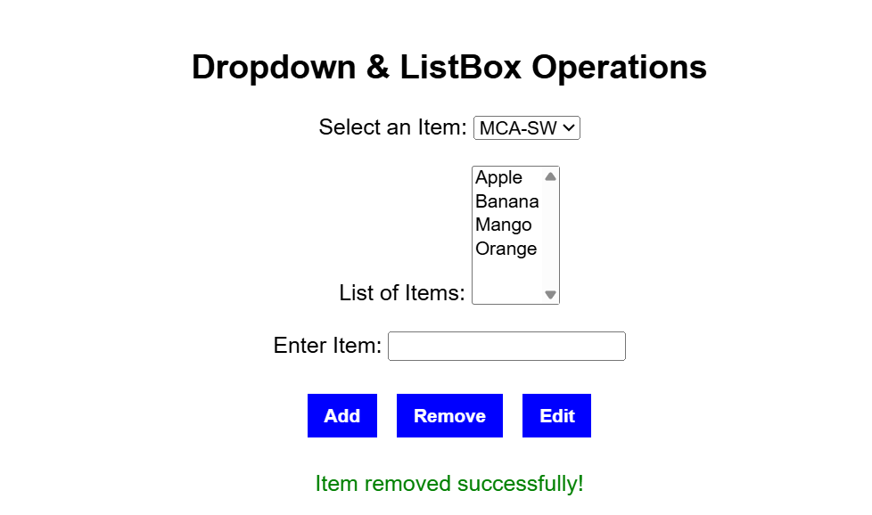

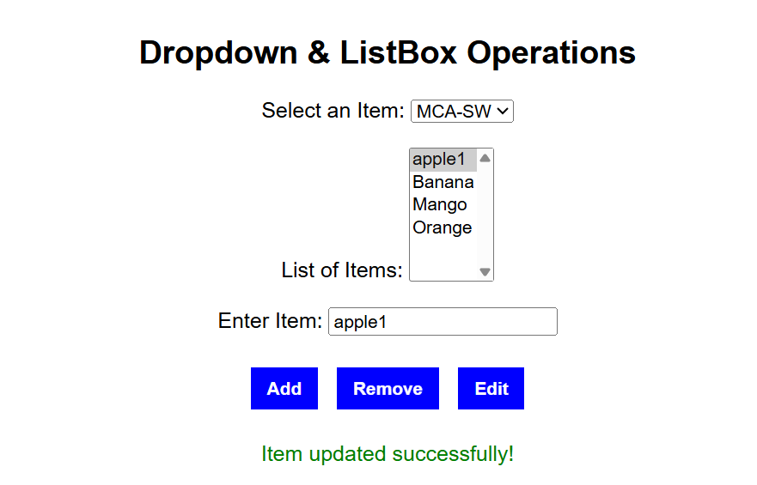

**Transfer items Operations –**

using System;

using System.Web.UI;

using System.Web.UI.WebControls;

namespace MyAsp

{

public partial class TwoList : System.Web.UI.Page

{

protected void Page_Load(object sender, EventArgs e)

{

}

// Transfer selected item from ListBox1 to ListBox2

protected void Button1_Click(object sender, EventArgs e)

{

if (ListBox1.SelectedItem != null)

{

ListBox2.Items.Add(ListBox1.SelectedItem);

ListBox1.Items.Remove(ListBox1.SelectedItem);

}

}

// Transfer all items from ListBox1 to ListBox2

protected void Button2_Click(object sender, EventArgs e)

{

foreach (ListItem item in ListBox1.Items)

{

ListBox2.Items.Add(item);

}

ListBox1.Items.Clear();

}

}

}

**Output –**

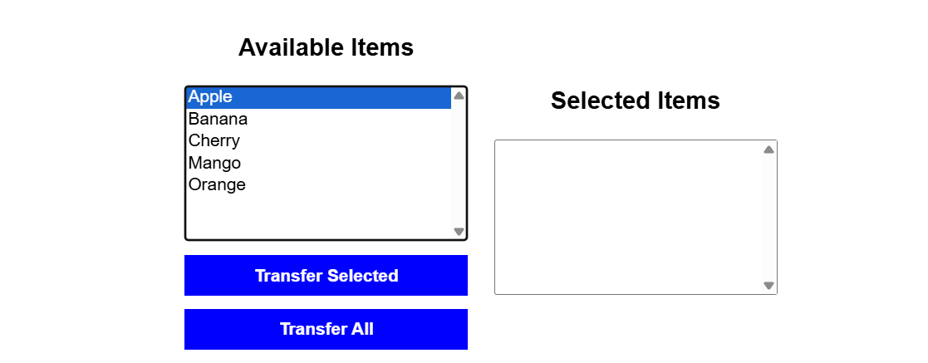

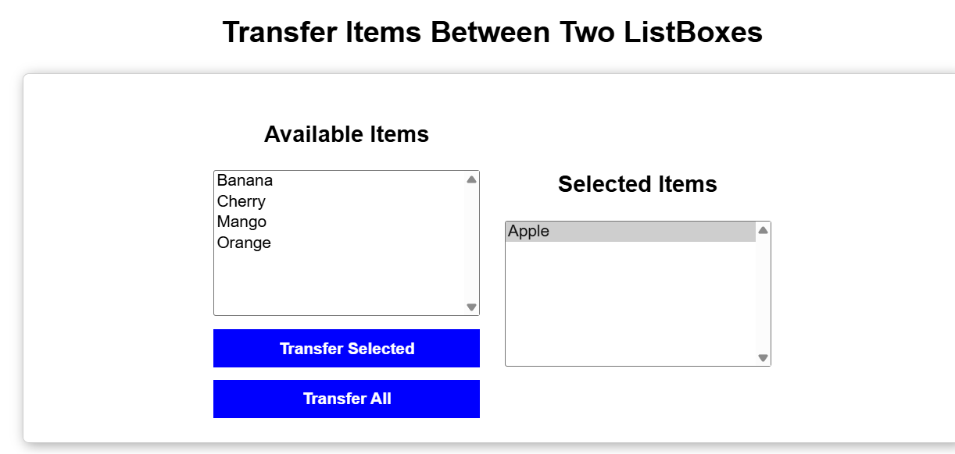

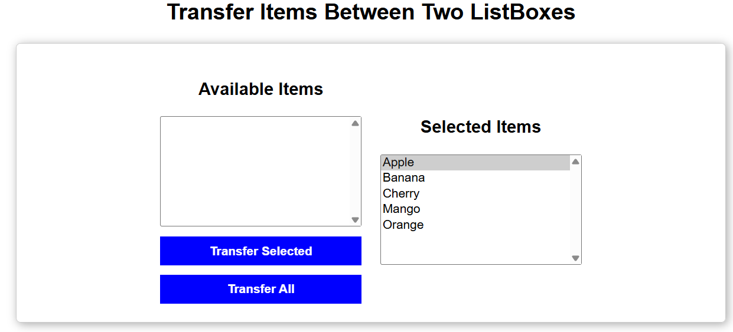

**Q.6 Develop ASP.Net Application through which user upload Image and that Image should be displayed in Image Control.**

using System;

using System.IO;

using System.Web;

namespace WebApplication

{

public partial class WebForm1 : System.Web.UI.Page

{

protected void Page_Load(object sender, EventArgs e)

{

lblMessage.Text = "";

}

protected void btnUpload_Click(object sender, EventArgs e)

{

if (fileUpload.HasFile)

{

try

{

string folderPath = Server.MapPath("~/Uploads/");

if (!Directory.Exists(folderPath))

{

Directory.CreateDirectory(folderPath);

}

string fileName = Path.GetFileName(fileUpload.FileName);

string filePath = folderPath + fileName;

fileUpload.SaveAs(filePath);

imgPreview.ImageUrl = "~/Uploads/" + fileName;

imgPreview.Visible = true;

lblMessage.Text = "Image uploaded successfully!";

}

catch (Exception ex)

{

lblMessage.Text = "Error: " + ex.Message;

}

}

else

{

lblMessage.Text = "Please select an image to upload.";

}

}

}

}

**Output –**

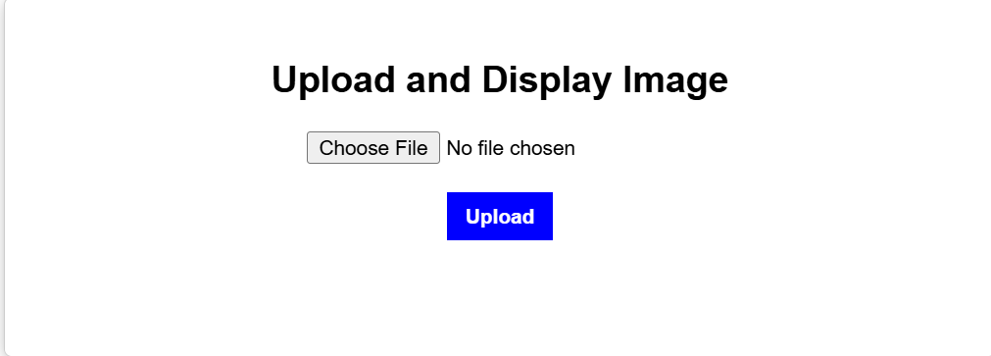

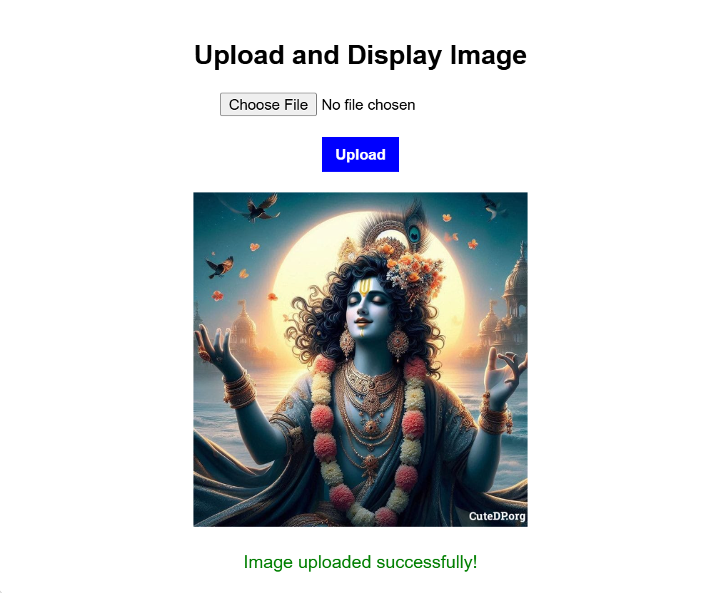

**Q.7 Demonstrate multiview and panel control in Asp.net.**

using System;

using System.Web.UI;

namespace WebApplication

{

public partial class WebForm1 : System.Web.UI.Page

{

protected void Page_Load(object sender, EventArgs e)

{

}

protected void btnNext1_Click(object sender, EventArgs e)

{

MultiView1.ActiveViewIndex = 1;

}

protected void btnPrev_Click(object sender, EventArgs e)

{

MultiView1.ActiveViewIndex = 0;

}

protected void btnNext2_Click(object sender, EventArgs e)

{

MultiView1.ActiveViewIndex = 2;

}

protected void btnPrev2_Click(object sender, EventArgs e)

{

MultiView1.ActiveViewIndex = 1;

}

}

}

**Output –**

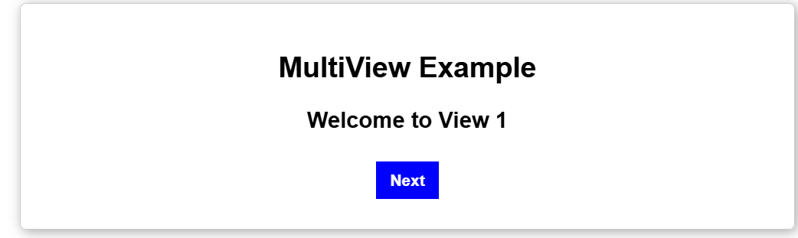





**Q.8 Demonstrate Calender control in Asp.net.**

using System;

using System.Web.UI;

namespace WebApplication

{

public partial class WebForm1 : System.Web.UI.Page

{

protected void Page_Load(object sender, EventArgs e)

{

}

protected void Calendar1_SelectionChanged(object sender, EventArgs e)

{

lblSelectedDate.Text = "You selected: " + Calendar1.SelectedDate.ToString("D");

}

}

}

**Output –**

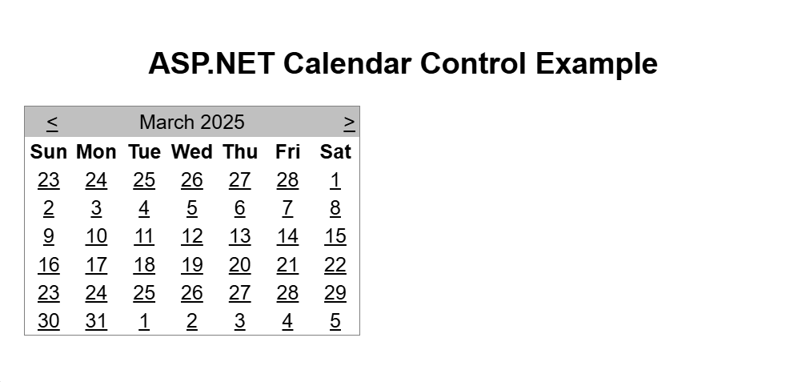

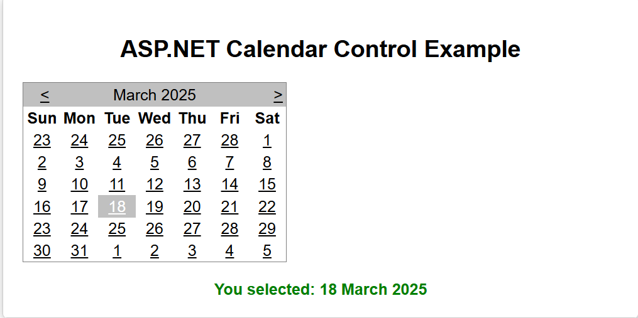

**Q.9 Create Sitemap for online shopping website.**

**Web.sitemap –**

<?xml version="1.0" encoding="utf-8" ?>

<siteMap xmlns="http://schemas.microsoft.com/AspNet/SiteMap-File-1.0">

<siteMapNode url="Sitemap.aspx" title="Online Shopping Website">

<siteMapNode url="Home.aspx" title="Home >" />

<siteMapNode url="Categories.aspx" title="Categories >" />

<siteMapNode url="Product.aspx" title="Product >" />

<siteMapNode url="Cart.aspx" title="Cart >" />

<siteMapNode url="Checkout.aspx" title="Checkout >" />

<siteMapNode url="Profile.aspx" title="Profile >" />

</siteMapNode>

</siteMap>

**Sitemap.aspx –**

<%@ Page Language="C#" AutoEventWireup="true" CodeBehind="Sitemap.aspx.cs" Inherits="AspExp.Sitemap" %>

<%@ Register Assembly="System.Web" %>

<!DOCTYPE html>

<html xmlns="http://www.w3.org/1999/xhtml">

<head id="Head1" runat="server">

<title>Site Navigation</title>

</head>

<body>

<form id="form1" runat="server">

<div>

<h2>Site Navigation</h2>

<asp:SiteMapPath ID="SiteMapPath1" runat="server"></asp:SiteMapPath>

<br /><br />

<asp:HyperLink ID="HyperLink1" NavigateUrl="~/Home.aspx">Home</asp:HyperLink> &nbsp;&nbsp;

<asp:HyperLink ID="HyperLink2" NavigateUrl="~/Categories.aspx">Categories</asp:HyperLink> &nbsp;&nbsp;

<asp:HyperLink ID="HyperLink3" NavigateUrl="~/Product.aspx">Product Details</asp:HyperLink> &nbsp;&nbsp;

<asp:HyperLink ID="HyperLink4" NavigateUrl="~/Cart.aspx">Cart</asp:HyperLink> &nbsp;&nbsp;

<asp:HyperLink ID="HyperLink5" NavigateUrl="~/Checkout.aspx">Checkout</asp:HyperLink> &nbsp;&nbsp;

<asp:HyperLink ID="HyperLink6" NavigateUrl="~/Profile.aspx">Profile</asp:HyperLink>

</div>

</form>

</body>

</html>

**Home.aspx –**

<%@ Page Language="C#" AutoEventWireup="true" CodeBehind="Home.aspx.cs" Inherits="AspExp.Home" %>

<!DOCTYPE html>

<html xmlns="http://www.w3.org/1999/xhtml">

<head id="Head1" runat="server">

<title>Home</title>

</head>

<body>

<form id="form1" runat="server">

<div>

<h2>Welcome to Our Online Store</h2>

<h2>Home Page</h2>

<asp:SiteMapPath ID="SiteMapPath1" runat="server"></asp:SiteMapPath>

<asp:HyperLink ID="HyperLink1" runat="server" NavigateUrl="~/Categories.aspx">Categories ></asp:HyperLink>

</div>

</form>

</body>

</html>

**Categories.aspx –**

<%@ Page Language="C#" AutoEventWireup="true" CodeBehind="Categories.aspx.cs" Inherits="AspExp.Categories" %>

<!DOCTYPE html>

<html xmlns="http://www.w3.org/1999/xhtml">

<head id="Head1" runat="server">

<title>Categories</title>

</head>

<body>

<form id="form1" runat="server">

<div>

<h2>CATEGORIES</h2>

<asp:SiteMapPath ID="SiteMapPath1" runat="server"></asp:SiteMapPath>

<asp:HyperLink ID="HyperLink1" runat="server" NavigateUrl="~/Home.aspx">Home ></asp:HyperLink>

<asp:HyperLink ID="HyperLink2" runat="server" NavigateUrl="~/Cart.aspx">Cart ></asp:HyperLink>

</div>

</form>

</body>

</html>

**Product.aspx –**

<%@ Page Language="C#" AutoEventWireup="true" CodeBehind="Product.aspx.cs" Inherits="AspExp.Product" %>

<!DOCTYPE html>

<html xmlns="http://www.w3.org/1999/xhtml">

<head id="Head1" runat="server">

<title>Product</title>

</head>

<body>

<form id="form1" runat="server">

<div>

<h2>PRODUCT DETAILS</h2>

<asp:SiteMapPath ID="SiteMapPath1" runat="server"></asp:SiteMapPath>

<asp:HyperLink ID="HyperLink1" runat="server" NavigateUrl="~/Categories.aspx">Categories ></asp:HyperLink>

<asp:HyperLink ID="HyperLink2" runat="server" NavigateUrl="~/Cart.aspx">Cart ></asp:HyperLink>

</div>

</form>

</body>

</html>

**Cart.aspx –**

<%@ Page Language="C#" AutoEventWireup="true" CodeBehind="Cart.aspx.cs" Inherits="AspExp.Cart" %>

<!DOCTYPE html>

<html xmlns="http://www.w3.org/1999/xhtml">

<head id="Head1" runat="server">

<title>Cart</title>

</head>

<body>

<form id="form1" runat="server">

<div>

<h2>YOUR SHOPPING CART</h2>

<asp:SiteMapPath ID="SiteMapPath1" runat="server"></asp:SiteMapPath>

<asp:HyperLink ID="HyperLink1" runat="server" NavigateUrl="~/Categories.aspx">Categories ></asp:HyperLink>

<asp:HyperLink ID="HyperLink2" runat="server" NavigateUrl="~/Checkout.aspx">Checkout ></asp:HyperLink>

</div>

</form>

</body>

</html>

**Checkout.aspx –**

<%@ Page Language="C#" AutoEventWireup="true" CodeBehind="Checkout.aspx.cs" Inherits="AspExp.Checkout" %>

<!DOCTYPE html>

<html xmlns="http://www.w3.org/1999/xhtml">

<head id="Head1" runat="server">

<title>Checkout</title>

</head>

<body>

<form id="form1" runat="server">

<div>

<h2>CHECKOUT PROCESS</h2>

<asp:SiteMapPath ID="SiteMapPath1" runat="server"></asp:SiteMapPath>

<asp:HyperLink ID="HyperLink1" runat="server" NavigateUrl="~/Cart.aspx">Cart ></asp:HyperLink>

<asp:HyperLink ID="HyperLink2" runat="server" NavigateUrl="~/Profile.aspx">Profile ></asp:HyperLink>

</div>

</form>

</body>

</html>

**Profile.aspx –**

<%@ Page Language="C#" AutoEventWireup="true" CodeBehind="Profile.aspx.cs" Inherits="AspExp.Profile" %>

<!DOCTYPE html>

<html xmlns="http://www.w3.org/1999/xhtml">

<head id="Head1" runat="server">

<title>Profile</title>

</head>

<body>

<form id="form1" runat="server">

<div>

<h2>YOUR PROFILE</h2>

<asp:SiteMapPath ID="SiteMapPath1" runat="server"></asp:SiteMapPath>

<asp:HyperLink ID="HyperLink1" runat="server" NavigateUrl="~/Checkout.aspx">Checkout ></asp:HyperLink>

<asp:HyperLink ID="HyperLink2" runat="server" NavigateUrl="~/Home.aspx">Home ></asp:HyperLink>

</div>

</form>

</body>

</html>

**Output –**

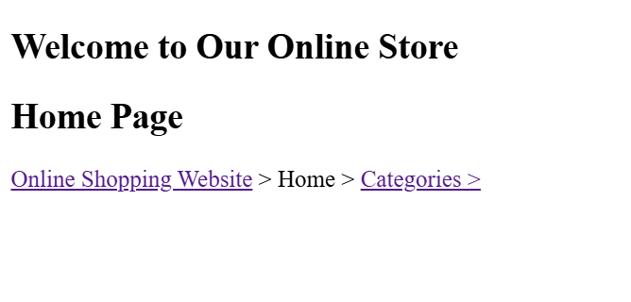

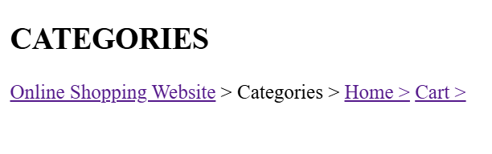

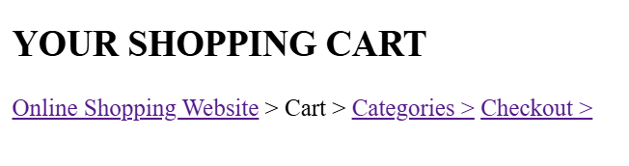

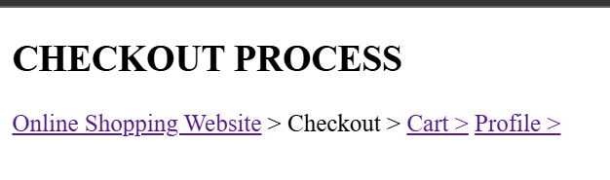

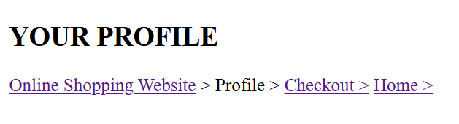

**Q.10 Write a program to create a web page showing use of following validation controls**

**a. Required field validator**

**b. Range validator**

**c. Compare validator**

**d. Custom validator**

**e. Regular expression validator**

**f. Validation summary**

**ValidationDemo.aspx –**

<%@ Page Language="C#" AutoEventWireup="true" CodeBehind="ValidationDemo.aspx.cs" Inherits="AspExp.ValidationDemo" %>

<!DOCTYPE html>

<html xmlns="http://www.w3.org/1999/xhtml">

<head id="Head1" runat="server">

<title>Validation Controls Form</title>

<style>

body {

font-family: Arial, sans-serif;

background-color: #f4f4f4;

display: flex;

justify-content: center;

align-items: center;

height: 100vh;

}

.container {

background: white;

padding: 30px;

width: 400px;

box-shadow: 0px 0px 10px rgba(0, 0, 0, 0.1);

border-radius: 8px;

}

.form-group {

margin-bottom: 15px;

}

label {

font-weight: bold;

display: block;

margin-bottom: 5px;

}

input {

width: 100%;

padding: 8px;

border: 1px solid #ccc;

border-radius: 5px;

}

.error {

color: red;

font-size: 12px;

}

.btn {

width: 100%;

padding: 10px;

background: #007BFF;

color: white;

border: none;

cursor: pointer;

border-radius: 5px;

}

.btn:hover {

background: #0056b3;

}

</style>

</head>

<body>

<form id="form1" runat="server">

<div class="container">

<h2 style="text-align:center;">User Registration</h2>

<div class="form-group">

<label>Enter Name:</label>

<asp:TextBox ID="txtName" runat="server"></asp:TextBox>

<asp:RequiredFieldValidator ID="rfvName" runat="server"

ControlToValidate="txtName" ErrorMessage="Name is required!"

CssClass="error"></asp:RequiredFieldValidator>

</div>

<div class="form-group">

<label>Enter Age (18-60):</label>

<asp:TextBox ID="txtAge" runat="server"></asp:TextBox>

<asp:RangeValidator ID="rvAge" runat="server"

ControlToValidate="txtAge" MinimumValue="18" MaximumValue="60"

Type="Integer" ErrorMessage="Age must be between 18 and 60!"

CssClass="error"></asp:RangeValidator>

</div>

<div class="form-group">

<label>Confirm Age:</label>

<asp:TextBox ID="txtConfirmAge" runat="server"></asp:TextBox>

<asp:CompareValidator ID="cvAge" runat="server"

ControlToValidate="txtConfirmAge" ControlToCompare="txtAge"

ErrorMessage="Ages do not match!" CssClass="error"></asp:CompareValidator>

</div>

<div class="form-group">

<label>Enter Email:</label>

<asp:TextBox ID="txtEmail" runat="server"></asp:TextBox>

<asp:RegularExpressionValidator ID="revEmail" runat="server"

ControlToValidate="txtEmail"

ValidationExpression="^[\w-\.]+@([\w-]+\.)+[\w-]{2,4}$"

ErrorMessage="Invalid Email Format!" CssClass="error"></asp:RegularExpressionValidator>

</div>

<div class="form-group">

<label>Enter Password:</label>

<asp:TextBox ID="txtPassword" runat="server" TextMode="Password"></asp:TextBox>

<asp:CustomValidator ID="cvPassword" runat="server"

ControlToValidate="txtPassword"

OnServerValidate="ValidatePassword"

ErrorMessage="Password must be at least 6 characters long!"

CssClass="error"></asp:CustomValidator>

</div>

<asp:ValidationSummary ID="vsSummary" runat="server"

CssClass="error" HeaderText="Please fix the following errors:" />

<asp:Button ID="btnSubmit" runat="server" Text="Submit" CssClass="btn" />

</div>

</form>

</body>

</html>

**ValidationDemo.aspx.cs –**

using System;

using System.Web.UI;

using System.Web.UI.WebControls;

namespace AspExp

{

public partial class ValidationDemo : Page

{

protected void Page_Load(object sender, EventArgs e)

{

}

protected void ValidatePassword(object source, ServerValidateEventArgs args)

{

if (args.Value.Length >= 6)

args.IsValid = true;

else

args.IsValid = false;

}

}

}

**Output –**

