**Q.1)Write a Program**

1. **Set oprations**

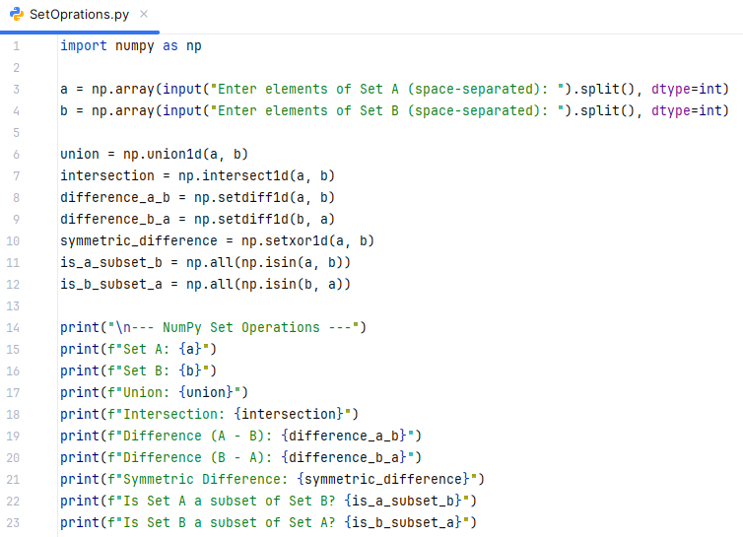

**Output:**

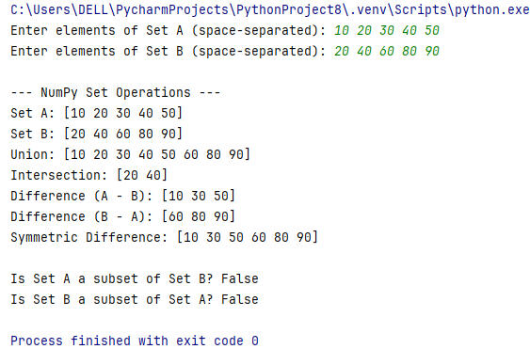

1. **Arithmetic opration using numpy.**

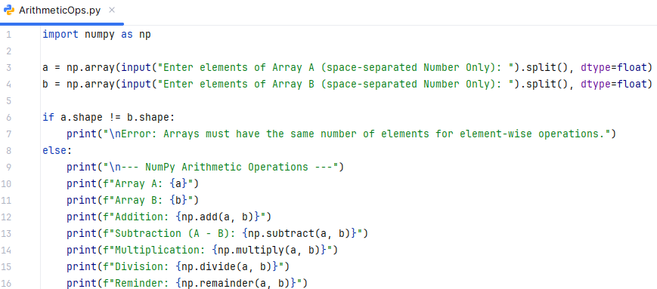

**Output:**

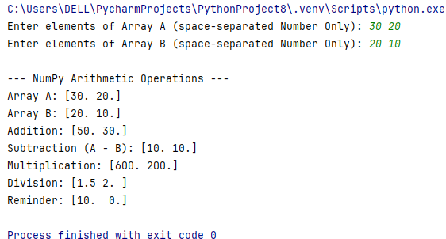

**Q.2) Write a program to demonstarate copy and View.**

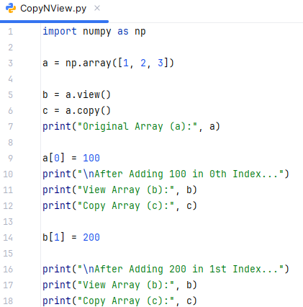

**Output:**

