**Q.1) Write a program for hybrid inheritance involving multiple inheritance in single program.**

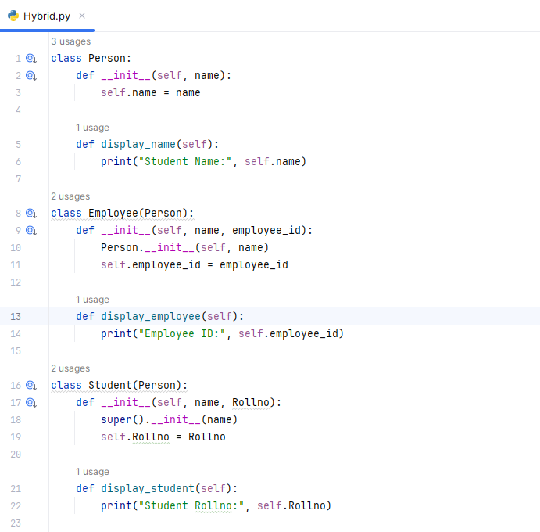

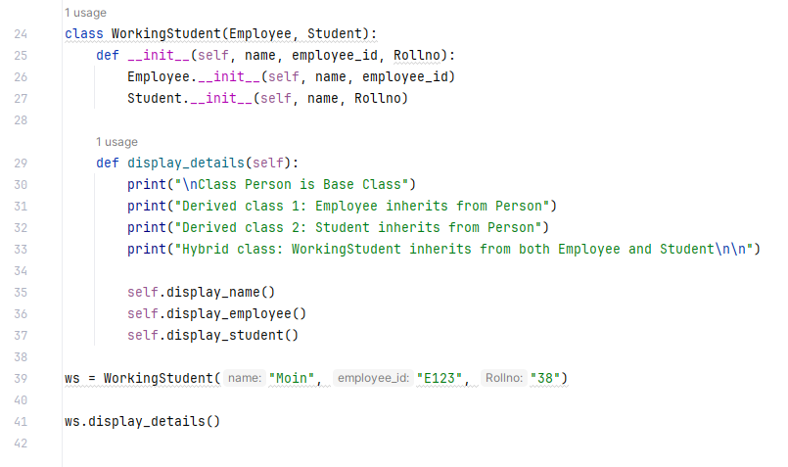

**Output:**

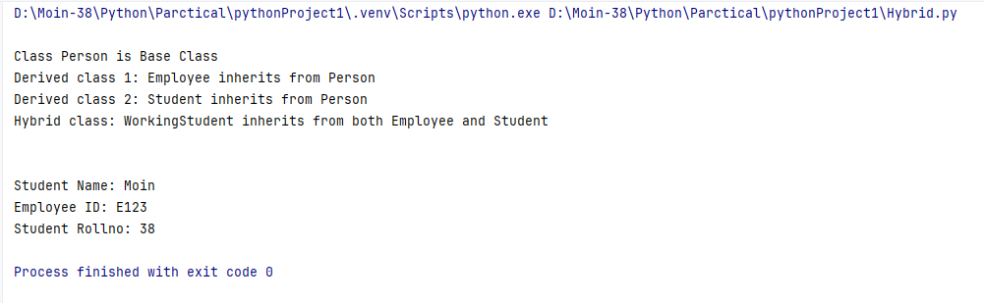

**Q.2) Write a program for implementing python method overriding (use multiple inheritance).**

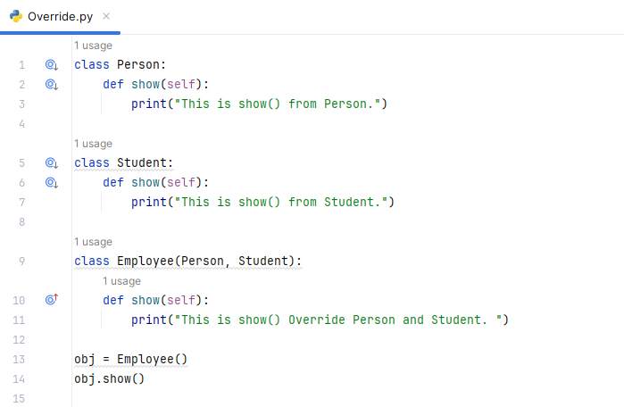

**Output:**

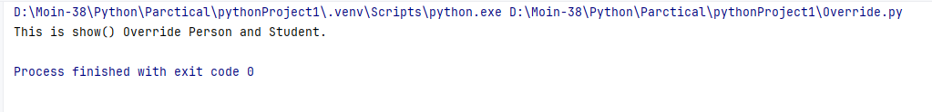

**Q.3) Write a program to implement data hiding using access modifiers.**

**1) Public**

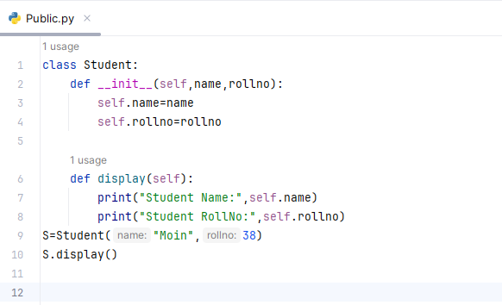

**Output:**

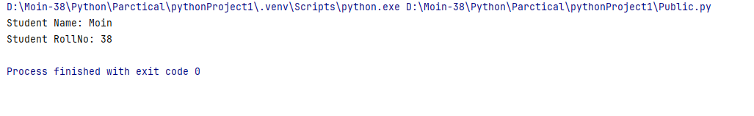

**2) Protected**

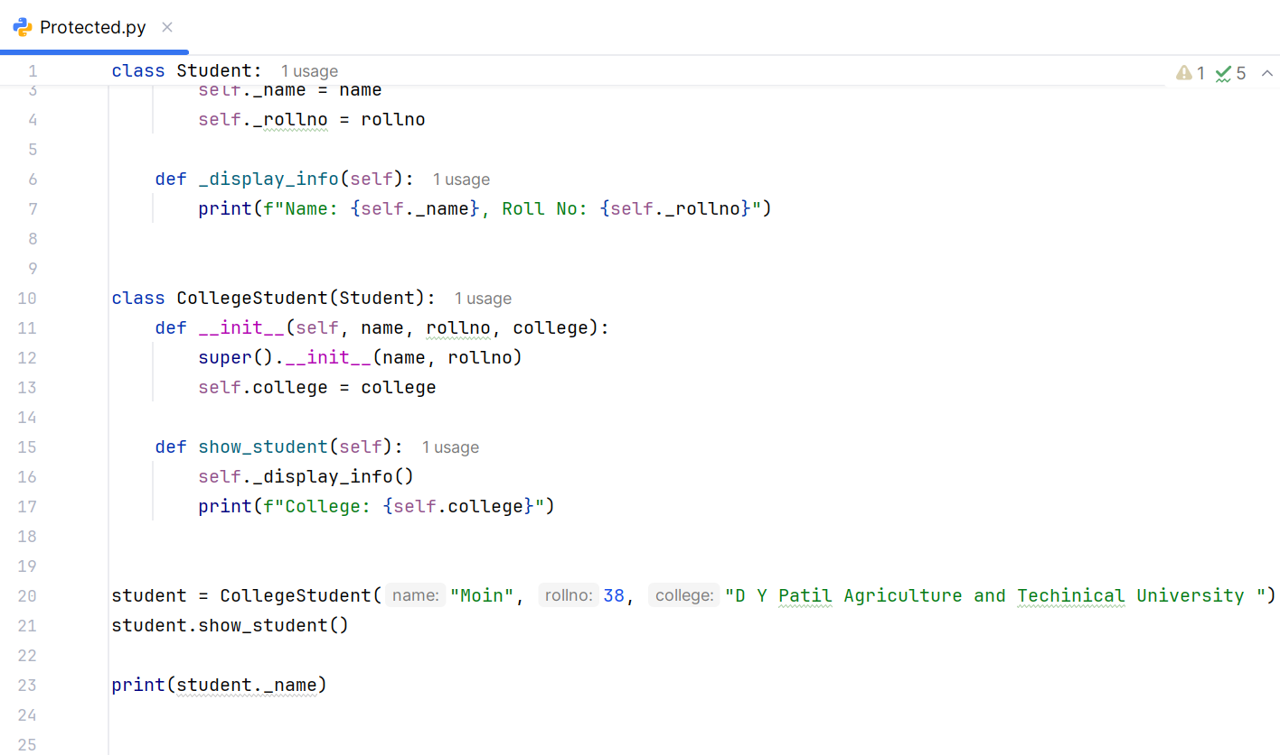

**Output:**

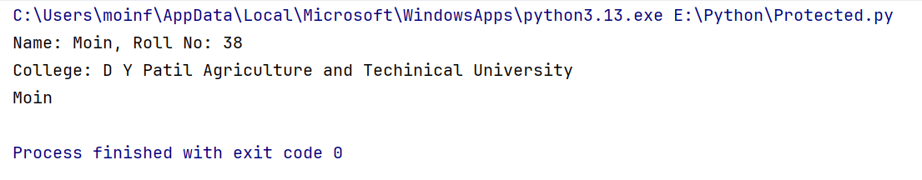

**3) Private**

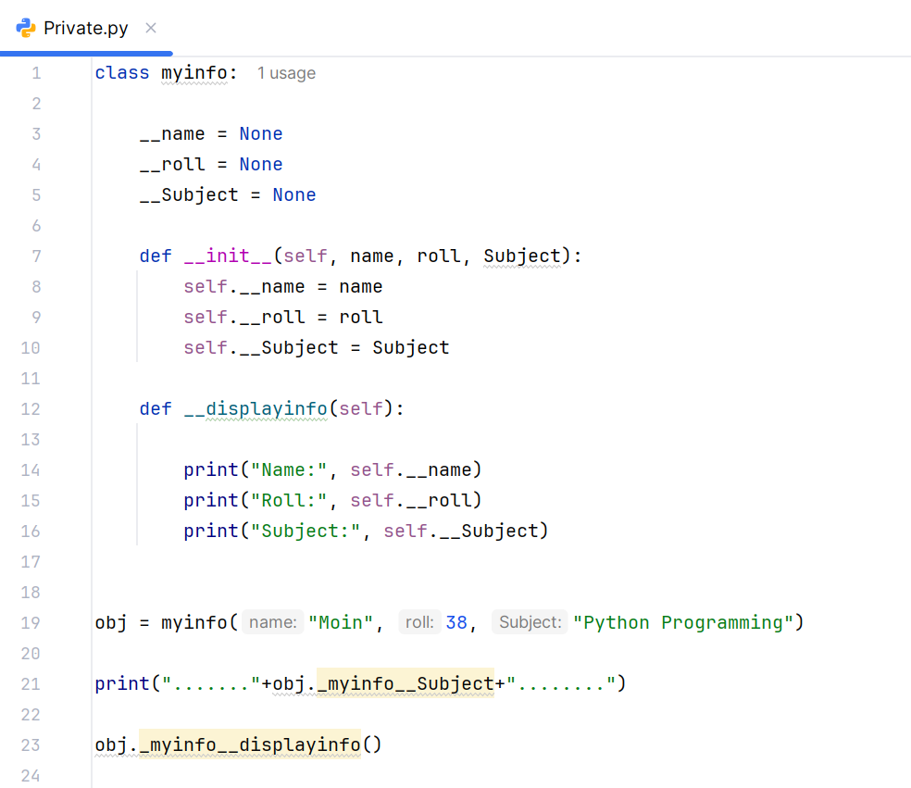

**Output:**

