**Q.1) Write down the steps to install Numpy.**

**A) Using Python (cmd)**

**Step 1 : Open Command Prompt and Check if Python is installed or not**

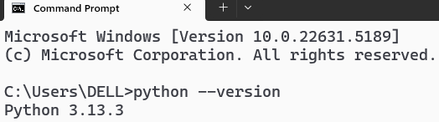

**Step 2 : Check if pip is installed or not**



**Step 3 : Install NumPy**

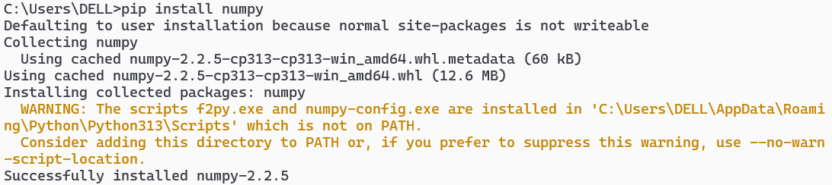

**Step 4 : Verify the Installation**

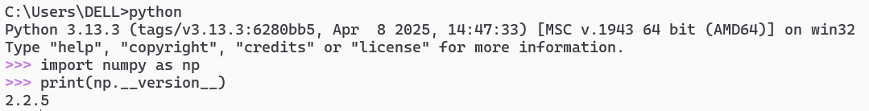

**B) Using PyCharm (any editor)**

**Step 1 : Open PyCharm and your project.**

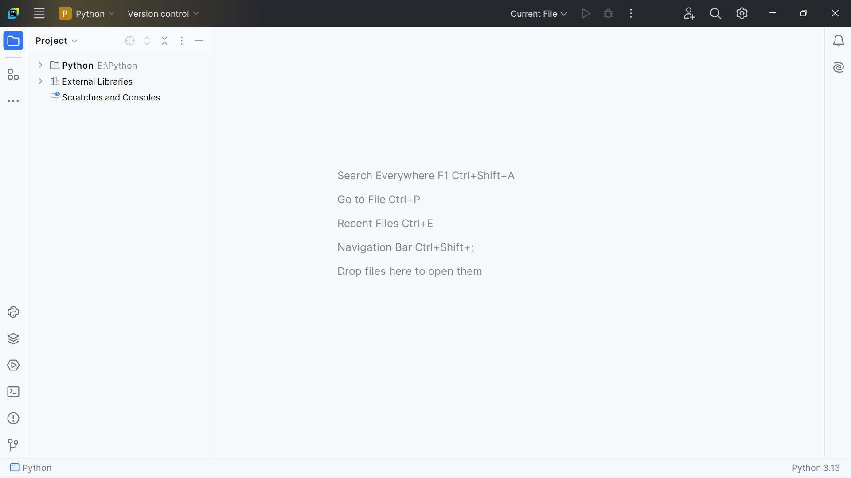

**Step 2 : Go to the top menu:**  
**File > Settings** (**or** **PyCharm > Preferences** **on Mac).**

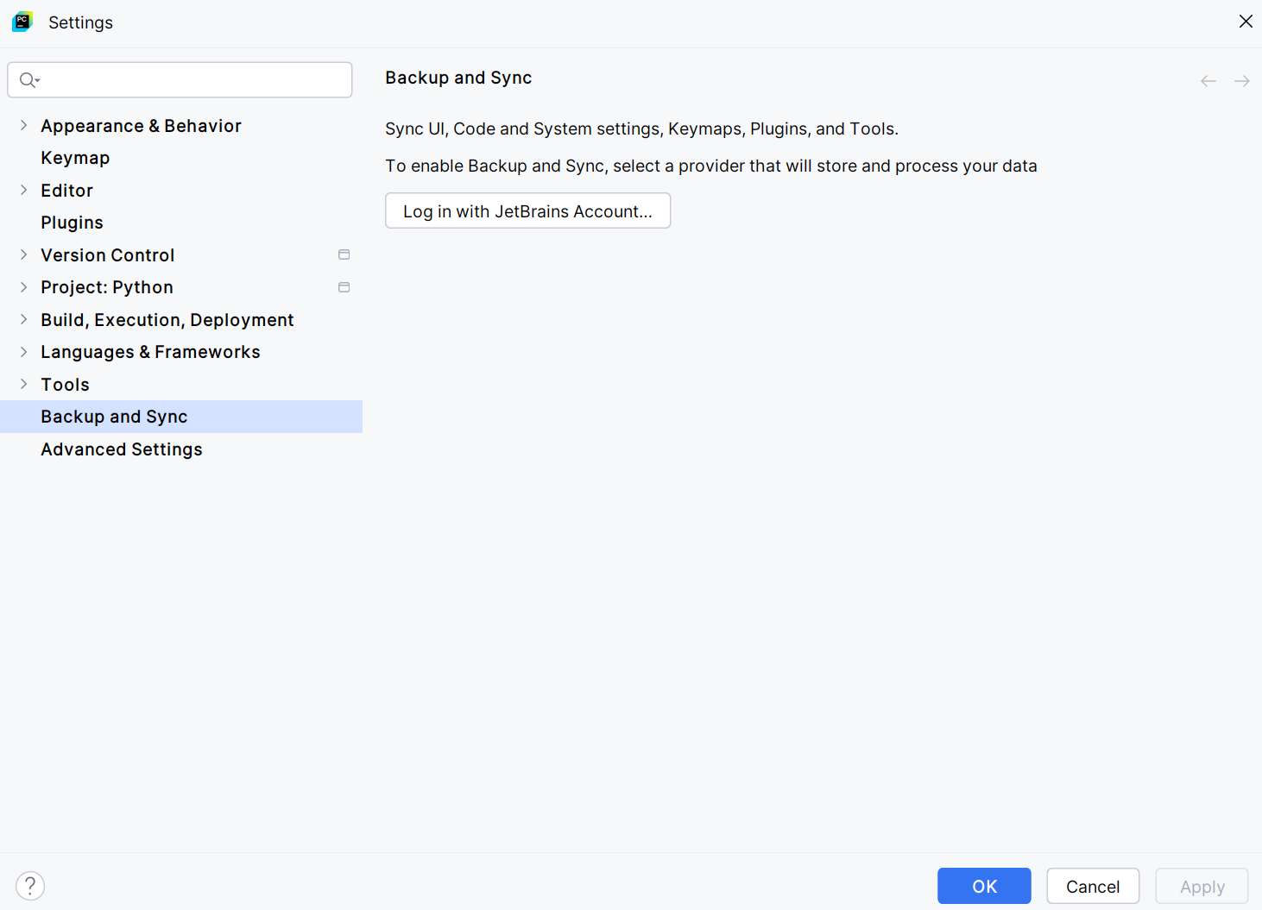

**Step 3 : In the left sidebar:**  
**Project: your_project_name > Python Interpreter**

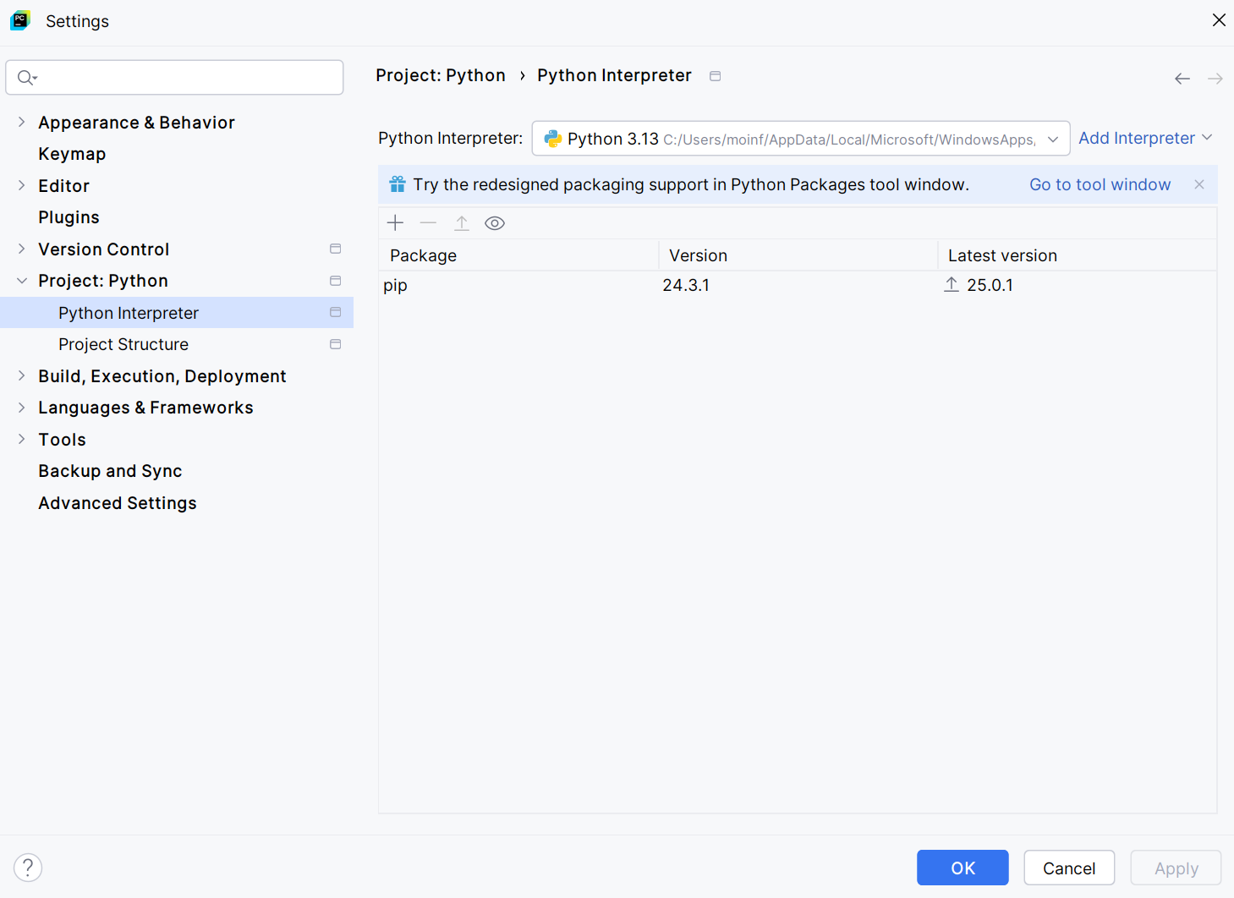

**Step 4 : Click the** **+ (plus sign)** **on the right to add a package.Search for** **numpy** **in the pop-up window.**

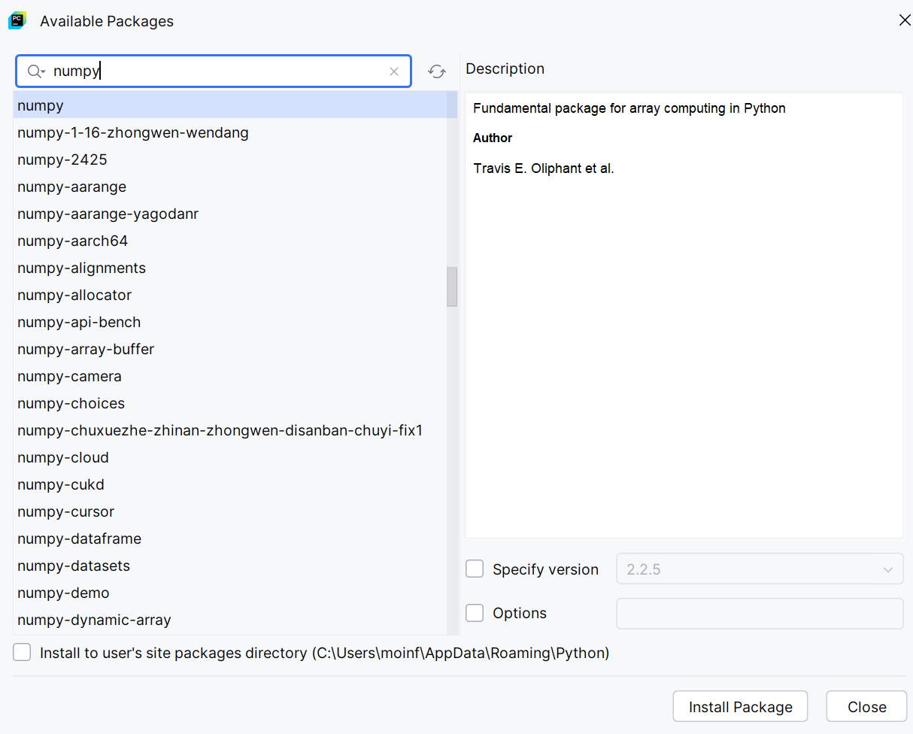

**Step 6 : Select numpy from the list, and click Install Package at the bottom**

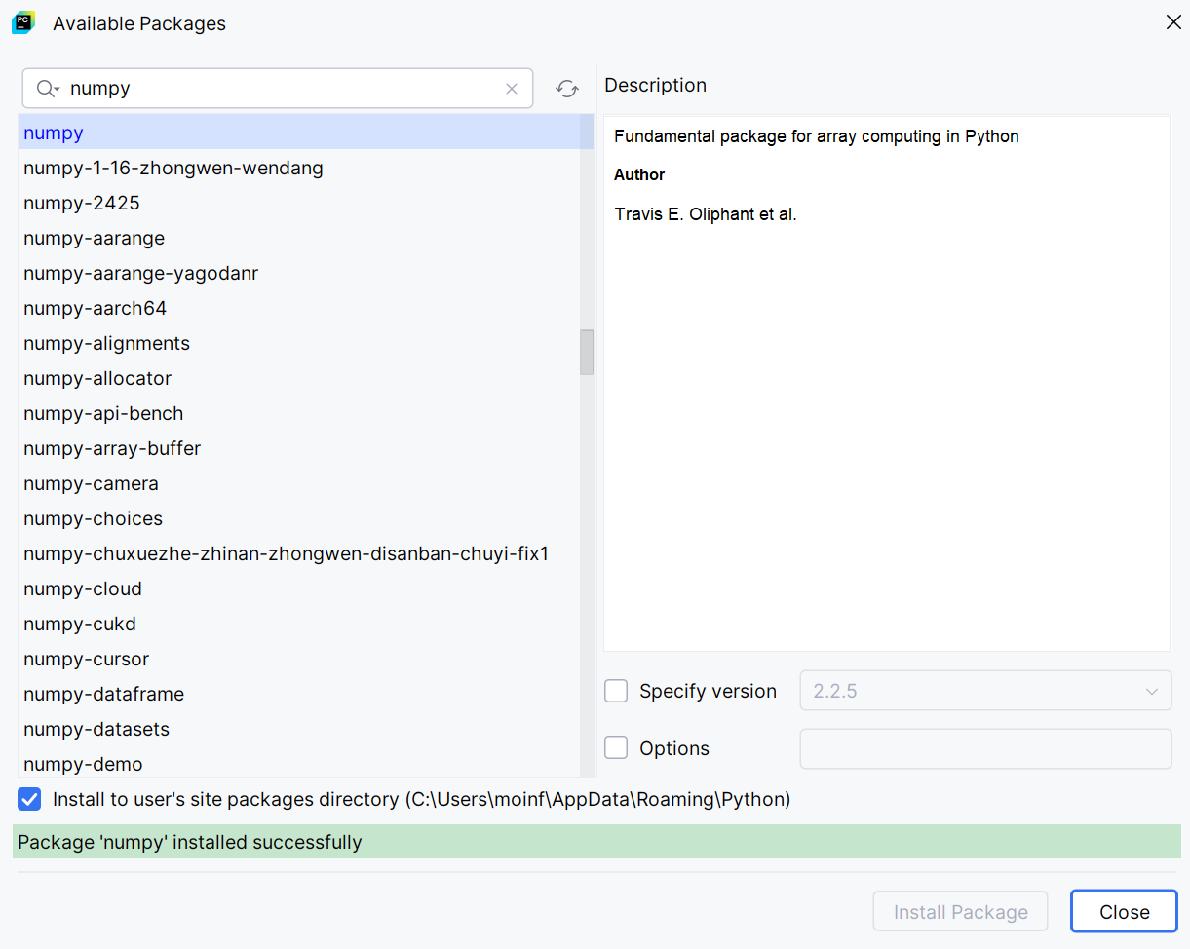

**Q.2) Write a program using numpy create array, find the type etc.**

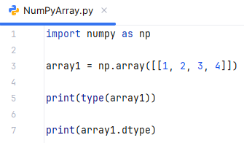

**Output:**

