**Q.3) Write a program to demonstrate use of statements with – A) Dictionary B) Range C) Shallow & Deep Copy**

**A) Dictionary**

**1.Create Dictionary**

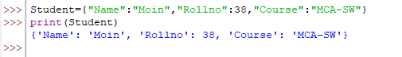

**2.Accessing Element**

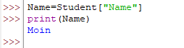

**3.get()**

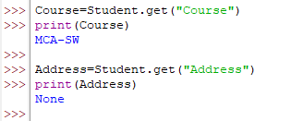

**4.Adding items**



**5.Update items**

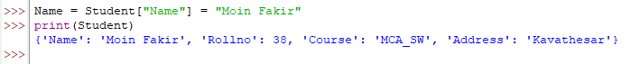

**6.Delete items**

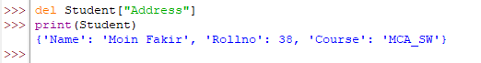

**B) Range**

**1.Create Range**

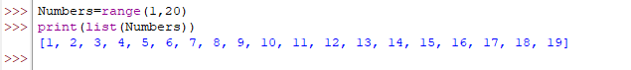

**2.Create Range with for loop**

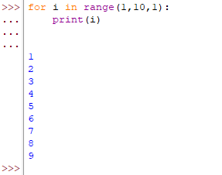

**3.Reverse Numbers**

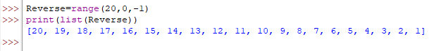

**4.Slicing**

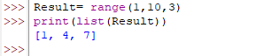

**5.Checking Items in range**

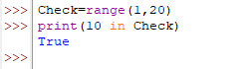

**6.Specific start & stop**

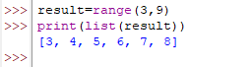

**C) Shallow and Deep Copy**

**I. Shallow Copy**

**1.Creating Shallow Copy**

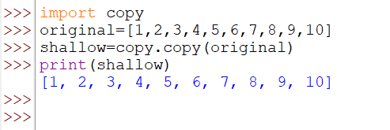

**2.Slicing**

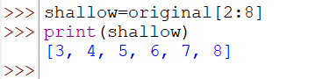

**3.Update Items**

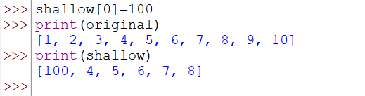

**II. Deep Copy**

**1.Creating Deep Copy**

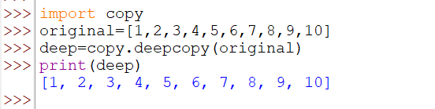

**2.Update Items**

