**Experiment No.5**

**A) Write a program to return a value from ‘Return statement’.**

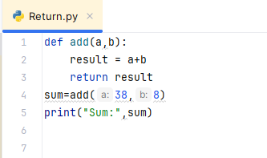

**Output:**

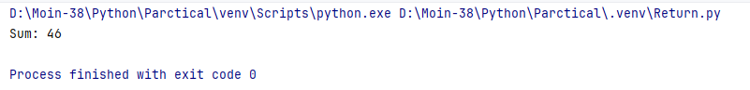

**B) Write a Program Pass the Function as an argument another in Function.**

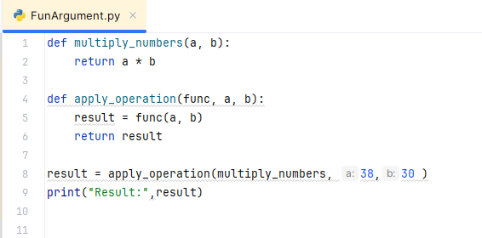

**Output:**

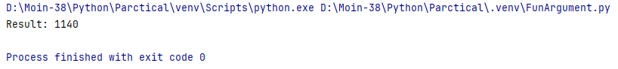

**C) Write a program to demonstrate lambda Function.**

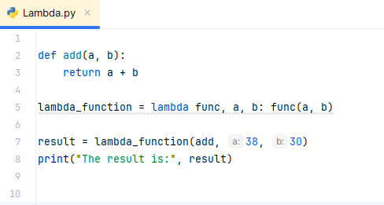

**Output:**

