**Q.1) Implement a program:**

**Tasks:**

**1) Ask the user for a line number and reach that specific line and reads that specific line from the file.**

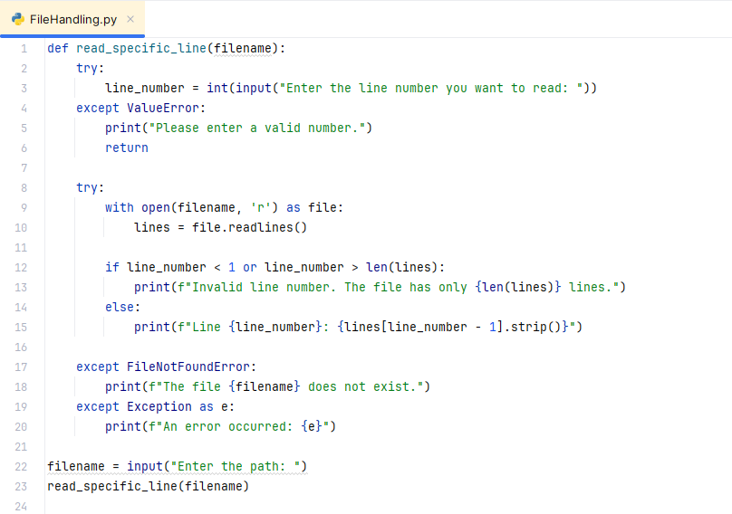

**Output:**

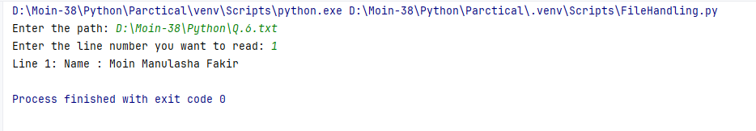

**2) Write a program that counts the number of words in the file , read the file and split the content into words and print the word count.**

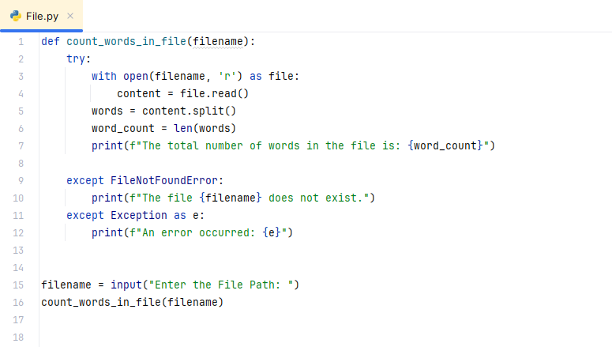

**Output:**

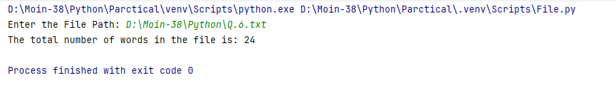

**3) Write a program that attempts who open a file and read its content.**

**Handle the file FileNotFoundError.**

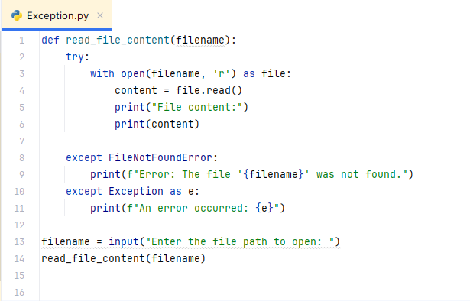

**Output:**

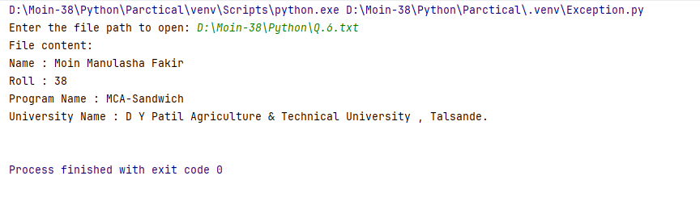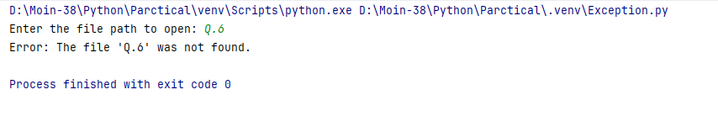

**Q.2) Write a program to exception handling with try-except-else-finally.**

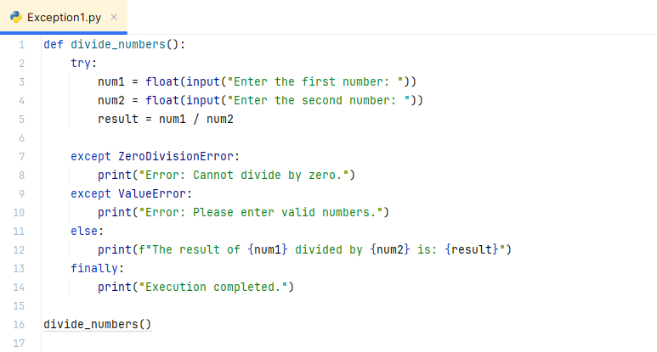

**Output:**

**Valid Input:**

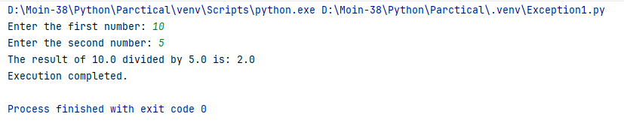

**ZeroDivisionError:**

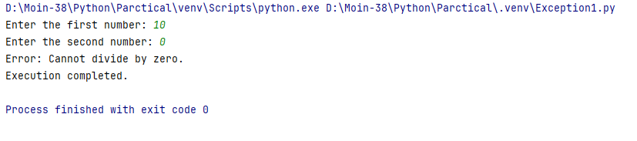

**ValueError (Invalid input):**

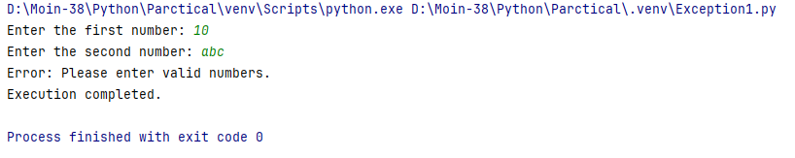

**Q.3) Write a program to exception handling :**

**A) Clauses**

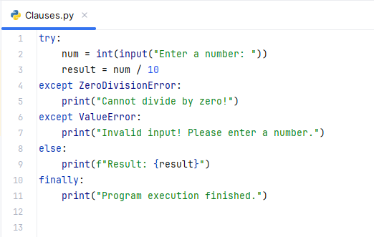

**Output:**

**ZeroDivisionError:**

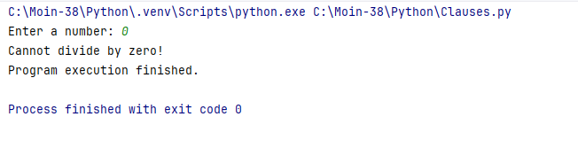

**ValueError (Invalid input):**

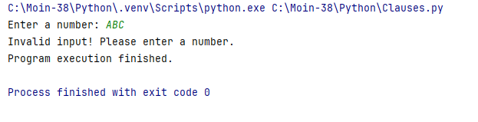

**Valid Input:**

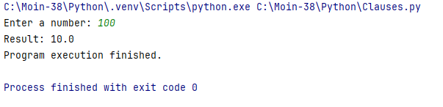

**B) Assertion**

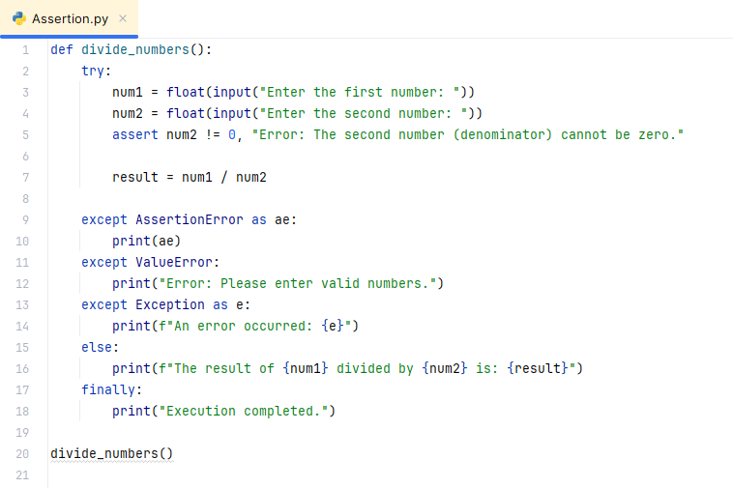

**Output:**

**Valid Input:**

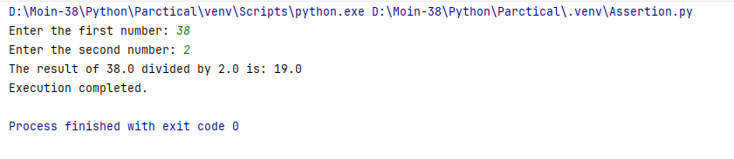

**ZeroDivisionError:**

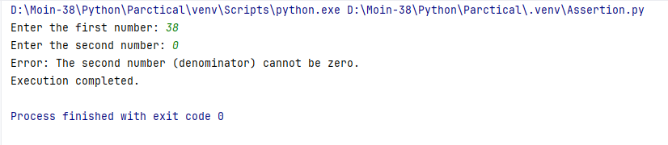

**ValueError (Invalid input):**

