1. **Write a program to create a child class that will inherits all the variable and methods from the parent class.**

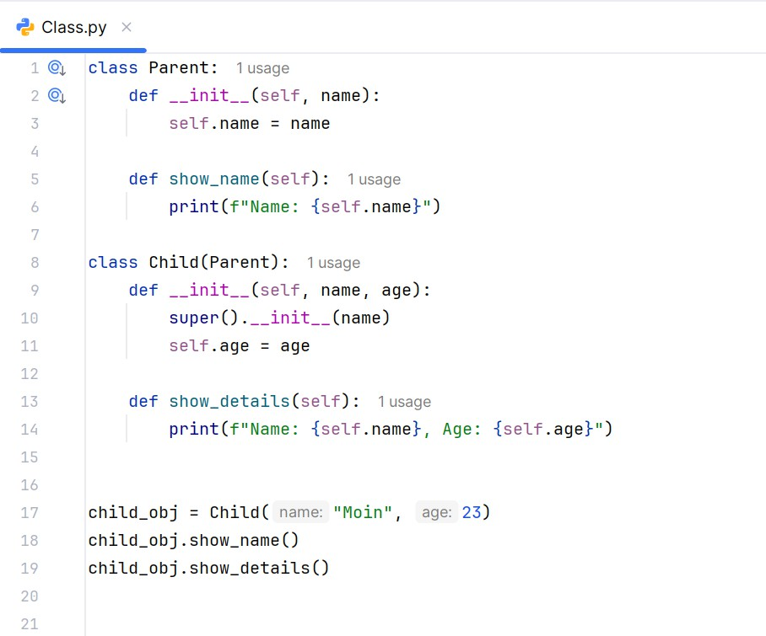

Output:

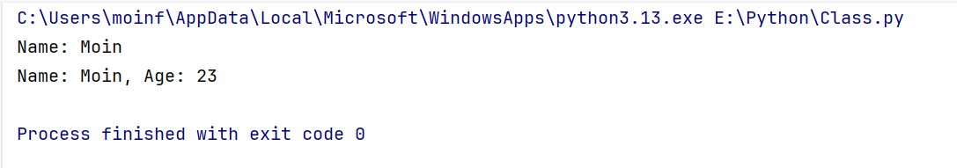

1. **Write a program to implement a constructor with default parameter self, using parameter and Non parameterized constructor in python.**

Self:

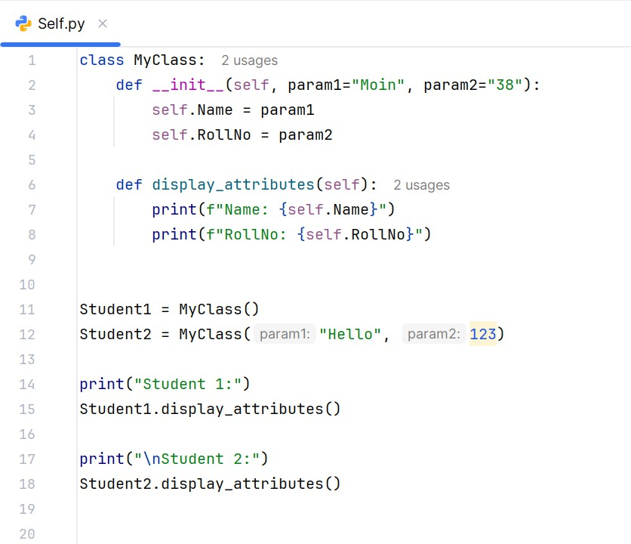

Output:

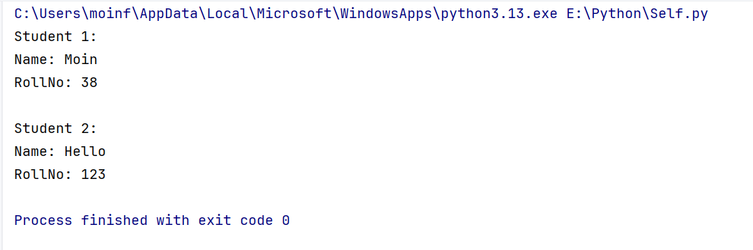

Parameterized:

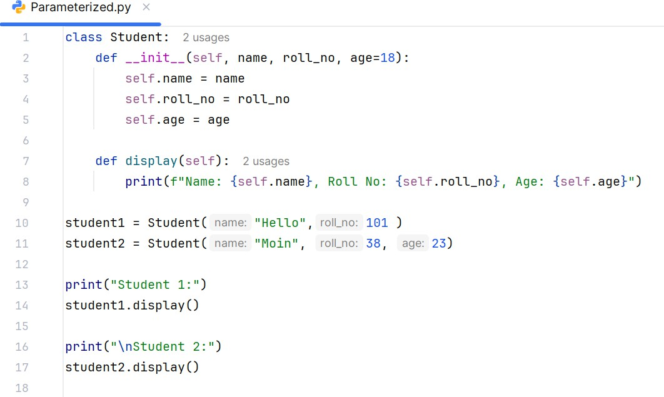

Output:

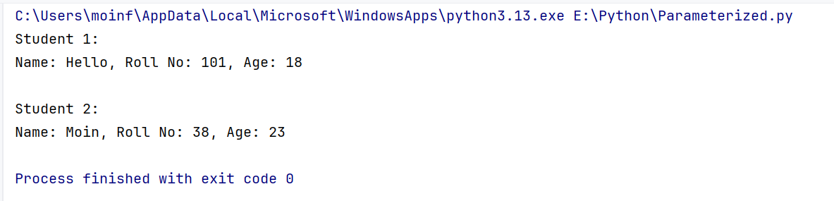

Non-Parameterized

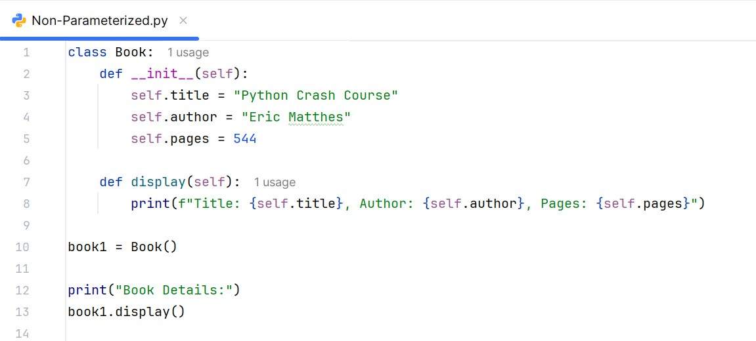

Output:

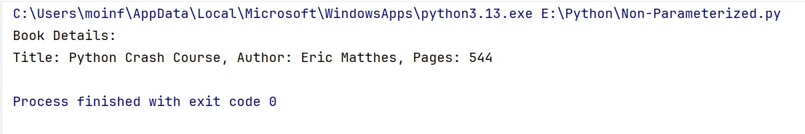

1. **Write a program to initialize destructor in python.**

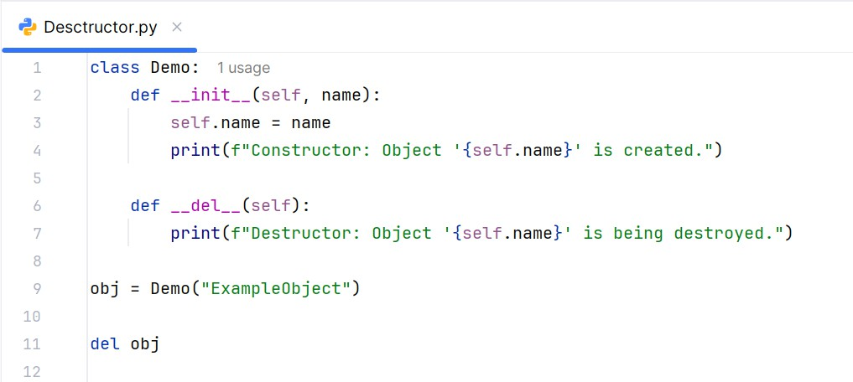

Output:

