**INDEX**

| Sr.No. | Context | Page No. |
| --- | --- | --- |
| 1. | **Introduction to project**   * 1. Introduction   2. Existing System   3. Need and scope of computer system   4. Organization profile |  |
| 2. | **Proposed System**  2.1 Objective   * 1. Requirement engineering * SRS * Purpose * User Characteristics * Feasibility Study |  |
| 3. | **System Analysis**   1. System Diagram  * DFD * ERD * UML * Use-Case Diagram * Sequence Diagram * Class Diagram |  |
| 4 | **System Design**   1. Database Design 2. Input and Output Design |  |
| 5. | **Implementation**   1. System Requirements  * Hardware * Software |  |
| 7. | **Output**   1. Crystal Reports |  |
| 8. | Bibliography |  |

**1) Introduction to Project**

**1. Introduction**

We have created a Thyroid algorithm and Influenza system, which would not only detect the thyroid diseases but also, general influenza diseases present around us. Due to the vast improvement in computer science and especially medical field we have developed this algorithm for doctors so that they can easily detect thyroid and prescribe medicines accordingly.

Here it will not only make this process computerized but also make it user-friendly and less time consuming for the doctors who will be able to attend more patients and detect thyroid and influenza at ease.

Here we have three modules

1. Thyroid Algorithm

2. Doctor

3. Patient

Here the doctor is the admin and he has the authority to add diseases and their synonyms, generate reports, and provide prescription. And the role of the patient is to just tell his/her symptoms to the doctor provide necessary basic information to them.

It makes convenient for the doctors to know the symptoms from remote place even if he is not in person seeing his patient. And here the doctor himself is given authority for prescription.

**1.2 Existing System**

There are no current systems available that would provide disease and symptom checker for doctors about Thyroid, there is only hospital management system available.

**Scope of the Project**

* To enable the use of expertise after working hours or at different locations.
* To automate a routine task that requires human expertise all the time, thus reducing operational costs.
* To replace a retiring or a leaving employee who is an expert.
* To hire an expert is costly.

**Organization Profile**

**2.Proposed System**

Our proposed system works as: -

Doctor pre-enters the symptoms in the Thyroid algorithm, also any new diseases if occurred.

We have provided login to the admin and the doctor so that it could maintain records and security.

The work of the patient is to provide his/her Symptoms so that the doctor can enter it in our algorithm and if the symptoms match our algorithm

It is shown in the Datagridview.

The work of the patient is just to provide the symptoms which he/she is going through the rest of the work is done by the algorithm.

**2.1 Objective**

Proposed algorithm is for the ease of the doctor and the patient.

If the doctor is not available, the doctor can remotely login into the algorithm and enter the symptoms and provide the information or suggestion regarding Medicines for the influenza.

By using ASP.Net control through .Net platform.

**Requirement Engineering**

* **SRS**
* **PURPOSE**

The main purpose of “**Thyroid Algorithm and Influenza Detection System”** is to save the time and money and to provide the forum to exchange the information between Patient and Client.

It stores the information of Patient and their Symptoms, and the doctor gives them the prescription.

**User Characteristics**

1. **Educational level:**

Users should be comfortable with this English language.

1. **Experience:**

Users should have prior information regarding this software.

1. **Skills:**

Users should have basic knowledge and should be comfortable using general purpose applications on computers.

* **Software System Attributes**
* **Security:**

Only authorized users will be able to access this software by entering the correct login name and corresponding password.

* **Maintainability:**

The software can be maintained in present or future. It will be easy to incorporate new requirements in the individual modules.

* **Portability:**

The software is easily portable on various systems.

* **FEASIBILITY STUDY**

Feasibility analysis begins once the goals are defined. It starts by generating broad possible solutions, which are possible to give an indication of what the new system should look like. This is where creativity and imagination are used. Analysts must think up new ways of doing things- generate new ideas. There is no need to go into the detailed system operation yet. The solution should provide enough information to make reasonable estimates about project cost and give users an indication of how the new system will fit into the organization. It is important not to exert considerable effort at this stage only to find out that the project is not worthwhile or that there is a need significantly change the original goal.

Feasibility of a new system means ensuring that the new system, which we are going to implement, is efficient and affordable. There are various types of feasibility to be determined. They are:

**1. Economically Feasibility**

Development of this application is economically feasible. The only thing to be done is making an environment with an effective supervision.

It is cost effective in the sense that has eliminated the paper work completely. The system is also time effective because the records are generated easily.

**2. Technical Feasibility**

The technical requirement for the system is economic and it does not use any other additional Hardware and software. Technical evaluation must also assess whether the existing systems can be upgraded to use the new technology and whether the organization has the expertise to use it.

Install all upgrades framework into the .Net package supported widows based application. this application depends on Microsoft SQL Server. Enter their id to generate their report.

**3. Operational Feasibility**

The system working is quite easy to use and learn due to its simple but attractive interface. User requires no special training for operating the system. Technical performance includes issues such as determining whether the system can provide the right information for the Department personnel student details, and whether the system can be organized so that it always delivers this information at the right place and on time using intranet services. Acceptance revolves around the current system and its personnel.

**Hardware & Software Requirements**

* Operating system : Windows 8 or later
* Front End : VB.NET 2015
* Back End : SQL Server 2012
* Processor : Intel Pentium or more
* Ram : 4GB or more
* Hard disk : 10 GB free space

**System Analysis**

**DIAGRAMS**

**E-R Diagram**

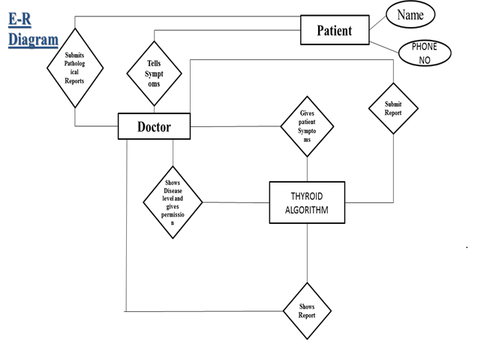



**Sequence Diagram**



**DFD Diagram**

**Class Diagram**

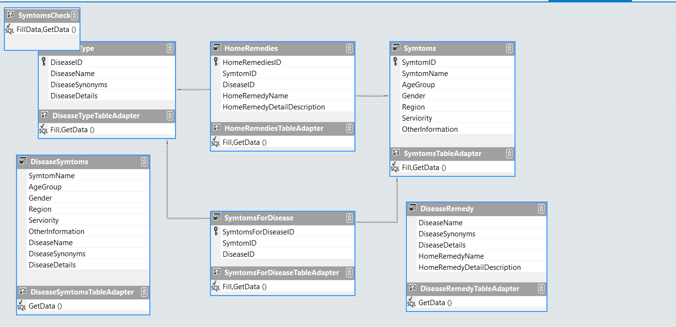

**SYSTEM DESIGN**

**DATABASE DESIGN**

* **Disease Entry Table:**

This table stores information about the disease name and disease synonyms and disease details.

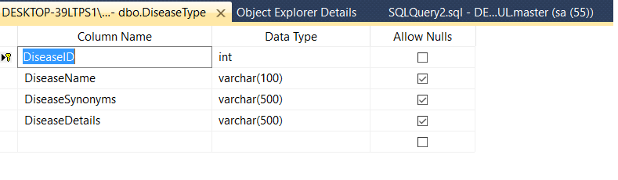

* **Home Remedies:**

This table is used to store the home remedies, Symptom ID, DiseaseID, Home remedy name, Home remedy detail description.

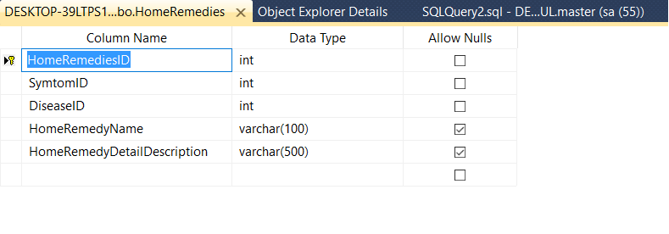

* **Symptom Entry** :

This table is used to store the Symptom ID, Symptom Name, Age Group, Gender, Region, Serviority and other information

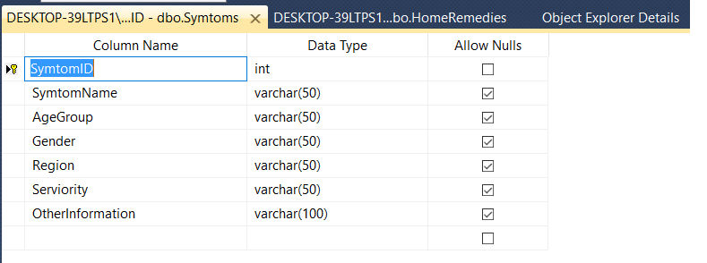

* **Patient Reports:**

This table is used to store the Patient reports, Home Remedies ID, Symptom ID, Disease ID, Patient Name, Patient contact number.

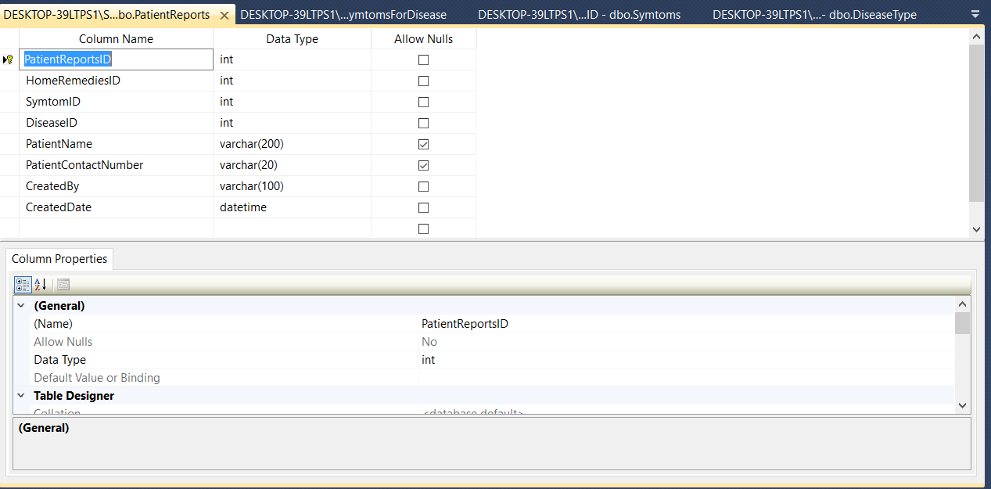

**Input and Outputs Design**

**Admin Login**:

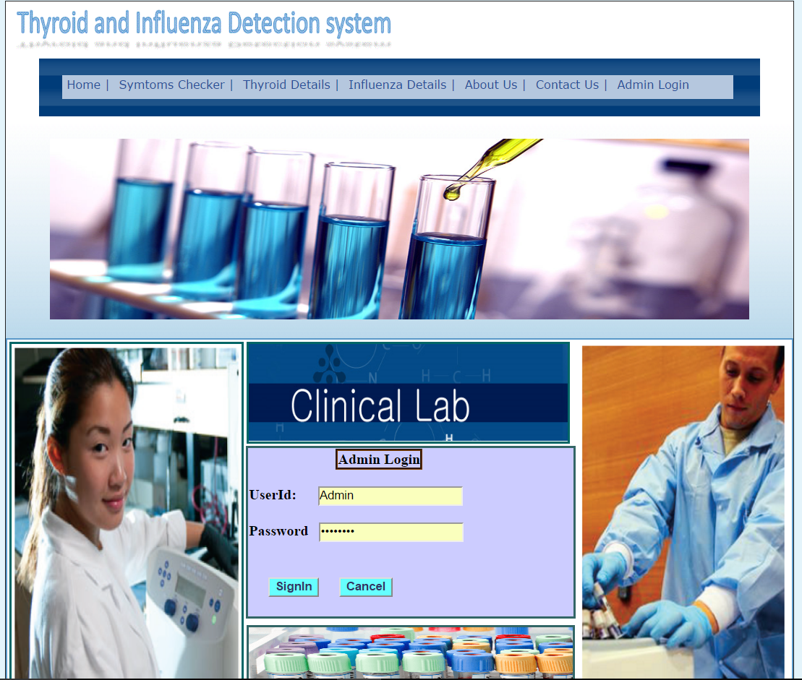

**Disease Entry Form:**

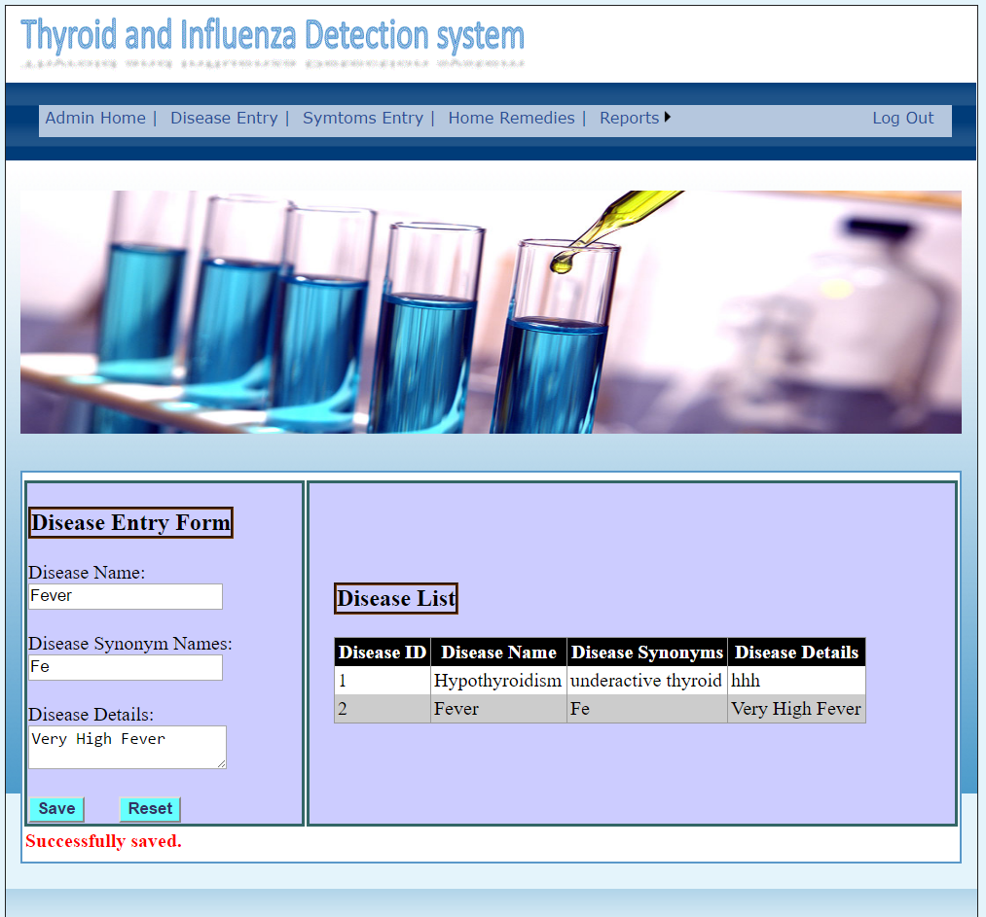

**Symptoms Entry Form:**

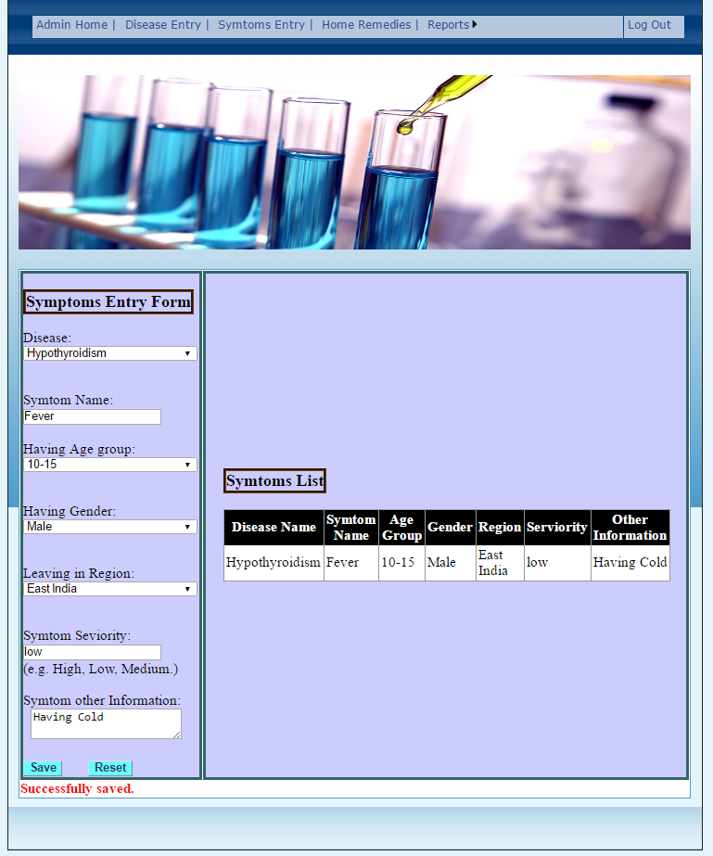

**Home Remedies Form:**

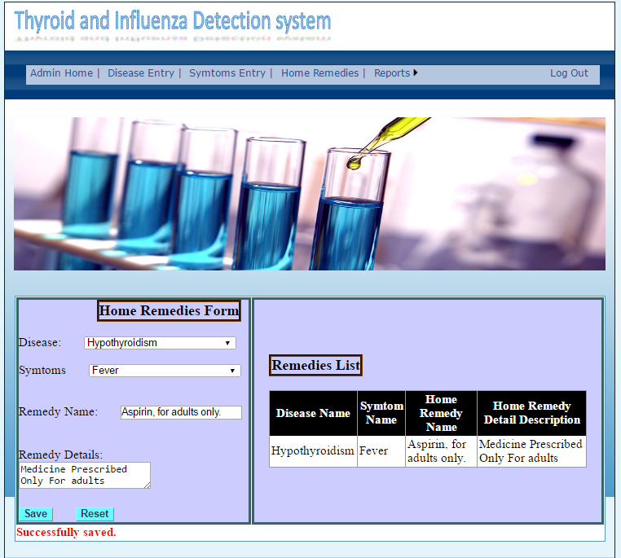

**Outputs Crystal Reports**

**Diseases Remedies Report**

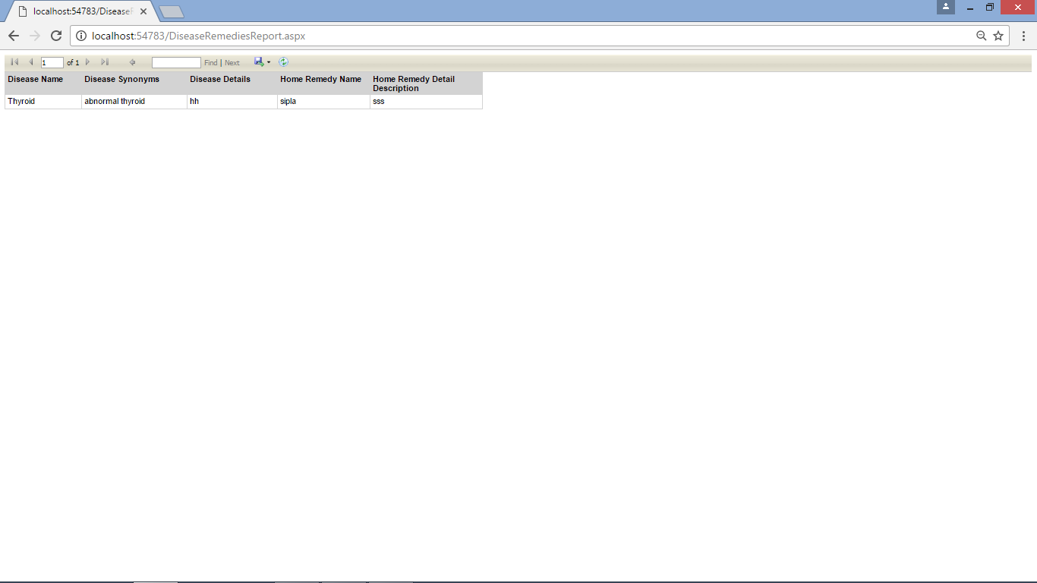

**Diseases Symptoms Report**

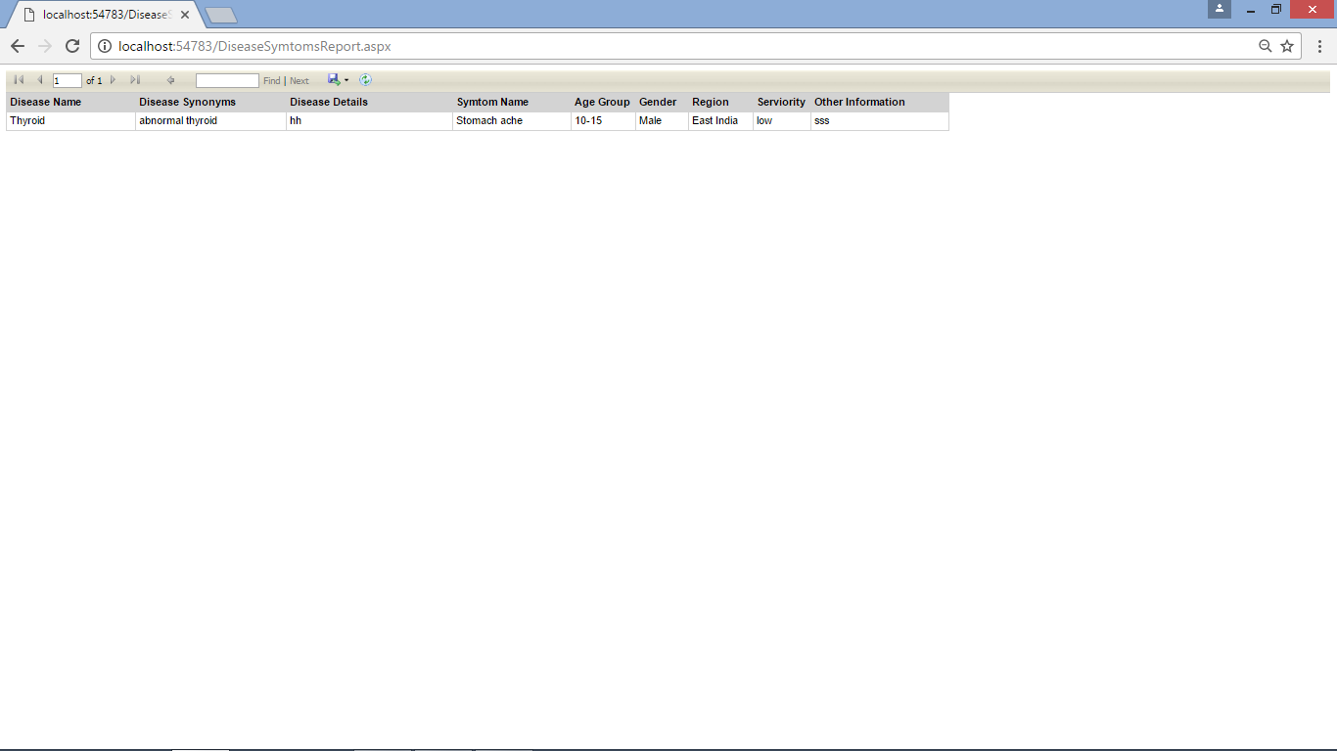

**Diseases Report**

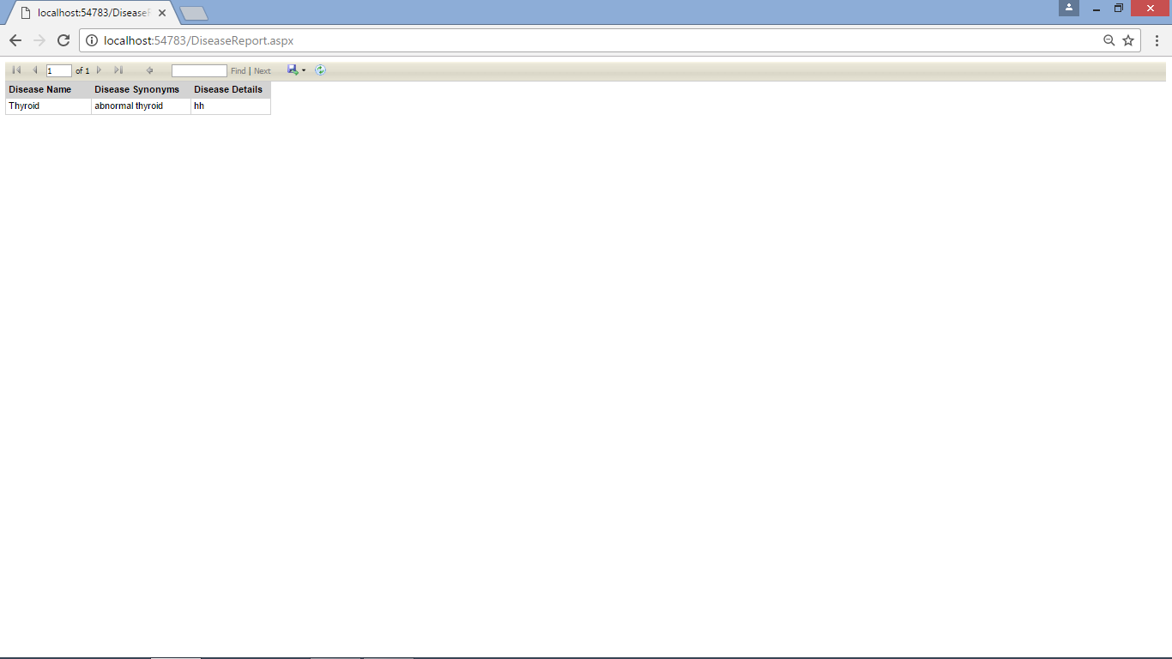

**Conclusion**

This system provides Symptom Checker Not only for Thyroid but Also for General influenza diseases. Doctor is Admin of this system who can Keep check of the patient entry as well as do new disease entry symptom regarding that Diseases and Keep entries regarding the Remedies required for the respective diseases

User just have to provides his Symptom to the doctor who is given the authority to access the System. Reports will be generated Regarding the Diseases and its remedies. Through this system, we provide a computerized system for Influenza detection so they can get all the information about electricity.

**Limitations**



**8. Bibliography**

**Websites**:-

1.www.google.com

2. http://www.thyroid.org/

**Book**:-

1.Visual basic .NET Black Book-Steve Holzne

2.Database system concepts – Korth Silberschartz

**Client**:-

Mrs. Aarti Soman.