MedAI Disease Detection Portal: An Integrated AI-Based Medical X-ray Analysis Platform for Chest Diseases, Bone Fractures, and Dental Abnormalities
[1] Harshal Pendor  AIDS  VIT  Pune, India  harshal.pendor23@vit.edu | [2] Yashraj Pisal  AIDS  VIT  Pune, India  yashraj.pisal23@vit.edu | [3] Srushti Kasurde  AIDS  VIT  Pune, India  srushti.kasurde23@vit.edu
[4] Ayushi Kamble
AIDS
VIT
Pune, India
ayushi.kamble@vit.edu

Abstract— Fragmented diagnostic tools in medical X-ray imaging present a significant clinical challenge, often requiring healthcare professionals to navigate isolated software applications across disparate anatomical domains. To address this limitation, this paper introduces the MedAI Disease Detection Portal, an integrated AI-powered healthcare portal that combines chest disease, bone fracture, and dental abnormality detection into a unified platform. The underlying methodology utilizes DenseNet121 for chest disease classification, MobileNetV2 for bone fracture detection, and Faster R-CNN with a ResNet-50 Feature Pyramid Network for dental abnormality localization. Experimental evaluations demonstrate robust performance, with the chest disease model achieving 93% test accuracy, 95% macro-average precision, 93% macro-average recall, and 94% weighted F1-score, while the bone fracture model attains 92% test accuracy. Furthermore, the platform integrates these multi-domain detection capabilities into a centralized web-based application featuring interactive patient and doctor dashboards, report interpretation tools, an AI chatbot, and emergency-service functionality.
Keywords— Medical image analysis, Deep learning, DenseNet121, MobileNetV2, Faster R-CNN, Healthcare portal
I. INTRODUCTION
Automated analysis of medical X-ray images plays a critical role in modern clinical diagnostics, providing essential decision support for identifying various clinical abnormalities [1, 2]. Medical imaging generates vast volumes of diagnostic data daily, and rapid, accurate interpretation is vital for timely patient care. However, manual radiological evaluation remains susceptible to human fatigue, subjectivity, and inconsistencies, particularly when managing diverse anatomical regions and complex pathological patterns [3]. To address these challenges, deep learning techniques have been increasingly applied to medical imaging to automate screening workflows and improve diagnostic precision across various clinical modalities [1, 2, 3, 4, 5]. Despite these advancements, existing computational tools typically operate as isolated systems designed for single-domain tasks, lacking a consolidated framework for multi-condition diagnostic support [2]. To bridge this gap, this paper introduces the MedAI Disease Detection Portal, an integrated AI-based medical X-ray analysis platform that combines multi-domain diagnostics—specifically chest diseases, bone fractures, and dental abnormalities—into a unified web-based application accompanied by patient and doctor dashboards. The key contributions of this work comprise an integrated medical image analysis platform combining chest disease, bone fracture, and dental abnormality detection within a unified web-based application. The remainder of this paper is organized as follows. Section II details the motivation and clinical use cases driving the development of the portal. Section III reviews related work in deep learning-based X-ray classification and localization. Section IV identifies the research gaps addressed by this study. Section V outlines the proposed methodology, including data preparation, architecture configurations, and web integration. Section VI presents experimental results and a comprehensive discussion. Finally, Section VII concludes the paper and outlines directions for future work.
II. MOTIVATION
Medical professionals frequently encounter fragmented diagnostic workflows when analyzing medical X-ray images, as existing computational tools typically operate as isolated systems dedicated to single anatomical domains [2]. In clinical practice, radiologists and clinicians must navigate separate software applications and diagnostic pipelines to evaluate disparate conditions, such as pulmonary diseases from chest radiographs, musculoskeletal injuries from bone X-rays, and localized defects from dental scans. This administrative and technical fragmentation increases the cognitive load on healthcare providers and can delay timely clinical decision-making. To assist radiologists and clinicians by providing automated multi-domain screening and visual confidence scores, this work is motivated by the need for an integrated medical image analysis platform combining multiple diseases into a unified application rather than separate systems. In an illustrative clinical scenario, a healthcare facility evaluates a patient presenting with multiple trauma or concurrent symptoms requiring simultaneous radiological assessment. Instead of utilizing disconnected software tools for each body region, the clinician interacts with the MedAI Disease Detection Portal to concurrently evaluate chest X-rays, bone fractures, and dental abnormalities. Specifically, the system detects chest diseases, bone fractures, and dental abnormalities through automated deep learning inference. The explicit AI angle of the portal relies on deep learning models—including DenseNet121 for chest disease classification, MobileNetV2 for bone fracture detection, and Faster R-CNN with ResNet-50 FPN for dental abnormality localization—to process incoming X-ray scans and generate prediction confidence scores and visual results. These computational outputs are delivered directly to clinical stakeholders via integrated patient and doctor dashboards, which streamline report interpretation, support clinical decision-making, and consolidate multi-domain diagnostic workflows into a single web-based application. Note that the narrative story, use case, and scenario elements described here are illustrative and hypothetical, as specific organizational incidents or patient statistics are missing from the project profile.
III. RELATED WORK
Recent advancements in medical image analysis have extensively explored the application of deep learning models to automate radiographic evaluation, spanning chest disease classification, bone fracture detection, and object localization [1, 2, 3]. A prominent thematic area in pulmonary diagnostics involves chest X-ray classification using DenseNet121 and transfer learning techniques [2, 4, 5]. Studies such as [2] and [5] demonstrated that initializing DenseNet121 with pre-trained weights enables effective multi-class pulmonary disease classification and the distinction between healthy and diseased lungs. Similarly, [4] and [6] evaluated convolutional neural network architectures including DenseNet121 and ResNet50 for identifying pulmonary conditions such as COVID-19, pneumonia, and tuberculosis, highlighting high classification accuracy supported by gradient-based interpretability mechanisms. In parallel, bone fracture detection has been investigated using various deep learning paradigms, ranging from custom convolutional neural networks to pre-trained architectures [1, 7, 8, 9, 10]. Research by [9] and [10] established the efficacy of MobileNetV2 and comparative CNN models in identifying musculoskeletal injuries from orthopedic X-rays, while other works explored architectures like EfficientNetB3 and YOLO configurations to enhance fracture identification performance [7, 8]. Furthermore, region-based object detection frameworks such as Faster R-CNN integrated with Feature Pyramid Networks (FPN) have been widely adopted for localizing anatomical abnormalities and lesions in medical imaging [3, 11, 12, 13]. For instance, [11] investigated Faster R-CNN architectures with ResNet-50 FPN and ResNeXt 101 FPN for bone fracture localization, demonstrating robust feature extraction capabilities. Despite these extensive contributions, current literature exhibits notable limitations. Existing studies predominantly focus on isolated diagnostic tasks within single anatomical domains rather than a consolidated, end-to-end platform covering chest diseases, bone fractures, and dental abnormalities simultaneously [1, 2, 3, 7, 8, 4, 5, 11, 12, 9, 13, 6, 14, 10, 15]. Moreover, region-based localization frameworks such as Faster R-CNN and FPN configurations suffer from challenges including high false negatives and overlapping predictions [11]. Additionally, many existing studies lack detailed reporting on hardware specifications, reproducible dataset metrics, and deployment nuances [1, 2, 3, 7, 8, 4, 5, 11, 12, 9, 13, 6, 14, 10, 15]. These isolated approaches and reporting gaps motivate the development of an integrated multi-domain diagnostic portal.
IV. RESEARCH GAPS
Synthesizing the limitations identified in contemporary literature reveals three critical research gaps that hinder the clinical deployment of automated radiological analysis systems. First, while individual deep learning models such as DenseNet121, MobileNetV2, and Faster R-CNN have been extensively studied for isolated diagnostic tasks, there is a demonstrated lack of unified multi-domain medical X-ray analysis systems combining chest, bone, and dental anomaly detection into a single platform [1, 2, 3, 7, 8, 4, 5, 11]. Prior investigations restrict their scope to single anatomical domains, requiring clinicians to navigate fragmented software tools. Second, region-based object detection frameworks utilizing Faster R-CNN and Feature Pyramid Network (FPN) configurations frequently encounter technical challenges, including high false negatives and overlapping predictions during abnormality localization [11]. Third, a significant proportion of existing studies fail to report comprehensive hardware specifications, exact dataset sizes, and deployment nuances, which limits reproducibility and clinical translation [1, 2, 3, 7, 8, 4, 5]. These shortcomings directly align with the approved research gap statement, confirming that while individual models are well-studied for specific isolated domains, a unified web-based application accompanied by patient and doctor dashboards is missing. The proposed work directly addresses these limitations by integrating DenseNet121 for chest disease classification, MobileNetV2 for bone fracture detection, and Faster R-CNN with ResNet-50 FPN for dental abnormality localization into the MedAI Disease Detection Portal, establishing a consolidated multi-domain diagnostic platform equipped with interactive patient and doctor dashboards.
V. PROPOSED WORK
The MedAI Disease Detection Portal implements an end-to-end multi-domain deep learning pipeline designed to process medical X-ray images and provide automated diagnostic support. The overall architecture integrates data acquisition, specialized preprocessing, distinct component models for chest disease classification [2], bone fracture detection [9], and dental abnormality localization [11], followed by a unified web-based deployment. A. Data Acquisition and Preparation. The system ingests medical X-ray images from publicly available repositories and Kaggle medical datasets. Prior to model ingestion, raw images undergo a rigorous data preparation pipeline comprising data cleaning, image resizing to 224x224 pixels for bone X-rays, pixel intensity normalization, noise reduction, and contrast enhancement. To improve model generalization and combat overfitting, image augmentation techniques are applied, including horizontal flipping, random rotation, and scaling [1, 11]. B. Dental Abnormality Detection. For dental X-ray analysis, the portal utilizes Faster R-CNN configured with a ResNet-50 Feature Pyramid Network (FPN) backbone [11]. The architecture extracts multi-scale feature representations to detect and localize subtle dental anomalies and bounding boxes with associated prediction confidence scores. C. Bone Fracture Detection. Bone fracture detection is executed using the MobileNetV2 architecture [9]. MobileNetV2 provides an efficient convolutional neural network design optimized for identifying musculoskeletal injuries and classifying orthopedic X-ray scans into fractured and non-fractured categories. D. Chest Disease Detection. Chest disease classification is powered by the DenseNet121 architecture [2, 4, 5], which evaluates frontal chest radiographs to classify conditions including COVID-19, Pneumonia, Tuberculosis, and Normal chest X-rays. Dense connectivity patterns maximize feature propagation and reuse across layers, facilitating the accurate differentiation of complex pulmonary pathologies [2]. E. Training Methodology. The models are trained using a transfer learning strategy leveraging pretrained weights initialized from ImageNet [1, 5]. A two-stage training methodology is employed, beginning with feature extraction followed by fine-tuning. For DenseNet121, training involves freezing and unfreezing the last 30 layers. Optimization is supported by focal loss and class weighting to address class imbalance, dropout regularization, global average pooling, and confidence thresholding. F. Web Portal Integration. The inference outputs—including disease predictions, confidence scores, and visual detection results—are integrated into a centralized web-based healthcare portal [2]. The platform features interactive patient and doctor dashboards, report interpretation tools, multilingual support, an AI chatbot, and emergency-service functionality. Note that exact dataset sizes, repository names, and hardware specifications used for training and inference are missing from the current project documentation.
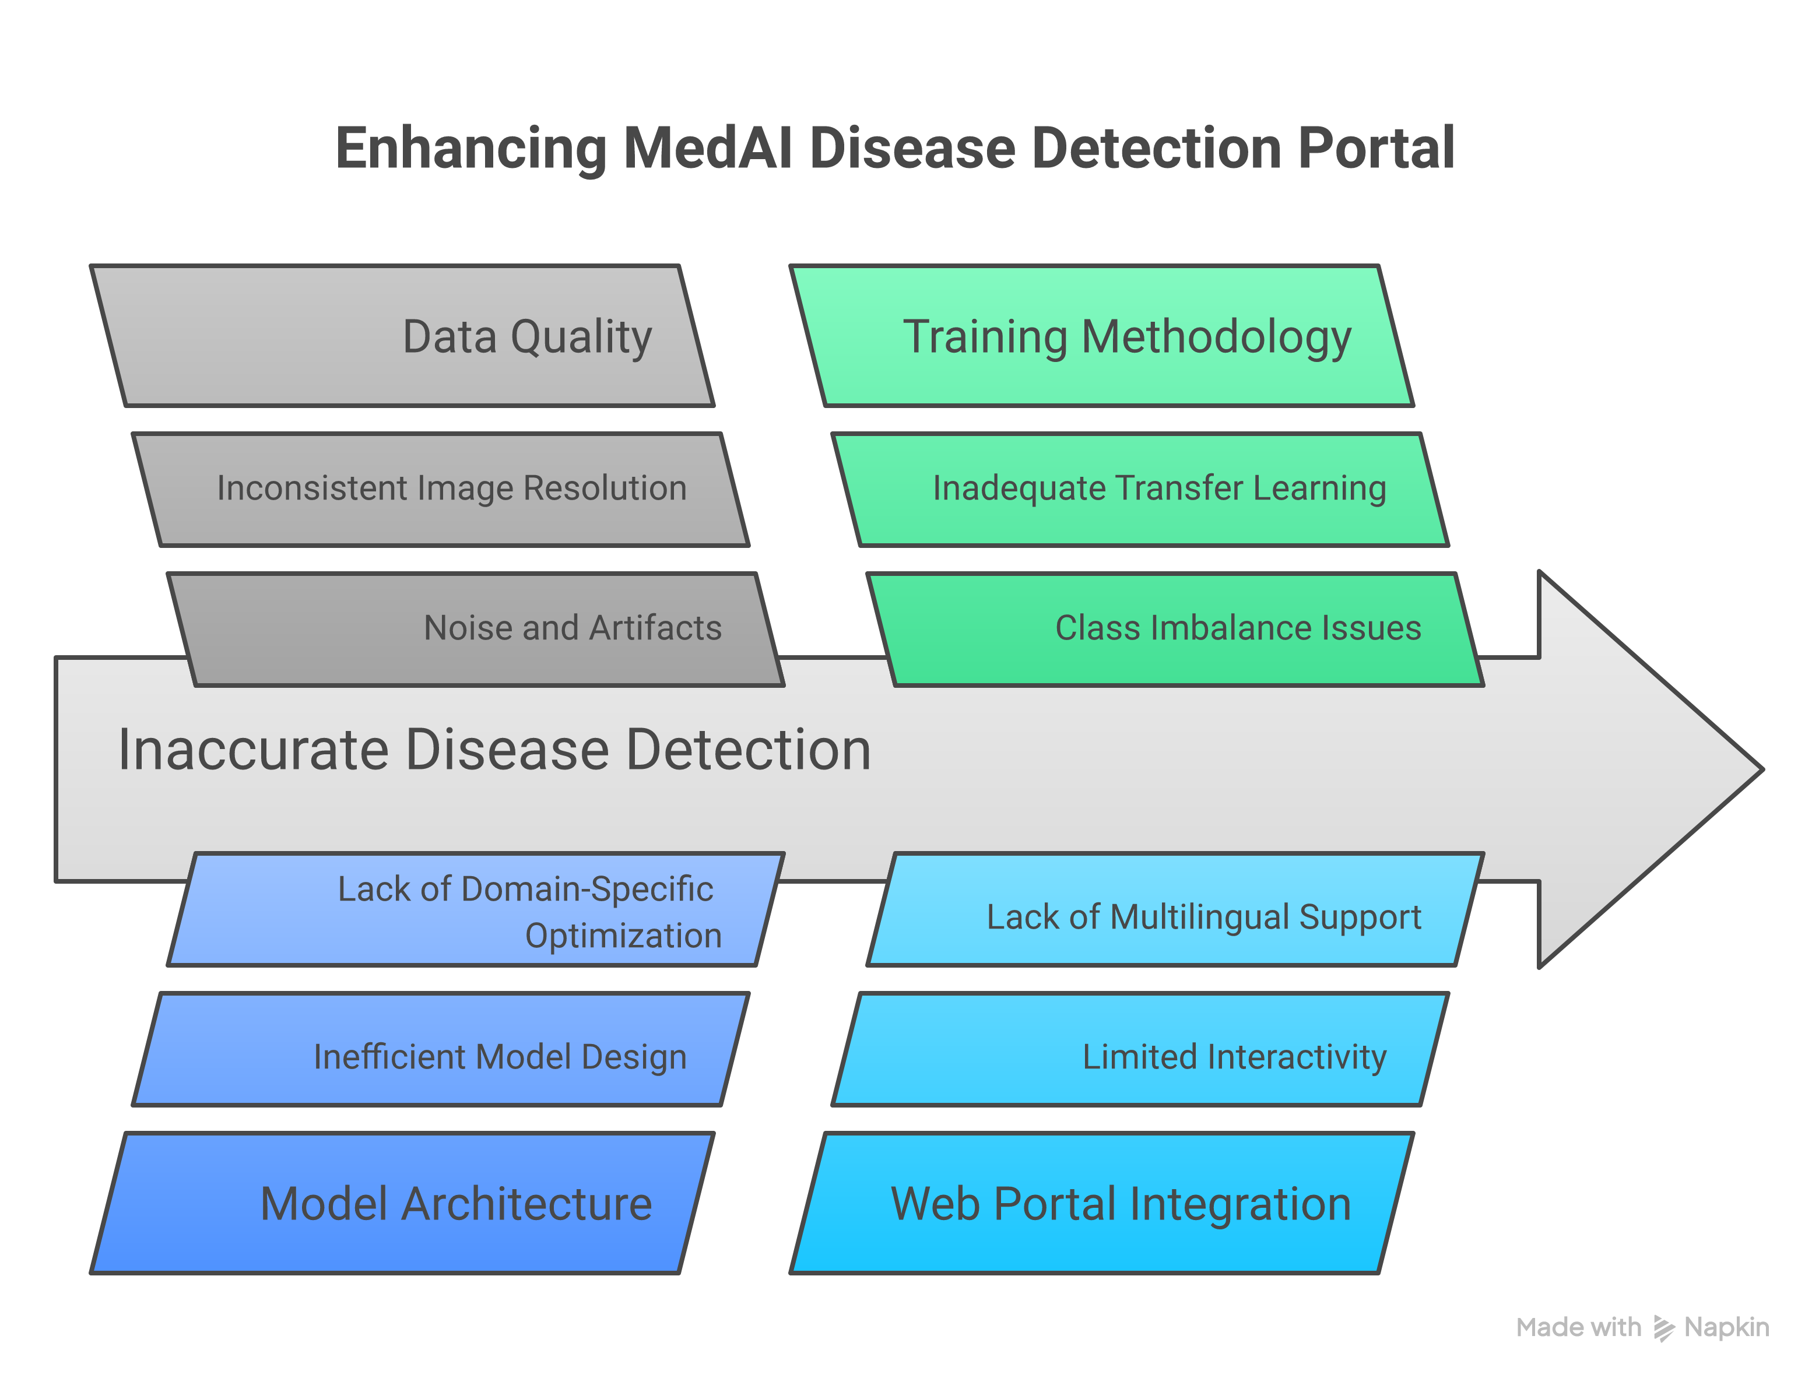
Fig. 1. System architecture and component flow.
VI. RESULTS AND DISCUSSION
VI. Results and Discussion. A. Experimental Results. The performance of the MedAI Disease Detection Portal was evaluated using training, validation, and testing datasets split from collected X-ray repositories, employing a comprehensive set of evaluation metrics including accuracy, precision, recall, F1-score, confusion matrix, Intersection over Union (IoU), average precision, and average recall. For chest disease classification using DenseNet121, the system achieved a test accuracy of 93%, a macro-average precision of 95%, a macro-average recall of 93%, and a weighted F1-score of 94%, confirming its effectiveness in identifying pulmonary conditions such as COVID-19, pneumonia, and tuberculosis [2, 4, 5]. For musculoskeletal analysis, the bone fracture detection model powered by MobileNetV2 attained a test accuracy of 92%, demonstrating robust classification capability across orthopedic X-ray scans [1, 9, 10]. Furthermore, the dental abnormality detection module utilizing Faster R-CNN with ResNet-50 Feature Pyramid Network successfully executed region-based object localization, generating bounding boxes and prediction confidence scores to highlight localized anomalies [11]. B. Discussion. Interpreting these experimental findings against the established research objectives indicates that the deep learning models successfully deliver automated diagnostic support with high quantitative precision. The chest disease classification accuracy of 93% and bone fracture accuracy of 92% align closely with performance benchmarks reported in contemporary literature for isolated domain models [2, 8, 5]. However, unlike prior studies that focus exclusively on single anatomical domains [1, 2, 3, 7, 8, 4, 5, 11], the primary advancement of this work lies in successfully bridging the multi-domain integration gap by consolidating chest, bone, and dental analysis into a single unified web portal equipped with interactive patient and doctor dashboards. Despite these promising results, several limitations must be acknowledged. Specifically, the exact dataset sizes, names of public repositories, hardware specifications utilized for training and inference, and specific implementation details regarding multilingual support and the AI chatbot are missing from the current project documentation. These reporting gaps highlight important directions for future work to ensure full reproducibility and clinical deployment readiness.
VII. CONCLUSION AND FUTURE WORK
VII. Conclusion and Future Work. A. Conclusion. Automated analysis of medical X-ray images addresses a critical diagnostic need by providing rapid decision support for chest diseases, bone fractures, and dental abnormalities. This paper presented the MedAI Disease Detection Portal, an integrated deep learning healthcare platform that unifies multi-domain radiological analysis into a single web-based application. By combining DenseNet121 for chest disease classification, MobileNetV2 for bone fracture detection, and Faster R-CNN with a ResNet-50 Feature Pyramid Network for dental abnormality localization, the portal successfully bridges the gap between fragmented diagnostic tools and comprehensive clinical workflows. Experimental results demonstrated robust empirical performance, achieving 93% test accuracy, 95% macro-average precision, 93% macro-average recall, and 94% weighted F1-score for chest disease detection, alongside 92% test accuracy for bone fracture detection, complemented by bounding-box localization and confidence scoring for dental anomalies. The primary contribution of this work is the delivery of a unified medical image analysis platform equipped with interactive patient and doctor dashboards, report interpretation tools, and emergency-service functionality. However, several limitations must be acknowledged, including the absence of exact dataset sizes, repository names, and detailed hardware specifications used during training and inference. B. Future Work. Building upon these findings, future work will focus on addressing current limitations and extending the platform capabilities through evidence-based improvements. Next steps include expanding dataset documentation with precise repository metrics and larger multi-center cohorts to improve model generalizability. Additionally, future development will target the optimization of Faster R-CNN and Feature Pyramid Network configurations to mitigate high false negatives and overlapping predictions during object localization. Finally, further refinement of the web portal will incorporate detailed evaluations of the multilingual support and AI chatbot implementation to enhance user interaction and clinical utility.
REFERENCES
[1] H. D, A. S, K. G., and D. R, "Automated Detection of Upper Extremity Bone Fractures in X-Ray Images Using Advanced Deep Learning Architectures", 2025 1st International Conference on Smart and Intelligent Systems (SISCON), pp. 1-6, 2025, doi: 10.1109/SISCON66686.2025.11409131
[2] J. Asha and T. Malathi, "AI-Powered Multi-Disease Chest X-Ray Analysis And Explainable AI System Using Densenet121 and Grad-Cam", International Journal of Research Publication and Reviews, 2026, doi: 10.55248/gengpi.07.0926.3025
[3] B. Zhong, J. Yi, and Z. Jin, "AC-Faster R-CNN: an improved detection architecture with high precision and sensitivity for abnormality in spine x-ray images", Physics in Medicine and Biology, vol. 68, 2023, doi: 10.1088/1361-6560/acf7a8
[4] Shivanshu, R. Bisht, K. Mittal, and G. S, "Evaluation of CNN Models for Accurate Classification of COVID-19, Pneumonia, Tuberculosis in Chest X-ray Images", 2023 3rd Asian Conference on Innovation in Technology (ASIANCON), pp. 1-6, 2023, doi: 10.1109/ASIANCON58793.2023.10270526
[5] L. Dasic, O. Pavić, T. Geroski, D. Milovanović, M. Petrovic, and N. Filipović, "Transfer Learning with Deep Convolutional Neural Networks for Respiratory Disease Classification in X-Ray Images", International Conferences on Biological Information and Biomedical Engineering, pp. 176-180, 2023, doi: 10.1109/BIBE60311.2023.00035
[6] S. Yechuri, G. Susmitha, P. A. Asmath, T. Jyothsna, E. L. Bhavani, and A. Dinesh, "Deep Learning–Based Chest X-ray Classification Using U-Net, DenseNet121, and CBAM Attention Mechanism", 2026 International Conference on Smart Communication and Sustainable Technologies (ICSCST), pp. 842-847, 2026, doi: 10.1109/ICSCST70031.2026.11709684
[7] P. Srinivasu, G. L. A. Kumari, S. C. Narahari, S. Ahmed, and A. Alhumam, "Exploring the impact of hyperparameter and data augmentation in YOLO V10 for accurate bone fracture detection from X-ray images", Scientific Reports, vol. 15, 2025, doi: 10.1038/s41598-025-93505-4
[8] A. Alsufyani, "Enhancing diagnostic accuracy in bone fracture detection: A comparative study of customized and pre-trained deep learning models on X-ray images", International Journal of Advances in Applied Sciences, 2025, doi: 10.21833/ijaas.2025.05.008
[9] V. V, S. K. Natarajan, A. M, N. P, M. A, and N. M. Hosahalli, "Efficient CNN-Based Bone Fracture Detection in X-Ray Radiographs with MobileNetV2", 2024 2nd International Conference on Recent Advances in Information Technology for Sustainable Development (ICRAIS), pp. 72-77, 2024, doi: 10.1109/ICRAIS62903.2024.10811726
[10] S. Padmakala, "Deep Learning in Radiology: A Comparative Study of CNN Architectures for Automated Detection of Bone Fractures", 2025 6th International Conference on Intelligent Communication Technologies and Virtual Mobile Networks (ICICV), pp. 751-756, 2025, doi: 10.1109/ICICV64824.2025.11085635
[11] A. S. Ahamed, T. P. U. Cabrel, M. Chuang, M. N. Jaman, and M. M. Billah, "Optimizing Automated Bone Fracture Detection Through Advanced Faster R-CNN Architectures Integrating Multi-Scale Feature Extraction and Data Augmentation Techniques", European journal of biology and medical science research, 2025, doi: 10.37745/ejbmsr.2013/vol13n1111
[12] G. A. Perdana, M. Nasari, M. A. Saputra, R. Halim, and K. Minor, "Enhancing Bone Fracture Detection in X-ray Images Using Faster R-CNN with EfficientNetV2", 2025 8th International Seminar on Research of Information Technology and Intelligent Systems (ISRITI), pp. 790-795, 2025, doi: 10.1109/ISRITI68345.2025.11393291
[13] S. Y, A. G., P. V, A. K, A. V, and R. K. L. Makesh, "Breast-FRUNET: Automated Breast Cancer Classification Using X-Ray Images with Faster R-CNN and U-Net", 2025 International Conference on Computing Technologies (ICOCT), pp. 1-8, 2025, doi: 10.1109/ICOCT64433.2025.11118812
[14] F. M. J. M. Shamrat, S. Azam, A. Karim, R. Islam, Z. Tasnim, P. Ghosh, and F. D. Boer, "LungNet22: A Fine-Tuned Model for Multiclass Classification and Prediction of Lung Disease Using X-ray Images", Journal of Personalized Medicine, vol. 12, 2022, doi: 10.3390/jpm12050680
[15] H. Zhang, S. Ji, M. Shao, H. Pu, and L. Zhang, "Non-Destructive Internal Defect Detection of In-Shell Walnuts by X-ray Technology Based on Improved Faster R-CNN", Applied Sciences, 2023, doi: 10.3390/app13127311

