OpenGov
Salesforce Developer Assessment
Architectural Assumptions & Schema Design
ERD · Object Inventory · Design Rationale

1. Architectural Assumptions

1.1 CPQ Quote Status
SBQQ__Status__c is assumed to include the value "Contracted". If a CPQ install lacks this value, it is added as a picklist option. The Record-Triggered Flow uses exact string match.

1.2 Product Family Convention
Product2.Family = "Hardware" is the marker that determines whether a Quote Line produces an Asset. CPQ propagates Product Family to SBQQ__QuoteLine__c.SBQQ__ProductFamily__c automatically when SBQQ__AssetConversion__c is enabled on the Product.

1.3 Quote Primary Contact
SBQQ__PrimaryContact__c on the Quote is populated. The Flow uses this to set Asset.ContactId, which is critical for Customer Community sharing (the Sharing Set's cross-reference checks require both Account AND Contact paths).

1.4 Asset Status Picklist
Asset.Status includes values "Purchased" (default for new Assets created by the Flow) and "Installed" (transitioned by Service team, triggers the Kickoff Task). Both are standard Salesforce Asset status values.

1.5 Sharing Model
Activity OWD External Access is set to "Controlled by Parent" so Community users can view Tasks on their Account. Asset and Warranty_Registration__c use ControlledByParent (Account) sharing. Account External OWD remains Private; access is granted via Sharing Sets.

2. Entity Relationship Diagram
The diagram below shows how Warranty_Registration__c (the only new custom object) connects to standard Sales Cloud objects, the CPQ managed package, and the Asset / Task objects auto-populated by the solution's automation.
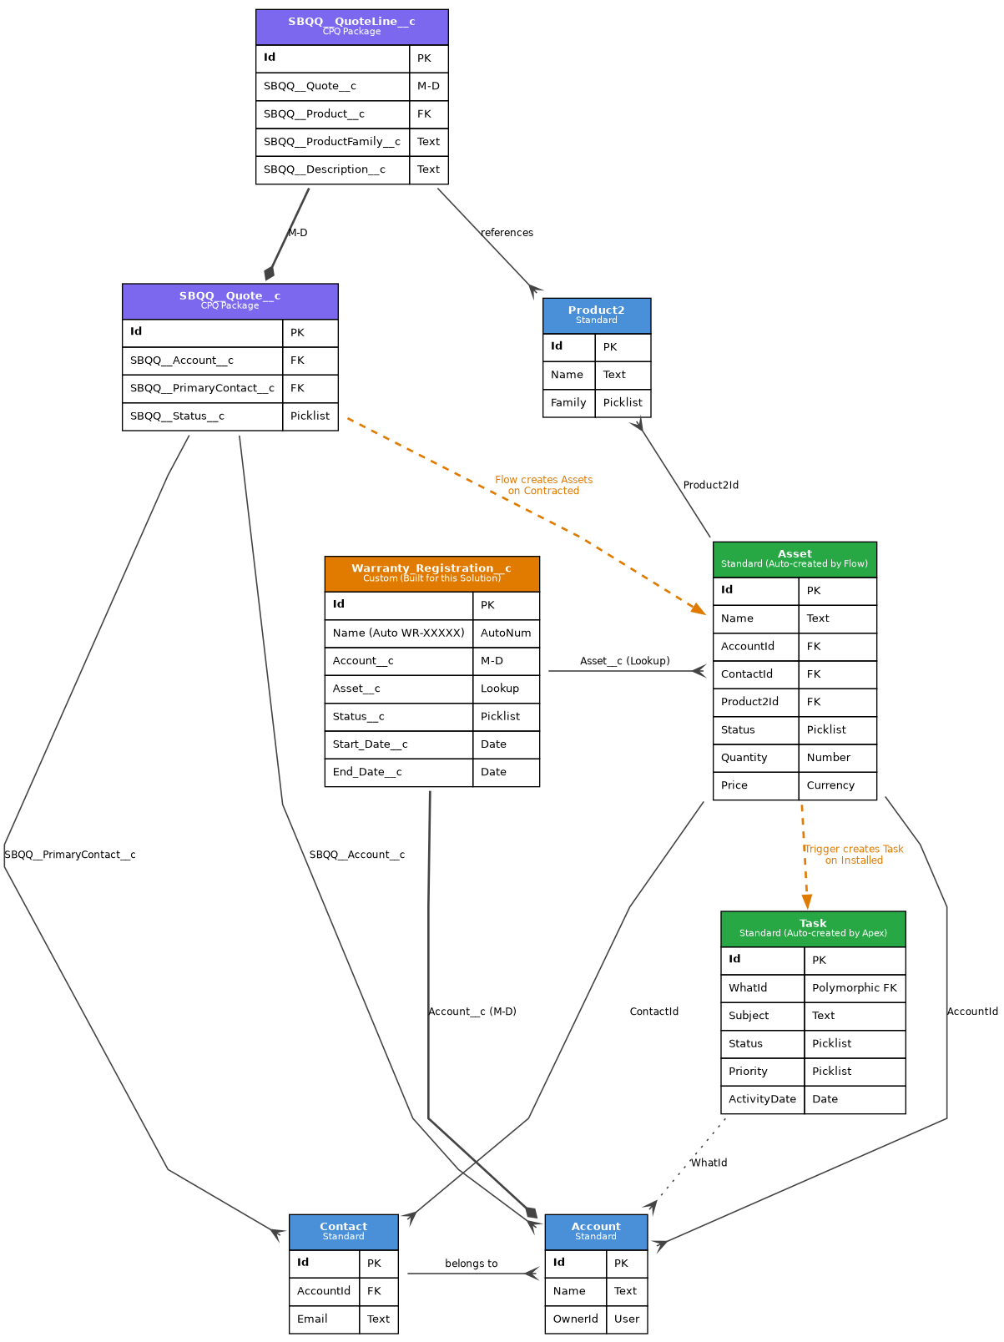

Legend
- Blue boxes: Standard Salesforce objects (Account, Contact, Product2).
- Purple boxes: Salesforce CPQ managed package objects (SBQQ__*).
- Green boxes: Standard objects auto-populated by this solution (Asset, Task).
- Orange box: The single custom object built for this solution.
- Diamond endpoint: Master-Detail relationship.
- Crow's foot endpoint: Lookup relationship.
- Orange dashed line: Automation creates the related record (not a stored FK).

3. Custom Object: Warranty_Registration__c
Single new custom object. Auto-Number Name (WR-00001 format). Sharing: ControlledByParent (Account).
Field Label | API Name | Type | Notes
Account | Account__c | Master-Detail(Account) | Required. Drives ControlledByParent sharing.
Asset | Asset__c | Lookup(Asset) | Delete behavior: SetNull. Optional at creation.
Status | Status__c | Picklist (restricted) | Draft (default), Active, Expired.
Start Date | Start_Date__c | Date | Required when Status = Active (via VR).
End Date | End_Date__c | Date | Must be > Start Date (Validation Rule).

Validation Rule
End_Date_After_Start_Date — fires when End Date is on or before Start Date.
AND(NOT(ISBLANK(Start_Date__c)),
NOT(ISBLANK(End_Date__c)),
End_Date__c <= Start_Date__c)

Why Master-Detail to Account
A warranty has no business meaning without an Account — it is a child record by definition. Master-Detail provides automatic cascade delete, ControlledByParent sharing inheritance (Community users see their own warranties without separate sharing rules), and rollup summary fields are available if needed. Lookup would have allowed orphan warranties, which the domain model does not permit.

Why Lookup (not Master-Detail) to Asset
A warranty registration record is meaningful even after the Asset is retired or deleted (audit/historical use). Master-Detail to Asset would cascade-delete the warranty when the Asset is gone, losing audit history. Lookup with SetNull preserves the warranty record. The relationship to Account is what controls sharing and ownership.

4. Key Relationships Explained

Quote → Asset (Automation, not FK)
The Asset is NOT directly related to the Quote via a foreign key. The Record-Triggered Flow creates Asset records when the Quote is Contracted, mapping fields from the Quote Line to the Asset. The relationship is procedural (automation creates the record), not structural (no stored Quote_ID field on Asset). If audit linkage is later required, a Source_Quote__c lookup field can be added.

Asset → Task (Automation, not FK)
Similarly, the Task is not stored as a child of the Asset. When the Apex Trigger detects Asset.Status changing to Installed, it creates a Task with WhatId = Asset.AccountId. The Task is related to the Account, not the Asset, because the Account Owner needs to coordinate onboarding across multiple assets.

Asset.ContactId: Why It's Set
Discovered during Community testing. With only AccountId set, customer users could READ the asset via Sharing Set, but could not WRITE related records because cross-reference checks require both Account AND Contact paths in Customer Community Plus licensing. The Flow now sets Asset.ContactId from SBQQ__PrimaryContact__c on the Quote. Beyond the bug fix, this is the correct domain model: "this contact at this customer owns this asset."

