**Wireframe**

**Customer Personality Anlysis**

Revision Number – 1.0

# Last Date of Revision: 11 – 5 -2024

Harshal K Zarikar

**Document Version Control**

|  |  |  |  |
| --- | --- | --- | --- |
| Date | Version | Description | Author |
| 11– 05 - 2024 | 1.0 | First Draft | Harshal Zarikar |

Contents

1. Landing Page
2. Prediction Results

**1.Landing Page**

Customer Personality Analysis Homepage is deployed using flask framework. Landing Page have 6 features Income, Age, relationship status, No of Children, education level, total number of purchases and total expenses and segment button to classify to which cluster he belongs.

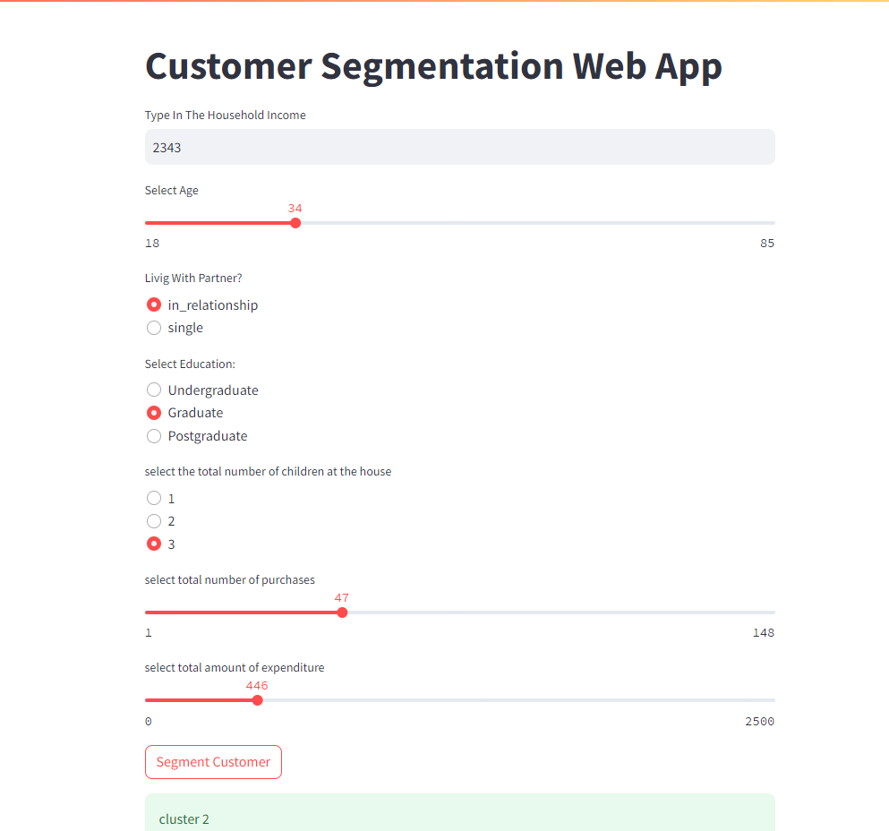

**2.Prediction Results**

User provides all the information and then clicks on segment cluster data button. The results displays the cluster number .

