**SMARTINTERNZ INTERNSHIP DOCUMENTATION**

**PROJECT TITLE:**

**UNLEASHING THE POTENTIAL OF OUR YOUTH:A STUDENT PERFORMANCE ANALYSIS**

**Team ID:LTVIP2023TMID07531**

**Team Size: 3**

**Team Leader:N.Harsha Moulika Team Member:N.Swetha Team Member:P.Ganesh Faculty Mentor:Y.Sravani**

**S V College Of Engineering,**

**Kadapa.**

# INTRODUCTION

* To realize the change, they are aspiring for, young people must take the lead, be change agents and bring about change for themselves and society. For that to happen, young people’s potential must be identified, unleashed, and nurtured.
* Have an open mind and strive towards lifelong learning. Unleashing potential requires an open mind, which allows possibilities for immersing into new territories, and uncomfort zones, accepting criticisms, and becoming vulnerable in complex and challenging terrain.
* Taking Risks and having grit (perseverance).Taking risks is one of the most frightening things one can endure. However, the most successful individuals are those who take risks and have the grit or courage to bounce back after unsuccessful attempts.
* Stay consistent and disciplined.Unleashing potential demands consistency in one’s actions, behavior, and attitude. Consistent is imbued with elements of self-discipline, which is not extrinsically but intrinsically driven.
* The academic performance of student is usually stored in various formats like files, documents, records etc. The available data would be analyzed to extract useful information. It becomes difficult to analyze student data by applying statistical techniques or other traditional database management tools.

# VISUVALIZATION

## 1.Introduction to Data Visualization:

* Data visualization involves presenting information and data in a graphical format.
* Utilizing visual elements like charts, graphs, and maps, data visualization tools offer an accessible way to interpret trends, anomalies, and patterns within data.
* It serves as a valuable tool for presenting complex data to non-technical audiences in a clear and comprehensible manner.

## Importance in Data Analysis:

* In the era of Big Data, data visualization tools and technologies are indispensable for analyzing vast datasets and facilitating data-driven decision-making.
* These tools help distill massive amounts of information into meaningful insights.

## Variety in Graphs and Parameters:

* The project employs diverse graphs plotted with various parameters tailored to distinct contexts.
* These graphical representations enhance understanding and provide a visual perspective of the data's narrative.

## Visualization in Action:

* The project showcases a compilation of visualizations, stories, and dashboards.
* These components synergistically explain and present the data analysis process and its outcomes.
* For a comprehensive overview, the provided demonstration link offers detailed insights into each plot, story, and dashboard.

**Technical Architecture:**

-*-{* ? • ···---IBM •



',.-

Iii

= 111 ,

··--Cognos

II Analytics

* ···---IBM



•

·- Cognos

·-Analytics

**Applications Required:**

IBM Cognos Analytics Workbench:

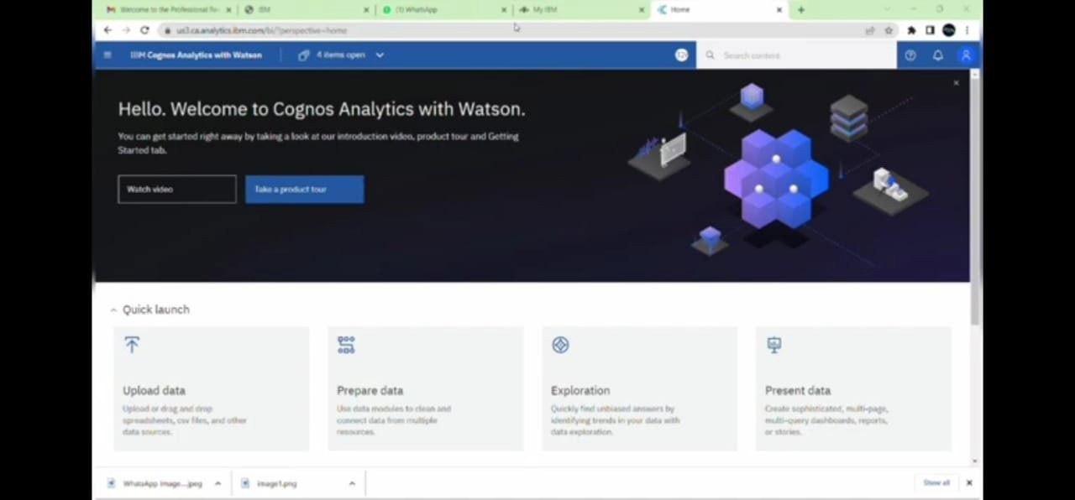

# DATASET

* Dataset plays a major role in doing Exploratory data analytics.
* To have a better result in your analytics, we should have the dataset to be cleaned. Cleaned in the sense, the data should not contain any noises in it. ➢ I have Took the dataset from an Kaggle Website.

DATA INFORMATION

Gender: sex of students -> (Male/female)

Race/Ethnicity: ethnicity of students -> (Group A, B, C, D, E)

Parental level of Education: parents final education ->(bachelor’s degree, some college, master’s degree, associate’s degree)

Test Preparation Course: complete or not complete before test.

# GRAPHS AND PLOTS DATA VISUVALIZATION

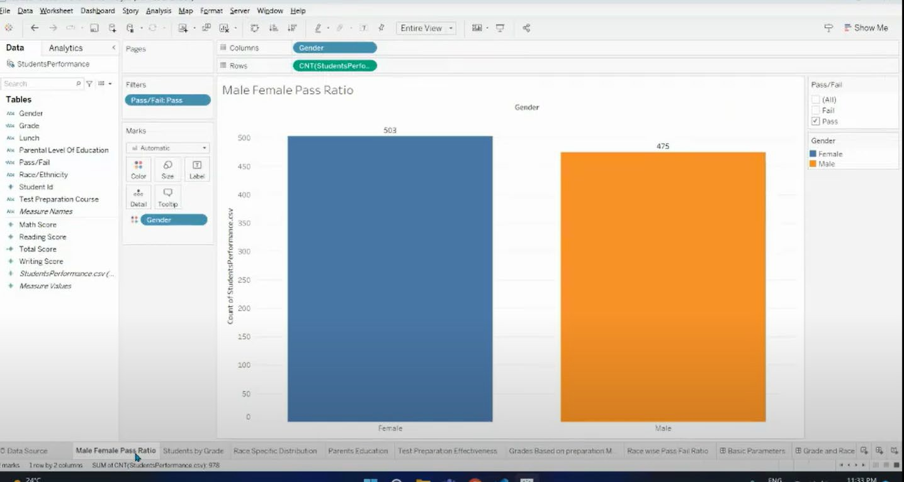**Male Female Pass Ratio**

* + Here in this we are using the Bichartgraph
  + Plotted a graph between Gender and Count.
  + Female pass ratio are 503
  + Male pass ratio are 475
  + That means 28 more females

## Students by Grade

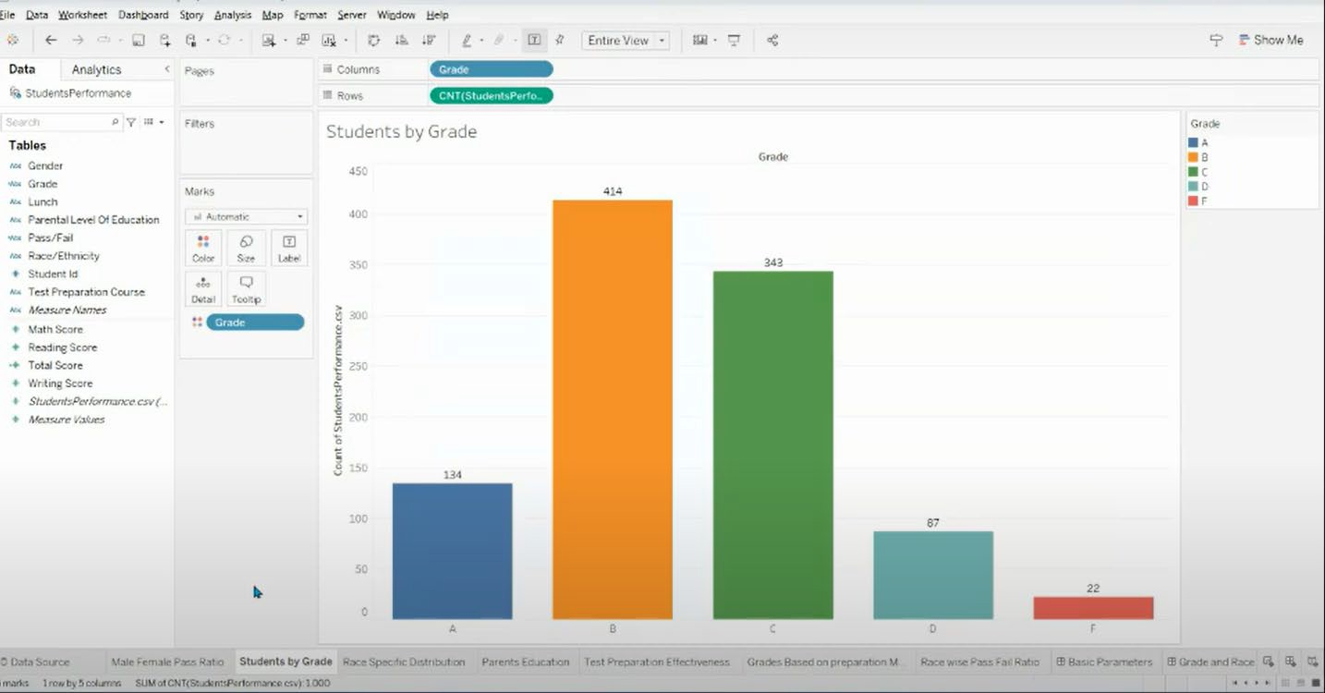

* Grade ranging from A to E.
* And counts of students performance
* 134 students score grade A
* 414 students score grade B.
* 343 students score grade C.
* 87 students score grade D.
* 22 students score grade D.
* Majority of students score grade B

## Race Specific Distribution

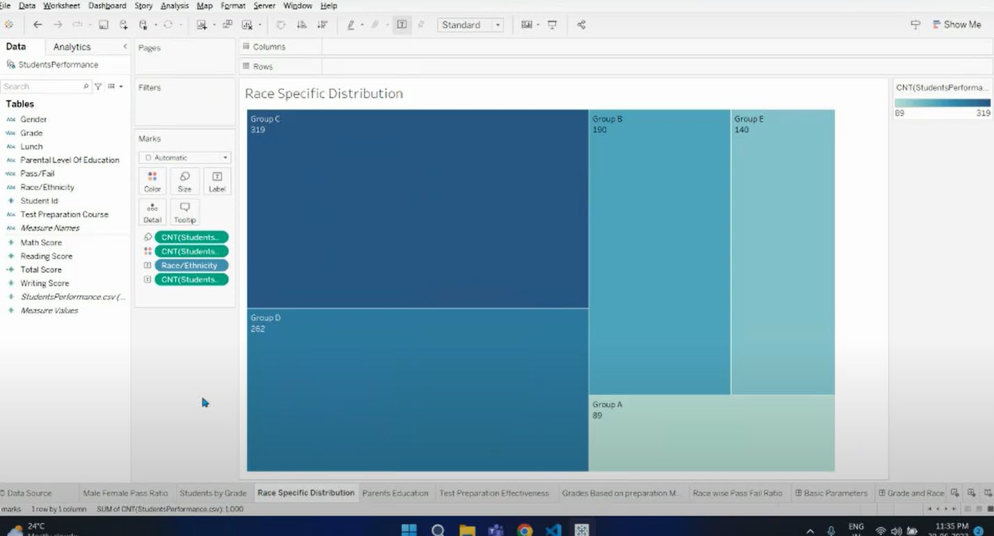

* + Here,Groups from A to E.
  + Maximum group of C Race-319 after that D-262,B-190,E-140,A-89

## Parent Education

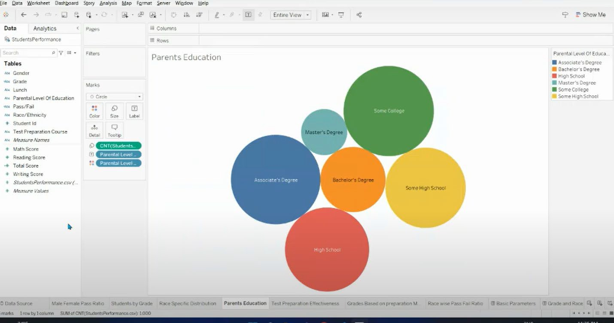

* Sort bubble visuvalization about Parent Education
* Largest number of parents are from college

## Test Preparation Effectiveness

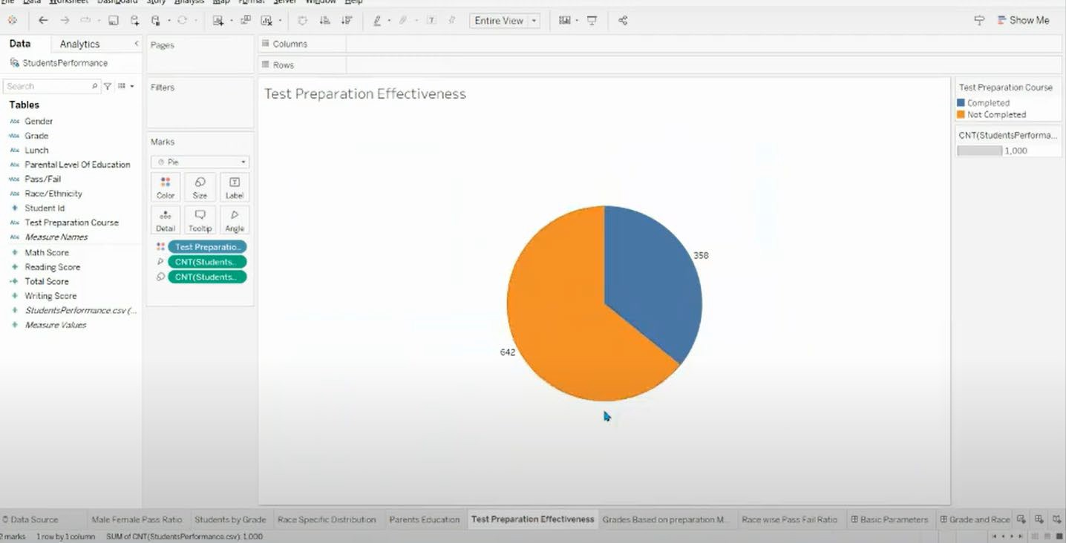

* The score of student whose parents possess master and bachelor level education are higher than others.
* Test preparation course is shows how many fileds of students is completed or not completed.

## Grade Based on Preparation Material

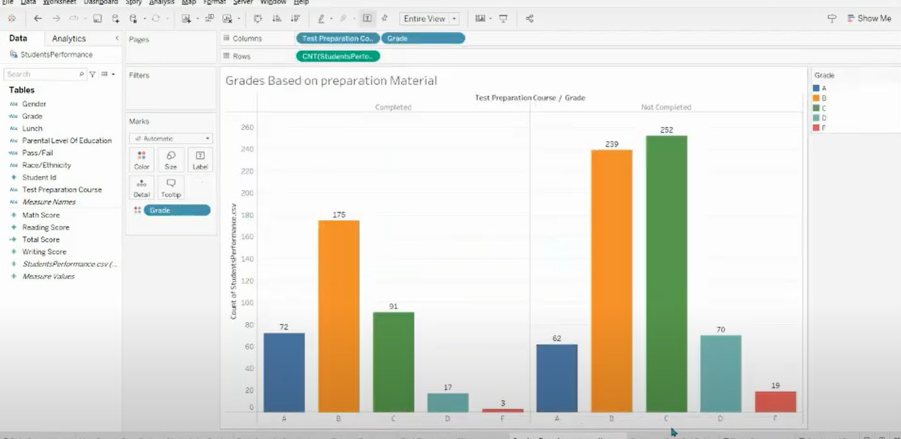

* The grade B having majority of students scored
* The fail percentage is 3% fail.who are completed there preparation with help of materials.
* The students who are not completed preparation with materials the all are score majority of grade C and B.
* The fail percentage is more 19%.

## Race wise Pass Fail ratio

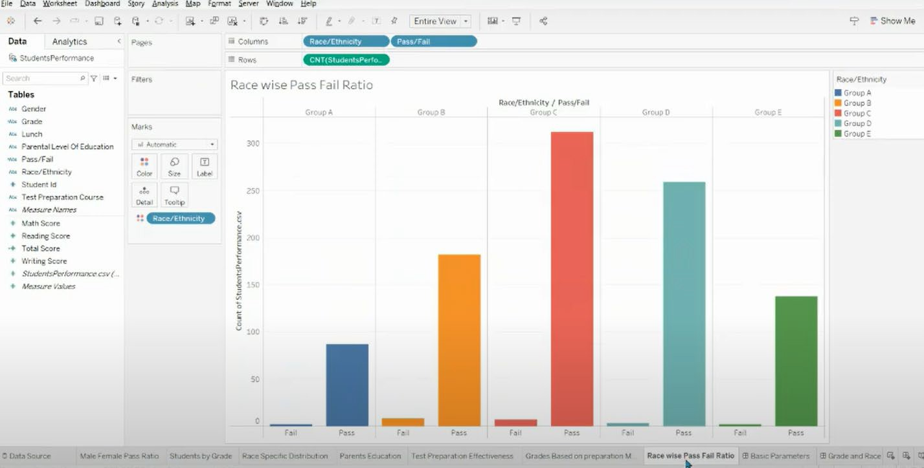

* + Here we having a G-A,G-B,G-C,G-D,G-E.In this all most all the students having a majority of pass percentage in the race wise,less fail percentage.

# DASHBOARD

A dashboard in Tableau is a versatile tool that facilitates the simultaneous comparison of various data views.

## Purpose and Usage:

* + Dashboards allow users to consolidate multiple visualizations into one display for effective data exploration.
  + Instead of navigating to separate worksheets, users can access a collection of views all at once within a dashboard.
  + Useful for regularly reviewed sets of views, streamlining analysis routines.

## Access and Connection:

* + Dashboards are accessed from tabs at the bottom of a Tableau workbook, similar to how worksheets are accessed.
  + Data in both sheets and dashboards are interconnected. Changes made in one affect the other.
  + Modifications to sheets or dashboards reflect the latest available data from the connected data source.

## Features and Components:

* + Dashboards offer various features to create charts and visuals, enhancing data representation.

## Filters:

* + Filter actions allow users to refine displayed data, focusing on specific information.
  + Filters assist in presenting valuable insights by trimming down data to userdefined criteria.
  + For instance, a filter can be employed to show data related to a particular district rather than an entire state or region.

## Highlight Actions:

* + Highlight actions direct attention to specific data points, emphasizing them while dimming others.
  + Users can execute highlight actions in different ways, such as using legends, highlighter, or advanced actions.
  + This feature is helpful for pinpointing significant data points within a visualization.

## URL Actions:

* + URL actions enable hyperlinks to external web pages or embedded web elements within the dashboard.
  + Useful for seamlessly integrating additional information from external sources directly within the dashboard.

Basic Parameters

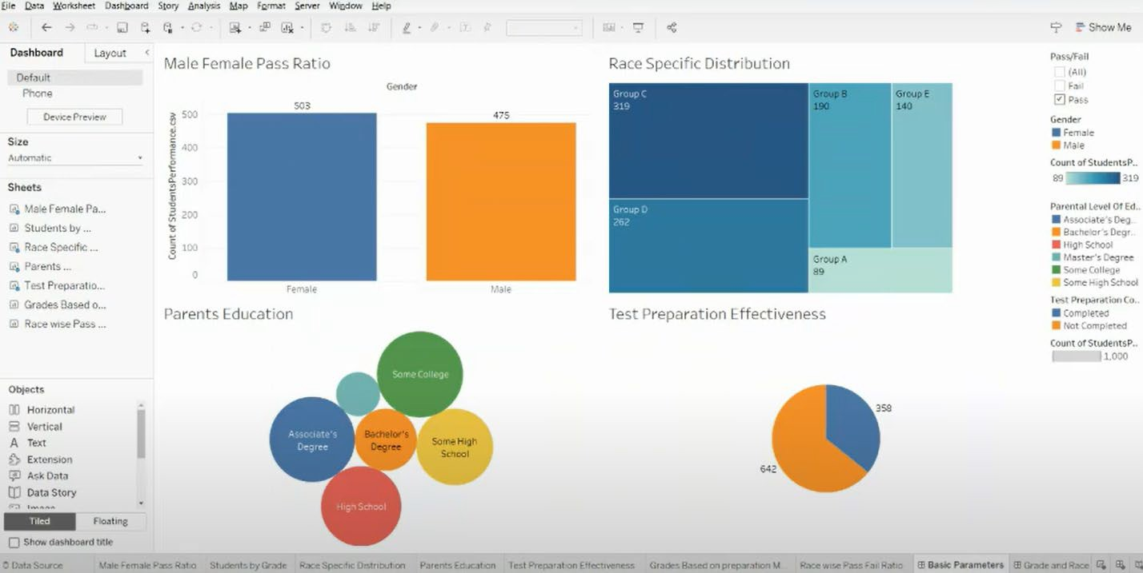

Grades & Review Analysis

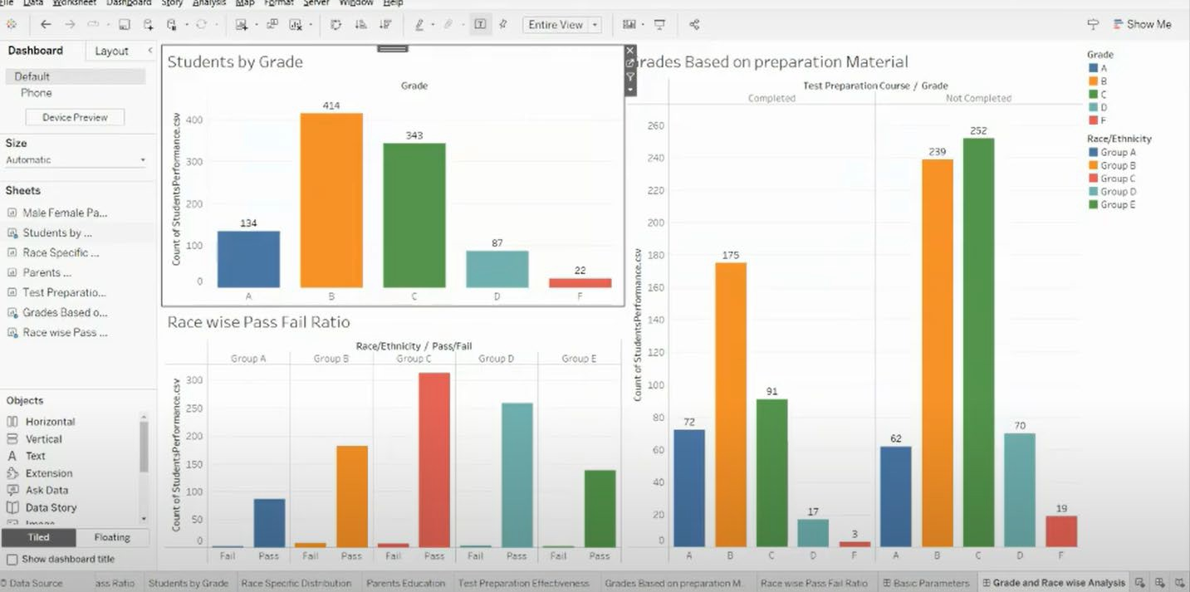

# STORIES

## Story:

* + A story in Tableau is a cohesive sequence of interactive visualizations and dashboards that are combined to convey a data-driven narrative. It allows

users to present and share insights effectively by structuring a series of visual elements that guide viewers through a data analysis process.

* + A story typically includes multiple sheets, dashboards, and sometimes textbased explanations to provide context and interpretation. This arrangement aids in highlighting patterns, trends, and relationships in the data.
  + The interactive nature of a Tableau story empowers users to engage with the visualizations, enabling a comprehensive understanding of the data story being presented.
  + A story is a sheet, so the methods you use to create, name, and manage worksheets and dashboards also apply to stories (for more details, see workbook and sheets).

# STORY SCREENSHOTS



**ABOUT US**

Wel(ome to "Unteash1ng the Pote?mlal of Our Youth: A Student Performance Analysis! we are passionate t11bou1 understanding and ma:.:imizlng trie educational ov1eomes of our youtn. our mission is lOprO\l'icie valvabre Ins-gr.ts and visualilations that 'Shed light on 1he performance and achievements of studems across various demograpnics

We believe m the power of data to uncover patterns and correlations. enabling us to make Informed decisions and take targctl'd actions 10 enhance student success. In this analysis. we focus on S<''.lera1 key aspects *of* s.tudent perlormanc,e, to gain *a*

comprehensive understanding or their educauonal journey.

**TABLEAU STORY**

Student Performance Analysis

I < ·o e"·- :

>

Jr.,."TI' •::

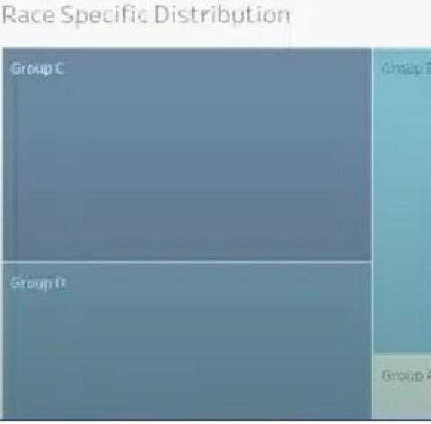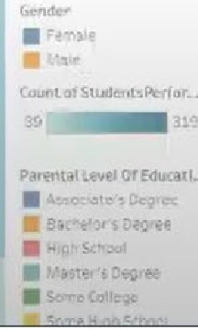

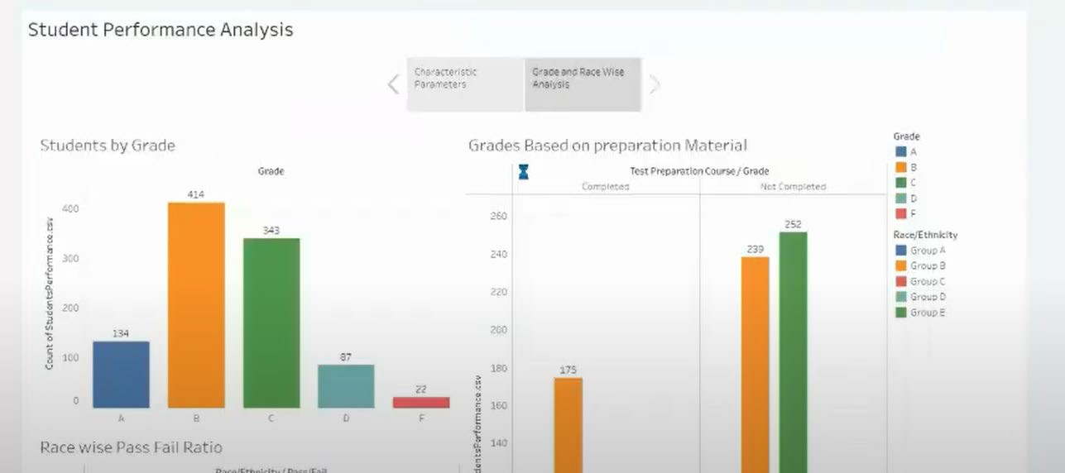

# CONCLUSION

This analysis has taught us that,factors such as parental level of education, socioeconomic disadvantage, test preparation courses affect the students performances in the exams. But there are many exceptions as well. There are students with a low parental level of education scoring full marks. Also, some students have not completed the test preparation course getting full marks. These

students may have their own strategies for test preparations. Socioeconomic disadvantage also has many exceptions. These students did not allow economic obstacles to affect their efforts. So, many factors are affecting the students’ performances. Some have great effects while some not. Also, there are other factors to be considered as well which are not mentioned in the dataset. Factors such as facilities at school, the quality and methods of teaching, peer pressures, hours spent studying, diets, sleeping patterns etc. Such factors also affect the performance of the students.