DESIGN AND ANALYSIS OF ALGORITHM

Dynamic programming in a heuristically confined state space: A stochastic resource-constrained project scheduling application

Ahalyanjuna (22PD02)  
Dharani (22PD11)  
Harshan M V(22PD14)

Resource Constraint Project Scheduling Problem(RCPSP) helps us to address the uncertainties in task duration, costs and the results of the task using discrete time Markov chain which enables us to model probabilistic correlation of the uncertain parameters. Here we take M projects into considerations with each project consisting of a sequence of tasks that has to be carried forwarded to complete the project as a whole. Each of the task has the result (F,S1,S2,…), cost, time to complete the task. There exist probability to transition from one state to another. One significant consideration is the immediate adjacent jobs taken into account.

An heuristic approach is undertaken to select the path, that is, the sequence of tasks that has to be undertaken to complete the task.

Libraries/frameworks and components used:

numpy, HTML,CSS

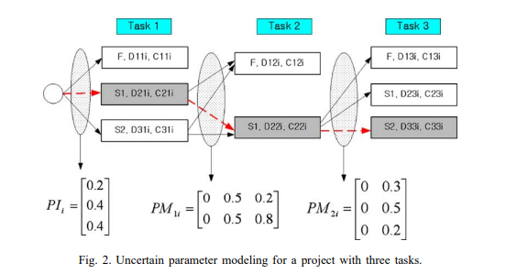

Dynamic programming formulation:

The project provides a dynamic programming-based solution to optimize task scheduling within a set time limit, accommodating uncertainties in task success rates, costs, and durations. Each task is characterized by its probability of success, cost, and expected duration.

The scheduling algorithm uses a heuristic policy to simulate potential task outcomes, creating a confined state space that reflects probable execution paths. Within this confined space, the dynamic programming approach calculates an optimal schedule by maximizing rewards in a tabular structure, balancing the likelihood of task success against associated costs.

Through backward iteration, the scheduler determines the sequence of tasks that achieves the highest reward within the time constraint. This produces an optimal task execution plan, selecting tasks based on priority, while adhering to resource and time limitations. The final output is an optimized schedule that aligns with task priorities and constraints, ensuring the best possible outcome given the uncertainties involved.

Conclusion and Future scope:  
The complexity of the problem can be extended further by considering all possibilities instead of the immediate jobs. This requires a more sophisticated approach since we have to implement an algorithm that involves a heuristic search that reduces the size of the search space/ state space.