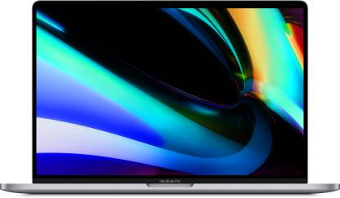

**Name** Apple mac book pro

**Brand** Apple

**Colour** Space Grey

**Memory** 16 GB

**Storage** 1 TB

**Screen** 16-inch

**Display**

**Battery Life** Upto 16 hours

**Processor** Intel Core i9

**Generation**  9

**Operating** mac0S

**System**

**PRICE­­­­ : 2,22,810**

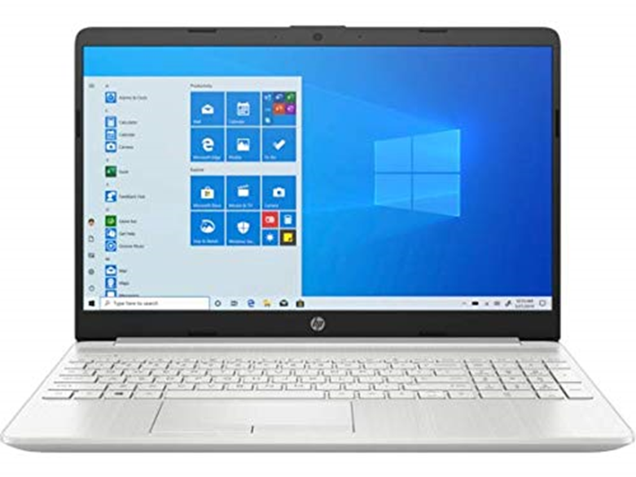

**Name** HP 15s Ryzen 3

**Brand** HP

**Colour** White

**Memory** 4GB

**Storage** 512GB

**Screen** 15.6 inch

**Display**

**Battery Life** Upto 13 hours

**Processor** AMD Ryzen R3-2200U

**Generation**  3

**Operating** Windows 10 OS

**System**

**PRICE :** 41,990

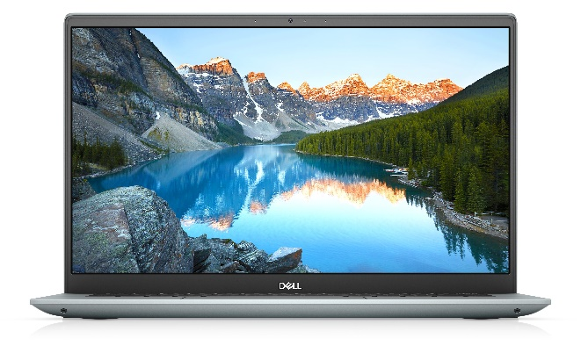

**Name** DELL INSPIRON 5401

**Brand** DELL

**Colour** Natural color

**Memory** 16GB

**Storage** 512GB

**Screen** 14 inch

**Display**

**Battery Life** 9 hours

**Processor** intel core i7

**Generation**  11

**Operating** Windows 10 OS

**System**

**PRICE :** 85,861



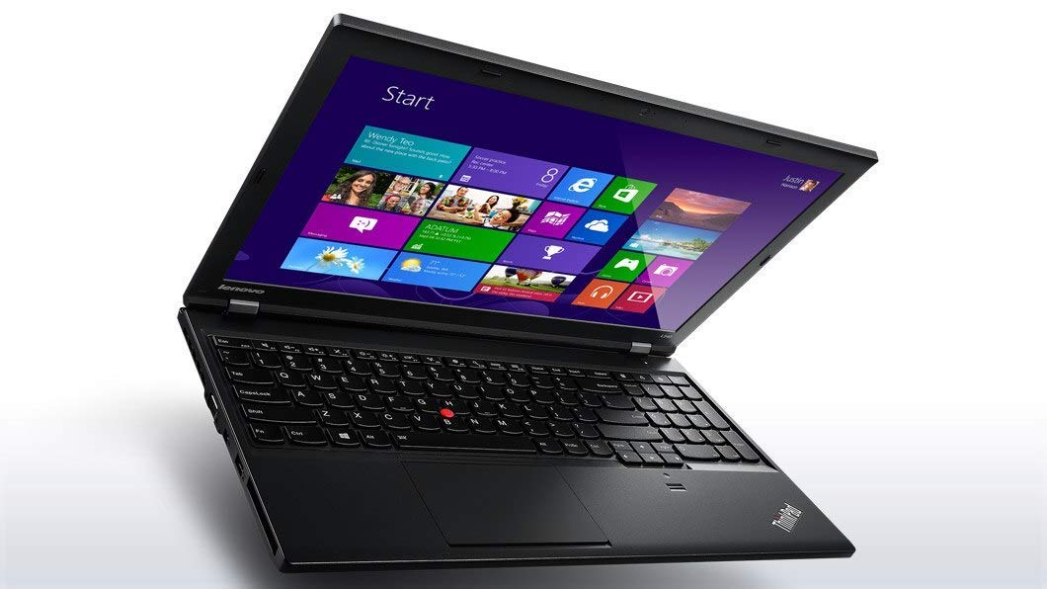

**Name** Lenovo ThinkPad E15

**Brand** Lenovo

**Colour** Black

**Memory** 4GB

**Storage** 256 GB

**Screen** 15.6GB

**Display**

**Battery Life** 14 hours

**Processor** Intel Core i3

**Generation** 11

**Operating** Windows 10

**System**

**PRICE: 44,990**