**1 Introduction**

In today’s global landscape, the process of making informed business decisions has become increasingly complex, particularly when it comes to analyzing sales data. Sales represent a critical component of any business’s success. Therefore, it is essential to leverage data to gain insights into sales performance (Shubho et al., 2022). The advancement of technology is enhancing the ability of organizations to achieve better outcomes while utilizing fewer resources (Kumar et al., 2022).

Business Intelligence and Analytics (BIA) encompasses the creation of technologies, systems, methodologies and applications aimed to analyze crucial business data so as to derive meaningful insights regarding business operations (Lim et al., 2013). The potential benefits derived from data and analysis across various organizations have generated significant interest in Business Intelligence and Analytics (BIA). This focuses on examining essential business data, enabling enterprises to gain deeper insights into their operations and market dynamics, thereby facilitating timely and informed decision-making (Chen et al., 2012).

The domains of Business Intelligence (BI) management, scope, data quality and data visualization exhibit significant relationship with the quality of strategic decision-making. The implementation of effective BI management practices enhances the quality of decision-making, underscoring the importance of managing BI resources effectively. Furthermore, both data quality and data visualizations play a crucial role in influencing the quality of decision-making. The utilization of advanced visualization tools, coupled with the assurance of high quality data, lead to improved outcomes in decision-making (Abu-Alsondos., 2023).

Business owners must consider all relevant factors during the decision-making process as there is a significant rise in business strategies and data management. This situation underscores the necessity for a tool that effectively measures and monitors business growth. The performance dashboard serves as a tool for information management, enabling the monitoring of metrics, Key Performance Indicators (KPIs) and other essential elements relevant to the business or specific process. A dashboard simplifies complex data, enabling users to monitor current performance through the utilization of data visualizations (Kumar and Belwal., 2017).

Key Performance Indicators (KPIs) serve as essential metrics that facilitate data-driven decision-making processes. This is crucial in enhancing the overall manageability of the organization (Westin., 2024).

Key Performance Indicators (KPIs) plays a crucial role in assessing performance within the industry. They serve as tools for highlighting areas for potential enhancement by recognizing poor performance. Various aspects of performance can be evaluated through KPIs (Lindberg et al., 2015).

Key Performance Indicators (KPIs) encompass both financial and non-financial metrics that organizations employ to assess and enhance their success in relation to their long-term objectives. Appropriate selection of these indicators is of at most importance for effective performance (Teau and Protopopescu., 2015).

Data visualization plays a crucial role in the process of data analysis, as it facilitates a clearer understanding of the data in a manner that is engaging, straightforward and accessible to all individuals, regardless of language barrier. Additionally it allows for the efficient representation of large datasets within a compact format. Microsoft Power BI is a widely recognized tool for data analysis, offering innovative methods for visualizing information (Singh et al., 2023).

Data visualization aims at enhancing the significance of data through visual representation. By utilizing data visualization software, individuals can more readily identify patterns, trends and correlations that may remain undetected in text based data. Essentially, data visualization involves the graphical representation of quantitative information, transforming both extensive and limited datasets into visual formats that facilitate easier understanding for the human brain. Properly executed data visualizations provide essential insights into complex datasets, presenting them in a meaningful manner (Islam and Jin., 2019).

Power BI has significantly transformed the landscape of business intelligence, data visualization and analytics. This platform facilitates the exploration, transformation, visualization of data through reports and dashboards, which can be shared among users within the same organization or across different entities. Power BI has emerged as a great option for business intelligence solutions, particularly for small and medium-sized enterprises. Once a dataset is uploaded to Power BI, users can generate multiple reports with a single click, leveraging the platform’s automated data analysis capabilities, thereby minimizing the need for human intervention. This automation also contributes to a reduction in human errors associated with calculations and statistical methods (Krishnan., 2017).

Several research investigations have shown that Business Intelligence (BI) systems significantly improve decision-making processes in a range of industries. For instance Dewan et al., (2023), “developed a dynamic dashboard using Microsoft Power BI, specifically designed to address the distinct requirements of small businesses which enhanced the evaluation of operational processes and facilitating informed decision-making”. Similarly Al-Kassab et al., (2014), “aims to demonstrate the significance of visualizing the performance information for a leading European apparel retailer, highlighting its essential role in enhancing business decision-making”. The findings of Yigitbasioglu and Velcu-Laitinen (2012) suggests that “dashboards are regarded as valuable tools in performance management, serving not only to track individual performance but also to facilitate various other purposes, including communication”. The results of Destiandi and Hermawan (2018) says, ”Academic assessments can be displayed through a dashboard that facilitates decision-making processes and provides information required to make key results”. The findings from these studies collectively highlight the benefits of BI tools in facilitating managerial decision-making across various contexts.

This study focuses on the development of a Sales and Marketing Analytics Dashboard System by using Power BI, a prominent Business Intelligence (BI) platform recognized for its intuitive interface and robust analytical features. This study seeks to develop an interactive dashboard system by leveraging data of an EU Superstore obtained from Google Dataset Search. The dashboard is designed to aggregate and visualize sales and marketing data in real time while providing customization options that enable users to alter the dashboard to their individual needs.

**1.1 Research Objectives**

The research aims to address the following objectives:

* **To develop an engaging and user-friendly dashboard system capable of aggregating, analyzing and visualizing Sales and Marketing data in real time**

This objective aims to develop a dashboard system that facilitates an intuitive user experience through a well-structured and adaptable interface. This system must enable users to effortlessly navigate through various sections, while ensuring that the visual representations are clear and precise. The dashboard must allow users to track sales and marketing performance with minimal training or technical knowledge.

* **To provide customization features within the dashboard, allowing users to adjust the visualizations, metrics and Key Performance Indicators (KPIs) in accordance to their needs and objectives**

This objective aims to offer customization of the dashboard to the users based on their requirements. Users should have the capability to choose and alter the Key Performance Indicators (KPIs), modify the time periods, filter data across various dimensions such as City, Product Category, Segment and customize the visual representations to correspond with their objectives.

* **To evaluate the effectiveness and efficiency of the Sales and Marketing Analytics dashboard system in meeting stakeholder requirements, while enhancing data-driven decision-making**

This objective aims to perform a comprehensive evaluation of the dashboard system’s performance, focusing on its capacity to deliver precise and actionable insights that improve decision-making processes. The assessment will incorporate user feedback regarding the usability, effectiveness and overall satisfaction with the dashboard system.

* **To explore and apply various data visualizations within the Power BI platform that improve the clarity of sales and marketing data**

This objective aims to emphasize the application of creative visualizations including heat maps and gauge meter to convey complex data in a more comprehensible and significant manner.

**1.2 Research Questions**

**Question #1**

What techniques can be employed to develop an user-friendly and engaging dashboard system utilizing Power BI for the efficient analysis and visualization of sales and marketing data?

**Question #2**

What customization options should be integrated into the dashboard to enable users to adjust visual representations, metrics and Key Performance Indicators (KPIs) in alignment with their objectives?

**Question #3**

How does the development of Sales and Marketing Analytics Dashboard System improve decision-making efficiency?

**Question #4**

What are the key elements that affect user satisfaction regarding the Sales and Marketing Analytics Dashboard System?

**1.3 Research Limitations**

* **Data Quality and Availability**

The dataset used for this research has been obtained from Google Dataset Search which is publicly available. Therefore, there is a possibility of poor quality and incompleteness of the data which could lead to inaccurate analysis of the data.

* **Complexity of Customization**

Although customization serves as a primary goal of the dashboard, excessive customization options may lead to increased complexity , thereby hindering users’ ability to navigate and understand the system effectively.

* **Technological Constraints**

Power BI requires a Microsoft work or school account for the purpose of sharing reports with others or publishing to web. If users do not have permissions, the admin must grant access to the dashboard. This requirement may limit the ease of sharing among users.

Chapter one presents an overview of the application of Business Intelligence (BI) and BI tools, especially Power BI, in enhancing the decision-making process. It also gives a brief introduction to the role of dashboards, key performance indicators and visualizations of data. This chapter identifies the research objectives and questions, focused on the development of the sales and marketing analytics dashboard. Additionally, the chapter addresses the limitations of the research.

The second chapter explores the existing literature about the role of data analytics in sales and marketing, the role of business intelligence tools, especially Power BI, in strategic decision-making processes. This chapter also discusses about the dashboard and the evolution of the Business Intelligence (BI) tools. Previous work related to sales dashboard using Power BI is also presented.

In third chapter, a detailed methodological framework has been discussed to create an user-friendly and analytical dashboard. This methodological framework includes the process of data collection, data cleaning and visualization of data through the use of Power BI.

The fourth and the final chapter provides a comprehensive analysis of the Sales and Marketing Analytics dashboard using Power BI, highlighting its effectiveness in delivering actionable insights to Sales, profit and returns. The analysis also elaborates the function of dashboard in facilitating effective analysis through visualizations

**2 Literature Review**

**2.1 Introduction**

This literature review presents an extensive overview of the background, previous research and studies related to data analytics of sales and marketing, emphasizing the significance of the dashboard systems and data visualization techniques. This section aims to explore the effectiveness of data analytics tools like Power BI and the significance of data visualizations in sales and marketing.

Data Analytics and Business Intelligence (BI) has become a significant area of research, highlighting the impact of data-related problems to addressed in business organizations (Chen et al., 2012).

Business Intelligence (BI) tools transform data into actionable insights and intelligence. Power BI offers advanced data analytics and reporting functions. Real-time reporting is a key feature of Power BI. This significantly enhances the ability of an organization to make informed strategic decisions (Zadeh et al., 2020).

**2.2 Role of Data Analytics in Sales and Marketing**

According to Davenport and Harris (2017), analytics mean the extensive use of data, statistical and quantitative analysis, explanatory and predictive models and fact-based management to drive decisions and actions.

Data Analytics, prescriptive and predictive analysis are powerful tools that can improve sales performance. These are very valuable to broadly transform sales performance in all functional areas of an organization (Dearborn., 2015).

Baier et al., (2012) described a quantitative analysis and optimization methodology designed to improve the performance and productivity of the IBM global sales force. The analytical methods implemented optimize the sales capacity and profitable sales growth (Baier et al., 2012).

Wedel and Kannan., (2016) provided a critical examination of marketing analytics methods and their potential to support marketing decisions. The significance of marketing analytics has become increasingly prominent within the industry, leading to a need for new, powerful metrics, as well as advanced analytical techniques, to enhance the efficiency and effectiveness of data-driven marketing practices (Wedel and Kannan., 2016).

Hallikainen et al., (2020) investigates the impact of customer big data analytics on the performance of the sales growth and customer relationships. The use of data analytics significantly promotes the sales growth, leading to improved financial results, while also strengthening the performance of customer relationship, which reflects non-financial outcomes.

**2.3 Power BI and the evolution of BI tools**

Sharma and Djiaw., (2011) explores the role of Business Intelligence (BI) tools in facilitating knowledge sharing among employees with an organization. Business Intelligence (BI) is an essential process for enhancing the performance of an organization. It facilitates the identification of a firm’s knowledge assets and highlights the gaps with respect to its environment (Sharma and Djiaw., 2011).

According to Tvrdikova (2007), Business Intelligence (BI) tools facilitate acquiring, management, sharing and delivery of high-quality data. The integration of Business Intelligence (BI) solutions into comprehensive information system enhances the efficiency and quality of work across all the departments engaged in the decision-making process at every organization level. This integration provides increased user confidence in the reliability of data and improves the effectiveness of support units, ultimately leading to the development of innovative solutions (Tvrdikova., 2007).

From Hall (2000), it can noted that organizations aim to seek the data intelligently in order to create business intelligence that can enhance future profitable opportunities.

Power BI is a Software as a Service (SaaS) offered in Azure cloud, which is a powerful business intelligence and analytics platform for visualizing data and discover insights from the data through modelling and visualizations (Knight et al., 2018).

The Power BI experience focuses on extracting insights from the data. It commences with the selection of the dataset, followed by the development of reports based on the data and ultimately organizing the visual representations of these reports within a dashboard (Ferrari and Russo., 2016).

**2.4 Data Visualizations**

In discussing about the data visualizations, it can be inferred from Bhargava et al., (2018) that the process of visualizing a data set involves delivering the importance of the data and is a crucial part of data analytics, executed after the data cleaning. In recent days, data visualization has become increasingly valuable in business intelligence and analytics across various sectors (Bhargava et al., 2018).

The most common use with Power BI for users is the ability to create impactful visualizations of the data. Power BI contains a variety of visualization options. Categorical data can be visualized through Bar and column charts, pie and donut charts, scatter charts. The bar chart displays rectangular bars horizontally where the length of the bar represents the data, whereas column chart represents vertically. Both visualizations are used to compare two or more data. Both these visualizations have three different formats; first is stacked, the second is clustered and the final one is 100% stacked. Pie chart and Donut charts are used to visualize a particular segment to the whole, rather than comparing two different values. Both these visualizations are very effective in allowing interactive filtering (Knight et al., 2018).

**2.5 Dashboards**

Dashboards are the most common and popular application of data visualization techniques. Almost every industry including non-profit organization and service utilize dashboards to facilitate decision-making based on analysis (Sarikaya et al., 2019).

In recent years, dashboards have gained significant popularity as effective tool fro conveying critical information in a concise and visually accessible manner. Dashboards are significantly powerful to visually present the information quickly and clearly (Few., 2006).

A dashboard functions as a visual representation of data insights and Key Performance Indicators (KPIs) derived from various data sources. In Power BI, dashboards generally integrate various visualizations such as charts, graphs, tables and maps, all organized on a single platform to provide a comprehensive view of the data. Users have the ability to engage with these visualizations, allowing them to explore the data more thoroughly, examine particular details or apply filters according to their individual preferences (Chiar et al).

**2.6 Existing work on sales dashboard using Power BI**

Several research have explained the effectiveness of Power BI in developing sales dashboards that offer in-depth insights into organizational performance. These dashboards commonly feature visual representations including bar charts, line graphs and pie charts which assist users in tracking sales metrics and make informed data-driven decisions.

Kallel et al., (2024) created an interactive dashboard using Power BI for the sales department of a pharmaceutical lab located in Tunisia. Initially the necessary data was gathered and imported, followed by the use of Power Query Editor for data cleaning. Subsequently, all the collected data was systematically and connected through data model. This integration of data into a unified information system as data models, after importing from various sources, facilitates reporting and minimizing data redundancy. Finally, the use of Power BI is essential for the visualization of the selected Key Performance Indicators (KPIs). In summary, the resulting dashboard serves as a powerful tool for sales managers, supporting them in monitoring their sales processes to enhance overall performance (Kallel et al., 2024)

Another example is the work by Singh et al., (2022), who used Power BI as a tool in creating a dashboard for data analytics of sales data. The dashboard consists of the following pages: Homepage, Customer Analysis, Product Analysis, Sales Team Analysis and Locations Analysis. The development of the dashboard started with data cleaning using Power Query Editor within Power BI. The Home page of the dashboard was the crucial starting point for the users which provided a detailed overview of the project and the data that has been analyzed. The Customer Analysis page offers the transaction details of a company, delivering insights into customer behaviour and needs. The Product Analysis page of the dashboard displays the performance of the product that includes, sales and profit of the products, which is a crucial part of business intelligence (BI). The Sales Team Analysis page is designed to show the Key Performance Indicators (KPIs) such as the revenue generated, gross profit and others. The Location Analysis page offers insights into the performance of several store locations on the basis of the profit obtained from the sales (Singh et al., 2022).

Moreover, Yeramarus Muralidhar (2021) presented a dashboard for business oriented retail analytics data using Power BI as a platform. This analytical dashboard was created to understand the historic trend and business performance. This dashboard was created for the stakeholders to know the growing trends in the business with the help of visualizations. The development of the dashboard involved three main stages: data preparation, data modelling and data visualization. The dashboard contains five tabs: Overview, Product wise, Market wise, Geographic wise and What if Analysis. Multiple cards are used to represent KPIs like Total Sales, Total Orders, Unique Customers, Return Products and Total Profit. The desired page can be navigated with the help of a direct click on the specific tab. A filter is also provided to check year wise and manager wise insights. The data for the years 2011, 2012 and 2013 has been visualized in the dashboard (Yeramarus Muralidhar., 2021)

Kanagaraj and Venkatesh., (2023) illustrates the demonstration of a dashboard using Power BI for conducting rigorous sales research. The Key Performance Indicators (KPIs) of the dashboard includes Gross sales, total costs, average cost, marginal cost, Net sale, Profit, etc. The dashboard contains Year wise Total cost and Total profit, State/Province wise Monthly sales, Product wise sales analysis. This comprehensive research examines the historical, current and future aspects of the sales sector. It highlights the significance of business analytics in developing precisely targeted marketing strategies by integrating diverse data sources and using the Data Analysis Expressions (DAX) within the Power BI dashboard (Kanagaraj and Venkatesh., 2023).

Chiar et al developed eight dashboards including the index in the Power BI model, each designed to focus on specific type of analysis, thereby highlighting various aspects of sales. Monthly Trend Analysis, Product Analysis, Online Channel Analysis, Analysis by region, Customer Analysis, Top 20 billed customers, Top 20 Quality clients were the dashboard created. Monthly Trend Analysis is designed to offer a comprehensive overview of Frolla, facilitating a comparison between two years. Product Analysis provides analysis from product view. This is essential to understand the trends of the products. Online Channel Analysis represents the insights of online sales. Analysis by region focuses on the geographical aspect by displaying region-wise turnover by comparing two years. Customer Analysis presented explores customer behaviour by examining the quantities acquired by each customer, the revenue generated over the two-year period encompassing the previous year and current year, as well as the overall total. Top 20 billed customers provides a in-depth analysis of the top 20 customers by turnover. Top 20 Quality clients highlights the quantities purchased by the customers (Chiar et al).

**3 Methodology**

**3.1 Introduction**

Power BI provides an user-friendly interface that allows users to develop and customize visual representations effectively. Power BI exhibits significant scalability, enabling it to manage complex datasets and analytical tasks. This scalability ensures that the system can evolve alongside the requirements of the organization, effectively accommodating rising data volumes over time (Jeyaboopathiraja and Vishwaa., 2024).

The main objective of this research is to develop and execute an analytics dashboard that includes data collection, data cleaning and processing the data in a way that facilitates strategic decision-making in sales and marketing. This chapter describes the methodological framework employed to accomplish the main objective. It begins with a summary of the research strategy, followed by an in-depth description of the data collection process, data cleaning and preparation, as well as the development of visual representations using Power BI. Furthermore, this chapter will address the application of Data Analysis Expressions (DAX) calculations and techniques utilized to assess the performance of the dashboard.

**3.2 Research Approach**

This research uses a combination of both qualitative and quantitative research methods to comprehensively assess the performance and the usability of the dashboard.

**3.2.1 Quantitative Research Method**

Quantitative methods are used to examine the sales and marketing data presented in the Power BI dashboard. Through the application of Data Analysis Expressions (DAX), the research aims to measure essential Key Performance Indicators (KPIs), sales and profitability. The Quantitative analysis facilitates the identification of trends and patterns within the data, which are vital for making informed decisions.

**3.2.2 Qualitative Research Method**

Qualitative methods are used to collect feedback from users concerning their experiences with the dashboard. By conducting survey, the research aims to capture insights into user interactions with the dashboard, the challenges they faced and the overall experience with the dashboard. This qualitative data offers a comprehensive understanding of the contextual elements that affect user satisfaction and the performance of the dashboard. Qualitative analysis is also used to collect suggestions and concerns raised by the users that can be used for the enhancement of the dashboard.

**3.3 Research equipment and software**

**3.3.1 Hardware Requirement**

* **Processor:** Multi-core CPU for processing data.
* **Memory:** 8 GB RAM recommended for handling large datasets.

**3.3.2 Software Requirement**

* **Python:** A programming language used for data cleaning and filtering. Python libraries such as pandas, numpy were employed.
* **Kaggle:** An accessible online platform for running python code without local installation.
* **Power BI Desktop:** A Business Intelligence (BI) tool used for developing and designing the Sales and Marketing Analytics Dashboard.
* **Power BI Online Service:** A cloud-based platform used for sharing reports and dashboards with other users.
* **Data Analysis Expressions (DAX):** Specifically used within Power BI to create custom measures that serve as Key Performance Indicators (KPIs).

**3.4 Research Strategy**

The research strategy for developing an user-friendly and interactive Sales and Marketing Dashboard using Power BI as a platform is characterized by a structural framework. This framework is organized into distinct phases, each targeting particular aspects of the research objectives. The following is a comprehensive outline of the research strategy.

**3.4.1 Data Collection and Preparation**

The initial phase involves gathering the essential data required for the development of the Sales and Marketing Analytics Dashboard. The data collection process should be systematic, ensuring that the data is precise and relevant.

* **Data Sourcing**

The primary dataset utilized in this research is obtained through the Google Dataset Search, specific to an EU Superstore and is publicly accessible. This dataset encompasses Sales transactions, Customer Information, Product Information, Product returns, etc. The dataset must be thoroughly examined for the analysis. The dataset is available in Excel format. The Excel file of the dataset comprises of two spreadsheets: Orders and Returns.

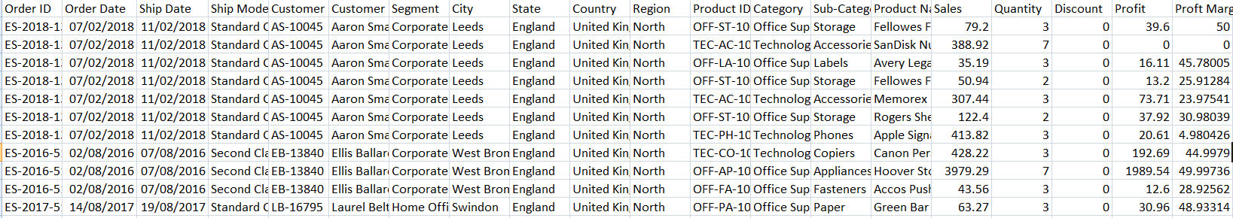

Figure Orders

The Orders spreadsheet contains Order ID, Order Date, Ship Date, Ship Mode (First class, Same Day, Second Class, Standard Class), Customer ID, Customer Name, Segment (Consumer, Corporate, Home Office), City, State, Country, Region, Product ID, Category (Furniture, Office Supplies, Technology), Sub-Category, Product Name, Sales, Quantity, Discount, Profit.

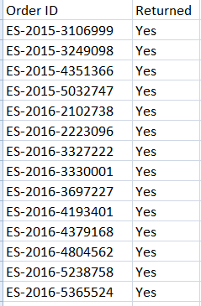

Figure Returns

The Returns spreadsheet contains Order ID and Returned (Yes or No). Given that the Order ID in Orders matches the Order ID in Returns.

* **Data Cleaning and Filtering**

Unprocessed Raw data often contains inconsistencies, inaccuracies and irrelevant information that may affect the precision of the analysis. Consequently, the data cleaning procedure is essential for maintaining the quality of the data. Within the Kaggle platform, Python will be used to implement a range of data cleaning techniques, which will include:

1. **Handling Null Values:** Recognizing and addressing missing data by eliminating the incomplete entries in the dataset.
2. **Removing Duplicates:** It is essential to ensure that there are no duplicate or repeated entries which may affect the analysis.
3. **Filtering Data:** The dataset encompasses data from various countries. In focus of the research objectives, it will be refined to feature only the data relevant to United Kingdom. This geographical concentration facilitates an in-depth analysis of sales and marketing performance of the superstore specific to this country.
4. **Removing unnecessary columns:** Row ID is one column which is not essential for the analysis, thereby removing it.

* **Adding Profit Margin column**

An additional column will be added to the dataset to compute the profit margin for each sale. The profit margin is generally determined as follows:

This calculation is computed for each sale in the dataset, leading to the creation of an additional column that indicates the profit margin associated with each sale. This metric will play a vital role in the profit analysis segment of the dashboard.

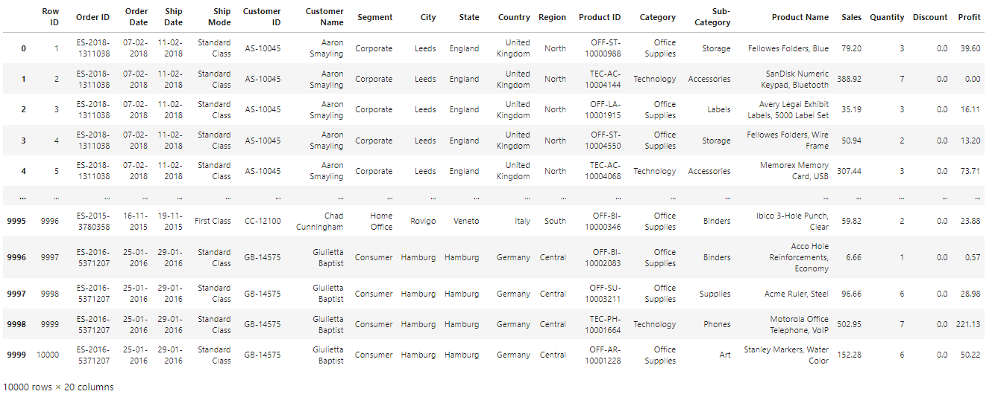

Figure Data before cleaning and filtering

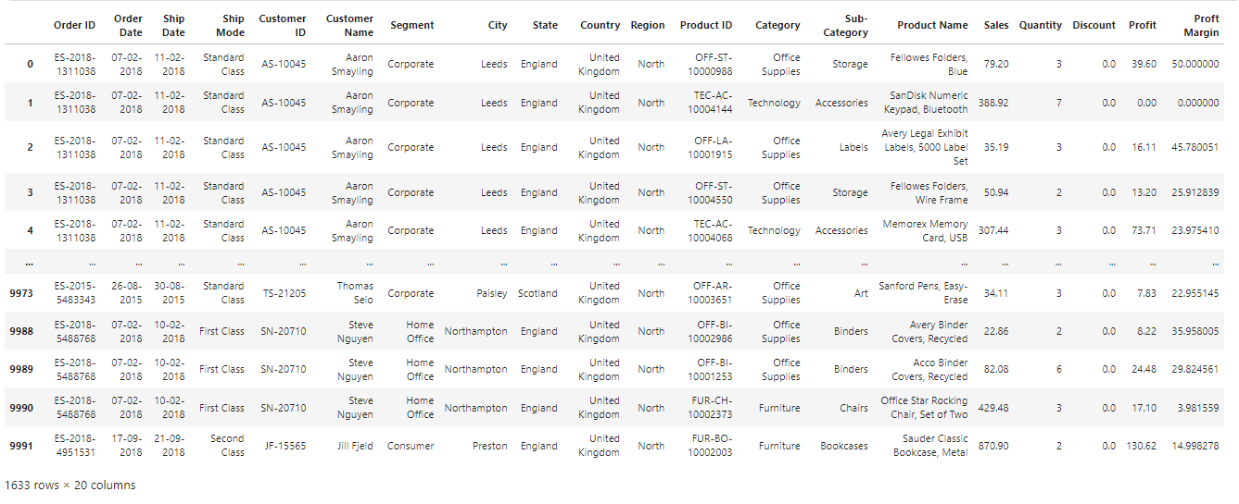

Figure Data after cleaning and filtering

The conclusion of this phase will result in a well-organized dataset, incorporating an additional column for profit margin. This dataset will form the basis for the dashboard and essential for providing precise insights.

**3.4.2 Dashboard design and development**

Following the preparation of the data, the subsequent phase involves the design and development of the Sales and Marketing Analytics Dashboard System using Power BI. This stage is essential, as it focuses on converting the refined and enhanced dataset into actionable insights that are readily interpretable and used by decision-makers.

* **Data Modelling in Power BI**

The initial task in Power BI involves establishing a data model that effectively illustrates the relationships among various data entities. A well-organized data model is essential for providing precise and insightful analysis.

1. **Importing the Dataset**

The cleaned dataset is imported into Power BI Desktop. Power BI accommodates a range of data formats, such as Excel, CSV and direct connections to the database. The dataset is imported in Excel format, ensuring that all data points are accurately aligned and available within the Power BI framework.

1. **Creating Relationships**

Power BI desktop provides an agile approach to build the data model. Relationships are the most crucial part of Power BI desktop [26].

Power BI facilitates the establishment of connections among various tables within the dataset. For example, Orders data is linked to Returns data through Order ID. The significance of these relationships lies in their necessity for conducting multi-dimensional analysis, such as computing return rates. Relationships are established through the primary fields that link various tables, thereby facilitating the comprehensive analysis of all relevant data.

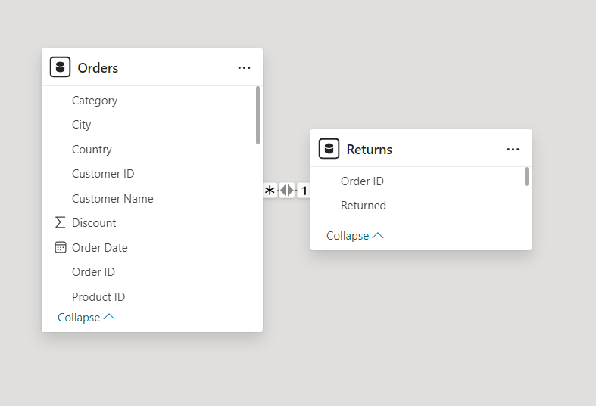**Figure 5 Relationship**

1. **Data Model Validation**

Once the data model has been established, it is crucial to conduct a validation process to confirm that all relationships are properly defined and the data is represented accurately. Any inconsistencies or errors should be resolved prior to advancing to the subsequent phase.

* **DAX Calculations and Measures**

Power BI provides access to a language Known as Data Analysis Expressions or DAX. This language enhances the analytical capabilities of our data model by enabling the creation of calculated columns, measures and tables. Each of these components is developed using DAX, which is designed to be user-friendly and similar to formula language used in Excel (Pearson et al., 2020). A key step in developing the Sales and Marketing Analytics Dashboard involves creating dynamic measures using Data Analysis Expressions (DAX). This phase is crucial for converting unprocessed data into significant insights that can be applied within the dashboard. DAX is used for calculations that facilitate in-depth analysis of sales, profitability and returns, thereby enabling the dashboard to deliver dynamic and real-time insights based on user interactions.

The DAX Calculations and Measures involves the following steps:

* **Identifying the Key Performance Indicators (KPIs)**

Determine the essential Key Performance Indicators (KPIs) that must be calculated to achieve the research objectives. These KPIs include Total Sales, Total Profit, Profit Margin, Net Sales after Returns, Return Rate Percentage and other KPIs that are relevant to sales performance.

* **Creation of DAX Measures**
* **Total Sales:** This measure aggregates the values in the Sales Column of the Orders table to determine the overall revenue produced.



Figure DAX for Total Sales

* **Total Profit:** This measure aggregates the values in the Profit Column of the Orders table to determine the total profit obtained.



Figure DAX for Total Profit

* **Average Order Value:** This is the measure of Total Sales to the number of orders.



Figure DAX for Average Order Value

* **City with Highest Profit:** This is a measure to identify the City in which highest profit is gained.



Figure DAX for City with Highest Profit

* **City with Highest Sales:** This is a measure to identify the City in which highest sales revenue has been generated.



Figure DAX for City with Highest Sales

* **Discount Impact %:** A measure to find the percentage of profit loss due to the discounts offered.



Figure DAX for Discount Impact %

* **Discounted Sales %:** A measure to find the percentage of total sales revenue from the discounted orders.



Figure DAX for Discounted Sales %

* **Net Profit after Discount:** A measure to calculate the total profit gained after the effect of discount on the orders.



Figure DAX for Net Profit after Discount

* **Product Category with Highest Sales:** This is a measure to identify the product category that produces the highest amount of sales revenue.



Figure DAX for Product Category with Highest Sales

* **Profit Margin %:** A measure to calculate the percentage of the amount of total sales that is converted into profit.



Figure DAX for Profit Margin %

* **Segment with Highest Profit:** A measure to identify the segment in which the highest profit is gained.



Figure DAX for Segment with Highest Profit

* **Top Product Category by Profit:** A measure to identify the top product which produced the highest profit.



Figure DAX for Top Product Category by Profit

* **Total Quantity Sold:** A measure to compute the total quantities of products sold.



Figure DAX for Total Quantity

* **Total Sales after Discount:** A measure to calculate the total sales revenue generated after applying all discounts.



Figure DAX for Total Sales after Discount

* **Net Profit after Returns:** A measure to calculate the total profit after considering all the returns.



Figure DAX for Net Profit after Returns

* **Net Sales after Returns:** A measure to calculate the total sales revenue after considering all the returns.



Figure DAX for Net Sales after Returns

* **Return Rate %:** A measure to calculate the percentage of total orders returned.



Figure DAX for Return Rate %

* **Total Returns:** A measure to find the number of orders returned.



Figure DAX for Total Returns

* **Dashboard Structure and Navigation**

The structure and navigation of the dashboard are designed to improve user experience and facilitate easy access to insights. It comprises of four main pages: Overview, Sales Analysis, Profit Analysis, Return Analysis. Each page is designed to address a particular aspect, allowing users to navigate between pages through a menu which is accessed by clicking the menu button on the upper left corner of each page.

1. **Overview page**

The Overview Page functions as the starting point to the dashboard, offering a clear overview of the dashboard along with the summary of total sales revenue year by year. A bar graph is used to display the total sales revenue year over year. The total sales for each year is shown in separate cards, thereby allowing users to easily grasp the overall performance with minimal effort.

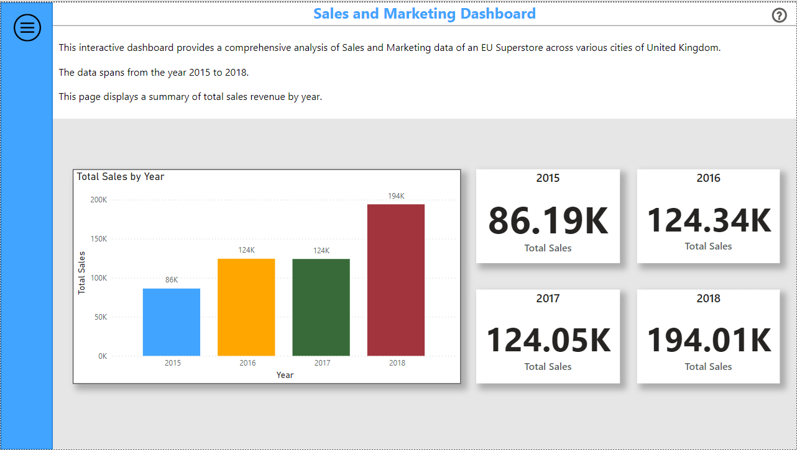

Figure Overview page

1. **Sales Analysis page**

The Sales Analysis page offers an in-depth examination of the sales data, highlighting the aspects such as product performance, sales and geographic distribution. This page is divided into two tabs: KPIs and Visuals.

The KPIs tab displays the calculated Key Performance Indicators related to sales such as Total Sales, Total Quantity, Average Order Value, Average of Discount, Net Sales, Discounted Sales %. The page also displays the City and Product Category with Highest Sales. Users are given with State Selection to view insights for specific state.

In Visual tab, a bar chart illustrates the overall sales figures by product category, enabling users to identify which categories are performing best. A line chart to represent the total sales by month. The Sales distribution among different segments is represented visually using a pie chart. A heat map illustrates sales distribution across various cities of United Kingdom, offering geographical insights into the performance of sales. Users have the ability to engage with the visualizations through the use of slicers (filters), allowing them to customize the data according to their requirements.

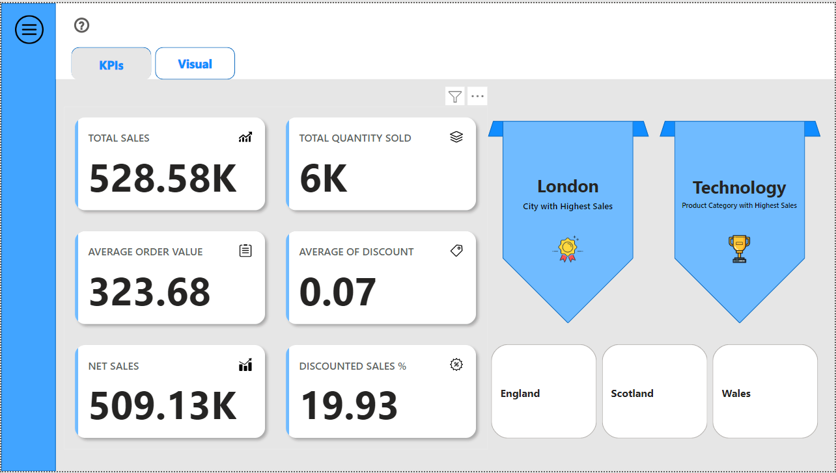

Figure KPI tab of Sales Analysis page

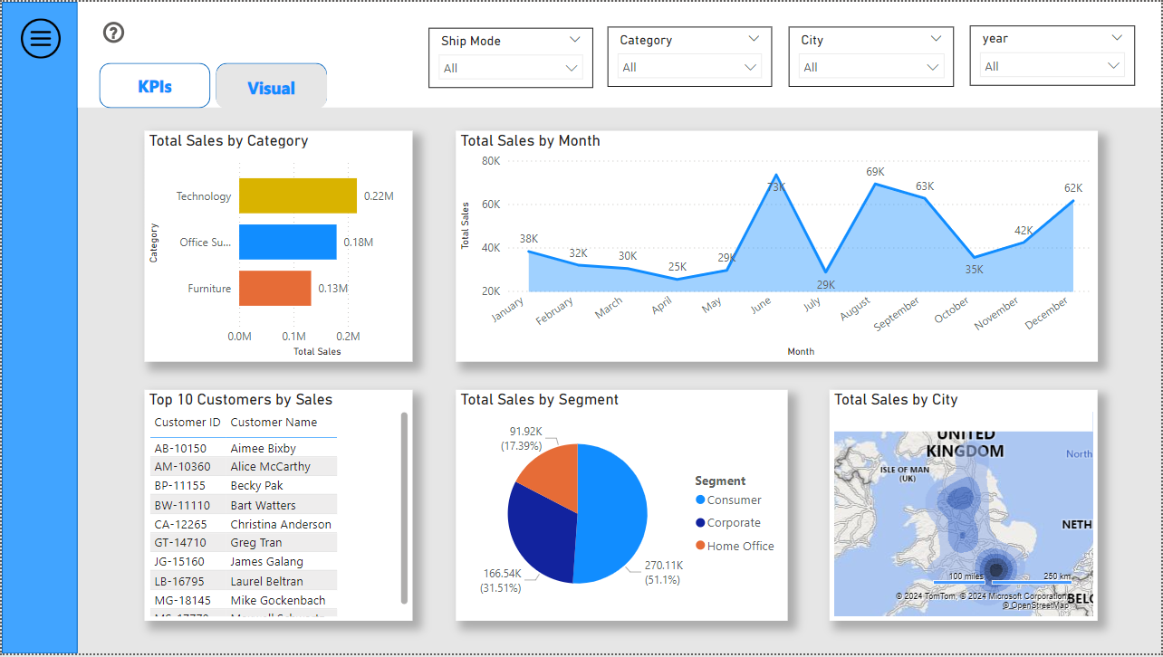

Figure Visual tab of Sales Analysis page

1. **Profit Analysis page**

The Profit Analysis page offers an analysis of profitability, enabling users to understand which products, segments and cities are most significantly impacting overall performance. Similar to the Sales Analysis page, this page is also divided into two tabs: KPIs and Visual.

The KPIs tab displays the calculated Key Performance Indicators related to profit such as Total Profit, Profit Margin %, Net Profit, Discount Impact %, City and Segment with Highest Profit. Users are also provided with State Selection to view data for specific state.

In Visuals tab, a clustered bar chart shows profit distribution by product category. A line chart to represent the profitability over month. The page also highlights the top 10 products with highest profits. A pie chart that displays the profit distribution across various segments. A Gauge meter is used to show the overall profit and the impact of discounts. Users are provided with the option to customize the visualizations by using the slicers (filters). The filters include Ship Mode, Category, City, Year.

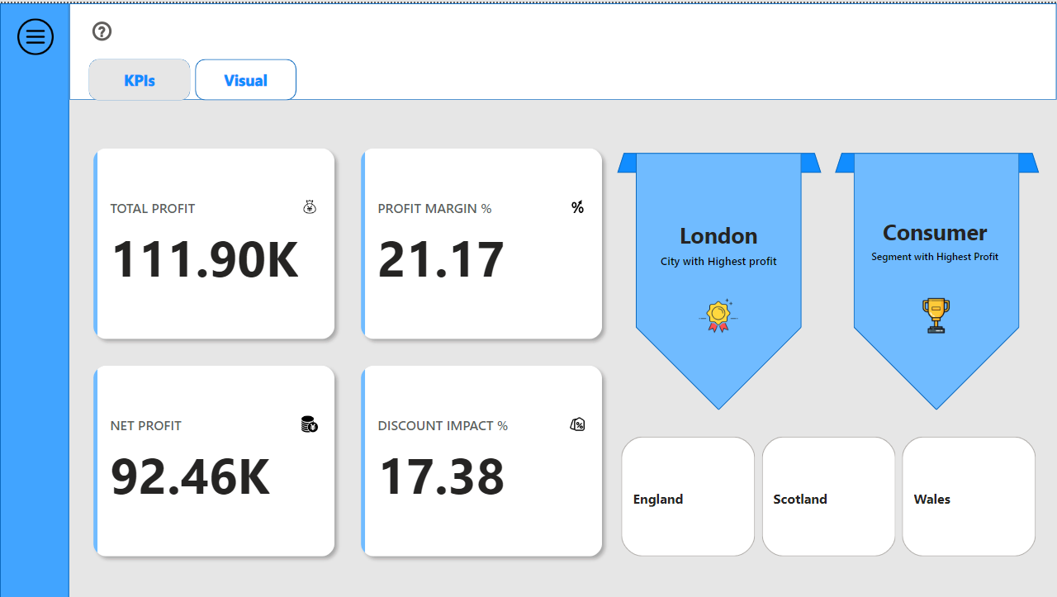

Figure KPI tab of Profit Analysis page

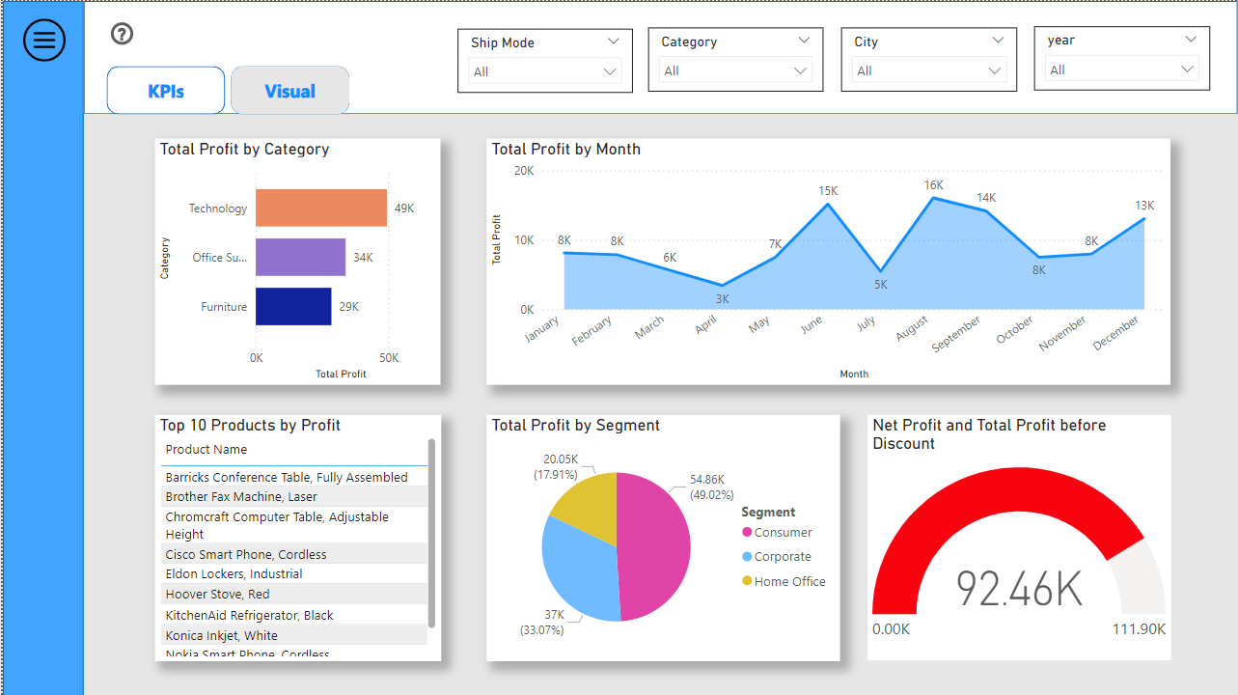

Figure Visual tab of Profit Analysis page

1. **Return Analysis page**

The Return Analysis page focuses on the analysis of product returns and their effect on sales and profitability. This page features the total number of orders returned, the percentage of orders that were returned, the net sales after the product returns, the net profit obtained after the returns. The visualizations include a 100% stacked bar chart to compare the sales before and after considering the returns, a donut chart to show the impact of returns on profitability across various segments, a pie chart to display the effect of returns on sales by product category and a line graph to represent the number of orders returned over time. Users are allowed to filter data by category, city, segment and year with the help of slicers (filters) provided.

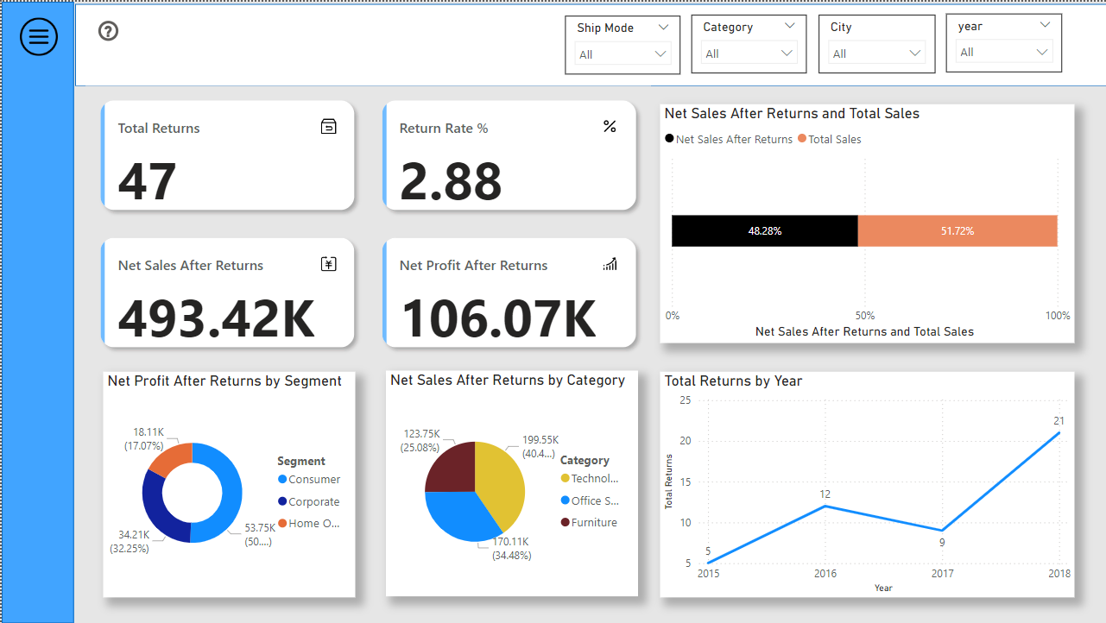

Figure Return Analysis page

1. **Help Section**

Each page contains a help icon through which the help section can be accessed. The Help section instructs users on how to use the dashboard features and refining the data using the slicers (filters) for precise analysis. It is not necessary for the users to have prior expertise in using the dashboard as this section can guide them.

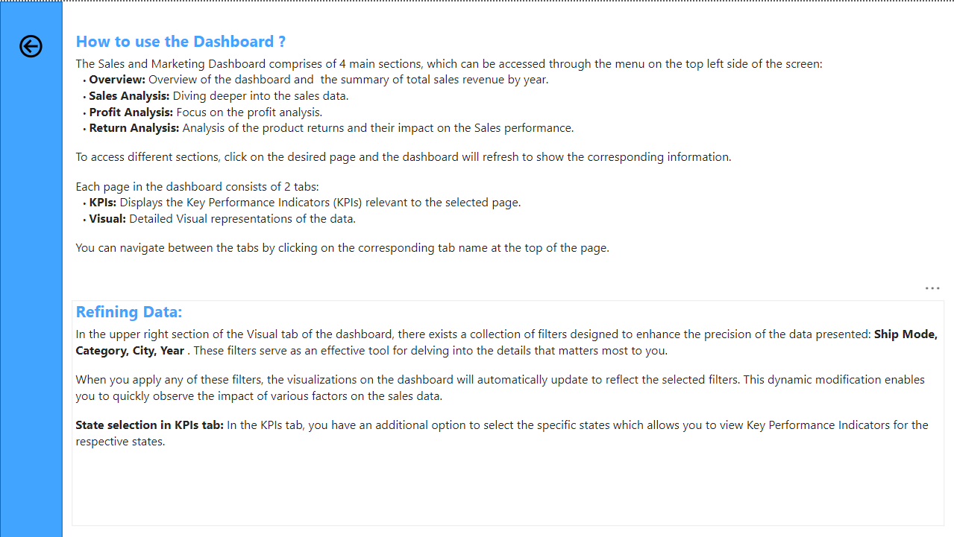

Figure Help Section

**3.4.3 Deployment and User Feedback**

Upon the completion of the dashboard’s development, it is subsequently deployed to the Power BI online service, facilitating wider access and enabling sharing with the stakeholders. Permissions are established to ensure that only individuals with appropriate authorization are able to view and engage with the dashboard. The dashboard is then shared directly with the users through email invitations.

Finally, feedback is captured through an online survey platform called Qualtrics University of Strathclyde. The survey contains a set of questions for the users upon the experience with the dashboard. The users will be asked about the dashboard’s ease of use, depth, challenges and suggestions for the dashboard. The results of the feedback will encompass in-depth findings and suggestions for future enhancement of the dashboard.

**3.5 Challenges and solutions**

The development of Sales and Marketing Analytics Dashboard System presented various challenges that could have influenced the overall performance and precision of the dashboard. This section outlines these challenges and the strategies used to address them.

**Challenge #1 Data Quality and Unwanted Columns**

**Problem:** A primary challenge encountered in this research involved maintaining the quality of the data and the unnecessary columns contained in the data. As the dataset used for this research is obtained through Google Dataset Search, which is publicly available, it may contain various inconsistencies including duplicate entries, null values and columns that are not needed for the data analysis.

**Solution:** In order to tackle these challenges, a thorough data cleaning process was executed using python. This process includes removing null values and duplicate entries throughout the dataset. Furthermore, unwanted column like Row ID was removed and a new column called Profit Margin was added into the dataset to enhance analytical depth.

**Challenge #2 Designing User-friendly dashboard**

**Problem:** Another challenge was to develop a dashboard that is user-friendly as well provide comprehensive analytical capabilities.

**Solution:** In response to this challenge, the dashboard was developed with a user-friendly interface. The navigation process was simplified by implementing a menu, which facilitates effortless navigation across different pages such as Overview, Sales Analysis, Profit Analysis and Return Analysis. In addition to that, interactive components such as filters were integrated to allow users to customize data.

**Challenge #3 Deployment of the dashboard to the Power BI online service**

**Problem:** Power BI online service requires a school or work account with admin controls to share the dashboard to external users to receive user feedback.

**Solution:** Registered for the Office 365 E5 free trial for 60 days to get a work account with full access. External users were given appropriate access to view the dashboard without installation of Power BI Desktop to get the feedback from them for future enhancements.

**4 Analysis**

This section provides a detailed analysis of the Sales and Marketing Analytics Dashboard System developed using Power BI, emphasizing its effectiveness in providing actionable insights related to Sales, Profits and Product Returns. The analysis discusses the role of the dashboard in enabling the efficient analysis and representation of the sales and marketing data. It also considers the customization features available, their effect on the decision-making and the elements that affect user satisfaction. Each section of the analysis part corresponds to the following research questions and aims to address them through a comprehensive evaluation of the dashboard’s performance.

**Question #1**

What techniques can be employed to develop an user-friendly and engaging dashboard system utilizing Power BI for the efficient analysis and visualization of sales and marketing data?

**Question #2**

What customization options should be integrated into the dashboard to enable users to adjust visual representations, metrics and Key Performance Indicators (KPIs) in alignment with their objectives?

**Question #3**

How does the development of Sales and Marketing Analytics Dashboard System improve decision-making efficiency?

**Question #4**

What are the key elements that affect user satisfaction regarding the Sales and Marketing Analytics Dashboard System?

**4.1 Visualization Techniques**

The visualization features of Power BI played a crucial role in the development of an interactive dashboard. A variety of techniques were utilized to ensure that the data is displayed in a way that is not only informative but also visually appealing:

* **Use of Interactive Visualizations**

The dashboard features a variety of interactive visualizations including clustered bar charts, line graphs, pie charts and heat maps. These visualizations are dynamic, enabling users to engage with the data by exploring specific categories or time frames in a detailed way.

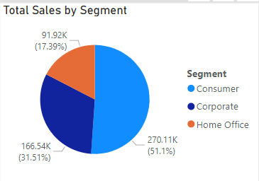

Figure Pie Chart for Total Sales by segment

The above pie chart represents the overall sales by different segments from 2015 to 2018. Users can also be able to view the total sales by segment for each year separately.

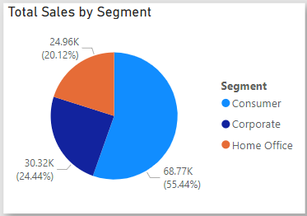

Figure Pie Chart for Total Sales by Segment in 2017

The above pie chart represents the total sales by different segments in the year 2017. Likewise, the pie chart can modified to view the data for 2015, 2016 and 2018.

* **Custom Visuals**

A uniform design was implemented throughout the dashboard, improving its visual quality by providing a user-friendly interface. Custom visuals including gauge meter for Net Profit and Profit Margin offers quick insights to the users, which are essential for prompt decision-making.

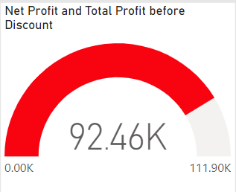

Figure Gauge Meter

The above figure represents the gauge meter for Net Profit and Total Profit before discount.

**4.2 Enhanced User Engagement**

The development of the dashboard prioritized user engagement as a key aspect. Various techniques were implemented to make the dashboard more dynamic and engaging:

* **Navigation and Structure**

The dashboard features a well-organized and user-friendly design. Users can effortlessly navigate across different pages (Overview, Sales Analysis, Profit Analysis, Return Analysis) through the menu which can be accessed via a menu button in every page. This navigation promotes a comprehensive exploration of the dashboard by the users.

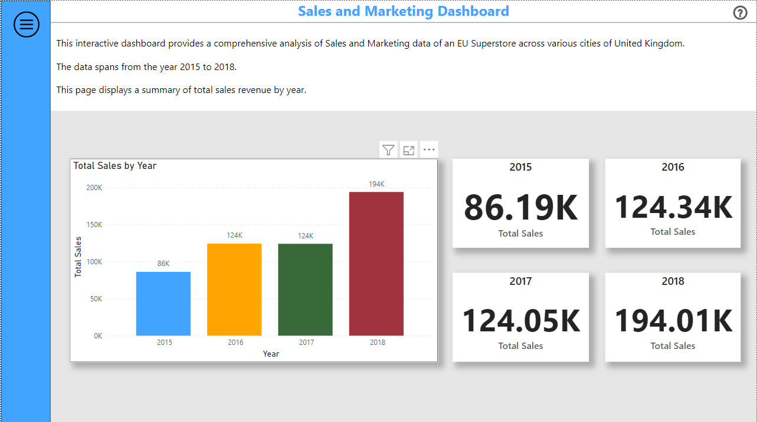

Figure Menu Button (Highlighted)

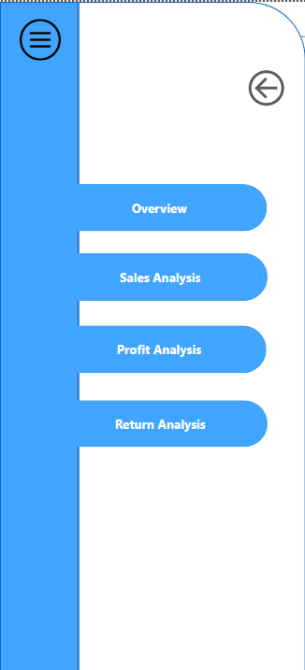

Figure Navigation Menu

* **Interactive Slicers (filters)**

In order to improve user engagement, the dashboard incorporates interactive filters, which enable users to customize the data visualizations according to particular criteria including product category, segment, city and time period (year).

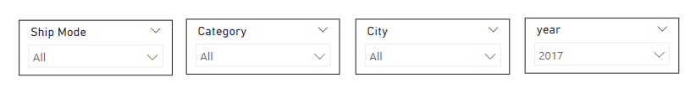

Figure Filter Bar

**4.3 Customizable Visualizations**

Customization plays a vital role in ensuring that a dashboard addresses the various requirements of its users. The analysis of this section focuses on the customization features embedded within the dashboard and examines how these features enable users to adjust the dashboard according to their needs.

**4.3.1 Sales data visualization 2015 vs Sales data visualization 2018**

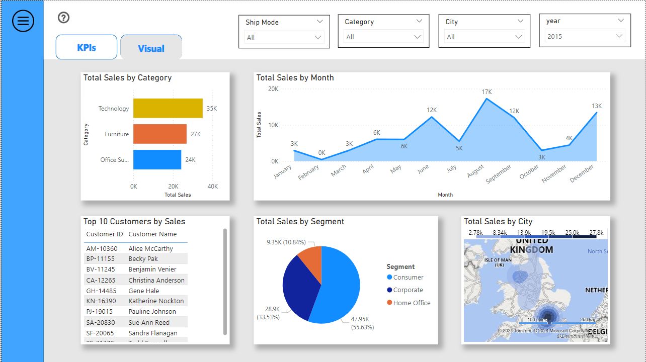

Figure Sales data visualization 2015

Through the above data visualization, it can be inferred that in 2015, the month of August has recorded the highest amount of sales revenue with around 17k. The consumer segment leads the chart with the highest sales (about 47.95k).

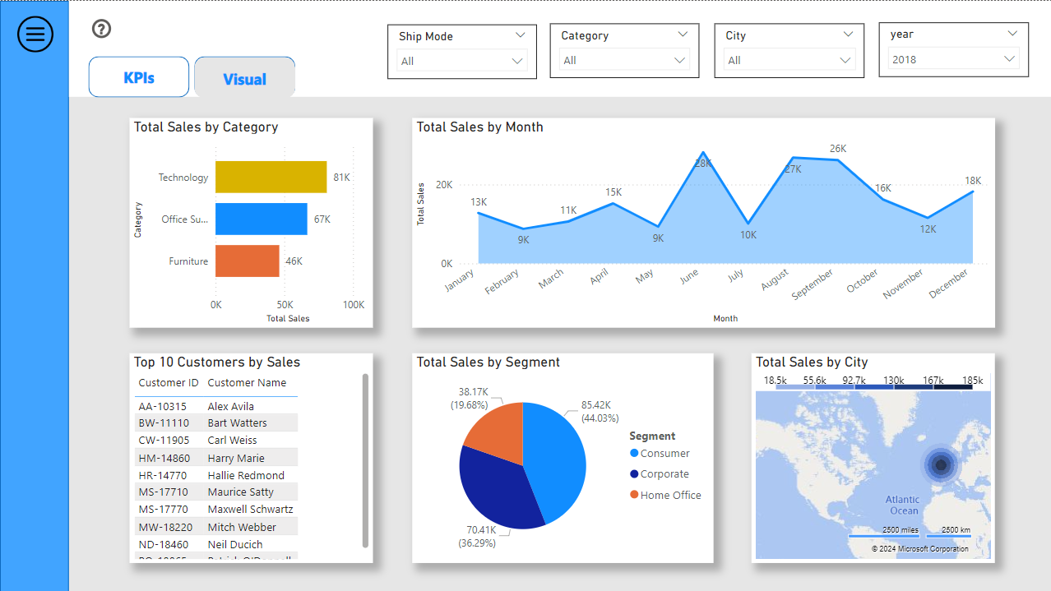

Figure Sales data visualization 2018

On the other hand, in 2018, July records the highest sales revenue with about 28k. The Consumer segment has the highest sales of around 85.42k. The comparison of sales between different product categories can also be viewed.

**4.3.2 Sales data visualization for Glasgow city vs Sales data visualization for Edinburgh city**

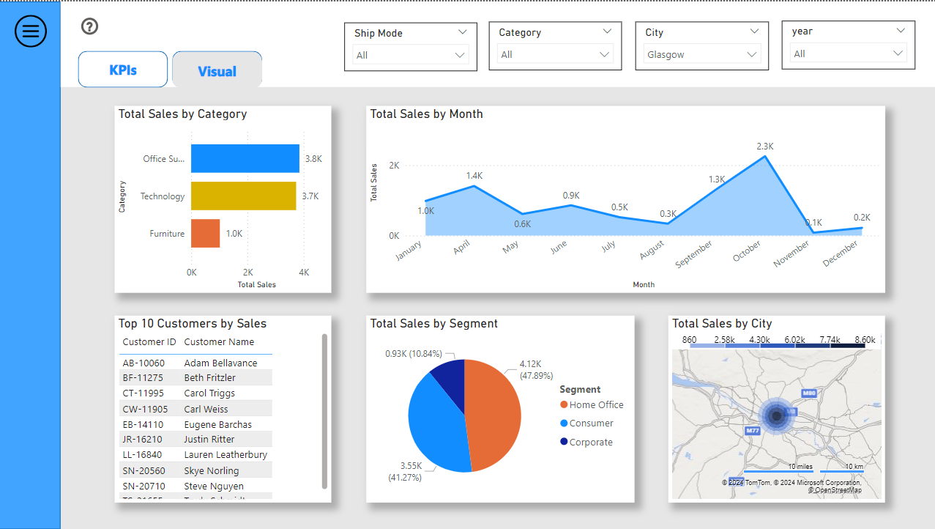

Figure Sales data visualization for Glasgow city

As of the above data visualization, for Glasgow city, the highest sales has been generated in the month of October over the years (2015 to 2018) with around 2.3k. The Home Office segment tops the list with highest sales of around 4.12k. In the product category, office supplies has the highest sales with about 3.8k.

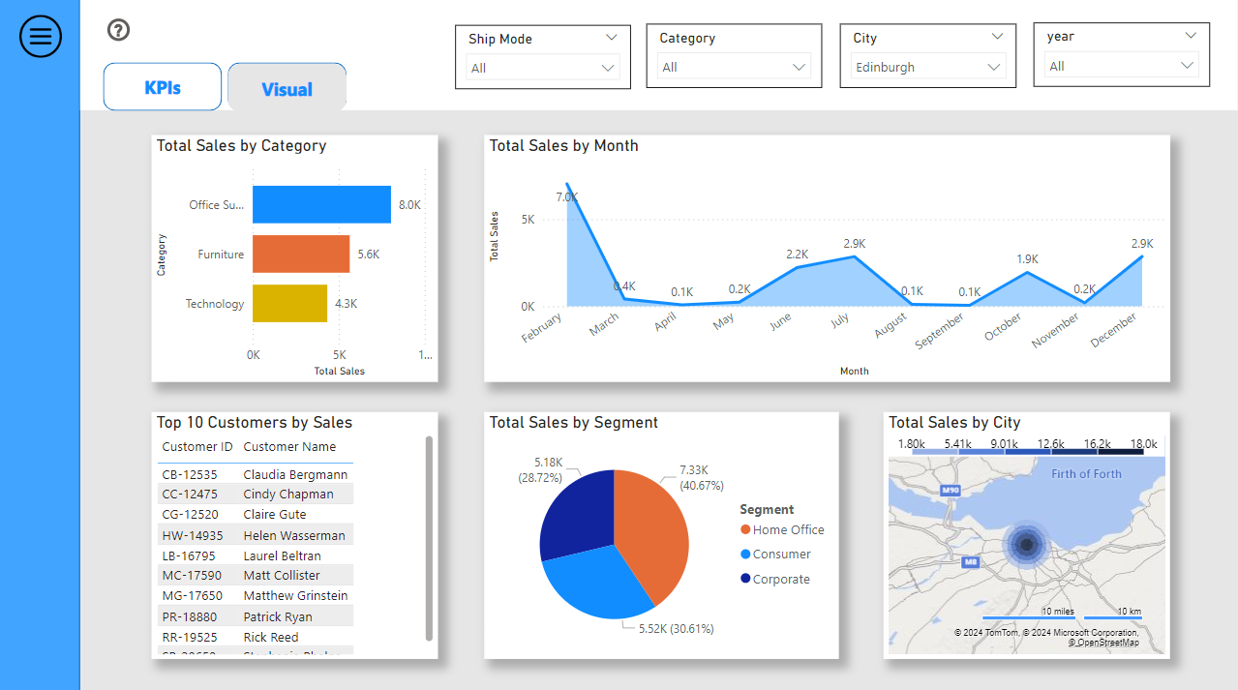

Figure Sales data visualization for Edinburgh city

For Edinburgh city, February month has the maximum amount of sales with about 7k. The Home Office segment ranks first in the total sales generated with around 7.3k.

Similarly, the users can adjust the visualizations according to their requirement based on specific city, product category, ship mode or year.

**4.4 KPI Customization**

Key Performance Indicators (KPIs) serve as a fundamental component of the dashboard, offering insights into essential business metrics. The dashboard offers a functionality that allows users to filter KPIs by individual states within the United Kingdom. This capability is especially beneficial for evaluating the performance in particular regions. By choosing a specific state, users can access KPIs such as Total Sales, Profit Margin and Return Rate that is associated with a specific state, thereby facilitating more focused decision-making.

**4.4.1 Profit KPIs for England vs Profit KPIs for Scotland**

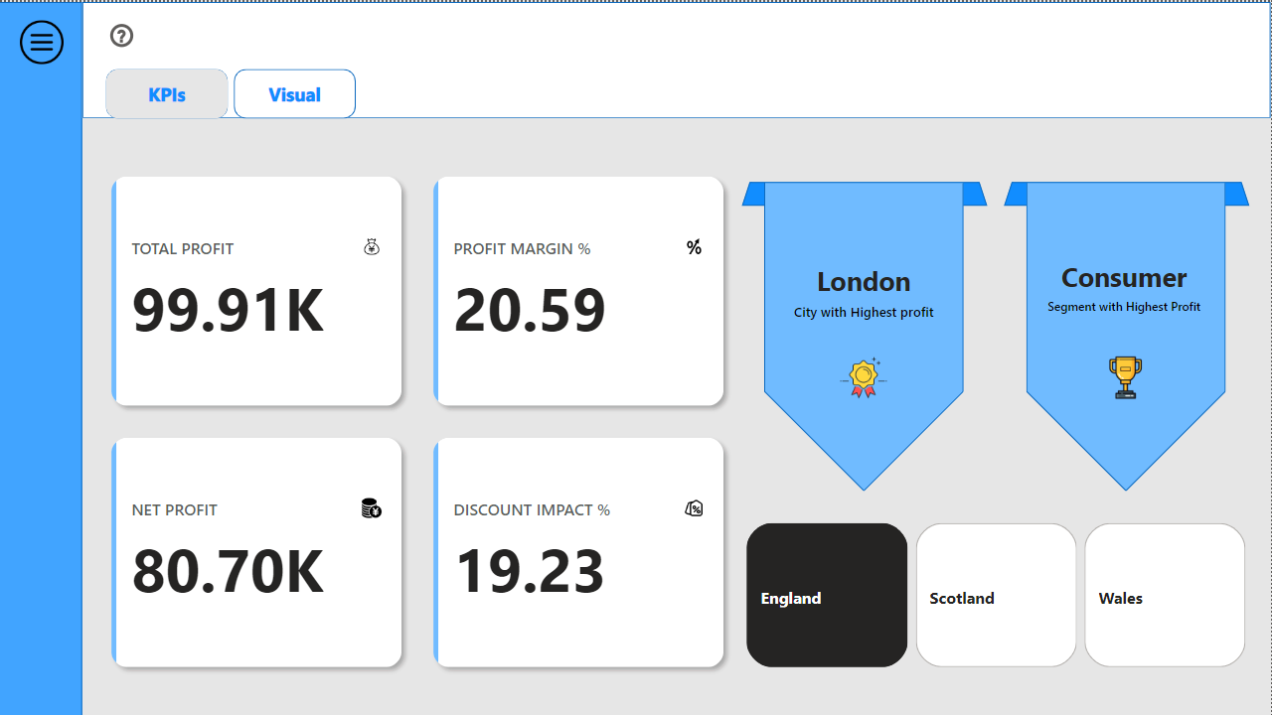

Figure Profit KPIs for England

As inferred from the above figure, in England, the total profit is 99.91k. The profit margin % is 20.59 and the Net profit generated is about 80.70K. London is the city in England in which the highest profit has been gained. Consumer segment is considered to have the highest profit. Likewise insights for Scotland and Wales can also be gathered by clicking on the state selection.

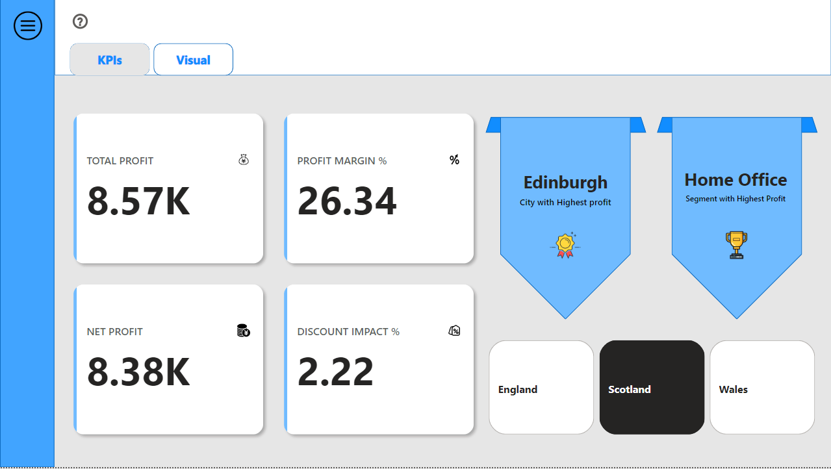

Figure Profit KPIs for Scotland

In Scotland, Edinburgh is the city with highest profit. The total profit gained in Scotland is about 8.57k between the year 2015 to 2018. The Net profit gained is 8.38k and the profit margin % is 26.34.

**4.5 Data Centralization**

A primary method by which the dashboard enhances the decision-making efficiency is through the centralization of all data relevant to sales and marketing (sales, profitability, product returns) within a single platform. The centralization of data streamlines the decision-making process by removing the necessity for decision-makers to refer multiple data reports, thereby conserving time and minimizing the errors in data analysis. This capability is essential for facilitating prompt decision-making, especially in dynamic business environments.

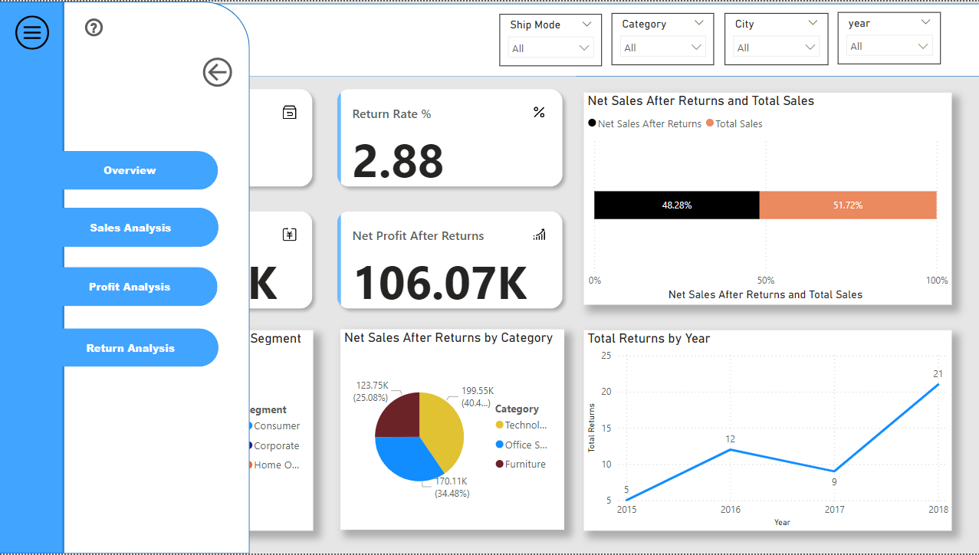

Figure Centralization of Sales, Profit and Product Returns

**4.6 Enhanced Data visualization**

The implementation of enhanced data visualization methods within the dashboard greatly improves the effectiveness of data analysis and helps in effective decision-making. Interpreting complex datasets in their raw form can pose significant challenges. The implementation of visualizations such as heat maps and line charts allows decision-makers to quickly analyze the essential insights. Heat maps serve as a valuable tool for users to understand patterns and relationships across multiple dimensions by visually depicting the density of the data. Line charts, on the other hand, monitors the trends over time, thereby facilitating the prediction for future performance.

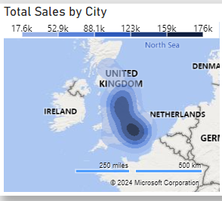

Figure Heat Map for Total Sales by City

For instance, a heat map illustrating sales performance across various cities enables users to quickly identify the areas with highest and lowest sales figures, thereby providing fast decision-making. The region with darker colour has the highest sales figure whereas the sales figures decreases as the colour fades.

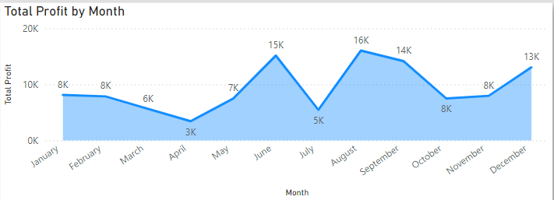

Figure Line chart for Total Profit by month

The dashboard features visuals for analyzing trends over a time period, which includes line charts for sales and profitability. One such is given in the figure, which represents the line chart for total profit month-by-month. Such visuals facilitate the forecasting the future performance by leveraging the data over the past periods, thereby guiding the decision-makers in planning the business strategies.

**4.7 Usability and Performance**

A critical aspect of user satisfaction is the usability of the dashboard. The interface of the dashboard is designed to be user-friendly, featuring a well-organized structure and easier navigation. Users are able to efficiently locate the information they require without the necessity of prior expertise with Power BI. The Help section which can be accessed from every page can also guide them clearly.

Another significant aspect of user satisfaction is the performance of the dashboard. The performance of the dashboard include the page load time when the user filters a data to a specific category. When the user customize the data according to their needs using the filters available, the page rendering typically takes less five seconds to load the insights of the selected criteria.

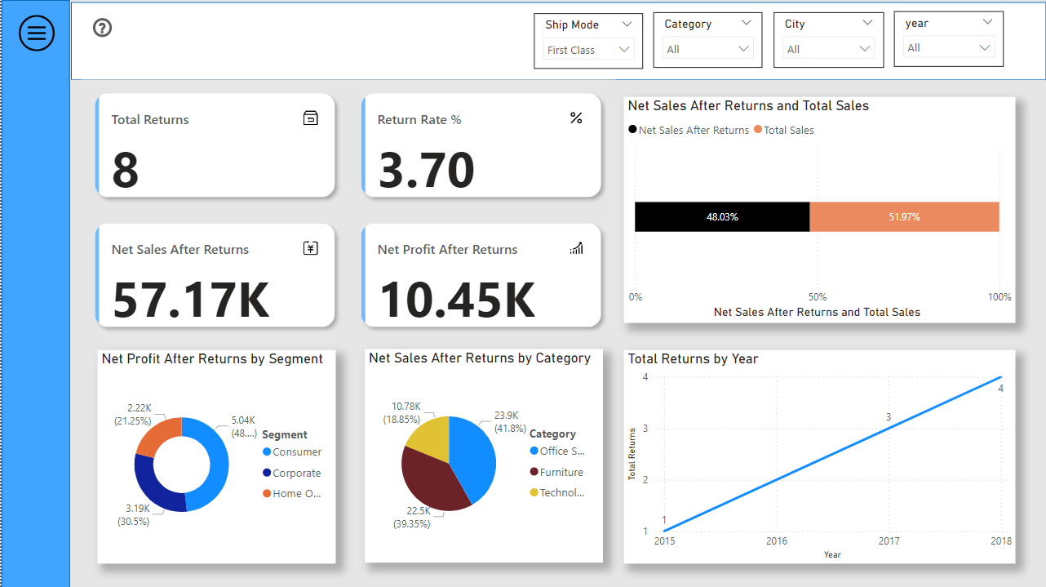

Figure Return Analysis for First Class Ship mode

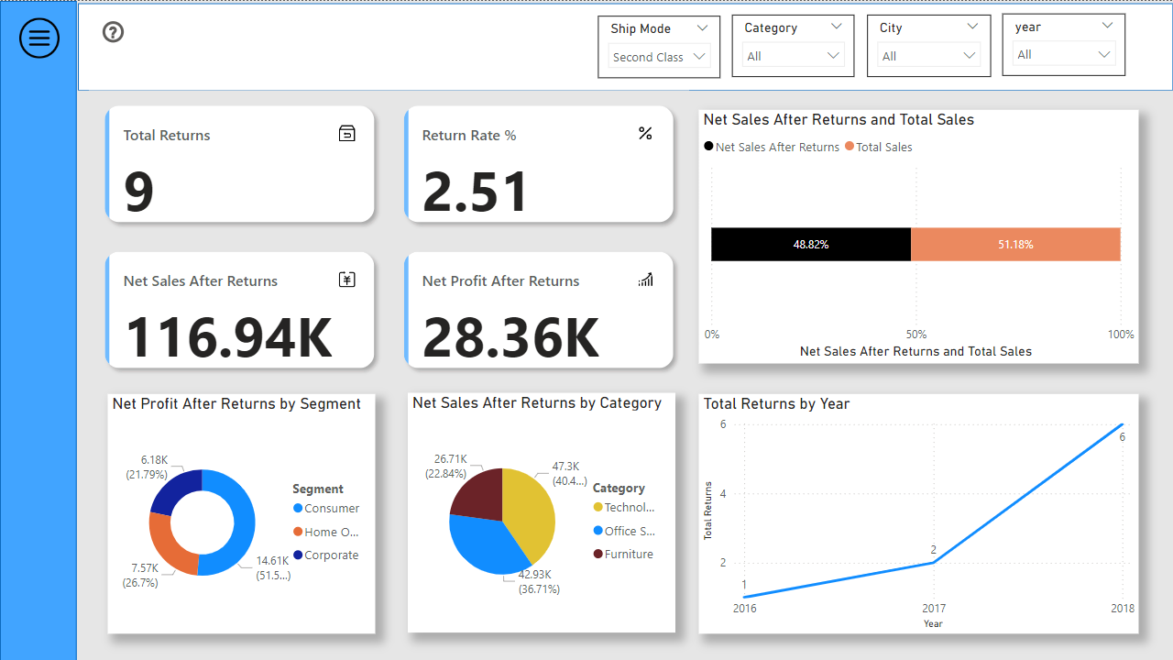

Figure Return Analysis for Second Class Ship mode

Figure 45 shows the return analysis of the First Class Ship mode. When the ship mode is changed to second class, the insights for that ship mode loads within 3 seconds, thereby saving time for the decision-makers.

**4.8 User Feedback Analysis**

As a part of the research, an user survey was conducted to collect user feedback aimed at assessing the effectiveness, usability and overall user experience of the sales and marketing dashboard. The results obtained from the survey were helpful in understanding the extent to which the dashboard fulfilled the user expectations and highlighted potential areas for future enhancement. The user feedback survey was distributed carefully to a selected group of stakeholders. The purpose of the survey was to evaluate various critical dimensions of the dashboard which includes usability, performance and overall user satisfaction.

**4.8.1 Key findings of the Survey**

1. **Overall Experience and ease of use**

Based on the responses from the survey, the following observations were made concerning the user experience:

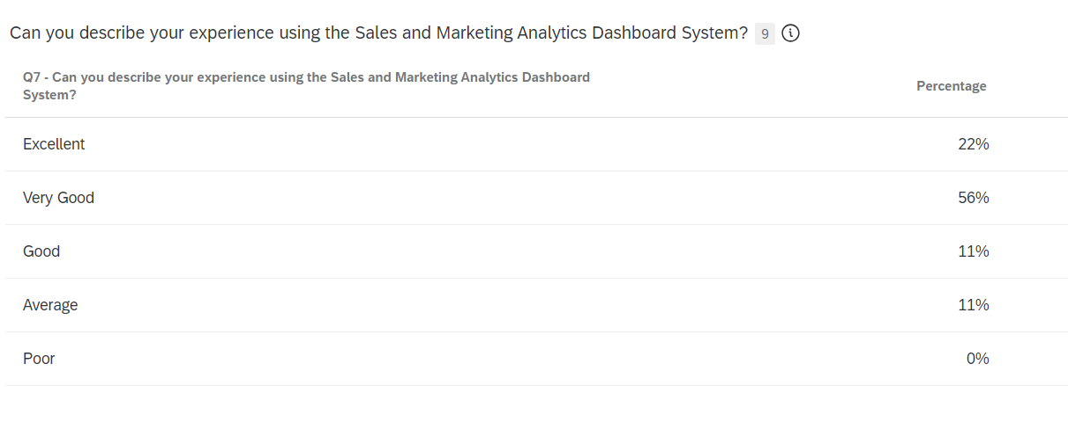

Figure Percentage of User experience

A total of 22% of participants assessed their experience as “Excellent” which can be inferred that these users found the dashboard to be very user friendly and effective. A significant portion of participants, specifically 56%, assessed their experience as “Very Good”. This suggests that the dashboard is effective across various dimensions, offering user-friendly interface and providing useful insights. A total of 11% participants assessed their experience as “Good” which indicates that although these users found the dashboard to be beneficial, there may be particular areas that fell short of expectations. An additional 11% of participants assessed their experience as “Average”. These individuals may found the dashboard to be moderately beneficial, but they likely faced that influenced their overall experience and satisfaction. Importantly, there were no respondents who classified their experience as ”Poor”, which is a favourable sign that the dashboard does not have major issues.

1. **Impact on decision-making**

Another significant component of the user feedback survey aimed to explore the impact of the dashboard on the strategies and decision making. The survey aims to evaluate the extent to which the insights offered by the dashboard in enhancing the decision-making processes.

67% of the participants reported that the analytics offered by the dashboard greatly enhanced the decision-making processes. This majority suggests that the dashboard successfully provides actionable insights that influence decision-making.

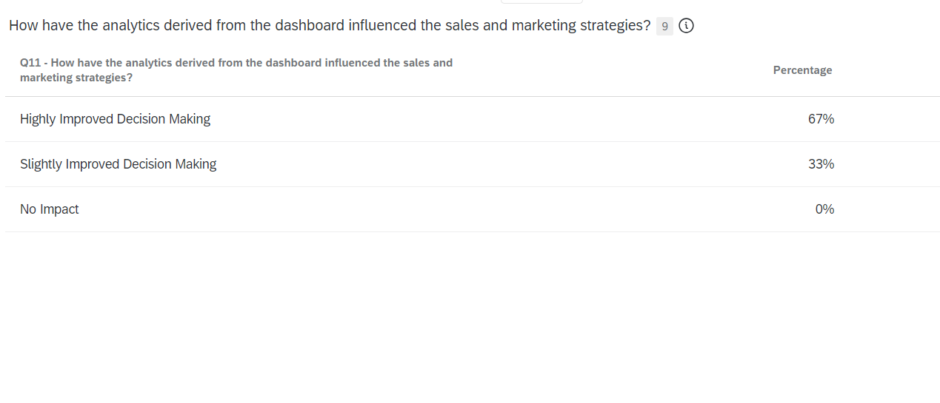

Figure Influence of dashboard in decision making

A total of 33% of participants indicated that the dashboard had a modest positive effect on decision making processes. This observation suggests that, although the dashboard proves to be beneficial, there may be improvements to deliver more clear insights.

**4.9 Answering the Research Questions**

**Question #1 What techniques can be employed to develop an user-friendly and engaging dashboard system utilizing Power BI for the efficient analysis and visualization of sales and marketing data?**

**Answer:** To develop an user-friendly and engaging dashboard system, an easily accessible menu is designed to easily navigate different sections of the dashboard system. Each section provides an in-depth analysis of specific aspects of sales and marketing. The use of interactive visualizations and filters makes the dashboard interactive and engaging. The structure and layout design of the dashboard is very much user-friendly.

**Question #2 What customization options should be integrated into the dashboard to enable users to adjust visual representations, metrics and Key Performance Indicators (KPIs) in alignment with their objectives?**

**Answer:** Interactive slicers (filters) such as Product Category, ship mode, city and year has been implemented to customize data dynamically. Users are also allowed to filter the Key Performance Indicators (KPIs) to specific states in alignment with their objectives.

**Question #3 How does the development of Sales and Marketing Analytics Dashboard System improve decision-making efficiency?**

**Answer:** The dashboard significantly minimizes the time needed for data collection and analysis by integrating all relevant information into a single platform. Therefore, this enables the time taken for decision-making. Also, the ability of the dashboard to visualize the insights through interactive charts and graphs enhances the precision of decision-making process.

**Question #4 What are the key elements that affect user satisfaction regarding the Sales and Marketing Analytics Dashboard System?**

**Answer:** The key elements that affect user satisfaction are the usability and performance of the dashboard. The dashboard is well- organized and user-friendly which enhances the usability for the users.

**5 Conclusion and Future work**

This research report offers an in-depth examination of the development of a Sales and Marketing Analytics Dashboard system using Power BI. It highlights the delivery of actionable insights related to sales performance, profitability and product returns. The research illustrates the importance of a comprehensive data analytics dashboard in improving business decision-making processes. The primary advancements of the research includes the identification of essential and crucial key performance indicators (KPIs) that are important for business success. The dashboard developed as a result of this research delivers insights into sales patterns, profit margins and the effects of product returns.

The dashboard facilitates an in-depth exploration of particular areas of interest integrating interactive filters , enabling users to analyze aspects such as the top performing product categories or the customer segments with high profits. The dashboard’s capacity to emphasize critical performance metrics, monitor sales patterns and evaluate profit margins serves a robust and powerful resource for organizations to improve competitive advantage.

In conclusion, this research effectively achieved its objectives by developing a data analytics dashboard that significantly improves business decision-making processes. The insights produced by this dashboard are essential for organizations aiming to implement a data-driven strategy in their sales and marketing efforts, providing a way to enhanced customer engagement and increase in profitability. The research covers all the main objectives of the research by answering the research questions provided.

**5.1 Future Work**

Based on the user feedback obtained from the survey, multiple aspects of the sales and marketing analytics dashboard can be improved to address the user requirements more effectively and enhance the overall performance. The following recommendations outline possible enhancements of the future:

* **Integration of Q&A feature**

Based on the user feedback and the need to improve the user interactivity, most users suggested the inclusion of Q&A feature in the sales and marketing analytics dashboard. This feature will enable users to engage with the dashboard in a more seamless manner, facilitating inquiries in plain language and obtaining prompt and visual responses. Users suggested this improvement so as to quickly acquire specific insights that could reduce time in decision-making process. The Q&A feature in Power BI enables users to input inquiries using natural language, receiving responses in the form of visual representations such as graphs and charts. This capability minimizes the necessity for users to navigate through filtering options. It enables users varying technical knowledge to quickly derive insights, thereby improving the functionality of the dashboard. For example, the users might ask “What is the total sales in Glasgow?” The dashboard quickly responses to the question with the answer with the help of the data analysis. The Q&A feature acts as a chatbot for the data.

* **Adding Time Period filters for KPIs**

In response to user feedback, another significant improvement for the Sales and Marketing Analytics Dashboard is the addition of time period filters for the Key Performance Indicators (KPIs). This addition enables users to dynamically modify the time frame of the KPIs presented on the dashboard, facilitating more accurate and relevant insights. Some users expressed that the capability to analyze Key performance Indicators (KPIs) across multiple time frames such as monthly, quarterly and yearly, could greatly improve their decision-making. For instance, evaluating KPIs over different intervals may facilitate the recognition of trends and seasonal variations.

* **Optimization for mobile**

Some users have indicated the necessity for a mobile optimized version of the dashboard, which would facilitate access to insights while on the move. Many suggested to create a mobile optimized version of the dashboard that retains the essential features and visual clarity found in the desktop version. This may require the implementation of responsive design techniques that adapt to various screen dimensions and facilitate interaction by touch.

**References**

[1] Shubho, O.Q., Tumpa, Z.N., Dipto, W.I.R. and Alam, M.R. (2022). Real-Time Data Visualization Using Business Intelligence Techniques in Small and Medium Enterprises for Making a Faster Decision on Sales Data. Decision Intelligence Analytics and the Implementation of Strategic Business Management, pp.189–198. doi: <https://doi.org/10.1007/978-3-030-82763-2_17>.

[2] Kumar, S., K, K.P. and S, A.P. (2022). Technology for Better Business in Society. International Journal of Philosophy and Languages (IJPL), [online] 1(1), pp.117–144. doi: <https://doi.org/10.47992/IJPL.2583.9934.0007>.

[3] Lim, E.-P., Chen, H. and Chen, G. (2013). Business Intelligence and Analytics. ACM Transactions on Management Information Systems, 3(4), pp.1–10. doi: <https://doi.org/10.1145/2407740.2407741>.

[4] Chen, H., Chiang, R.H.L. and Storey, V.C. (2012). Business intelligence and analytics: From big data to big impact. MIS Quarterly, 36(4), pp.1165–1188. doi: <https://doi.org/10.2307/41703503>.

[5] Abu-AlSondos, I. (2023). The impact of business intelligence system (BIS) on quality of strategic decision-making. International Journal of Data and Network Science, [online] 7(4), pp.1901–1912. Available at: <https://growingscience.com/beta/ijds/6364-the-impact-of-business-intelligence-system-bis-on-quality-of-strategic-decision-making.html>.

[6] Kumar, S.M. and Belwal, M. (2017). Performance dashboard: Cutting-edge business intelligence and data visualization. 2017 International Conference On Smart Technologies For Smart Nation (SmartTechCon). doi: <https://doi.org/10.1109/smarttechcon.2017.8358558>.

[7] Westin, J. (2024). New Sales KPIs Reports to Improve Data-based Decision Making. [online] www.theseus.fi. Available at: <https://www.theseus.fi/handle/10024/857375>.

[8] Lindberg, C.-F., Tan, S., Yan, J. and Starfelt, F. (2015). Key Performance Indicators Improve Industrial Performance. Energy Procedia, [online] 75(75), pp.1785–1790. doi: <https://doi.org/10.1016/j.egypro.2015.07.474>.

[9] Teau, A.-M. and Protopopescu, C.E. (2015). Key Performance Indicators – Management Tools for Sales Improvement. Romanian Statistical Review Supplement, [online] 63(6), pp.65–71. Available at: <https://ideas.repec.org/a/rsr/supplm/v63y2015i6p65-71.html>.

[10] Singh, G., Kumar, A., Singh, J. and Kaur, J. (2023). Data Visualization for Developing Effective Performance Dashboard with Power BI. 2023 International Conference on Innovative Data Communication Technologies and Application (ICIDCA). doi: <https://doi.org/10.1109/icidca56705.2023.10100169>.

[11] Islam, M. and Jin, S. (2019). An Overview of Data Visualization. 2019 International Conference on Information Science and Communications Technologies (ICISCT). doi: <https://doi.org/10.1109/icisct47635.2019.9012031>.

[12] Krishnan, V. (2017). Research Data Analysis with Power BI. ir.inflibnet.ac.in. [online] Available at: <https://ir.inflibnet.ac.in/handle/1944/2116>.

[13] Dewan Hafiz Nabil, Md. Habibur Rahman, Rahman, A. and Menezes, B.C. (2023). Managing supply chain performance using a real time Microsoft Power BI dashboard by action design research (ADR) method. Cogent engineering, 10(2). doi: <https://doi.org/10.1080/23311916.2023.2257924>.

[14] Al-Kassab, J., Ouertani, Z.M., Schiuma, G. and Neely, A. (2014). Information visualization to support management decisions. International Journal of Information Technology & Decision Making, 13(02), pp.407–428. doi: <https://doi.org/10.1142/s0219622014500497>.

[15] Yigitbasioglu, O.M. and Velcu-Laitinen, O. (2012). The Use of Dashboards in Performance Management: Evidence from Sales Managers. The International Journal of Digital Accounting Research, 12, pp.36–58. doi: <https://doi.org/10.4192/1577-8517-v12_2>.

[16] Destiandi, N. and Hermawan, A. (2018). Business Intelligent Method For Academic Dashboard. bit-Tech, 1(2), pp.11–20. doi: <https://doi.org/10.32877/bt.v1i2.42>.

[17] Zadeh, A., Zolbanin, H., Sengupta, A. and Schultz, T. (2020). Enhancing ERP Learning Outcomes through Microsoft Dynamics. Journal of Information Systems Education, [online] 31(2), pp.83–95. Available at: <https://aisel.aisnet.org/jise/vol31/iss2/1/>.

[18] Davenport, T. and Harris, J., 2017. Competing on analytics: Updated, with a new introduction: The new science of winning. Harvard Business Press.

[19] Dearborn, J., 2015. Data driven: How performance analytics delivers extraordinary sales results. John Wiley & Sons.

[20] Baier, M., Carballo, J.E., Chang, A.J., Lu, Y., Mojsilovic, A., Richard, M.J., Singh, M., Squillante, M.S. and Varshney, K.R., 2012. Sales-force performance analytics and optimization. IBM Journal of Research and Development, 56(6), pp.8-1.

[21] Wedel, M. and Kannan, P.K. (2016). Marketing Analytics for Data-Rich Environments. Journal of Marketing, 80(6), pp.97–121. doi: <https://doi.org/10.1509/jm.15.0413>.

[22] Hallikainen, H., Savimäki, E. and Laukkanen, T. (2020). Fostering B2B sales with customer big data analytics. Industrial Marketing Management, [online] 86(1). doi: <https://doi.org/10.1016/j.indmarman.2019.12.005>.

[23] Sharma, R.S. and Djiaw, V., 2011. Realising the strategic impact of business intelligence tools. Vine, 41(2), pp.113-131.

[24] Tvrdikova, M. (2007). Support of Decision Making by Business Intelligence Tools. [online] IEEE Xplore. doi: <https://doi.org/10.1109/CISIM.2007.64>.

[25] Hall, H. (2000). Online information sources: tools of business intelligence? Journal of Information Science, 26(3), pp.139–143. doi: <https://doi.org/10.1177/016555150002600303>.

[26] Knight, D., Knight, B., Pearson, M., Quintana, M. and Powell, B., 2018. Microsoft Power BI Complete Reference: Bring your data to life with the powerful features of Microsoft Power BI. Packt Publishing Ltd.

[27] Ferrari, A. and Russo, M., 2016. Introducing Microsoft Power BI. Microsoft Press.

[28] Bhargava, M.G., Kiran, K.T.P.S. and Rao, D.R., 2018. Analysis and design of visualization of educational institution database using power bi tool. Global Journal of Computer Science and Technology, 18(C4), pp.1-8.

[29] Sarikaya, A., Correll, M., Bartram, L., Tory, M. and Fisher, D. (2019). What Do We Talk About When We Talk About Dashboards? IEEE Transactions on Visualization and Computer Graphics, 25(1), pp.682–692. doi: <https://doi.org/10.1109/tvcg.2018.2864903>.

[30] Few, S., 2006. Information dashboard design: The effective visual communication of data. O'Reilly Media, Inc..

[31] Kallel, M.B.E., Bouajaja, S. and Elloumi, A. (2024). Developing a Sales Dashboard with Power BI – A Case Study in a Pharmaceutical Company. Decision Making Advances, [online] 2(1), pp.142–147. doi: <https://doi.org/10.31181/dma21202438>.

[32] Singh, S., Noida, G. and Gupta, A. (2022). Power BI Dashboard for Data Analytics of Sales Data. [online] International Advance Journal of Engineering, Science and Management. IAJESM. Available at: <https://iajesm.in/admin/papers/65c9b6356b558.pdf>.

[33] Yeramarus Muralidhar, N. (2021). Retail analytics in Power BI. krex.k-state.edu. [online] Available at: <https://krex.k-state.edu/items/598c3975-1da3-46e4-996c-d87bdb9e2109>.

[34] K. Kanagaraj and R. Venkatesh, "Enhancing Business Performance: A Comprehensive Study of Sales and Distribution Analytics in Speciality Retail Sectors," 2023 International Conference on Research Methodologies in Knowledge Management, Artificial Intelligence and Telecommunication Engineering (RMKMATE), Chennai, India, 2023, pp. 1-5, doi: 10.1109/RMKMATE59243.2023.10369436.

[35] Chiar, R., Mo Tesi Di Laurea, Scarponi, D., Roberto, M., Relatore, Ma, C. and Nina, R. (n.d.). Business Intelligence to support Sales and Marketing: the case of Microbiscottificio Frolla UNIVERSITÀ POLITECNICA DELLE MARCHE FACOLTÀ DI ECONOMIA ‘GIORGIO FUÀ’. [online] Available at: https://tesi.univpm.it/retrieve/a4f7b1f3-3bc3-4d0c-999b-dbee20e6b34b/Roberto%20Marchetti%20-%20master%20thesis.pdf [Accessed 31 Aug. 2024].

[36] JEYABOOPATHIRAJA, J. and Vishwaa, S.S. (2024), Creating a Revenue Analysis Dashboard Using Power BI.

[37] Pearson, M., Knight, B., Knight, D. and Quintana, M. (2020). Extending Your Data Model with DAX Calculations. Apress eBooks. doi: <https://doi.org/10.1007/978-1-4842-6008-1_20>.