

Bachelor of Information and Communication Technology (BICT) Honours Degree

CTEC 22043: Object Oriented Programming
Student No: CT/2022/001

Q1. Write a program that displays a frame window 800 pixels wide and 600 pixels high. Set the title of the frame to Welcome to Java.

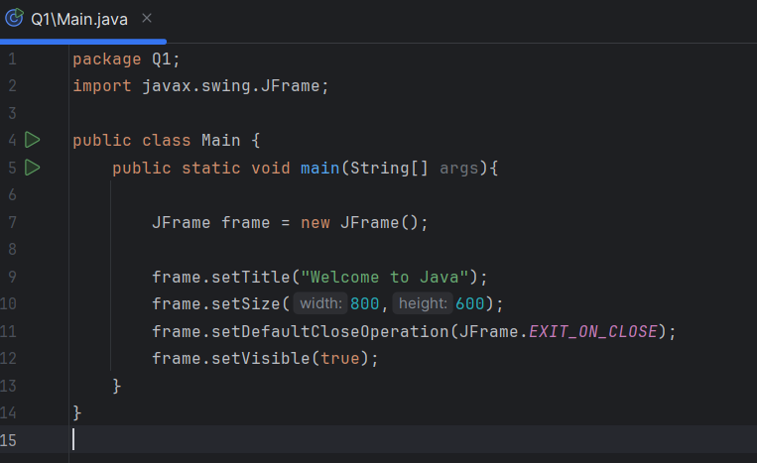

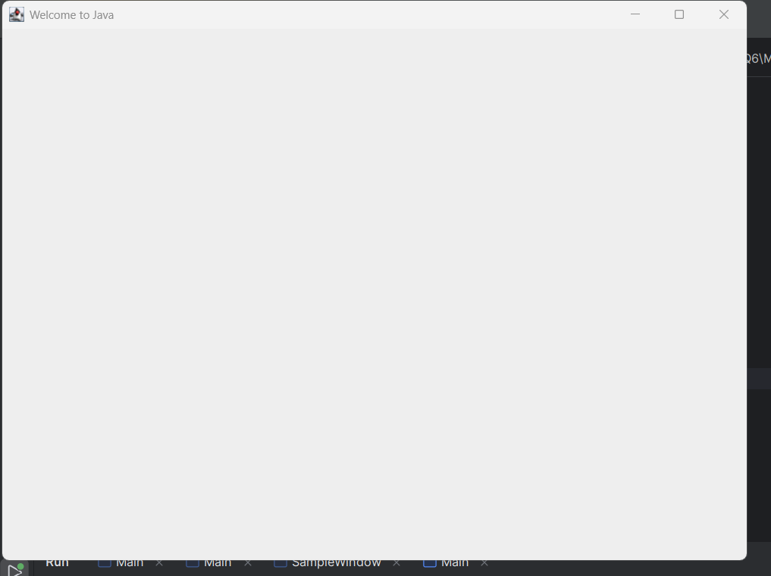
Q2. Input the user’s first and last name as two separate strings. Then display a frame window with its title set to the input values (User’s full name). For example, if the input values are James and Bond, the title would be James Bond.

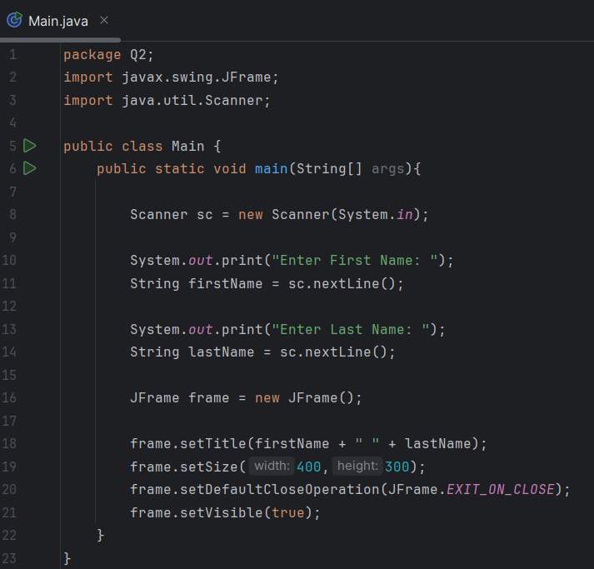

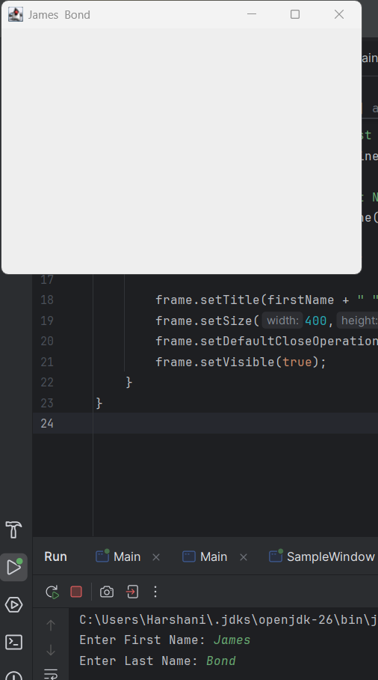
Q3. Input the user’s first, middle, and last name as three separate strings and display the name in the order of the first name, the middle initial, and the last name. Include the period after the middle initial. If the input strings are Jonathan, John, and Wick, for example, the output would be Jonathan J. Wick. Use the console window for output.

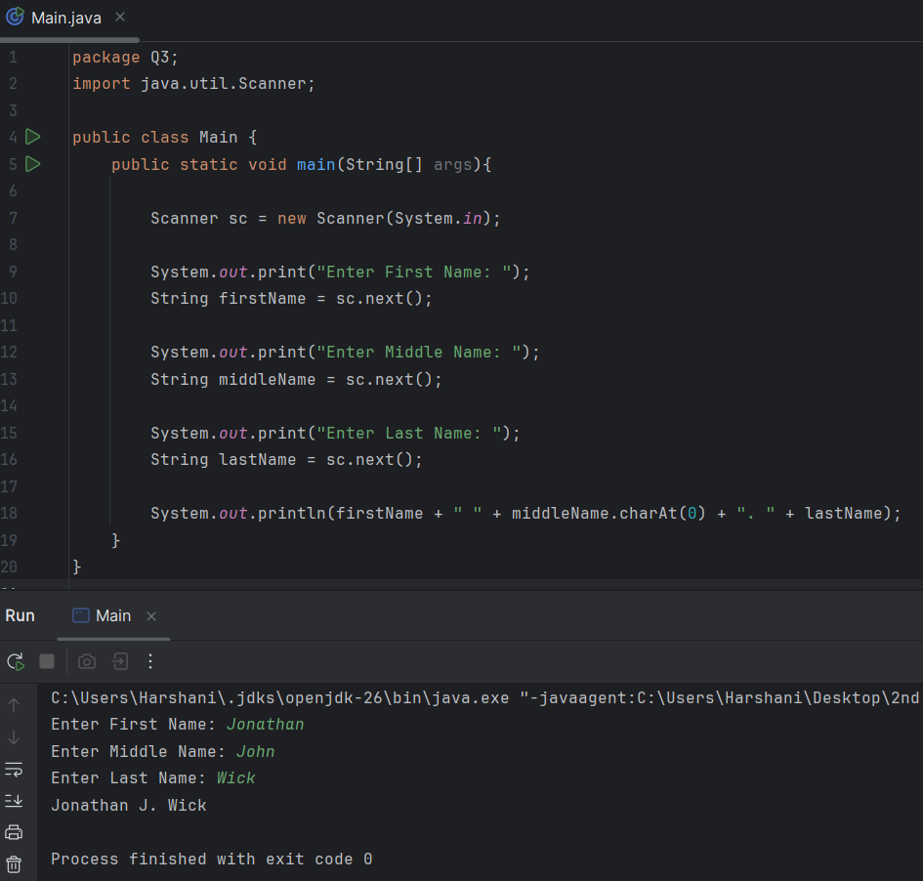

Q4. Write a program to display today’s date in this format: 17 May 2023. Use the console window for output.

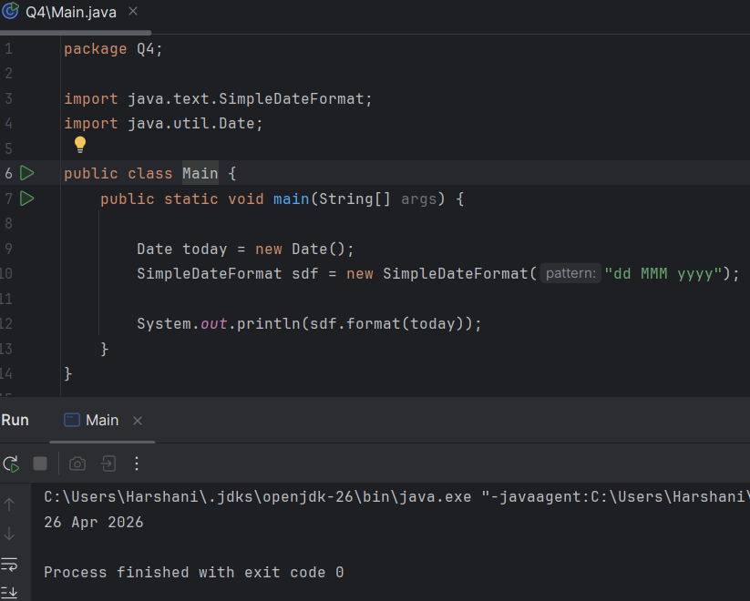

Q5. Repeat Exercise 4, but this time use this format: Wednesday, May 10, 2023

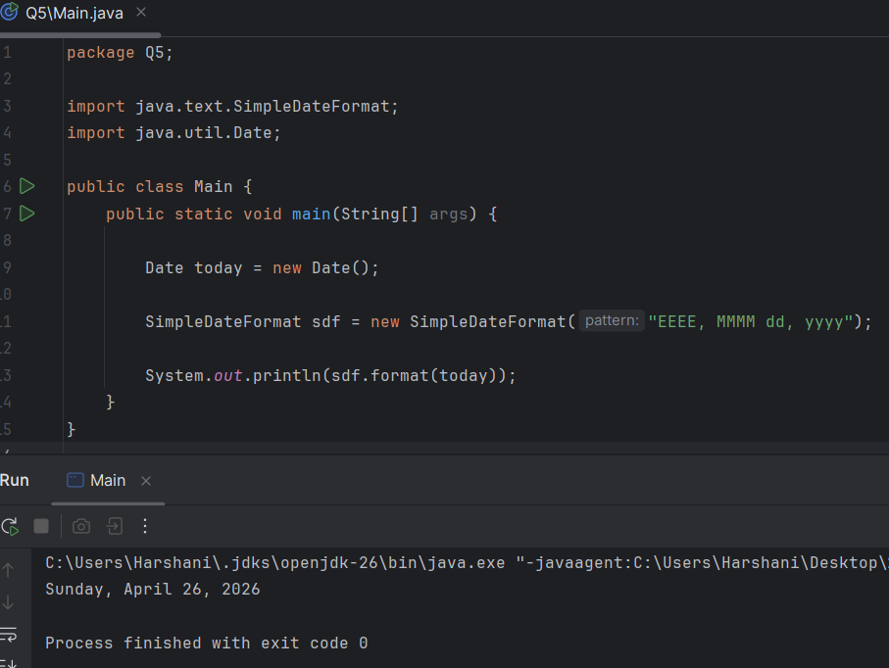

Q6. Write a program that displays a frame window W pixels wide and H pixels high. Use the Scanner to enter the values for W and H. The title of the frame is also entered by the user.

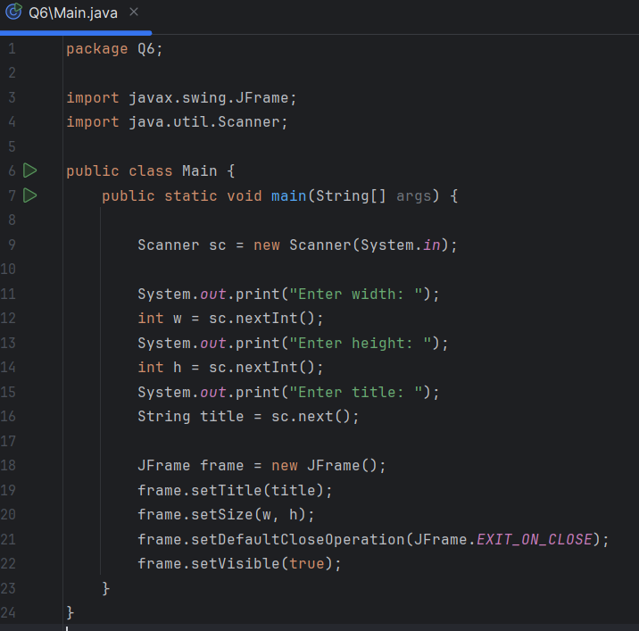
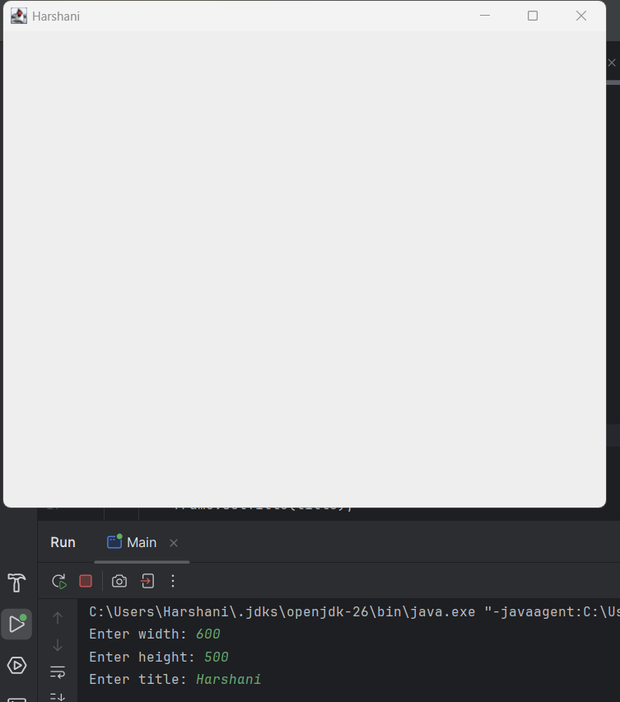

Q7. Display the current time in the title of a frame window using this format: 12:45:43 PM

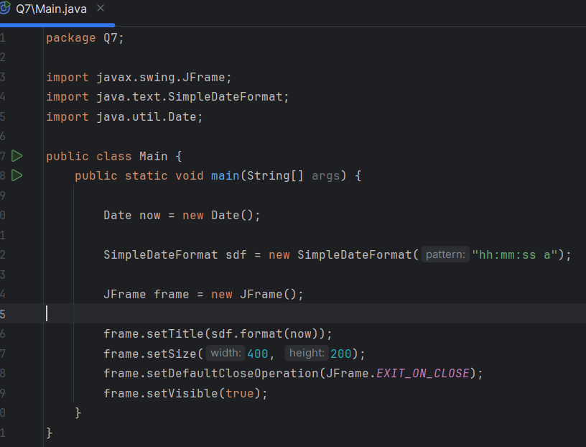

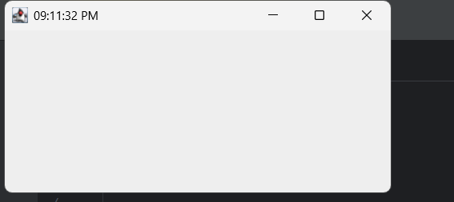
Q8. Using the Scanner, input a string that contains a single exclamation mark. Divide the input string into two strings, one before and the other after the exclamation mark, and output them. Do not include the exclamation mark in the output. For example, if the input string is one potato two potato ! three potato, then the output would be
one potato two potato
three potato
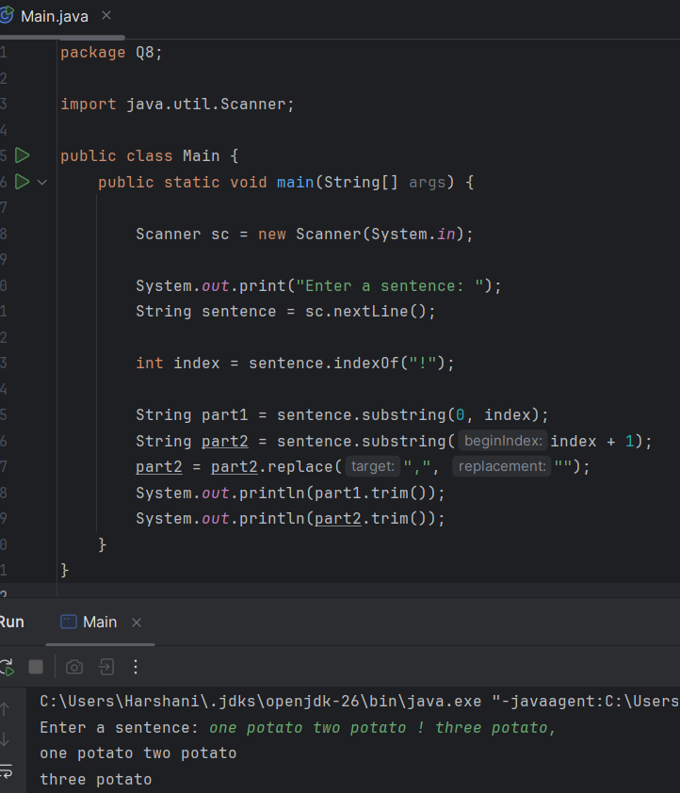
Q9. Write a program that accepts a string input and outputs the number of characters in the string and the first and last characters in separate lines. For example, if the input is I like Java then the output would be,
11
I
a
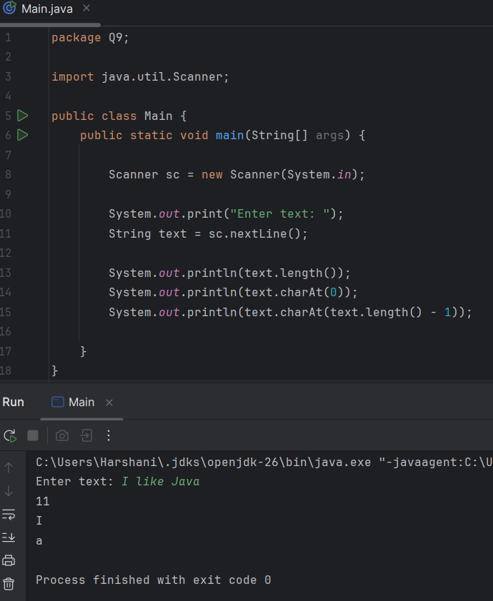
Q10. Write a program that accepts an odd-length word and prints out the middle character. For example, if the input is magnificent, which has 11 characters, you output the sixth character f.

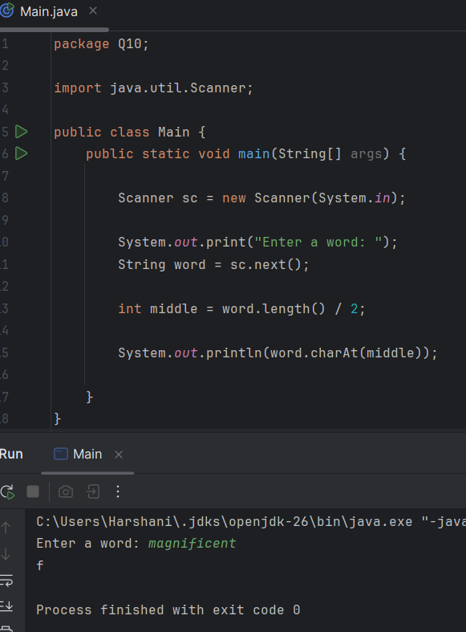
Q11. Write a program that asks the user for her or his full name in the format first middle last and replies with the name in the format last, first middle-initial. where the last name is followed by a comma and the middle initial is followed by a period. For example, if the input is Anthony Edward Stark then the output is Stark, Anthony E.

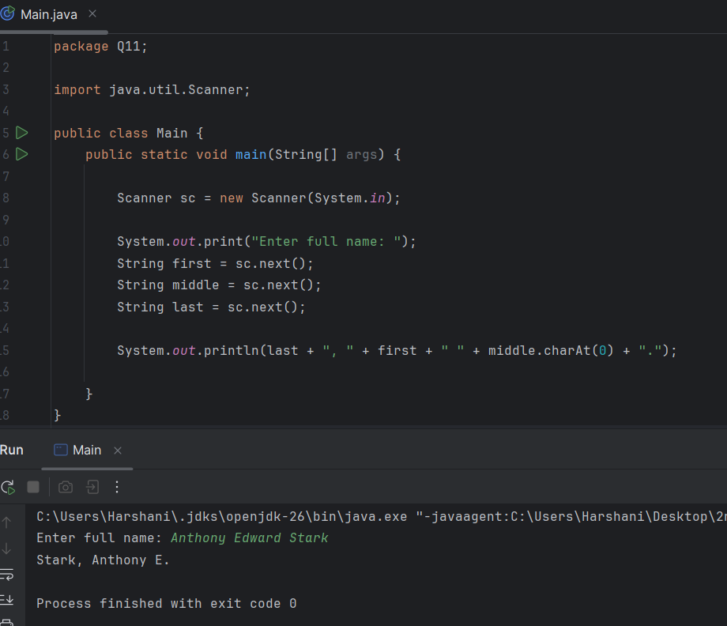

Q12. Write a Java program that displays a frame window 300 pixels wide and 200 pixels high with the title My First Frame. Place the frame so that its top left corner is at a position 50 pixels from the top of the screen and 100 pixels from the left of the screen.
• To position a window at a specified location, you can use the setLocation method like this, frame.setLocation( 50, 50 );
• Through experimentation, determine how the two arguments in the setLocation method affect the positioning of the window.

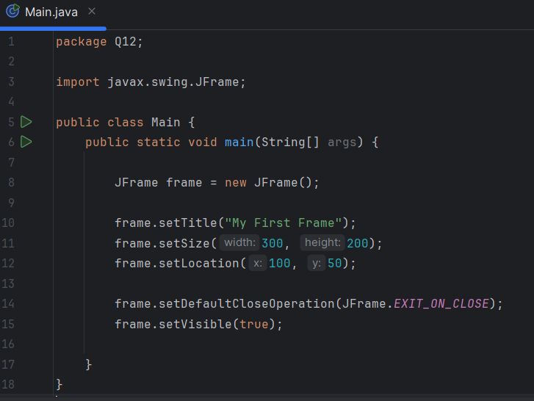
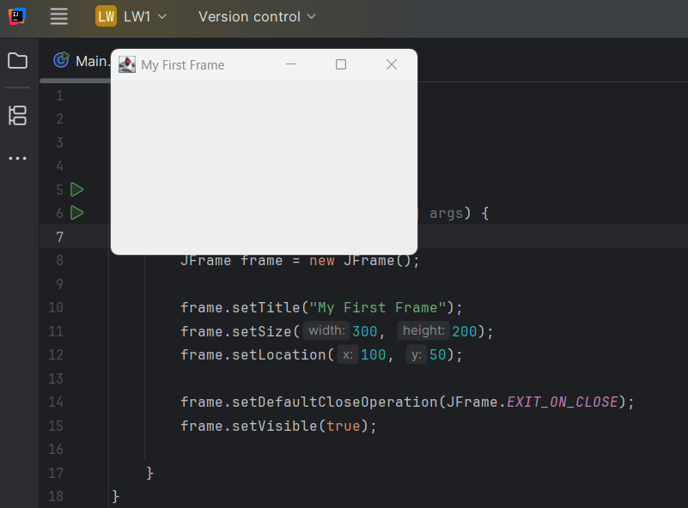

Extra Practical

