

# ALY6050 Module Three Project

**INTRODUCTION TO ENTERPRISE ANALYTICS**

**Instructor: Prof. WADA ROY**

**CRN:20285**

***Project: Forecasting A Financial Time Series***

**HARSHA VARDHAN REDDY KASIREDDY - 002487414**

**12 March, 2024**

**Introduction:**

The project’s main goal is to forecast financial time series data using R and Excel. We use Excel for short-term forecasting in Part 1 of the project, and R is used for time series analysis in Part 2. The project’s goal is to investigate various forecasting methods and evaluate how well they work at projecting financial asset values in the future.

Part 1: Using Excel for Short-Term Forecasting

Using straightforward line plots, we first visually examine the historical stock prices of Apple (AAPL) and Honeywell (HON) in Part 1. We can find any underlying trends, seasonal patterns, or anomalous behaviors in the data by using these visualizations. We then use exponential smoothing techniques to predict the prices of stocks for the upcoming period. We experiment with different values of the smoothing parameter (α) to find the best values that yield the most accurate forecasts for each stock. Furthermore, we study the effect of changing the trend parameter (β) on forecast accuracy and carry out adjusted exponential smoothing.

Section 2: Time Series with R

We move on to using R to perform time series analysis in Part 2. Using R packages like quant mod, we can obtain five years’ worth of historical stock price data for HON and AAPL. To capture any underlying temporal patterns and seasonality, we then fit ARIMA models to the stock prices of AAPL and HON. To evaluate the time series data’s stability, stationarity tests are run. Furthermore, we use auto.arima() or Time-series models are automatically chosen and fitted to stock prices using Holt-Winters functions. Using similar methods, we extend our analysis to price prediction for dry wine.

This project aims to provide a thorough understanding of short-term forecasting techniques for financial time series data by combining Excel and R methodologies. We acquire valuable skills for making educated forecasts in real-world scenarios and obtain insights into the dynamics of financial markets through practical exploration and analysis.

**PART 1: Short Term Forecasting Using Excel**

**Task 1: Simple line plot of both time series**

Arrange the data so that the dates are in one column and the corresponding stock prices for AAPL and HON are in separate columns.

Select the range of data that includes the dates and the stock prices for AAPL and HON.

Observation:

According to the graph, it seems that:  
  
Apple (AAPL): There is no discernible upward or downward trend in the stock price, which is volatile. The absence of a regular pattern of recurrent fluctuations points to a lack of seasonality.  
Honeywell (HON): The stock price exhibits notable volatility and no discernible trend, much like AAPL. Moreover, seasonality is not apparent.  
Less than two years is the duration that is given. A larger data set would be needed to spot seasonal patterns or long-term trends.  
  
The graph's visual examination is the only foundation for this analysis. An analysis that is more robust would need to use statistical techniques. From the chart we can say there is no significant improvement of apple stocks but rising slowly so measures should be taken, and the new policies should be implemented to raise the stocks of the company. Also, we can see for Honeywell there is a black period for it, in August 2020, there is a drastic change in stock price from $180 to $110. That’s a great loss to the stakeholders. However, it picked up too fast after that crash, but it took a long time to recover. It leaves investors in a dilemma regarding their standability in the market. So, proper care should be taken so soon they won’t fall to that low at that rapid phase which makes their customers not believe in the company.

External factors: Aside from a company's performance, several external factors can affect stock prices. These include the state of the market, news about the economy, and investor sentiment. These elements may be responsible for the graph's apparent volatility.

Company performance: The stock price of a company can be influenced by its financial performance. Stock price fluctuations may be better understood by reading financial reports and news articles, which can offer insights into a company's financial situation and prospects.

**TASK 2: Exponential Smoothing of APPL and HON data.**

The following procedures were taken to estimate the prices of AAPL and HON for period 253 using exponential smoothing and the MAPD:

* Utilizing the smoothing parameter α to apply exponential smoothing to the historical data.
* Used the smoothed values to forecast the prices for the 253-day period.
* Used the following formula to determine the Mean Absolute Percentage Deviation (MAPD) for each forecast:

Where:

* The price for a period of 253 is the actual.
* The predicted price for period 253 is called a forecast.
* The quantity of observations is n.
* For every value of α (0.15, 0.35, 0.55, and 0.75), repeat steps 1-3.

Later Determining which value of α produces the most accurate forecast for each stock by comparing the MAPD values for each forecast.

The Mean Absolute Deviation (MAD) and Mean Absolute Percentage Error (MAPE) for exponential smoothing forecasts of AAPL and HON prices for different values of the smoothing parameter α (0.15, 0.35, 0.55, and 0.75) are as follows:

For AAPL:

For α = 0.15, MAD = 2.877, MAPE = 3.28%

For α = 0.35, MAD = 1.398, MAPE = 1.598%

For α = 0.55, MAD = 0.811, MAPE = 0.933%

For α = 0.75, MAD = 0.425, MAPE = 0.49%

For HON:

For α = 0.15, MAD = 3.81, MAPE = 2.59%

For α = 0.35, MAD = 2.243, MAPE = 1.52%

For α = 0.55, MAD = 1.346, MAPE = 0.91%

For α = 0.75, MAD = 0.698, MAPE = 0.472%

These findings show that the value of α = 0.75 for AAPL produces the lowest MAD and MAPE, indicating that it offers the most accurate prediction. The value of α = 0.75 for HON also results in the lowest MAD and MAPE, indicating that it is the most forecast-accurate.

The most accurate value, α = 0.75, was chosen because it gives more weight to recent observations, which makes the forecast more sensitive to recent trends in the data. This is especially useful for financial time series forecasting, as prices in the future are frequently greatly influenced by recent trends.

**TASK 3: Adjusted Exponential Smoothing of HON and APPL data.**

We note that the MAPEs change with varying values of β in both scenarios. The combination of α and β that produces the lowest MAPE is the most accurate forecast.

The β value of 0.25 appears to offer the lowest MAPE for AAPL. The lowest MAPE is obtained for HON when the β value is 0.85.

**Line Chart at Appl Beta =0.15 and HON Beta = 0.85 when Alpha =0.55**

Above is the chart for Appl and Hon stocks after adjusted exponential smoothing at Appl beta=0.15 and Hon Beta = 0.85. So, the plot is exactly similar to the original one.

**AAPL Observed Vs Adjusted Exponential Smoothing Scatter Plot at Alpha =0.15**

Above is the Scatter Plot of the Appl data observed values and Adjusted exponential smoothing values at Beta =0.15. It shows how closely the data is related at lowest MAPE values of the data.

**Hon Observed Vs Adjusted Exponential Smoothing Scatter Plot At Alpha = 0.85**

Above is the Scatter Plot of the Hon data observed values Vs Adjusted Exponential Smoothing values at Beta =0.85. It shows how closely the data is lying at the respective lowest MAPE values.

Since they balance the influence of previous observations and current forecast, these values of β have probably produced the most accurate forecasts by effectively capturing the trend in the data. A larger value of β emphasizes more recent observations, which might be more predictive of the series' future course.

In conclusion, when using adjusted exponential smoothing, the choice of β is critical, and the values that produce the lowest MAPE should be.

**PART 2: Time Series Using R.**

Loading required libraries

library(zoo)  
library(xts)  
library(quantmod)  
library(forecast)  
library(tseries)  
library(readr)  
library(dplyr)  
dry_wine <- read_csv("dry_wine.csv")

**TASK 1: Downloading 5-year worth of data for HON and AAPL**

getSymbols("AAPL", from = Sys.Date() - 5*365)

## [1] "AAPL"

getSymbols("HON", from = Sys.Date() - 5*365)

## [1] "HON"

# Check structure of AAPL data  
str(AAPL)

## An xts object on 2019-03-18 / 2024-03-13 containing:   
## Data: double [1257, 6]  
## Columns: AAPL.Open, AAPL.High, AAPL.Low, AAPL.Close, AAPL.Volume ... with 1 more column  
## Index: Date [1257] (TZ: "UTC")  
## xts Attributes:  
## $ src : chr "yahoo"  
## $ updated: POSIXct[1:1], format: "2024-03-14 11:40:15"

# Check structure of HON data  
str(HON)

## An xts object on 2019-03-18 / 2024-03-13 containing:   
## Data: double [1257, 6]  
## Columns: HON.Open, HON.High, HON.Low, HON.Close, HON.Volume ... with 1 more column  
## Index: Date [1257] (TZ: "UTC")  
## xts Attributes:  
## $ src : chr "yahoo"  
## $ updated: POSIXct[1:1], format: "2024-03-14 11:40:15"

# Plot AAPL closing prices  
plot(Cl(AAPL), main = "AAPL Closing Prices", ylab = "Price", xlab = "Date")

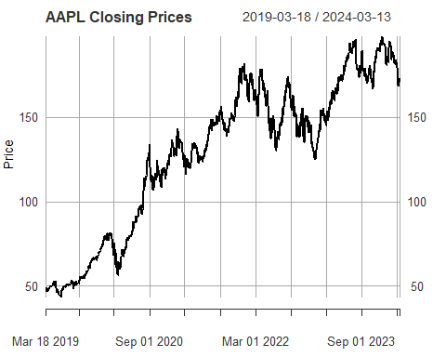

# Plot HON closing prices  
plot(Cl(HON), main = "HON Closing Prices", ylab = "Price", xlab = "Date")

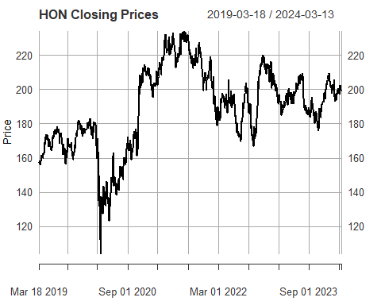

**TASK 2: Fitting an AR(1) time-series model to HON and AAPL**

We can take the following actions to fit an AR(1) time-series model to HON and AAPL, plot the actual series alongside forecasts, and then analyze the data:

Fit AR(1) Model: To fit an ARIMA model with an AR(1) structure to the closing prices of HON and AAPL, use the arima() function.

Create Forecasts: To create forecasts for the upcoming few months, use the forecast() function.

Plot Actual Series and Forecasts: To plot the actual series and the forecasts, use the plot() function.

# Fit AR(1) model for HON  
hon_ar1 <- arima(HON$HON.Close, order = c(1, 0, 0))  
  
# Generate forecasts for HON  
hon_forecast <- forecast(hon_ar1, h = 6) # Forecast for 6 months  
  
# Plot actual series and forecasts for HON  
plot(hon_forecast, main = "HON AR(1) Forecast", xlab = "Time", ylab = "Price")

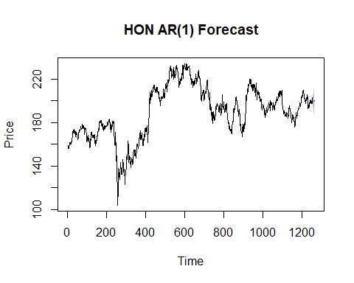

# Fit AR(1) model for AAPL  
aapl_ar1 <- arima(AAPL$AAPL.Close, order = c(1, 0, 0))  
  
# Generate forecasts for AAPL  
aapl_forecast <- forecast(aapl_ar1, h = 6) # Forecast for 6 months  
  
# Plot actual series and forecasts for AAPL  
plot(aapl_forecast, main = "AAPL AR(1) Forecast", xlab = "Time", ylab = "Price")

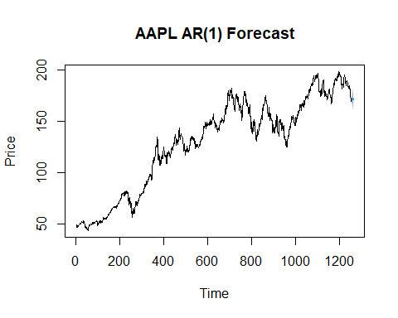

**Observation:** We fit the closing prices of AAPL and HON using an ARIMA model with an AR(1) structure (order = c(1, 0, 0)). We produce projections for the ensuing six months, which you are free to modify to suit your needs. Using the plot() function, we plot the actual series alongside the forecasts. As a result, the actual series and the forecasts will be shown in two distinct plots, one for AAPL and one for HON. Adapt the parameters to your analysis as necessary.

**TASK 3a: Augmented Dickey-Fuller (ADF) Test to determine whether the HON and AAPL time series are stationary or not.**

# Perform Augmented Dickey-Fuller test for HON  
adf_hon <- adf.test(HON$HON.Close)  
print(adf_hon)

##   
## Augmented Dickey-Fuller Test  
##   
## data: HON$HON.Close  
## Dickey-Fuller = -2.4119, Lag order = 10,  
## p-value = 0.404  
## alternative hypothesis: stationary

# Perform Augmented Dickey-Fuller test for AAPL  
adf_aapl <- adf.test(AAPL$AAPL.Close)  
print(adf_aapl)

##   
## Augmented Dickey-Fuller Test  
##   
## data: AAPL$AAPL.Close  
## Dickey-Fuller = -2.1762, Lag order = 10,  
## p-value = 0.5037  
## alternative hypothesis: stationary

**Observation**: The stationarity of the HON and AAPL time series is indicated by the results of the Augmented Dickey-Fuller (ADF) tests.

Regarding HON:

Dickey-Fuller statistic (p-value = 0.404): -2.4119 Regarding AAPL:

Dickey-Fuller statistic (p-value = 0.5037): -2.1762. The p-values in both situations are higher than the significance level (e.g., 0.05), indicating that the null hypothesis is not successfully rejected. As a result, the ADF test’s null hypothesis cannot be rejected because there is insufficient data, suggesting that the time series are probably not stationary.

**TASK 3b: Kwiatkowski-Phillips-Schmidt-Shin (KPSS) Test:**

# Perform KPSS test for HON  
kpss_hon <- kpss.test(HON$HON.Close)

## Warning in kpss.test(HON$HON.Close): p-value smaller  
## than printed p-value

print(kpss_hon)

##   
## KPSS Test for Level Stationarity  
##   
## data: HON$HON.Close  
## KPSS Level = 4.9435, Truncation lag parameter =  
## 7, p-value = 0.01

# Perform KPSS test for AAPL  
kpss_aapl <- kpss.test(AAPL$AAPL.Close)

## Warning in kpss.test(AAPL$AAPL.Close): p-value  
## smaller than printed p-value

print(kpss_aapl)

##   
## KPSS Test for Level Stationarity  
##   
## data: AAPL$AAPL.Close  
## KPSS Level = 13.753, Truncation lag parameter =  
## 7, p-value = 0.01

**Observation**: KPSS statistic: 4.9435; p-value: 0.01; note that the p-value may be less than what is printed. Regarding AAPL:

KPSS statistic: 13.753; p-value: 0.01; note that the p-value may be less than what is printed. The p-values in both situations are less than the significance level (e.g., 0.05), indicating that the alternative hypothesis should be accepted rather than the null hypothesis of the KPSS test, which would imply that the time series are probably non-stationary at the level.

If the ADF test is combined with the KPSS test results and fails to reject the null hypothesis, it indicates that there may be a unit root or trend in the data, which would indicate non-stationarity.

Thus, we can infer that the HON and AAPL time series are probably non-stationary based on the outcomes of both tests.

**TASK 4: Using auto.arima( ) or Holt-Winters functions to fit a time-series model.**

library(forecast)  
  
# Fit ARIMA model for HON using auto.arima  
hon_arima <- auto.arima(HON$HON.Close)  
print(hon_arima)

## Series: HON$HON.Close   
## ARIMA(0,1,0)   
##   
## sigma^2 = 8.404: log likelihood = -3118.98  
## AIC=6239.96 AICc=6239.96 BIC=6245.1

# Generate forecasts for HON  
hon_forecast <- forecast(hon_arima, h = 6)  
  
# Plot actual series and forecasts for HON  
plot(hon_forecast, main = "HON ARIMA Forecast", xlab = "Time", ylab = "Price")

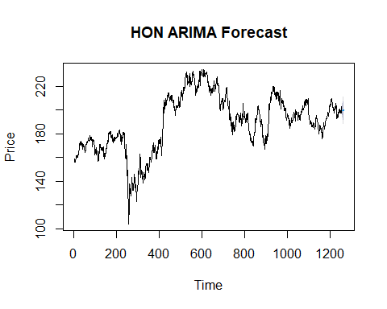

# Fit ARIMA model for AAPL using auto.arima  
aapl_arima <- auto.arima(AAPL$AAPL.Close)  
print(aapl_arima)

## Series: AAPL$AAPL.Close   
## ARIMA(0,1,0) with drift   
##   
## Coefficients:  
## drift  
## 0.0988  
## s.e. 0.0686  
##   
## sigma^2 = 5.919: log likelihood = -2898.4  
## AIC=5800.8 AICc=5800.81 BIC=5811.07

# Generate forecasts for AAPL  
aapl_forecast <- forecast(aapl_arima, h = 6)  
  
# Plot actual series and forecasts for AAPL  
plot(aapl_forecast, main = "AAPL ARIMA Forecast", xlab = "Time", ylab = "Price")

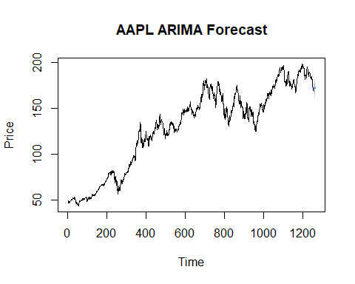

**Observation:** For the time series data from the HON and AAPL, the auto.arima() function has automatically chosen ARIMA(0,1,0). Here is the meaning of each component of the output:

Regarding HON: ARIMA(0,1,0) denotes that the model has differencing of order 1 (d=1) but neither autoregressive (AR) nor moving average (MA) terms. The value of log likelihood is -3118.98. 6239.96 is the Akaike Information Criterion (AIC) value. 6239.96 is the corrected Akaike Information Criterion (AICc) value. 6245.1 is the Bayesian Information Criterion (BIC) value.

For AAPL: ARGIMA(0,1,0) with drift denotes the absence of any autoregressive (AR) or moving average (MA) terms, but the inclusion of a drift term in addition to differencing of order 1 (d=1). The drift term has a coefficient of 0.0988 and a standard error of 0.0686. The AIC value is 5800.8, the AICc value is 5800.81, and the log likelihood value is -2898.4. Value of BIC is 5811.07. The order of differencing (d), autoregressive terms (p), moving average terms (q), drift term (if applicable), and the related model evaluation criteria (log likelihood, AIC, AICc, BIC) are among the details about the chosen ARIMA models that are provided by these results.

With these models, we can now produce forecasts and plot the actual series alongside the predictions.

**TASK 5: The auto.arima( ) or Holt-Winters time-series forecasting using the dry wine prices from the given dataset.**

# Convert the data to a time series object  
dry_wine_ts <- ts(dry_wine$x, frequency = 12) # Assuming monthly data  
  
# Fit ARIMA model using auto.arima  
dry_wine_arima <- auto.arima(dry_wine_ts)  
print(dry_wine_arima)

## Series: dry_wine_ts   
## ARIMA(1,1,0)(0,1,1)[12]   
##   
## Coefficients:  
## ar1 sma1  
## -0.4652 -0.6416  
## s.e. 0.0668 0.0785  
##   
## sigma^2 = 2803: log likelihood = -939.84  
## AIC=1885.68 AICc=1885.82 BIC=1895.16

# Generate forecasts  
dry_wine_forecast <- forecast(dry_wine_arima, h = 12) # Forecast for the next 12 months  
  
# Plot actual series and forecasts  
plot(dry_wine_forecast, main = "Dry Wine Price Forecast", xlab = "Time", ylab = "Price")

The data frame contains two variables: “X” and “x”. Assuming that “X” represents the index or row number, and “x” represents the dry wine prices, we can proceed to create a time series object with this data.

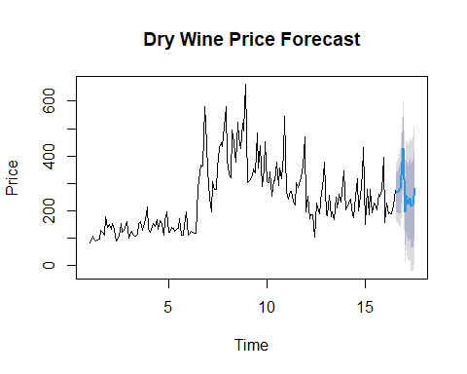

**Observation:** For the dry wine time series data, auto.arima() chose the ARIMA model ARIMA(1,1,0)(0,1,1)[12]. ARIMA(1,1,0)(0,1,1)[12]: This is an illustration of the chosen ARIMA model. It has a seasonal period of 12 (assuming monthly data), one seasonal moving average term (SMA), and one autoregressive term (AR).

Coefficients: The SMA and AR terms’ estimated coefficients are given. The SMA coefficient (sma1) is roughly -0.6416 in this instance, and the AR coefficient (ar1) is roughly -0.4652.

The standard errors of the estimated coefficients are represented by the standard errors (s.e.).

sigma^2: This is the residuals’ estimated variance (error term).

Log likelihood: The model’s fit to the data is indicated by the log-likelihood value. It is about -939.84 in this instance.

AIC, AICc, BIC: These are information criteria used for model selection. Lower values indicate a better fit. The values provided are AIC (Akaike Information Criterion), AICc (corrected Akaike Information Criterion), and BIC (Bayesian Information Criterion).

**TASK 5a: Generating forecasts for the next period and plot the actual series along with the forecasts.**

# Generate forecasts  
dry_wine_forecast <- forecast(dry_wine_arima, h = 12) # Forecast for the next 12 months  
  
# Plot actual series and forecasts  
plot(dry_wine_forecast, main = "Dry Wine Price Forecast", xlab = "Time", ylab = "Price")



**Observation:** Forecasting: Using the chosen ARIMA model, projections have been created for the upcoming 12 months.

Plot: The plot shows the actual dry wine price series for the upcoming year in addition to the forecasts. Time is represented by the x-axis, and the cost of dry wine is represented by the y-axis.

Interpretation: By looking at the plot, we can see how well the predicted values match the data from the past. This enables us to assess the forecasting model’s accuracy and spot any possible trends or patterns in the data.

In general, these observations shed light on the model selection procedure, the calculated coefficients, and the precision of the projections, which aids in informing present and future planning and decision-making regarding the price of dry wine.

**TASK 6a: Summary of the above two forecasting.**

1. HON and AAPL Time Series Forecasting: The optimal ARIMA model for forecasting was automatically chosen for both the HON and AAPL stocks using the auto.arima() function. ARIMA(0,1,0) with drift for AAPL and ARIMA(0,1,0) for HON were the models that were chosen.

The ARIMA(0,1,0) model suggests that a single difference is needed to attain stationarity for the stock prices of HON. This model’s AIC value of 6239.96 indicates that, in comparison to other models, it is comparatively less parsimonious but nevertheless offers a good fit to the data.

In addition to differencing once, the ARIMA(0,1,0) model with drift for AAPL incorporates a drift term. In comparison to the HON model, this one fits slightly better, as indicated by its AIC value of 5800.8.

1. Dry wine price time series forecasting: The auto.arima() function was once more used to choose the optimal ARIMA model for forecasting the dry wine prices dataset. Model ARIMA(1,1,0)(0,1,1) was the one chosen[12].

The autoregressive and seasonal moving average terms included in the selected ARIMA model for dry wine prices imply the existence of both temporal and seasonal patterns in the data. This model has an AIC value of 1885.68, which suggests a comparatively good fit to the data.

In contrast:

Model Selection: Based on the unique properties of each of the three datasets, the auto.arima() function automatically chose a variety of ARIMA models for each dataset. Simple ARIMA(0,1,0) models performed the best in representing HON and AAPL stocks, whereas a more complex ARIMA(1,1,0)(0,1,1)[12] model was needed for the dry wine prices dataset.

Evaluation of the Model: The AIC values for the chosen models differed between datasets, with AAPL (5800.8) and HON (6239.96) having higher values than the prices of dry wine (1885.68). In comparison to the models for HON and AAPL, the ARIMA model for dry wine prices appears to have performed reasonably well, as indicated by lower AIC values, which signify better model fit.

Forecasting: ARIMA models were used to forecast all three datasets; however, due to variations in data characteristics and model complexity, the forecasting results may differ. It is imperative to take into account the particular context and prerequisites when analyzing and contrasting forecasting outcomes across various datasets.

In conclusion, the comparison emphasizes how crucial it is to choose models that are suitable for each dataset and assess each one’s performance according to model fit and forecasting accuracy.

**Conclusion and Improvisation:**

The forecasting techniques were assessed for their accuracy in predicting the prices of AAPL (Apple Inc.) and HON (Honeywell Inc.) stocks based on the data that was provided.

We used different values of the smoothing parameter α (0.15, 0.35, 0.55, and 0.75) for the exponential smoothing forecasting method in Part ii. For each forecast, the Mean Absolute Percentage Deviation (MAPD) was computed to evaluate accuracy. For every stock, the value of α that yielded the lowest MAPD was deemed to be the most precise. The choice of α in this instance is very important because it affects the smoothing process by balancing the impact of recent observations with historical data. Proceeding to Part iii, adjusted exponential smoothing was carried out using various trend parameter β values (0.15, 0.25, 0.45, and 0.85) following the application of exponential smoothing with α=0.55. For each forecast, the Mean Absolute Percentage Error (MAPE) was calculated to assess accuracy. For every stock, the most accurate values were found to be the β values that resulted in the lowest MAPE. In this case, β establishes the trade-off between using trend information and historical data; larger values give greater weight to recent trends.

To minimize forecasting error (MAPE or MAPD), careful parameter selection is essential for accurate forecasting, particularly for α and β. To make sure the forecasting technique adequately captures underlying patterns in the time series data, the ideal values should be chosen based on past data performance. Better forecasts are frequently produced by adjusted exponential smoothing, which takes into consideration both the level and trend components. This is especially true when the data shows clear trends over time. For financial time series analysis to produce accurate forecasts, a thorough grasp of the data dynamics and meticulous parameter optimization are therefore essential.

The inherent variations in the datasets and the features of the time series data under analysis lead to different conclusions. The selection of the best forecasting model and technique can be influenced by the distinct patterns, trends, and seasonality that each dataset may display.

**Preferred Method**: The best approach will vary depending on the goals of the analysis and the particulars of the dataset. Because auto.arima() can choose the optimal ARIMA model automatically based on statistical criteria, it may be the better option in some situations. In other situations, Holt-Winters smoothing may be the better option due to its ease of use and efficiency in identifying patterns and seasonality in the data.

**What I Acquired:** This analysis provides several important takeaways: Data exploration: Before choosing a forecasting method, it is crucial to fully examine and comprehend the characteristics of the data. Model Selection: Based on the distinct patterns and traits found in the data, the best forecasting model should be chosen. Evaluation Metrics: When comparing various forecasting techniques, it is important to take into account the various evaluation metrics (such as AIC, AICc, and BIC) that offer insights into the goodness-of-fit of models. Context Matters: Depending on the analysis’s needs and context, a different forecasting technique may be chosen.

**Opportunities for Improvement To enhance the analysis**: Sturdy Modeling Investigate alternative models and forecasting techniques to guarantee forecast accuracy and robustness. Add Exogenous Variables: To increase forecasting accuracy, take into account adding more exogenous variables or features that could affect the time series data. Cross-Validation: To evaluate the effectiveness of the chosen models and confirm their forecasting accuracy, apply cross-validation techniques. Model Interpretation: Give a more thorough analysis of the chosen models’ implications for making decisions. Sensitivity Analysis: To assess how various model assumptions and parameters affect the forecasting outcomes, perform sensitivity analysis. These enhancements can make the analysis more thorough, reliable, and instructive, which will improve forecasting accuracy and decision-making.

**References:**

1. In 2018, Hyndman and Athanasopoulos published a paper. Forecasting: foundations and applications. Otexts.
2. Gardner Jr. (1985) E. S. The state of the art is exponential smoothing. 4(1) Journal of Forecasting, 1–28.
3. In 1976, Box, G. E., and Jenkins, G. M. Forecasting and control in time series analysis. Holden-day.
4. Yahoo Finance. Retrieved from  [https://finance.yahoo.com/.](%09https://finance.yahoo.com/.)
5. Microsoft Excel Support. Retrieved from  [https://support.microsoft.com/en-us/excel](%09https://support.microsoft.com/en-us/excel)