**1. Write a Python program to reverse the content of the string.**

**Do not use built in**

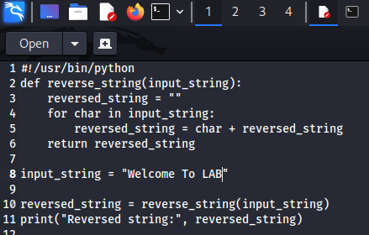

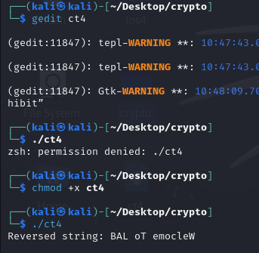

**2. Create a program that performs basic string compression using the counts of repeated characters. For example, the string “aabcccccaaa” would become “a2b1c5a3”.**

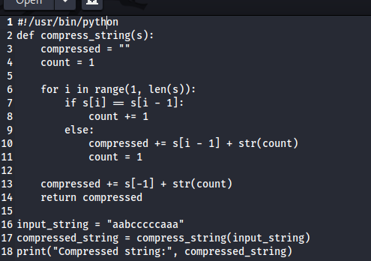

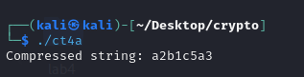

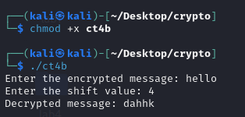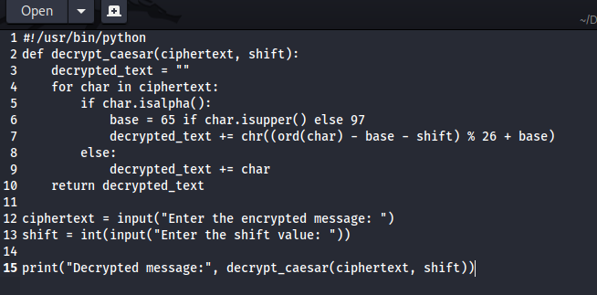**3. Get the Caesar cipher from the user Decrypt the cipher**

**4. Get the cipher encrypted using shift cipher. Identify the key used to encrypt using brute force**

**ie all the values in the key space**

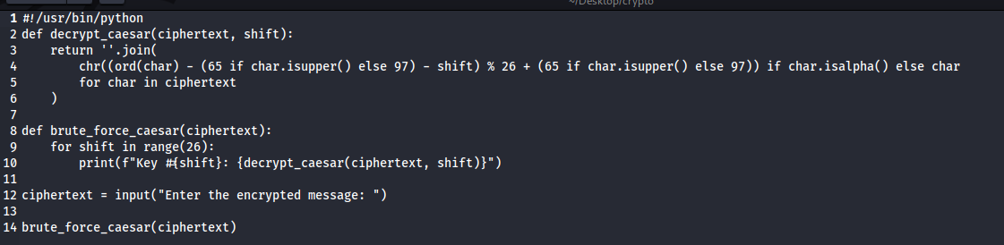

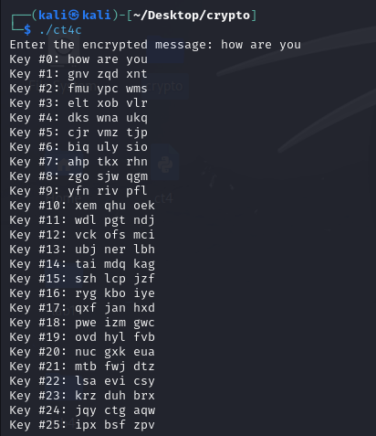

**5. Find the k value , Provided cipher text and plain text**

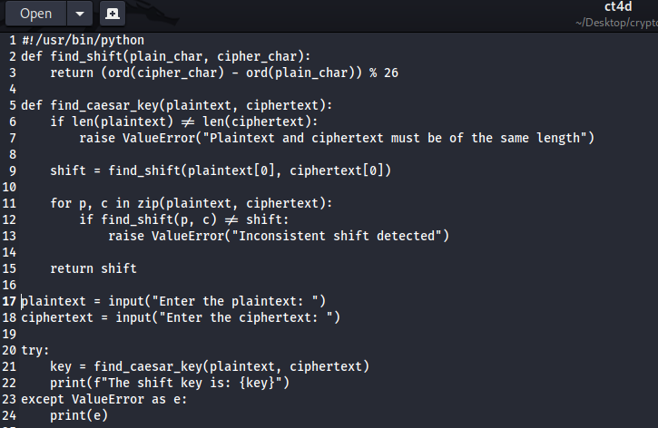

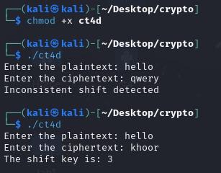

**6. Encrypt and decrypt the string using Atbash cipher**

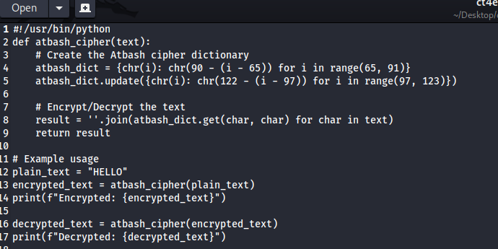

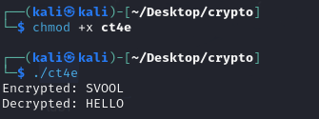

**7. Encrypt and decrypt using Affine cipher**

**add validation**

#!/usr/bin/python

def gcd(a, b):

while b != 0:

a, b = b, a % b

return a

def mod_inverse(a, m):

for x in range(1, m):

if (a * x) % m == 1:

return x

return None

def affine_encrypt(text, a, b):

if gcd(a, 26) != 1:

raise ValueError("a and 26 must be coprime.")

result = ""

for char in text:

if char.isalpha():

offset = 65 if char.isupper() else 97

result += chr(((a * (ord(char) - offset) + b) % 26) + offset)

else:

result += char

return result

def affine_decrypt(cipher, a, b):

if gcd(a, 26) != 1:

raise ValueError("a and 26 must be coprime.")

a_inv = mod_inverse(a, 26)

if a_inv is None:

raise ValueError("Multiplicative inverse for a does not exist.")

result = ""

for char in cipher:

if char.isalpha():

offset = 65 if char.isupper() else 97

result += chr(((a_inv * ((ord(char) - offset) - b)) % 26) + offset)

else:

result += char

return result

# Example usage

a = 5

b = 8

plain_text = "HELLO WORLD"

encrypted_text = affine_encrypt(plain_text, a, b)

print(f"Encrypted: {encrypted_text}")

decrypted_text = affine_decrypt(encrypted**_**text, a, b)

print(f"Decrypted: {decrypted_text}")