1. Print all the lines having the word "pattern".

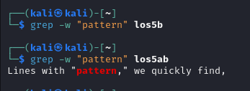

1. Pick out the blank lines in the file

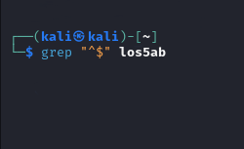

1. Count total number of empty lines in the file.

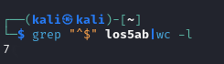

1. 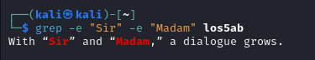Print the line which have both “Sir and Madam”.
2. pick out lines with “pattern1” “pattern2” or “pattern3”. (use the alternator |)

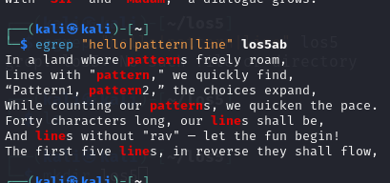

1. pick out lines that have at least two p's followed by any number of letters followed by 'ore'. The p's do not have to be next to each other.

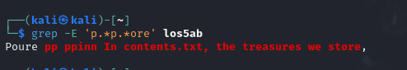

7. pick out all the lines with v, z or I in them

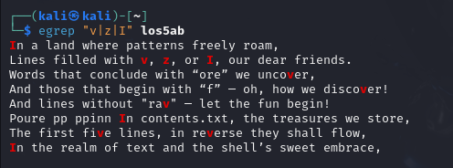

8. pick out all the lines that do not start with an uppercase letter.

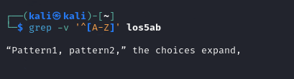

9. pick out all the lines that end with a dash –



10. pick out all the words that end with ore

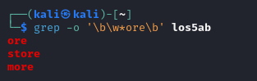

11. pick out all the words that start with f or F

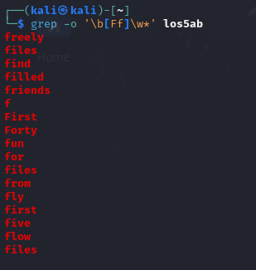

12. pick out lines that uses first letter alliteration - starting two words with the same letter.

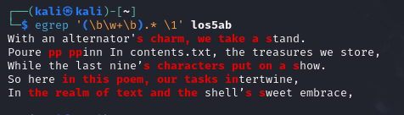

13. determine how many times contains the word "pattern".



14. to pick out lines with at least 40 characters:

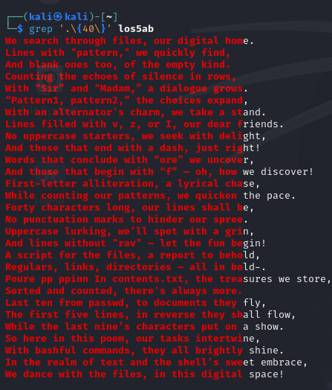

15. to pick out lines with no punctuation



16. to pick out lines with an uppercase letter other than the first character. (The first character on the line does not count.)

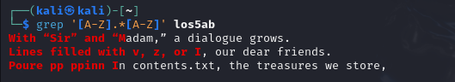

17. To pick out lines without rav

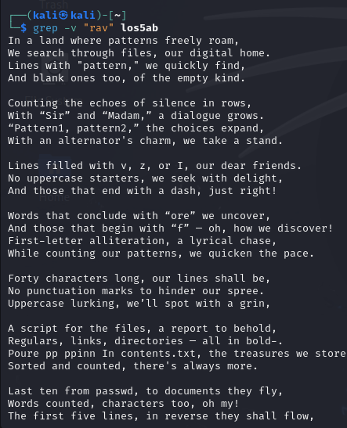

Quotes:

18. Write a shell script to generate a report with the following details.

- Number of regular files

- Number of links

- Number of directories

- Print the date when it was processed!

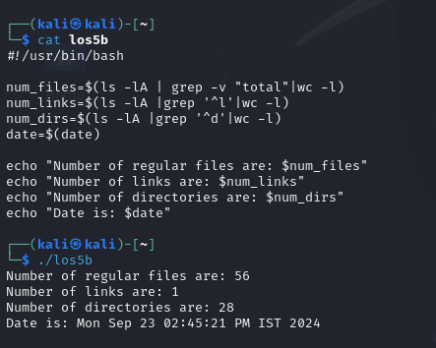

Redirection

19. List the contents of your current directory, including the ownership and permissions, and store the output to a file called contents.txt within your home directory.

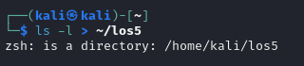

20. Sort the contents of the contents.txt file from your current directory and append it to the end of a new file named contents-sorted.txt.



21. Display the last 10 lines of the /etc/passwd file and redirect it to a new file in the your user’s Documents directory.



22. Count the number of words within the contents.txt file and append the output to the end of a file field2.txt in your home directory. You will need to use both input and output redirection.

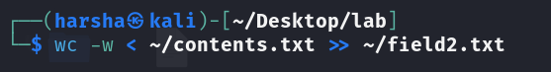

23. Display the first 5 lines of the /etc/passwd file and sort the output reverse alphabetically.

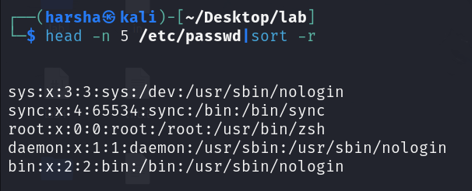

24. Using the previously created contents.txt file, count the number of characters of the last 9 lines.

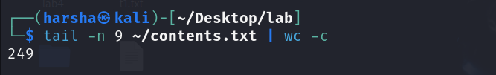

Debug

25. Debug the script 1_debug.sh

