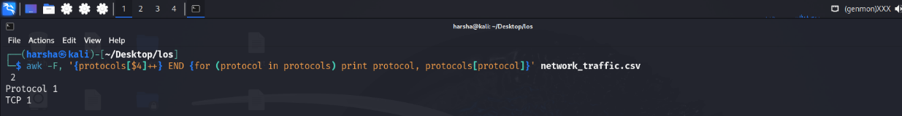
1.count how many packets use each protocol (TCP, UDP, ICMP)

2.filter and print only the dropped packets.
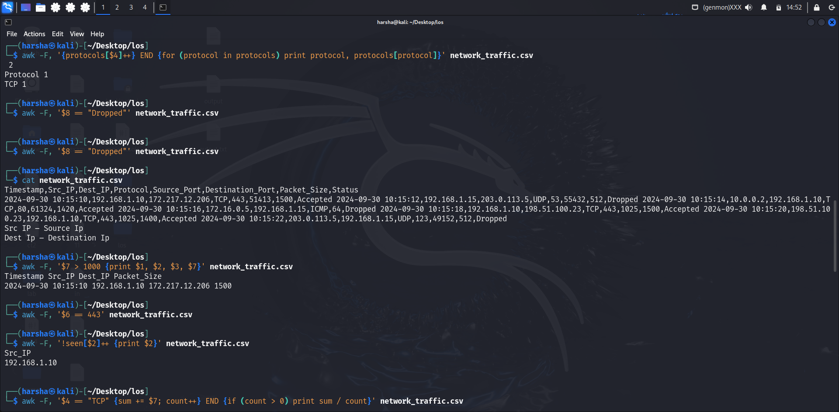

3.print the Timestamp, Source_IP, Destination_IP, and Packet_Size for packets that have a size greater than 1000 bytes.

4.display traffic that is directed to destination port 443.

5.print all unique Source_IP addresses from the network_traffic.csv file.

6.filter only TCP traffic and calculate the average packet size.
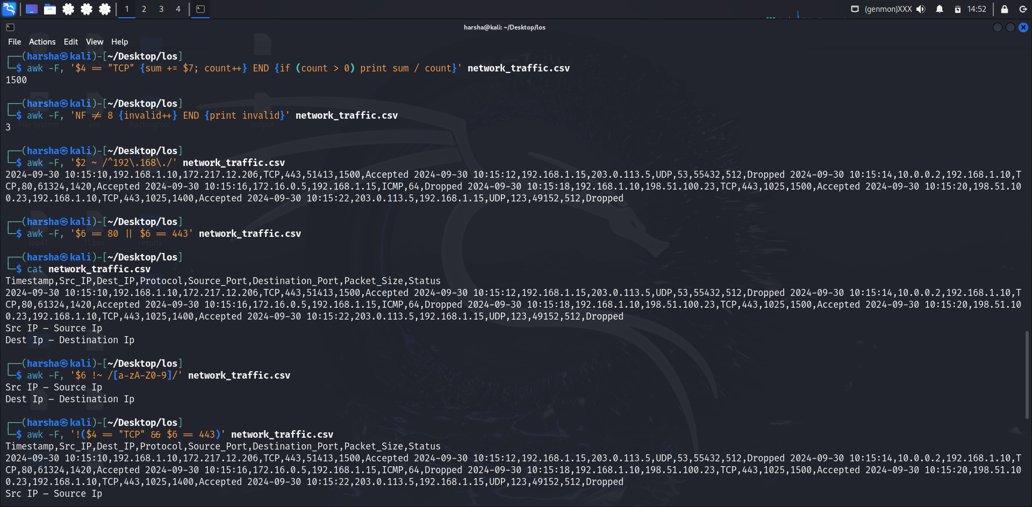

7.Count invalid records

8.extract and print all rows where the Source_IP is in the 192.168.x.x range.

9.match traffic directed to either port 80 (HTTP) or port 443 (HTTPS).

10.filter out rows where the Destination_Port contains any alphanumeric characters (letters or numbers).

11.filter out traffic where the protocol is TCP AND the destination port is 443 (HTTPS traffic).

12.filter out and print traffic where the Packet_Size is greater than 1000 OR the Status is Dropped.
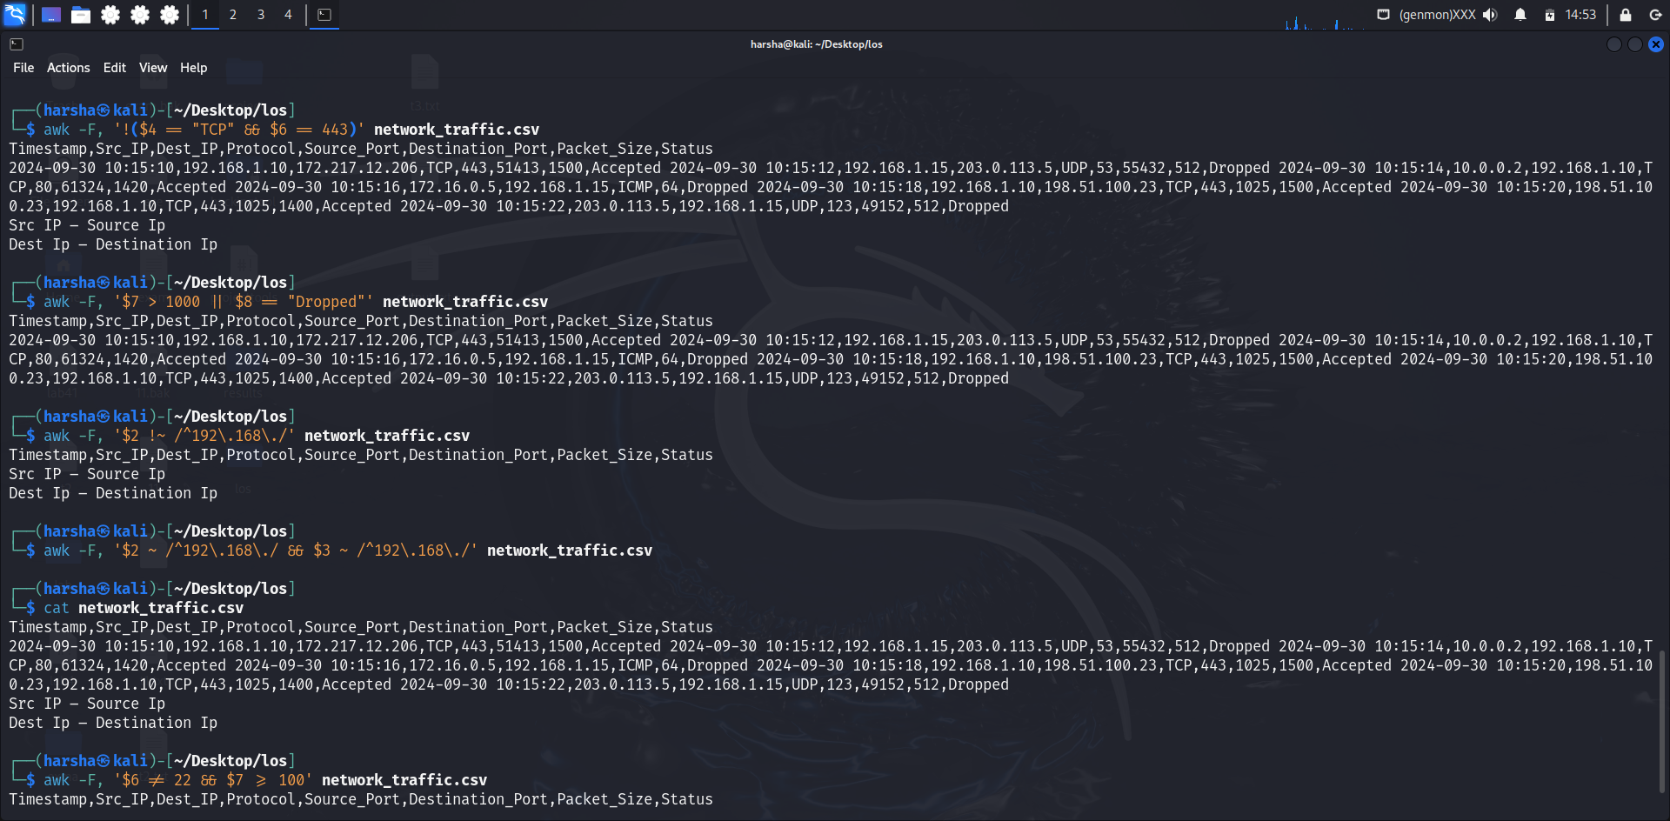

13.print traffic NOT originating from 192.168.x.x IP addresses.

14.filter rows where both Source_IP and Destination_IP are within the 192.168.x.x range.

15.filter out traffic where the destination port is 22 OR the packet size is less than 100 bytes.
