IPSC data. Double Inhibition

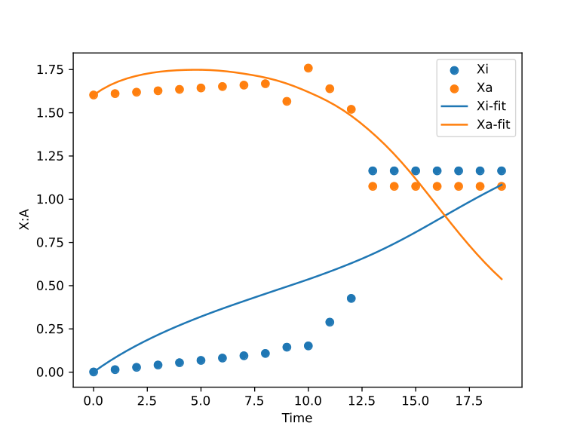n=4.69061130681539

**Inhibition**

K1=1.72729230379343

K2=0.794575299477114

a1=2.00572478753676

a2=0.333975361561726

**Decay**

c1=0.0843418204370419

c2=0.555318768459067



IPSC data. Double Inhibition with Self Activation

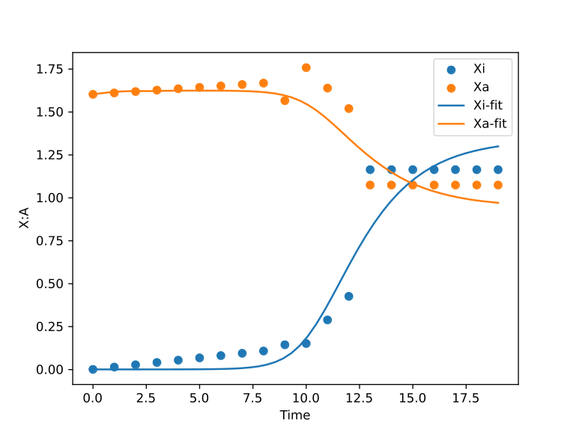n=1.01091589490725

**Inhibition**

K1=0.840387187585119

K2=1.21287390737187

a1=-0.00355669919350192

a2=1.3019762210339

**Self Activation**

K3=0.748865082336979

K4=1.33329237813302

b1=1.46858712145292

b2=0.789435817527975

**Degradation**

c1=0.702960911703544

c2=0.979435201878159



Timeshifted IPSC data. Double Inhibition

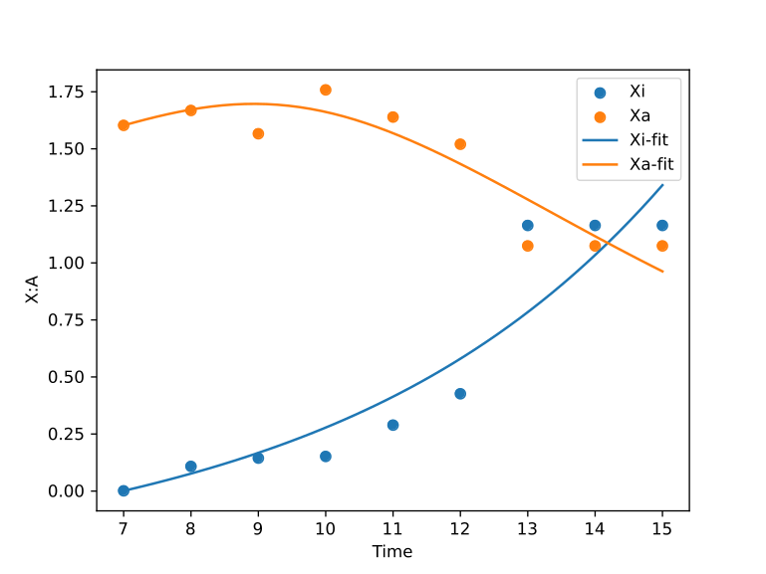n=1.84988897410296

**Inhibition**

K1=3.81123671763214

K2=0.383429769905525

a1=0.980266701390861

a2=0.0656044399948125

**Degradation**

c1=-0.194956476670639

c2=0.189441530837799



Timeshifted IPSC data. Double Inhibition with Self Activation

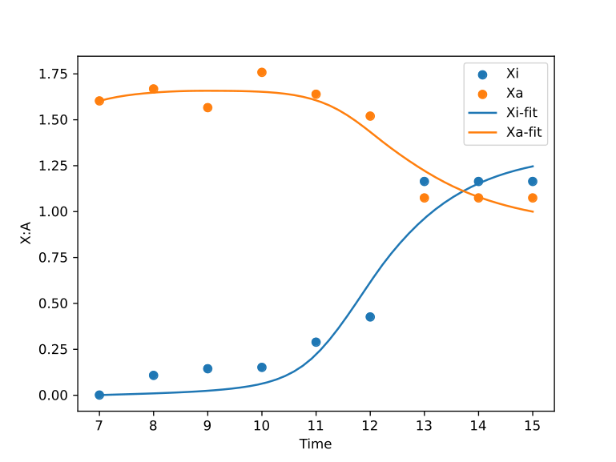n=1.36139248810483

**Inhibition**

K1=0.597844738843681

K2=0.942462863579184

a1=0.0273229213611089

a2=1.31116202195172

**Self Activation**

b1=1.56147781097103

b2=1.16542417722904

K3=0.383871047857515

K4=0.940142426288465

**Degradation**

c1=1.00385302470685

c2=1.41279166325019



Partial reactivation data. Double Inhibition with Self Activation

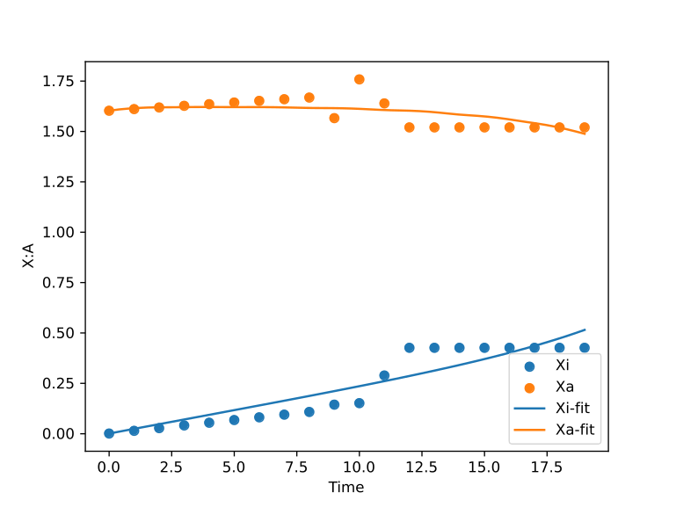n=3.34689563529546

**Inhibition**

K1=1.23770303858757

K2=0.985313537429607

a1=0.338361549168242

a2=1.66146563911895

**Self Activation**

K3=1.26926281819144

K4=1.96264416276486

b1=0.417740210930793

b2=-0.779094014516749

**Degradation**

c1=0.00075763797466554

c2=0.734433144640917



Timeshifted partial data. Double Inhibition with Self Activation

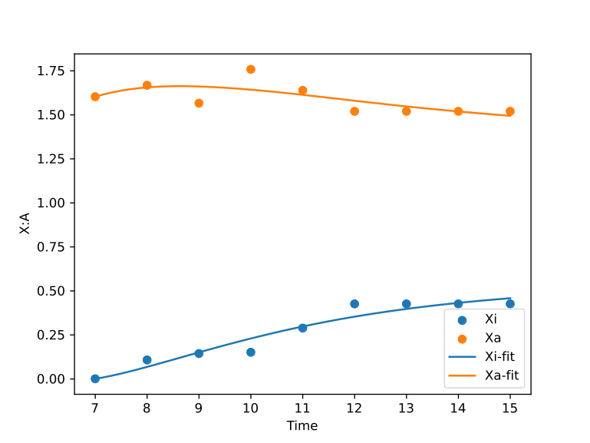n=0.675139240455651

**Inhibition**

K1=0.972808311888188

K2=1.43723115706515

a1=0.0937499553753753

a2=0.622856400010469

**Self Activation**

K3=3.32821547671623

K4=0.928551200211794

b1=1.16786026994376

b2=0.297732431685754

**Degradation**

c1=0.569632641498224

c2=0.352385337715491

