A Project Report on
AI-BASED PERSONALIZED LEARNING RECOMENDATION SYSTEM

- Problem Understanding:
Many students feel confused about what to study and which resources to use. Every student has different strengths, weaknesses, and learning styles. However, most learning platforms provide the same content to everyone.
For example, a student weak in Mathematics may need a strong foundation course, while a student preparing for JEE may need advanced Physics content. Without proper guidance, students may waste time on unsuitable materials.
To solve this problem, we developed an AI-based system that suggests suitable courses based on student input. The system also collects feedback and improves its recommendations over time.
Our goal was to build a smart and simple learning recommendation platform that gives personalized suggestions instead of general advice.
- Design and Architecture:
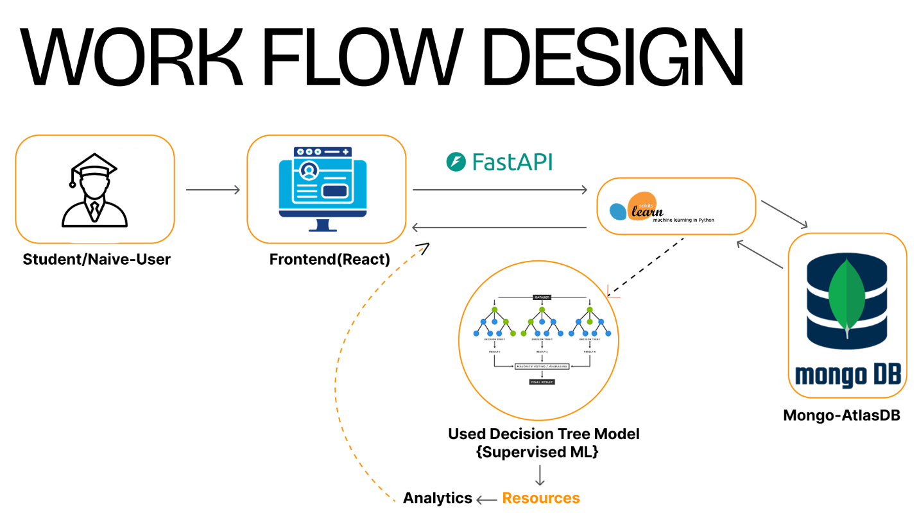
Fig 1. Workflow diagram
Overall Flow:
Student → Frontend → Backend → Machine Learning Model → Database → Result.
Frontend (React):
- Collecting student details (class level, weak subject, learning style)
- Sending data to the backend
- Displaying recommended course and resources
- Collecting feedback
- Showing analytics using charts
Backend (FastAPI - Python):
The backend:
- Receives requests form frontend
- Processes the data
- Sends input to the ML model
- Stores data in MongoDB
- Returns results to frontend
It acts as the main control system of the project.
Machine Learning Model:
We used a random forest classifier for prediction.
- Takes student details as input
- Predicts the most suitable course
- Provides a confidence score
The model is retrained automatically after every 20 feedback entries to improve.
Database (MongoDB):
MongoDB is used to store:
- Student inputs
- Recommended courses
- Confidence scores
- Feedback ratings
- Timestamps
This stored data is also used for analytics and retraining.

- Implementation Details

Step 1: Input Collection
The student enters:
- Class Level
- Weak Subject
- Learning Style
- Goal
The data is stored using React state management.
Step 2: Sending Data to Backend
The frontend sends data to the backend using HTTP requests (Axios).
Step 3: Data Processing and Prediction
The backend:
- Converts categorical data into numerical format(one-hot-encoding)
- Sends it to the trained Random Forest model
- Gets prediction result
- Calculates confidence score
Step 4: Displaying Results
The frontend displays:
- Recommended course
- Confidence percentage
- YouTube videos
- Book suggestions
Step 5: Feedback System
After receiving recommendation:
- User selects “Helpful” or “NotHelpful”
- Optimal comment can be added
- Feedback is stored on MongoDB
Step 6:Retraining System
After every 20 feedback entries:
- The retraining script runs
- Old data from database is used as training dataset
- Model is retrained
- New model is saved
This makes the system adaptive and self-improving.
Step 7: Analytics Dashboard
The analytics section shows:
- Total recommendations
- Helpful percentage
- Not helpful percentage
- Most recommended course
- Average confidence
- Course distribution (bar chart)
This helps us analyze system performance.
- Results and Test Cases:
We tested the system using multiple student inputs.
Test case 1:
Input:
- Class Level:10
- Weak Subject: Math
- Learning Style: Visual
Output:
- Recommended Course: Math Foundation
- Confidence: High
Test Case 2:
Input:
- Class Level:11
- Weak Subject: Physics
- Goal :JEE
Output:
- Recommended Course: JEE Physics
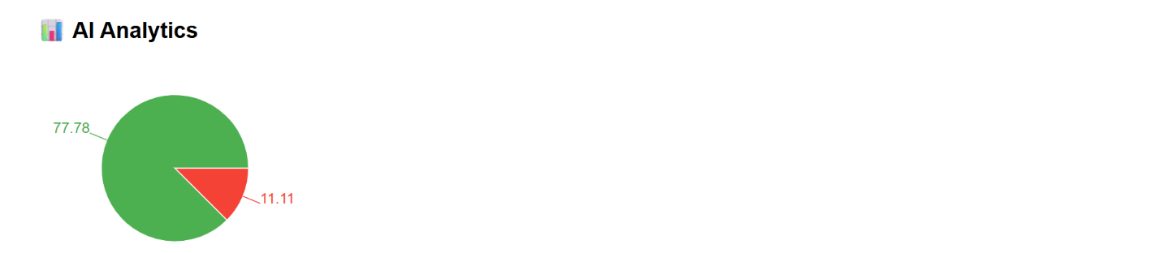
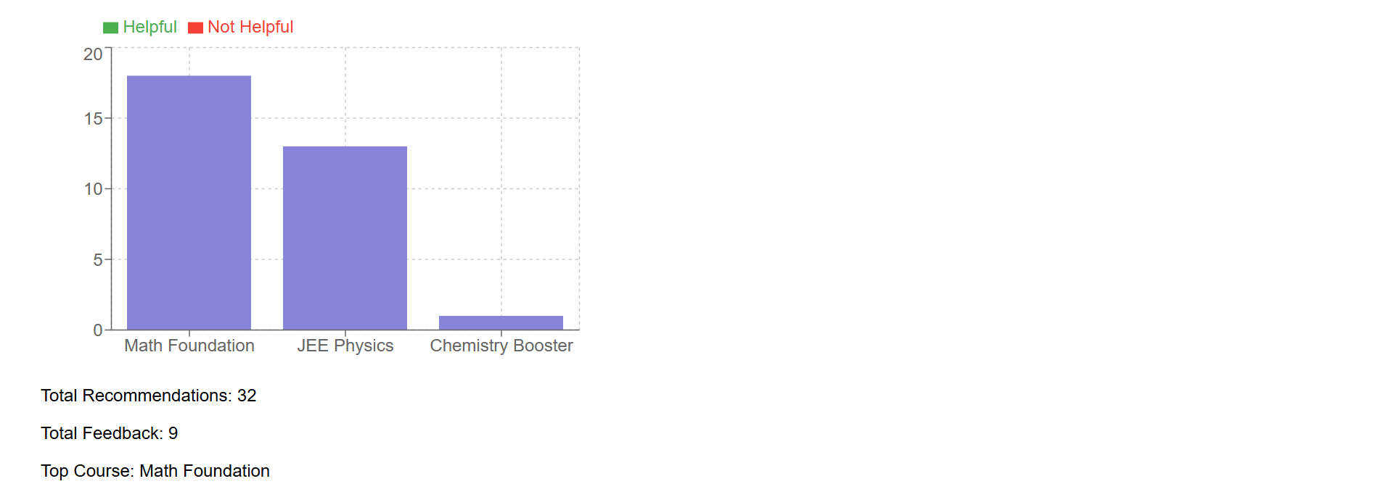
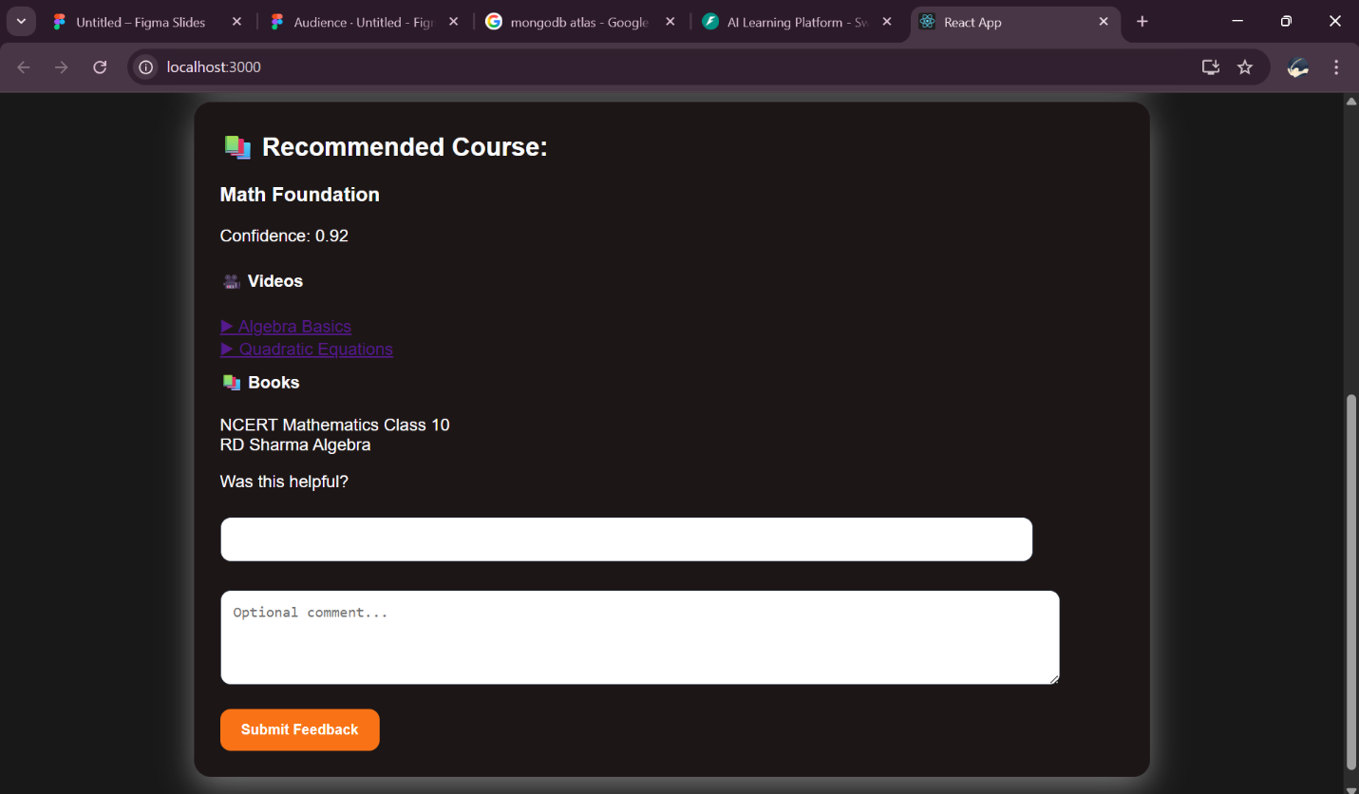
Feedback Testing
- Feedback was successfully stored in MongoDB.
- After 20 feedback submissions, the retraining process was triggered.
- Analytics updated correctly.

- Reflections and Future Scope:
Through this project we learned,
- Frontend and backend communication using APIs
- Integration of machine learning into a real application
- Storing and managing data using MongoDB
- Retraining a model using real-time feedback
- Visualize data using charts

- Future scope
In future we can improve this system by,
- Adding user login and authentication using JWT
- Using advanced ML models for better accuracy
- Deploying the project on cloud platform
- Creating a mobile application
- Adding more courses and subjects

- Team Member Contribution
Team member | Technical work | Report/Presentation
A.Harshavardhan Reddy- [24881A05Y7] | Developed FastAPI backend, implemented machine learning model using scikit-learn, integrated MongoDB, and built the auto-retraining pipeline. Technical content and architecture. | Contributed to project -Video presentation.
Y.VinayChary-[24881A05BY] | Designed and developed React frontend, implemented UI/UX components, styled dark theme interface, and handled user interaction flows | Contributed to report Documentation.

