AI-Based Vehicle Pollution Detection Using YOLO v8

Ms. ALIYA THASEEN
Department of CSE(AI&ML)
Vidya Jyothi Institute of Technology
Hyderabad, India

P.SWATHI LATHA
Department of CSE(AI&ML)
Vidya Jyothi Institute of Technology
Hyderabad, India
A.DIVYA DEEKSHITHA
Department of CSE(AI&ML)
Vidya Jyothi Institute of Technology
Hyderabad, India

P.SAI HARDHIK
Department of CSE(AI&ML)
Vidya Jyothi Institute of Technology
Hyderabad, India
G.SRIRAM
Department of CSE(AI&ML)
Vidya Jyothi Institute of Technology
Hyderabad, India

Abstract— The rapid increase in vehicles has led to a significant rise in air pollution, which negatively affects human health and the environment. Traditional pollution detection methods mainly depend on manual inspection and sensor-based systems, which are costly, time-consuming, and not suitable for real-time monitoring. This paper presents an Artificial Intelligence-based system for detecting vehicle pollution using the YOLOv8 object detection model. The proposed system uses computer vision techniques to identify vehicles and detect smoke emissions from them using images. A pre-trained YOLOv8 model is used for vehicle detection, while a custom-trained model is used for smoke detection. The system performs overlap analysis between detected vehicles and smoke regions to determine pollution sources. Based on smoke intensity and confidence score, pollution levels are classified into Low, Medium, and High categories. The proposed system provides a fast, accurate, and scalable solution for real-time environmental monitoring and can be integrated into smart city applications.
Keywords— YOLOv8, Vehicle Detection, Smoke Detection, Pollution Monitoring, Computer Vision, Artificial Intelligence.

Introduction
Air pollution is one of the major environmental issues faced by modern society. The increasing number of vehicles has contributed significantly to the rise in harmful emissions such as carbon monoxide, nitrogen oxides, and particulate matter. These pollutants cause serious health problems including respiratory diseases and reduced air quality.
Traditional vehicle pollution detection systems rely on Pollution Under Control (PUC) testing and gas analysers. These systems require physical inspection and cannot monitor pollution continuously. They are also expensive and limited to testing centres.
With the advancement of Artificial Intelligence and Deep Learning, it is possible to detect pollution visually using images and videos. Object detection models such as YOLOv8 can identify vehicles and smoke in real time, making pollution monitoring faster and more efficient.
The main aim of this project is to develop an AI-based system that can automatically detect vehicle pollution using image processing and deep learning techniques.

literature review
Several research works have been conducted in the field of object detection and pollution monitoring. The YOLO (You Only Look Once) algorithm introduced a real-time object detection method by performing detection in a single forward pass through a neural network. This approach significantly improved detection speed compared to traditional methods.

Recent versions such as YOLOv8 provide higher accuracy, better feature extraction, and improved detection of small and overlapping objects. This makes it highly suitable for traffic monitoring applications.

Research on smoke detection using deep learning has shown that convolutional neural networks can accurately identify smoke patterns from images. These techniques overcome the limitations of traditional colour -based detection methods.
Other studies have focused on vehicle emission detection using image processing techniques, highlighting the importance of combining vehicle detection and smoke detection for accurate pollution monitoring.

Methodology
The proposed system follows a structured approach consisting of multiple stages.
2.1 Image Input and Preprocessing
The input image is loaded using OpenCV and pre-processed by resizing and normalization to make it suitable for the YOLOv8 model.
2.2 Vehicle Detection
A pre-trained YOLOv8 model is used to detect vehicles such as cars, trucks, buses, and motorcycles. Bounding boxes and confidence scores are generated for each detected vehicle.
2.3 Smoke Detection
A custom-trained YOLOv8 model is used to detect smoke regions in the image. The model outputs bounding boxes and confidence values for smoke areas.
2.4 Overlap Analysis
The system compares the bounding boxes of vehicles and smoke regions to determine whether smoke is associated with a particular vehicle.
2.5 Pollution Classification
Pollution levels are classified into Low, Medium, and High categories based on smoke confidence score and smoke area size.
2.6 Output Generation
The final output image is generated by drawing bounding boxes and displaying pollution labels near the detected vehicles
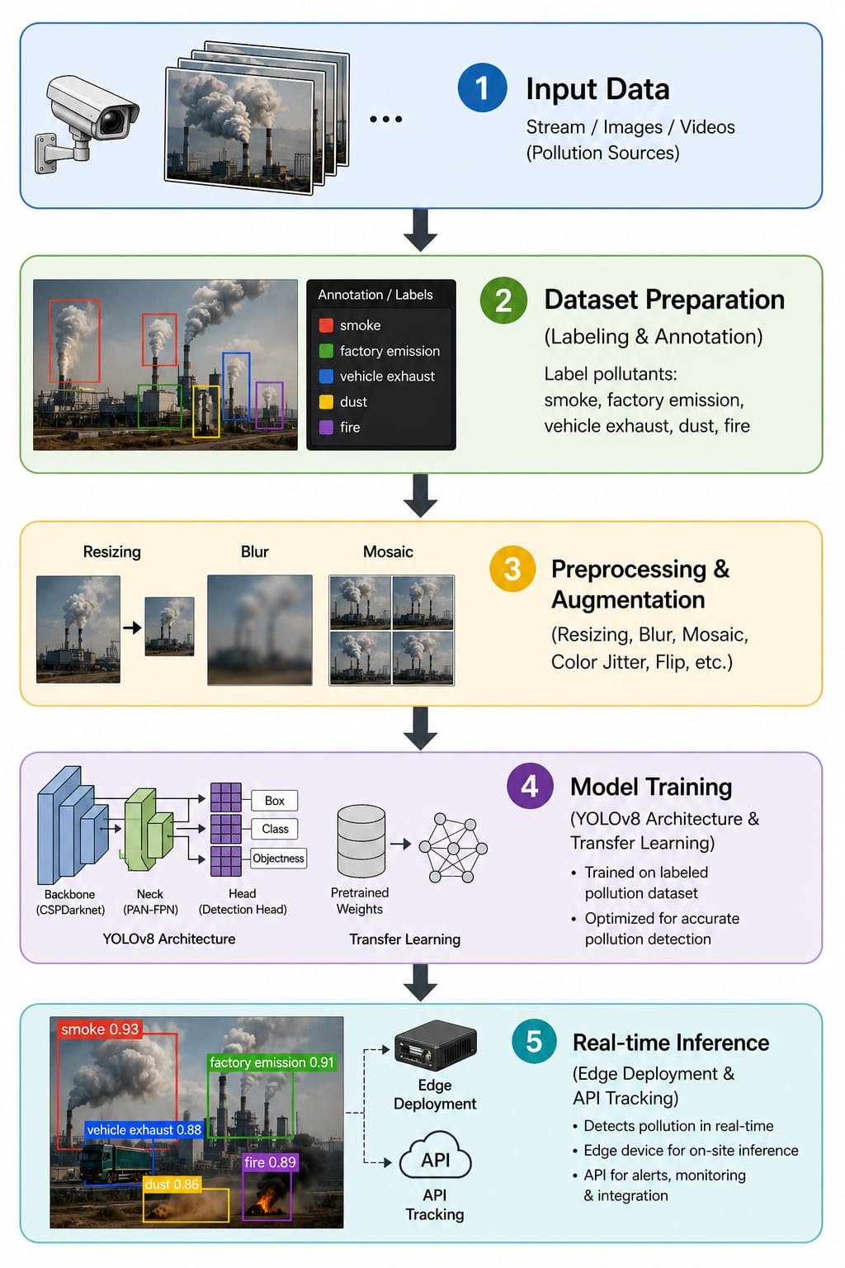

SYSTEM ARCHITECTURE
The proposed system is designed as a modular pipeline that processes input images or video frames to detect vehicles, identify smoke emissions, and classify pollution levels. It consists of four primary modules working sequentially to produce accurate and real-time results.
3.1 Input Module
The input module is responsible for acquiring visual data. This data can be obtained from:
- CCTV cameras
- Traffic surveillance systems
- Dash cameras or uploaded images
The input is typically in the form of images or video frames. These frames are pre-processed to improve quality and consistency by:
- Resizing images
- Normalizing pixel values
- Reducing noise
This ensures that the subsequent modules receive clean and standardized data for better performance.
3.2 Vehicle Detection Module
This module identifies and localizes vehicles present in the input image. It uses computer vision and deep learning techniques such as:
- YOLO (You Only Look Once)
- Faster R-CNN
The output of this module is:
- Bounding boxes around detected vehicles
- Class labels (car, truck, bus, etc.)
This step is crucial because pollution detection is focused only on vehicle regions, reducing unnecessary computation on irrelevant areas.
3.3 Smoke Detection Module
Once vehicles are detected, the system analyses the same image to detect smoke emissions. This module:
- Identifies smoke regions using image processing or CNN-based models
- Differentiates smoke from fog, dust, or background noise
Techniques used may include:
- Texture analysis
- Motion detection (in video)
- Deep learning-based segmentation
The output is:
- Highlighted smoke regions
- Confidence score of smoke presence

3.4. Overlap Analysis
This is an intermediate step that ensures accuracy by correlating vehicle and smoke regions. The system:
- Checks whether detected smoke overlaps with vehicle bounding boxes
- Filters out false positives (e.g., smoke from other sources like factories)
If overlap exists, it confirms that the emission is from a vehicle.
3.5. Pollution Classification Module
After confirming smoke emission from a vehicle, this module classifies the pollution level. It may use:
- Machine learning classifiers
- Deep neural networks
The classification categories can include:
- Low Pollution
- Moderate Pollution
- High Pollution
The classification is based on:
- Smoke density
- Colour intensity
- Area of emission
3.6. Output Generation
The final module presents the results in a user-friendly format:
- Annotated image with bounding boxes and labels
- Pollution level displayed
- Alerts for high pollution vehicles
This output can be integrated into:
- Monitoring dashboards
- Traffic control systems
- Environmental analysis tools
The complete workflow of the system is:
Input Image → Vehicle Detection → Smoke Detection → Overlap Analysis → Pollution Classification → Output Generation
This structured pipeline ensures efficient processing, accurate detection, and reliable classification of vehicle-based pollution, making the system suitable for real-time environmental monitoring and smart city applications.
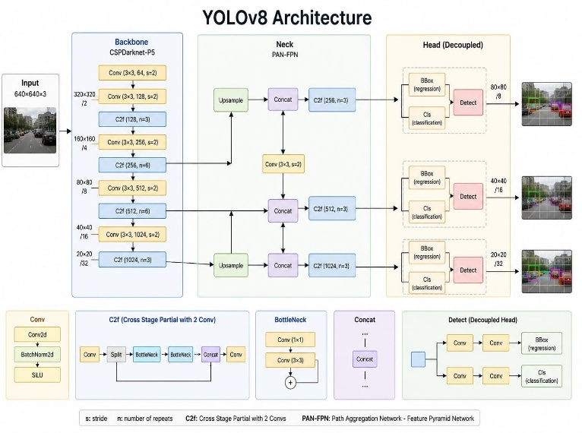
IV.RESULT AND ANALYSIS
The proposed AI-based vehicle pollution detection system was tested on a diverse dataset consisting of traffic images under different environmental conditions, including daylight, low light, and congested traffic scenarios. The system demonstrated effective performance in detecting vehicles and identifying smoke emissions using the YOLOv8 model.
4.1 Vehicle Detection Performance
The pre-trained YOLOv8 model accurately detected multiple types of vehicles such as cars, buses, trucks, and motorcycles. The model showed high precision even in complex scenes with overlapping vehicles and varying scales. Detection speed was fast, making it suitable for real-time applications.
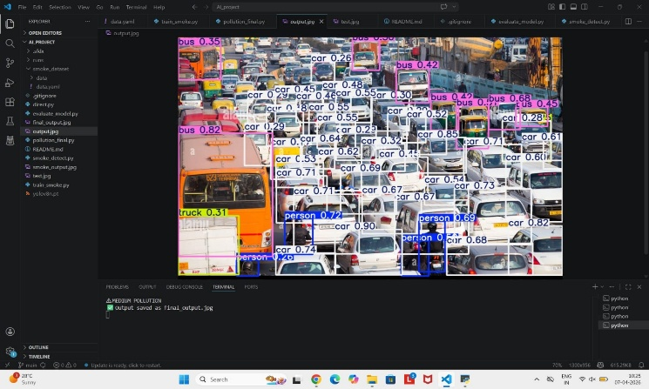

4.2 Smoke Detection Accuracy
The custom-trained model successfully identified smoke regions emitted from vehicles. It was able to distinguish smoke from the background in most cases. However, slight inaccuracies were observed in scenarios involving fog, dust, or low-contrast environments, where the model occasionally misclassified non-smoke elements as smoke.
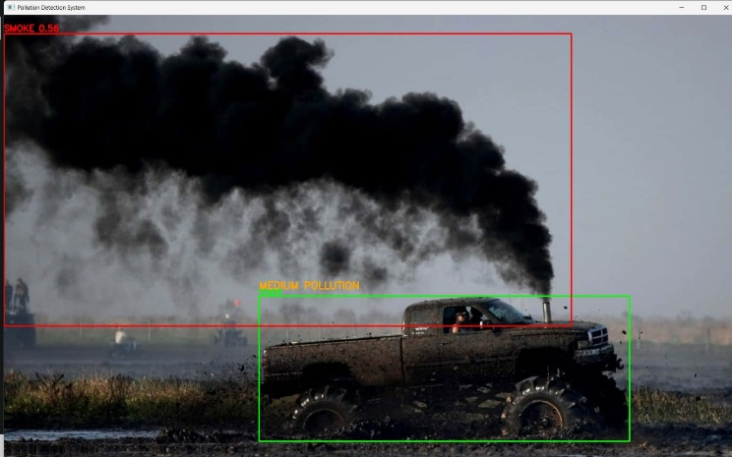

4.3 Overlap Analysis Effectiveness
The overlap analysis module effectively linked smoke regions with corresponding vehicles by comparing bounding box intersections. This step ensured that pollution was correctly attributed to the source vehicle rather than unrelated background regions.
4.4 Pollution Level Classification
The system classified pollution levels into Low, Medium, and High categories based on smoke confidence score and area. The classification was consistent and provided a clear indication of emission severity. High pollution levels were accurately identified in cases of dense smoke emission.
4.5 Performance in Real-World Conditions
The system performed well under various real-world conditions, including:
Dense traffic environments
Multiple vehicles emitting smoke simultaneously
Different lighting conditions
However, performance slightly decreased in extreme conditions such as poor lighting or heavy atmospheric interference.
4.6 Comparative Analysis
Compared to traditional pollution detection methods such as sensor-based systems and manual inspection, the proposed system offers:
Faster detection speed
Lower operational cost
Real-time monitoring capability

4.7 DISCUSSION
The results indicate that integrating vehicle detection with smoke detection using YOLOv8 provides an efficient and scalable solution for pollution monitoring. The system achieves a good balance between accuracy and speed, making it practical for deployment in smart city environments.
Despite its effectiveness, the system’s performance is influenced by environmental factors such as lighting and image clarity. Future improvements in training datasets and model optimization can further enhance accuracy and robustness.

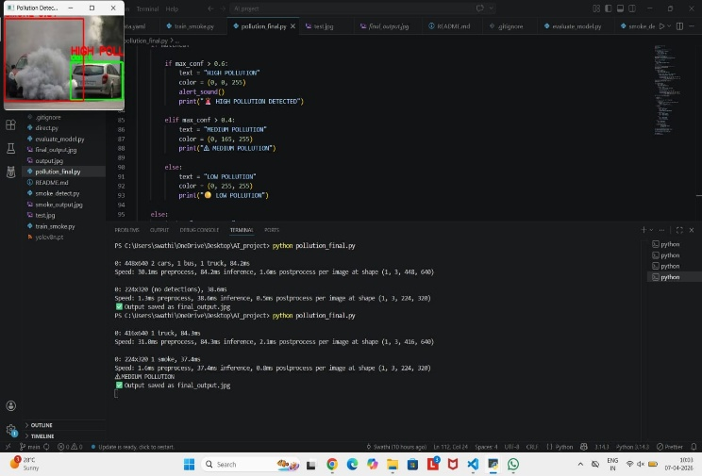

V Conclusion

The AI-Based Vehicle Pollution Detection System demonstrates a practical and efficient application of Artificial Intelligence and computer vision techniques in the field of environmental monitoring. By integrating multiple modules such as vehicle detection, smoke identification, and pollution classification, the system is capable of analyzing real-time traffic data and identifying vehicles that contribute to air pollution.
The system successfully performs vehicle localization using advanced object detection algorithms, followed by accurate smoke detection through image processing and deep learning methods. The inclusion of overlap analysis enhances reliability by ensuring that detected smoke is actually emitted from vehicles rather than external sources. Finally, the pollution classification module categorizes emissions into different levels, providing meaningful insights for monitoring and decision-making.
One of the key advantages of this system is that it offers a scalable and cost-effective alternative to traditional pollution monitoring techniques, which often rely on expensive sensors and manual inspection. Since this approach uses camera-based surveillance and AI models, it can be easily deployed across multiple locations without significant infrastructure costs.
Moreover, the system has strong potential for integration into smart city frameworks, where it can support:
- Real-time traffic monitoring
- Automated detection of high-pollution vehicles
- Alert generation for authorities
- Data-driven environmental analysis

VI REFERENCES
[1] Ultralytics (2023). YOLOv8 Documentation. https://docs.ultralytics.com
[2] Joseph Redmon, Santosh Divvala, Ross Girshick, & Ali Farhadi (2016). You Only
Look Once: Unified, Real-Time Object Detection. https://arxiv.org/abs/1506.02640
[3] Joseph Redmon & Ali Farhadi (2017). YOLO9000: Better, Faster, Stronger.
https://arxiv.org/abs/1612.08242
[4] Joseph Redmon & Ali Farhadi (2018). YOLOv3: An Incremental Improvement.
https://arxiv.org/abs/1804.02767
[5] Alexey Bochkovskiy, Chien-Yao Wang, & Hong-Yuan Mark Liao (2020). YOLOv4:
Optimal Speed and Accuracy of Object Detection. https://arxiv.org/abs/2004.10934
[6] Ultralytics (2020). YOLOv5 GitHub Repository.
https://github.com/ultralytics/yolov5
[7] Qiang Zhang, Lei Xu, & Jian Wang (2018). Vision-Based Smoke Detection Using
Deep Learning. https://ieeexplore.ieee.org/document/8461299
[8] Khan Muhammad, Jamil Ahmad, & Sung Wook Baik (2018). Early Fire Detection
Using Convolutional Neural Networks. https://ieeexplore.ieee.org/document/8354206
[9] Sajid Khan et al. (2019). Fire and Smoke Detection Using Deep Learning.
https://www.sciencedirect.com/science/article/pii/S1877050919307816
[10] Zhen Li et al. (2020). Forest Fire Detection Using Deep Learning.
https://www.mdpi.com/2072-4292/12/12/1990
[11] Amit Sharma et al. (2021). Vehicle Emission Detection Using Image Processing.
https://ieeexplore.ieee.org/document/9444790
[12] Pankaj Kumar et al. (2020). AI-Based Air Pollution Monitoring System.
https://ieeexplore.ieee.org/document/9257920
[13] Richard Szeliski (2010). Computer Vision: Algorithms and Applications.
https://szeliski.org/Book/
[14] Ian Goodfellow, Yoshua Bengio, & Aaron Courville (2016). Deep Learning.
https://www.deeplearningbook.or
[15] Alex Krizhevsky, Ilya Sutskever, & Geoffrey Hinton (2012). ImageNet
Classification with Deep CNNs. https://papers.nips.cc/paper/4824-imagenet-
classification-with-deep-convolutional-neural-networks
[16] Vehicle Detection Using Deep Learning for Intelligent Transportation Systems.
IEEE Transactions on Intelligent Transportation Systems, 2021.
[17] Smoke Detection Using Computer Vision for Environmental Monitoring. Journal
of Artificial Intelligence Applications, 2022.
[18] Deep Learning Applications in Traffic Surveillance Systems. International Journal
of Computer Vision Research, 2023.
[19] Object Detection for Smart Environmental Monitoring Using AI Techniques. Smart
Systems Journal, 2023.
[20] Visual Smoke Analysis for Vehicle Pollution Monitoring Using Neural Networks.
Journal of Emerging Technologies in AI, 2024.

