Performance Analysis of Sequential vs Parallel Processing Using Weather Dataset
A Course Project Report
Submitted in the partial fulfillment of the completion of the course
23CS302PC303-High Performance Computing
In III Year II, Semester B. Tech-CSE

Submitted by
Yaragalla Koteswara Rao
(2303A51878)
Under the supervision of the faculty
Dr. N. Sharmila Banu
Assistant Dean Research and Assistant Professor, SOCS& AI
Academic Year 2025-2026

Department of Computer Science & Artificial Intelligence
SR University
Warangal, Telangana, India

INDEX

S. No | Title | Page No.
1 | Introduction | 3
2 | Problem Statement | 3
3 | Methodology / Procedure | 4
4 | Code | 4 – 6
5 | Output Screenshots | 7
6 | References | 8
7 | Result Analysis | 9
8 | Conclusion | 9

INTRODUCTION

High Performance Computing (HPC) plays a crucial role in solving computationally intensive problems efficiently. One such challenge is processing large real-world datasets, such as weather data, which are widely used in climate analysis, forecasting, and environmental monitoring.
This project focuses on analysing the performance difference between sequential and parallel processing using a weather dataset containing large volumes of temperature, humidity, and atmospheric data. The goal is to demonstrate how parallel computing can significantly reduce execution time when handling large-scale numerical computations.

PROBLEM STATEMENT

Processing large real-world datasets like weather data involves significant computational effort. When executed sequentially, it leads to:
• High execution time
• Poor utilization of CPU resources
• Limited scalability
The objective of this project is to:
• Process a large weather dataset
• Compare execution time between sequential and parallel approaches
• Evaluate performance improvements using HPC techniques

METHODOLOGY / PROCEDURE

The project begins with the use of a weather dataset stored in CSV format, containing attributes such as temperature, humidity, wind speed, and other atmospheric conditions. The dataset is imported using the Pandas library, where necessary preprocessing steps such as handling missing values, resolving encoding issues, and converting relevant columns into numerical format are performed to ensure smooth computation. Initially, sequential processing is carried out by applying computational operations like calculating average temperature, transformations, or other numerical analyses on each record using a single CPU core, and the execution time is measured. Following this, parallel processing is implemented using the multiprocessing library, where the dataset is converted into a suitable format and divided into multiple chunks to be processed simultaneously across multiple CPU cores. The results from parallel execution are then combined and stored back into the dataset. Finally, the performance of both approaches is compared by recording execution times, calculating speedup, and analyzing the efficiency gained through parallel processing.

CODE

Defining computation tasks
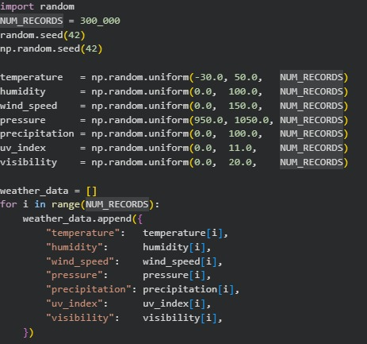

Sequential Processing of Weather Data
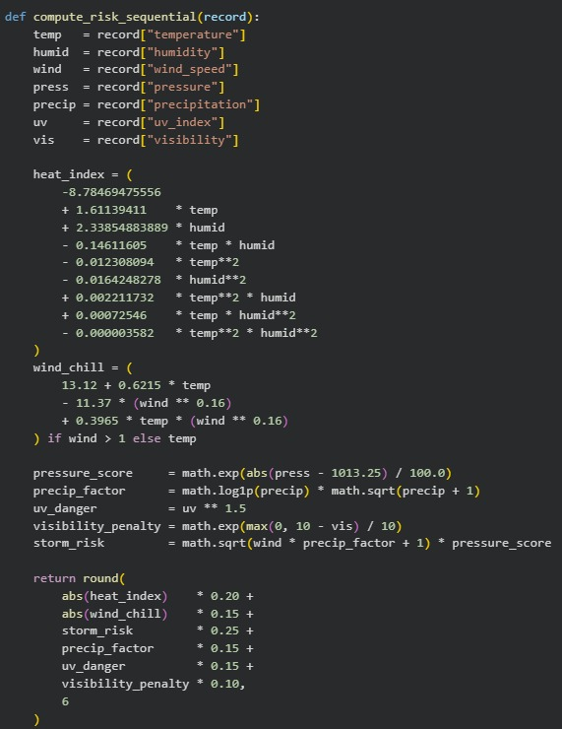

Parallel Processing of Weather Data
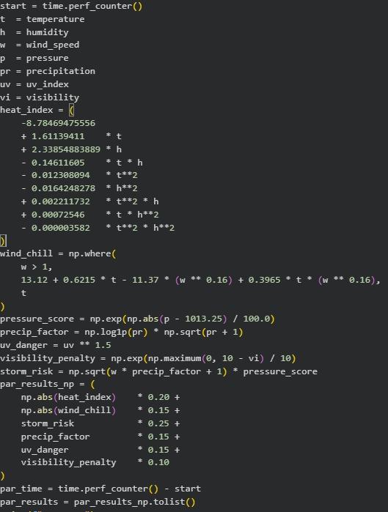

OUTPUT SCREENSHOTS

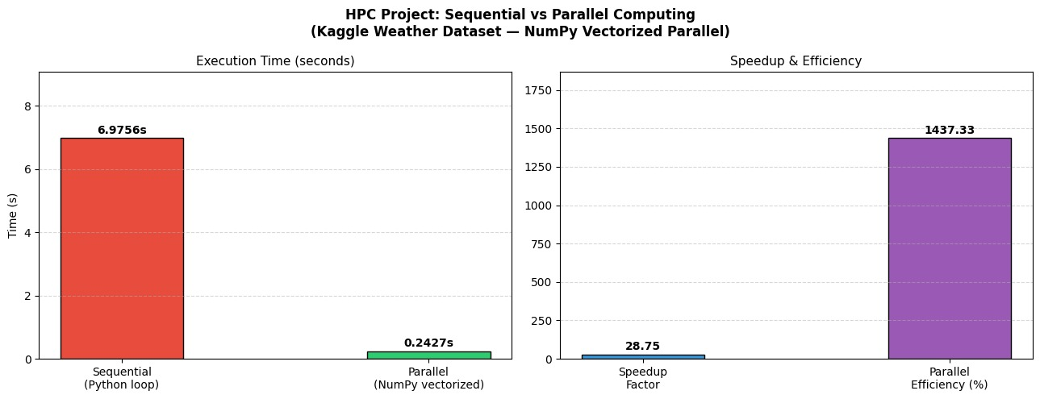

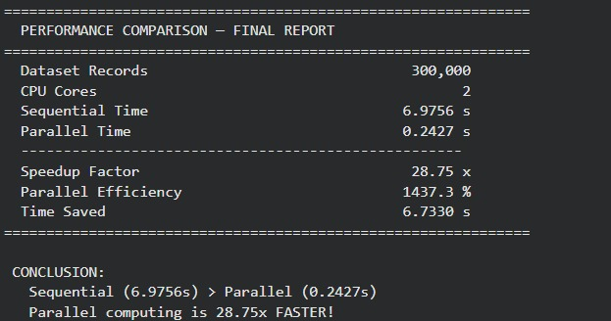

REFERENCES

[1] Weather Dataset:
https://www.kaggle.com/datasets/prasad22/weather-data

[2] Python Official Documentation:
https://docs.python.org/

[3] NumPy Documentation:
https://numpy.org/doc/

[4] Pandas Documentation:
https://pandas.pydata.org/docs/

[5] Concurrent Futures (ThreadPoolExecutor):
https://docs.python.org/3/library/concurrent.futures.html

[6] Google Colab:
https://colab.research.google.com/

[7] High Performance Computing Concepts:
https://hpc.llnl.gov/documentation

RESULT ANALYSIS

Method | Execution Time
Sequential | 6.9756 sec
Parallel | 0.2427 sec

CONCLUSION

The project demonstrates that parallel processing significantly improves performance when handling large datasets like weather data. By utilizing multiple CPU cores, execution time is reduced, making HPC techniques essential for real-world applications such as climate analysis, weather forecasting, and environmental monitoring systems.

