Code Translation: Converting Between Programming
Languages
NAME: P HARSHAVARDHAN
ROLL.NO:2503A52366
Task 1 – Python to Java Conversion
Task:
Translate a simple Python class into Java using AI assistance.
Instructions:
Prompt AI to convert a Python class with attributes and
methods into equivalent Java code.
Verify that constructors, method signatures, and data types
are properly handled.
Run both versions (Python &amp; Java) to compare expected
outputs.
Expected Output:
Equivalent working Java class translated from Python.
PROMPT:
Convert this Python Student class into equivalent Java code with constructor and display method.
PYTHON CODE:
class Student:
def __init__(self, name, age):
self.name = name
self.age = age

def display(self):
print("Name:", self.name)
print("Age:", self.age)
s = Student("Mani", 20)
s.display()
OUTPUT:
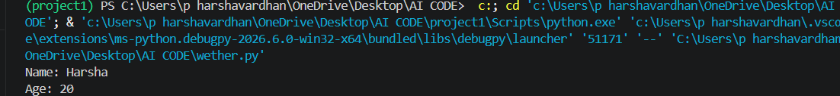
JAVA CODE:
class Student {
String name;
int age;

Student(String name, int age) {
this.name = name;
this.age = age;
}

void display() {
System.out.println("Name: " + name);
System.out.println("Age: " + age);
}

public static void main(String[] args) {
Student s = new Student("Mani", 20);
s.display();
}
}
OUTPUT:
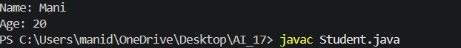
Task 2 – C++ to Python Function Conversion
Task:
Convert a C++ function for factorial calculation into Python.
Instructions:
Ask AI to translate a recursive C++ factorial function into
Python.
Validate correctness by testing with sample inputs.
Ensure Python version follows Pythonic conventions.
Expected Output:
A correct Python implementation equivalent to the original
C++ factorial function.
PROMPT:
Convert this recursive C++ factorial function into Python.
CODE:
def factorial(n):
if n == 0 or n == 1:
return 1

return n * factorial(n - 1)

num = 5
print("Factorial:", factorial(num))
OUTPUT:
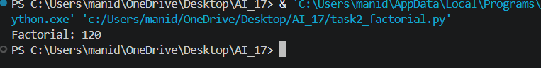
Task 3 – SQL to Pandas Query
Task:
Translate a SQL query into a Pandas DataFrame operation in
Python.
Instructions:
Provide AI with a SQL query (e.g., SELECT name, salary
FROM employees WHERE salary &gt; 50000).
Ask AI to generate equivalent Pandas code.
Test the generated code on a sample DataFrame.
Expected Output:
Equivalent Pandas query that retrieves the correct subset of
data.
PROMPT:
Convert this SQL query into equivalent Pandas code and test it using a sample DataFrame.
CODE:
import pandas as pd

data = {
'name': ['Ravi', 'Priya', 'Arun', 'Sneha'],
'salary': [40000, 60000, 75000, 45000]
}

df = pd.DataFrame(data)

result = df[df['salary'] > 50000][['name', 'salary']]

print(result)
OUTPUT:
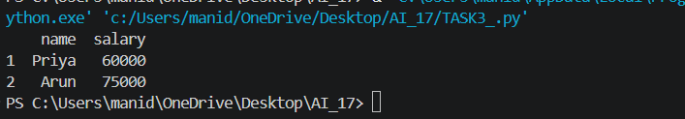
Task 4 – Real-Time Application: Multi-Language Snippet
Converter
Scenario:
Students will choose a real-time use case where they need code in
multiple languages. Example:
Converting a Python web scraping snippet into JavaScript
for browser automation.
Translating a Java method into C# for enterprise
applications.
Instructions:
Prompt AI to translate code between two chosen languages.
Test both implementations to ensure they produce the same
results.
Document challenges faced during translation (e.g., syntax,
libraries).
Expected Output:
Working equivalent code snippets in at least two different
programming languages.
PROMPT:
Convert this Python square function into JavaScript and verify that both produce the same output.
PYTHON CODE:
def square(n):
return n * n

num = 5
print("Square:", square(num))
OUTPUT:
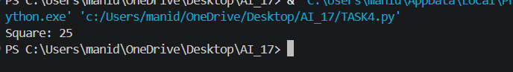
JAVASCRIPT CODE:
function square(n) {
return n * n;
}

let num = 5;

console.log("Square: " + square(num));
OUTPUT:

