AI for Data Processing: Data Cleaning and
Preprocessing Scripts
NAME: P HARSHAVARDHAN
ROLL.NO:2503A52366
Task 1 – Customer Data Cleaning
Task:
Use AI to generate a Python script for cleaning a customer
dataset.
Instructions:
Handle missing values in columns (age, income, city).
Remove duplicate records.
Standardize text values (e.g., city names in lowercase).
Encode categorical variables (gender, city).
Sample Code:
import pandas as pd
data = pd.read_csv(&quot;shopping_trends.csv&quot;)
print(data.head())
Dataset link:
https://www.kaggle.com/datasets/iamsouravbanerjee/customer-
shopping-trends-dataset?select=shopping_trends.csv
Expected Output:
• A cleaned Pandas data frame ready for analysis.
CODE:
import pandas as pd
from sklearn.preprocessing import LabelEncoder

# Load dataset
data = pd.read_csv("shopping_trends.csv")

print("Original Dataset:")
print(data.head())

# Remove duplicate records
data = data.drop_duplicates()

# Handle missing numerical values
for col in ["Age", "income"]:
if col in data.columns:
data[col] = data[col].fillna(data[col].median())

# Handle missing city/location values
for col in ["city", "Location"]:
if col in data.columns:
data[col] = data[col].fillna("unknown")

# Standardize text values
for col in data.select_dtypes(include="object").columns:
data[col] = data[col].str.strip()

# Convert city or location names to lowercase
for col in ["city", "Location"]:
if col in data.columns:
data[col] = data[col].str.lower()

# Encode gender and city/location
encoder = LabelEncoder()

for col in ["Gender", "city", "Location"]:
if col in data.columns:
data[col] = encoder.fit_transform(data[col].astype(str))

# Display cleaned dataset
print("\nCleaned Dataset:")
print(data.head())

print("\nMissing Values:")
print(data.isnull().sum())

# Save cleaned dataset
data.to_csv("cleaned_customer_data.csv", index=False)

print("\nCleaned data saved successfully!")
OUTPUT:
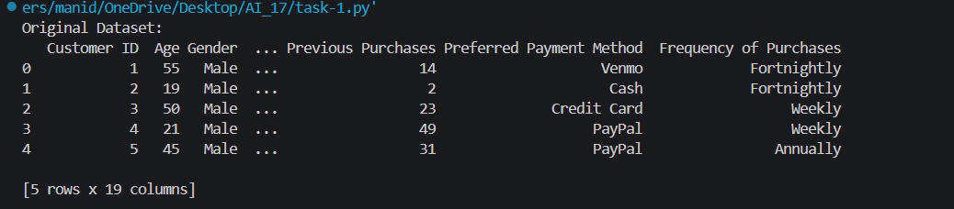
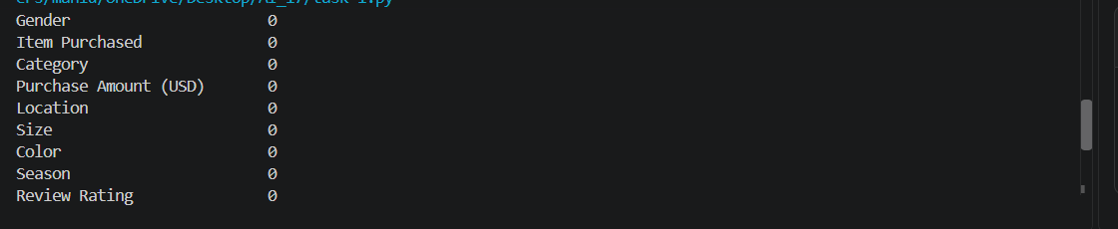
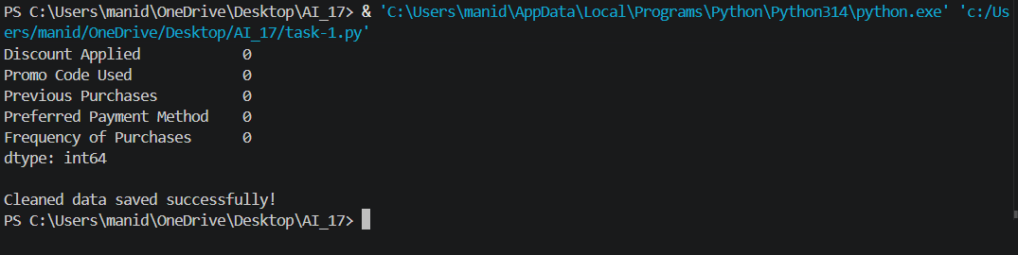
Task 2 – Sales Data Preprocessing
Task:
Preprocess sales transaction data using AI assistance.
Instructions:
Convert date columns into datetime format.
Create new features (month, year, day of week).
Normalize sales amount column.
Detect and handle outliers in dataset.
Sample Code:
import pandas as pd
data = pd.read_csv(&quot;sales_data.csv&quot;)
print(data.head())
Dataset link:
https://www.kaggle.com/datasets/vinothkannaece/sales-
dataset?select=sales_data.csv
Expected Output:
A transformed dataset with time-based features and
normalized values.
CODE:
import pandas as pd
from sklearn.preprocessing import MinMaxScaler

# Load dataset
data = pd.read_csv("sales_data.csv")

print("Original Dataset:")
print(data.head())

# Convert date column into datetime format
data["Sale_Date"] = pd.to_datetime(data["Sale_Date"])

# Create new date features
data["Month"] = data["Sale_Date"].dt.month
data["Year"] = data["Sale_Date"].dt.year
data["Day_of_Week"] = data["Sale_Date"].dt.day_name()

# Handle missing sales amounts
data["Sales_Amount"] = data["Sales_Amount"].fillna(
data["Sales_Amount"].median()
)

# Detect outliers using IQR
Q1 = data["Sales_Amount"].quantile(0.25)
Q3 = data["Sales_Amount"].quantile(0.75)

IQR = Q3 - Q1

lower_limit = Q1 - 1.5 * IQR
upper_limit = Q3 + 1.5 * IQR

# Remove outliers
data = data[
(data["Sales_Amount"] >= lower_limit) &
(data["Sales_Amount"] <= upper_limit)
].copy()

# Normalize sales amount
scaler = MinMaxScaler()

data["Normalized_Sales"] = scaler.fit_transform(
data[["Sales_Amount"]]
)

print("\nPreprocessed Dataset:")
print(data.head())

# Save processed dataset
data.to_csv("cleaned_sales_data.csv", index=False)

print("\nSales data preprocessing completed!")
OUTPUT:
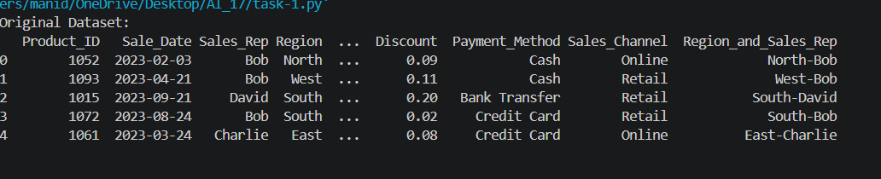
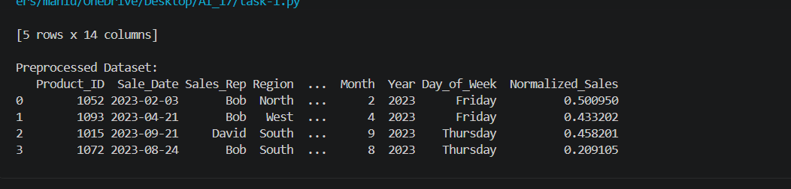
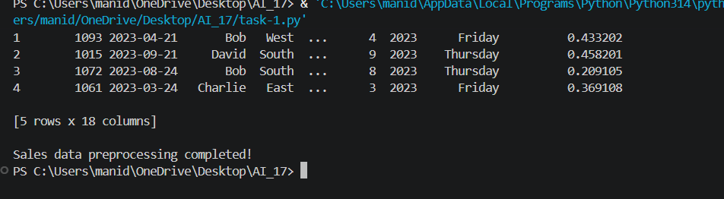
Task 3 – Healthcare Data Preparation
Task:
Clean and preprocess a healthcare dataset using AI scripts.
Instructions:
Handle missing values in blood_pressure, cholesterol.
Encode categorical features
Scale numerical features (min-max or standard scaling).
Split dataset into training and testing sets.
Dataset link :
https://www.kaggle.com/datasets/abdallaahmed77/healthcare-risk-
factors-dataset
Expected Output:
A preprocessed dataset ready for machine learning models.
CODE:
import pandas as pd
from sklearn.preprocessing import LabelEncoder, MinMaxScaler
from sklearn.model_selection import train_test_split

# Load dataset
data = pd.read_csv("dirty_v3_path.csv")

# Remove unnecessary columns if present
data = data.drop(
columns=["random_notes", "noise_col"],
errors="ignore"
)

# Handle missing numerical values
for col in ["Blood Pressure", "Cholesterol"]:
if col in data.columns:
data[col] = data[col].fillna(data[col].median())

# Handle missing values in other numerical columns
numeric_cols = data.select_dtypes(include="number").columns

for col in numeric_cols:
data[col] = data[col].fillna(data[col].median())

# Handle missing categorical values
categorical_cols = data.select_dtypes(include="object").columns

for col in categorical_cols:
data[col] = data[col].fillna(data[col].mode()[0])
data[col] = data[col].str.strip()

# Encode categorical columns
target = "Medical Condition"

for col in categorical_cols:
encoder = LabelEncoder()
data[col] = encoder.fit_transform(data[col].astype(str))

# Separate input and target
X = data.drop(columns=[target])
y = data[target]

# Scale numerical input features
scaler = MinMaxScaler()
X[numeric_cols.intersection(X.columns)] = scaler.fit_transform(
X[numeric_cols.intersection(X.columns)]
)

# Split into training and testing data
X_train, X_test, y_train, y_test = train_test_split(
X, y, test_size=0.2, random_state=42
)

print("Training Data Shape:", X_train.shape)
print("Testing Data Shape:", X_test.shape)

print("\nPreprocessed Data:")
print(X.head())

# Save preprocessed dataset
data.to_csv("cleaned_healthcare_data.csv", index=False)

print("\nHealthcare preprocessing completed!")
OUTPUT:
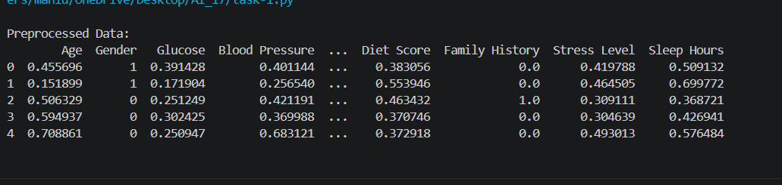
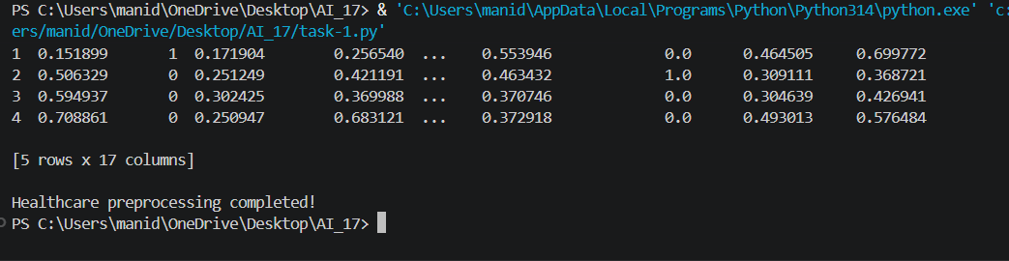
Task 4 – Employee Salary Data Preprocessing
Task:
Clean and preprocess an employee salary dataset using AI scripts.
Instructions:
• Handle missing values
• Detect and remove salary outliers.
• Standardize department names (lowercase).
• Apply label encoding to job location, department.
Dataset link:
https://www.kaggle.com/code/vishantmathur/employee-salary

Expected Output:
• A structured dataset ready for HR analytics.
CODE:
import pandas as pd
from sklearn.preprocessing import LabelEncoder

# Load dataset
data = pd.read_csv("employee_salary.csv")

print("Original Dataset:")
print(data.head())

# Handle missing numerical values
numeric_cols = data.select_dtypes(include="number").columns

for col in numeric_cols:
data[col] = data[col].fillna(data[col].median())

# Handle missing categorical values
categorical_cols = data.select_dtypes(include="object").columns

for col in categorical_cols:
data[col] = data[col].fillna(data[col].mode()[0])

# Standardize department names
data["Department"] = data["Department"].str.strip().str.lower()

# Detect salary outliers using IQR
Q1 = data["Salary"].quantile(0.25)
Q3 = data["Salary"].quantile(0.75)

IQR = Q3 - Q1

lower_limit = Q1 - 1.5 * IQR
upper_limit = Q3 + 1.5 * IQR

# Remove salary outliers
data = data[
(data["Salary"] >= lower_limit) &
(data["Salary"] <= upper_limit)
].copy()

# Apply label encoding
encoder = LabelEncoder()

data["Department"] = encoder.fit_transform(
data["Department"].astype(str)
)

data["Job Location"] = encoder.fit_transform(
data["Job Location"].astype(str)
)

print("\nCleaned Employee Dataset:")
print(data.head())

# Save cleaned dataset
data.to_csv("cleaned_employee_data.csv", index=False)

print("\nEmployee data preprocessing completed!")
OUTPUT:


