**INTERNET TECHNOLOGY LAB**

Week 1

**Question 1**

namespace IT_LAB_WEEK_1 {

class Program {

public static void arithmetic() {

Console.WriteLine("Enter two numbers");

int num1, num2;

int.TryParse(Console.ReadLine(), out num1);

int.TryParse(Console.ReadLine(), out num2);

Console.WriteLine("1. Addition\n2. Subtraction\n3. Multiplication\n4. Division");

int choice;

int.TryParse(Console.ReadLine(), out choice);

switch(choice) {

case 1:

Console.WriteLine("Sum of {0} and {1} is {2}", num1, num2, num1 + num2); break;

case 2:

Console.WriteLine("Difference of {0} and {1} is {2}", num1, num2, num1 - num2); break;

case 3:

Console.WriteLine("Product of {0} and {1} is {2}", num1, num2, num1 * num2); break;

case 4:

Console.WriteLine("Quotient of {0} and {1} is {2}", num1, num2, num1 / num2); break;

default:

Console.WriteLine("invalid option"); break;

}

}

}

public static void Main(string[] args) {

arithmetic();

}

}

}

**Output**

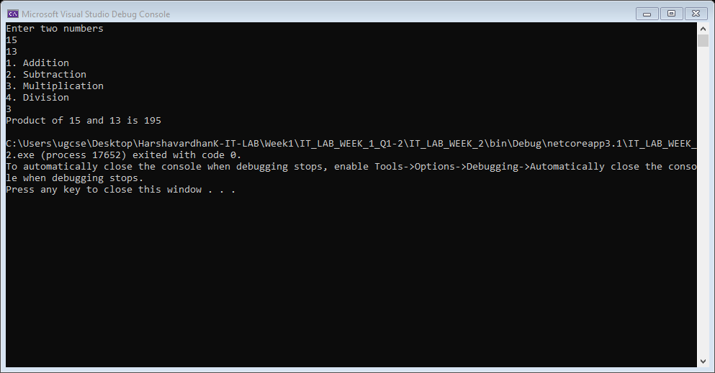

**Question 2**

using System;

namespace IT_LAB_WEEK_1 {

class Program {

static void Main(string[] args)

{

Console.WriteLine("Welcome to Date Time Add!");

Console.WriteLine("Enter date in format: DD:MM:YY:hh:mm:ss");

String inputDate;

inputDate = Console.ReadLine();

Console.WriteLine("Enter number of nano seconds to add:");

Int64 ticks = Int64.Parse(Console.ReadLine());

Console.WriteLine("After Adding: " + addTime(inputDate, ticks));

}

public static String addTime(String inputDate, Int64 ticks) {

int DAY = 0;

int YEAR = 2;

int SECOND = 5;

long NANO_TO_SECONDS = 1000000000;

String[] subStrings = inputDate.Split(':');

Int64 seconds = (ticks / NANO_TO_SECONDS);

Int64 carry = seconds;

String result = "";

String dayTemp = "";

Int64 add;

String temp = subStrings[0];

subStrings[0] = subStrings[2];

subStrings[2] = temp;

Int64[] mods = { 31, 12, 100, 24, 60, 60 };

for (int i = SECOND; i >= DAY; i--)

{

add = (carry + Int64.Parse(subStrings[i])) % mods[i];

carry = (carry + Int64.Parse(subStrings[i])) / mods[i];

if (i > YEAR)

result = ":" + (add + result);

else if (i != DAY)

dayTemp += ((add) + ":");

else

dayTemp += (add);

}

result = (dayTemp + result);

return result;

}

}

}

**Output**

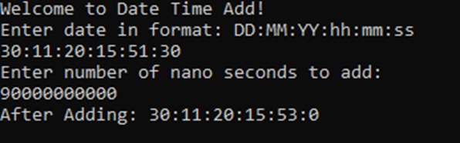

**Question 3**

using System;

using System.Collections.Generic;

using System.ComponentModel;

using System.Data;

using System.Drawing;

using System.Linq;

using System.Text;

using System.Threading.Tasks;

using System.Windows.Forms;

namespace IT_LAB_WEEK_1_WINFORMS

{

public partial class Form1 : Form

{

public Form1()

{

InitializeComponent();

}

private void button1_Click(object sender, EventArgs args)

{

Int64 salary = Int64.Parse(salaryTextbox.Text);

int position = comboBox1.SelectedIndex;

double bonus;

Console.WriteLine("hello");

if (position == 0)

{

bonus = (0.1 * salary);

}

else if (position >= 1 && position < 4)

{

bonus = (0.09 * salary);

}

else if (position >= 4 && position < 7)

{

bonus = (0.07 * salary);

}

else

{

bonus = (0.05 * salary);

}

bonusLabel.Text = bonus.ToString("0.##");

salaryLabel.Text = "hello";

}

private void button1_MouseClick(object sender, MouseEventArgs e)

{

Int64 salary = Int64.Parse(salaryTextbox.Text);

int position = comboBox1.SelectedIndex;

double bonus;

Console.WriteLine("hello");

if (position == 0)

{

bonus = (0.1 * salary);

}

else if (position >= 1 && position < 4)

{

bonus = (0.09 * salary);

}

else if (position >= 4 && position < 7)

{

bonus = (0.07 * salary);

}

else

{

bonus = (0.05 * salary);

}

bonusLabel.Text = bonus.ToString();

}

}

}

**Output**

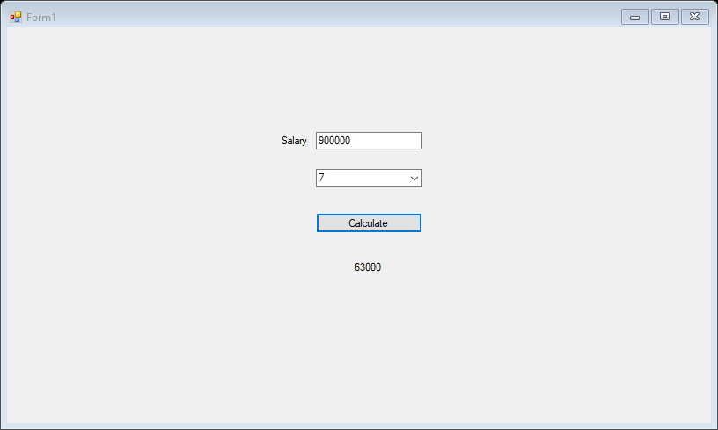

**Question 4**

using System;

using System.Collections.Generic;

using System.ComponentModel;

using System.Data;

using System.Drawing;

using System.Linq;

using System.Text;

using System.Threading.Tasks;

using System.Windows.Forms;

namespace Car_Purchase

{

public partial class Form1 : Form

{

public static String[] toyota = {"Corolla", "Yaris", "Innova", "Fortuner"};

public static String[] toyotaPrices = { "900000", "1700000", "2100000", "3500000" };

public static String[] marutiSuzuki = {"Baleno", "Swift", "Dezire"};

public static String[] suzukiPrices = { "1200000", "1000000", "875000" };

public static String[] hyundai = {"Grand i10", "i20 Asta", "i30"};

public static String[] hyundaiPrices = { "870000", "1100000", "2000000" };

public static String[] kia = {"Sonet", "Seltos"};

public static String[] kiaPrices = { "1250000", "2100000"};

public Form1()

{

InitializeComponent();

}

public void comboBox1_ItemSelected(Object observer, EventArgs e)

{

switch(comboBox1.SelectedIndex)

{

case 0:

listBox1.Items.Clear();

listBox1.Items.AddRange(marutiSuzuki);

break;

case 1:

listBox1.Items.Clear();

listBox1.Items.AddRange(hyundai); break;

case 2:

listBox1.Items.Clear();

listBox1.Items.AddRange(kia);break;

case 3:

listBox1.Items.Clear();

listBox1.Items.AddRange(toyota); break;

}

}

public void listBox1_ItemSelected(Object observer, EventArgs e)

{

String price;

switch (comboBox1.SelectedIndex)

{

case 0:

price = suzukiPrices[listBox1.SelectedIndex];

break;

case 1:

price = hyundaiPrices[listBox1.SelectedIndex];

break;

case 2:

price = kiaPrices[listBox1.SelectedIndex];

break;

case 3:

price = toyotaPrices[listBox1.SelectedIndex];

break;

default:

price = "0";

break;

}

label2.Text = price;

}

public void button1_Click(Object observer, EventArgs e)

{

MessageBox.Show("Thank you for Purchasing " + comboBox1.Text + " " + listBox1.SelectedItem);

}

public void button2_Click(Object observer, EventArgs e)

{

comboBox2.SelectedIndex = 0;

comboBox1.SelectedIndex = 0;

listBox1.SelectedIndex = 0;

label2.Text = "Uncalculated";

MessageBox.Show("Selections Reset");

}

}

**Output**

