**INTERNET TECHNOLOGY LAB**

WEEK 2

**Name: Harshavardhan K**

**Roll no: 06, CSE D**

**Reg No: 170905022**

**Question 1**

using System;

namespace IT_LAB_WEEK_2 {

public delegate void PriceChangedEventHandler(int newPrice);

public class Item {

private string name;

private int price;

public string Name {

get {

return name;

}

set {

name = value;

}

}

public event PriceChangedEventHandler PriceChanged;

public int Price {

get {

return price;

}

set {

price = value;

PriceChanged?.Invoke(value);

}

}

}

class Program {

public static void priceChangeDetected(int newPrice) {

Console.WriteLine("Price of the item changed to {0}", newPrice);

}

public static void quest1() {

Item item = new Item();

item.PriceChanged += priceChangeDetected;

item.Price = 1299;

}

public static void Main(string[] args) {

Item item = new Item();

item.PriceChanged += priceChangeDetected;

item.Name = "iPhone 12 Pro";

item.Price = 129000;

}

}

}

**Output**

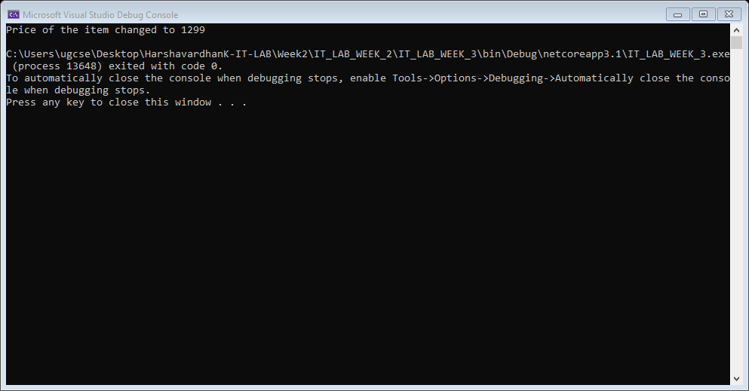

**Question 2**

using System;

namespace IT_LAB_WEEK_2 {

public class Item2 {

public string Name { get; set; }

public static int Cost;

public Item2(string name, int cost) {

Name = name;

Cost = cost;

}

public double CalcGst() {

return 0.08 * Cost;

}

}

class Program {

public static void quest2() {

Item2 item = new Item2("iPhone X", 129000);

Console.WriteLine(item.CalcGst());

}

public static void Main(string[] args) {

quest2();

}

}

}

**Output**

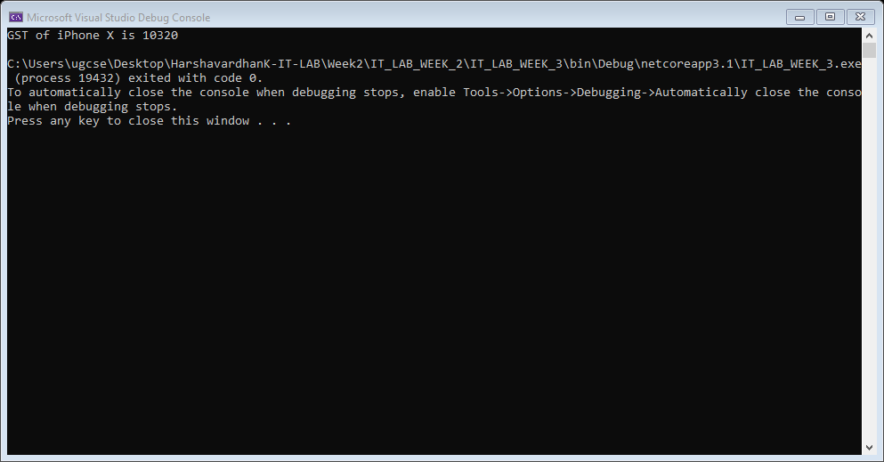

**Question 3**

using System;

namespace IT_LAB_WEEK_2 {

public delegate void TrafficDelegate();

public class TrafficSignal {

public void yellowSignal() {

Console.WriteLine("Get ready to move");

}

public void greenSignal() {

Console.WriteLine("Move");

}

public void redSignal() {

Console.WriteLine("Stop");

}

}

class Program {

public static void Main(string[] args) {

TrafficDelegate trafDel;

TrafficSignal trafSignal = new TrafficSignal();

trafDel = trafSignal.redSignal;

trafDel();

}

}

}

**Output**

