Internet Technology Lab

# Week 3

Name: Harshavardhan K

Roll No: 06 CSE D

Reg No: 170905022

## Question 1

**MagazineCover.aspx**

<%@ Page Language="C#" AutoEventWireup="true" CodeBehind="WebForm1.aspx.cs" Inherits="IT_LAB_WEEK3_Q1.WebForm1" %>

<!DOCTYPE html>

<html xmlns="http://www.w3.org/1999/xhtml">

<head runat="server">

<title></title>

</head>

<body>

<form id="form1" runat="server">

<div style="height: 672px">

<asp:TextBox ID="messageTextBox" runat="server" OnTextChanged="TextBox1_TextChanged" style="margin-left: 148px; margin-top: 46px" Width="152px">Type message</asp:TextBox>

<br />

<br />

<br />

<asp:Label ID="Label2" runat="server" Text="Choose font"></asp:Label>

<asp:DropDownList ID="fontDropDown" runat="server" Height="50px" style="margin-left: 58px; margin-top: 31px" Width="203px">

</asp:DropDownList>

<br />

<br />

<br />

<br />

<asp:Label ID="Label3" runat="server" Text="Choose size"></asp:Label>

<asp:DropDownList ID="fontSizeDropDown" runat="server" Height="24px" style="margin-left: 0px" Width="203px">

<asp:ListItem>14</asp:ListItem>

<asp:ListItem>16</asp:ListItem>

<asp:ListItem>18</asp:ListItem>

<asp:ListItem>20</asp:ListItem>

<asp:ListItem>22</asp:ListItem>

</asp:DropDownList>

<br />

<br />

<br />

<br />

<asp:Label ID="Label4" runat="server" Text="Choose color"></asp:Label>

<asp:DropDownList ID="colorDropDown" runat="server" Height="24px" Width="212px">

</asp:DropDownList>

<br />

<br />

<asp:Label ID="bgColor" runat="server" Text="Choose background"></asp:Label>

&nbsp;&nbsp;&nbsp;

<asp:DropDownList ID="backgroundColor" runat="server" Height="16px" Width="200px">

</asp:DropDownList>

<br />

<br />

&nbsp;<asp:Label ID="Label5" runat="server" Text="Upload image"></asp:Label>

&nbsp;&nbsp;&nbsp;&nbsp;&nbsp;&nbsp;&nbsp;&nbsp;&nbsp;&nbsp;&nbsp;

<asp:TextBox ID="imageLocal" runat="server"></asp:TextBox>

<br />

<br />

<br />

<asp:Button ID="generateButton" runat="server" OnClick="generate" Text="Generate" />

</div>

<asp:Panel ID="magazine" runat="server" style="position: absolute; margin-left: 598px; top: 32px; left: -86px; width: 554px; height: 405px;">

<asp:Label ID="titleLabel" runat="server" Text="Label"></asp:Label>

<asp:Image ID="coverImage" runat="server" Height="200px" style="margin-left: 149px; margin-top: 119px" Width="250px" />

</asp:Panel>

</form>

</body>

</html>

**MagazineCover.aspx.cs**

using System;

using System.Collections.Generic;

using System.Linq;

using System.Web;

using System.Web.UI;

using System.Drawing;

using System.Web.UI.WebControls;

namespace IT_LAB_WEEK3_Q1

{

public partial class WebForm1 : System.Web.UI.Page

{

protected void Page_Load(object sender, EventArgs e)

{

if(!IsPostBack)

{

// Set font options.

fontDropDown.Items.Add("Times New Roman");

fontDropDown.Items.Add("Arial");

fontDropDown.Items.Add("Verdana");

fontDropDown.Items.Add("Tahoma");

colorDropDown.Items.Add("White");

colorDropDown.Items.Add("Red");

colorDropDown.Items.Add("Green");

colorDropDown.Items.Add("Blue");

colorDropDown.Items.Add("Yellow");

backgroundColor.Items.Add("White");

backgroundColor.Items.Add("Red");

backgroundColor.Items.Add("Green");

backgroundColor.Items.Add("Blue");

backgroundColor.Items.Add("Yellow");

}

}

protected void TextBox1_TextChanged(object sender, EventArgs e)

{

titleLabel.Text = messageTextBox.Text;

}

protected void generate(object sender, EventArgs args)

{

magazine.BackColor = Color.FromName(backgroundColor.SelectedItem.Text);

string selectedFont = fontSizeDropDown.SelectedValue;

titleLabel.Font.Size = FontUnit.Point(Int32.Parse(selectedFont));

titleLabel.BackColor = Color.FromName(colorDropDown.SelectedItem.Text);

titleLabel.Text = messageTextBox.Text;

coverImage.ImageUrl = imageLocal.Text;

}

}

}

## **Output**

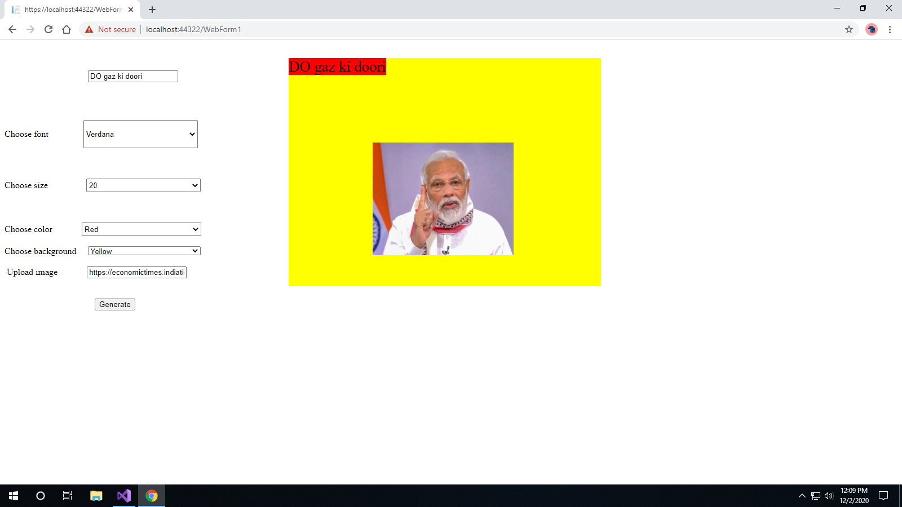

## Question 2

**Employee.aspx**

<%@ Page Language="C#" AutoEventWireup="true" CodeBehind="WebForm1.aspx.cs" Inherits="IT_LAB_WEEK3_Q2.WebForm1" %>

<!DOCTYPE html>

<html xmlns="http://www.w3.org/1999/xhtml">

<head runat="server">

<title></title>

</head>

<body>

<form id="form1" runat="server">

<div style="height: 502px; position: absolute; top: 15px; left: 10px; width: 1119px;">

<br />

<br />

<asp:Label ID="Label1" runat="server" Text=" Employee ID"></asp:Label>

&nbsp;&nbsp;&nbsp;

<asp:DropDownList ID="employeeIDDropDown" runat="server" Height="25px" Width="201px">

</asp:DropDownList>

&nbsp;&nbsp;&nbsp;&nbsp;&nbsp;&nbsp;&nbsp;&nbsp;&nbsp;

<asp:Button ID="chooseEmployee" runat="server" OnClick="choose_Employee" Text="Choose" />

<br />

<br />

<br />

<asp:Image ID="employeeImage" runat="server" Height="153px" Width="201px" />

<br />

<br />

<br />

<asp:TextBox ID="employeeNameTextbox" runat="server" style="margin-left: 97px" Width="192px">Enter name..</asp:TextBox>

<br />

<br />

<br />

<asp:TextBox ID="joinDateTextbox" runat="server" Width="188px">Enter join date..</asp:TextBox>

<br />

<br />

<br />

<asp:Button ID="eligible" runat="server" OnClick="elibible_Promotion" Text="Am I Eligible For Promotion" Width="192px" />

&nbsp;&nbsp;&nbsp;&nbsp;&nbsp;&nbsp;&nbsp;&nbsp;&nbsp;&nbsp;&nbsp;

<asp:Label ID="eligibleLabel" runat="server" Text="________"></asp:Label>

</div>

</form>

</body>

</html>

**Eligible.aspx.cs**

using System;

using System.Collections.Generic;

using System.Linq;

using System.Web;

using System.Web.UI;

using System.Web.UI.WebControls;

namespace IT_LAB_WEEK3_Q2

{

public partial class WebForm1 : System.Web.UI.Page

{

string[] images = {"https://www.hindustantimes.com/rf/image_size_960x540/HT/p2/2020/12/01/Pictures/president-trump-holds-thanksgiving-videoconference-military-members_2e7ba9e6-33ff-11eb-9c97-4dbf0d0924a0.jpg"

, "https://www.hindustantimes.com/rf/image_size_960x540/HT/p2/2020/12/01/Pictures/president-trump-holds-thanksgiving-videoconference-military-members_2e7ba9e6-33ff-11eb-9c97-4dbf0d0924a0.jpg"

, "https://www.hindustantimes.com/rf/image_size_960x540/HT/p2/2020/12/01/Pictures/president-trump-holds-thanksgiving-videoconference-military-members_2e7ba9e6-33ff-11eb-9c97-4dbf0d0924a0.jpg" };

protected void Page_Load(object sender, EventArgs e)

{

if(!IsPostBack)

{

employeeIDDropDown.Items.Add("E1");

employeeIDDropDown.Items.Add("E2");

employeeIDDropDown.Items.Add("E3");

}

}

protected void elibible_Promotion(object sender, EventArgs args)

{

string joinDate = joinDateTextbox.Text;

DateTime join;

var isValidDate = DateTime.TryParse(joinDate, out join);

if(isValidDate)

{

var now = DateTime.Now;

int years = now.Year - join.Year;

if(years > 5)

{

eligibleLabel.Text = "YES";

} else

{

eligibleLabel.Text = "NO";

}

}

}

protected void choose_Employee(object sender, EventArgs args)

{

int selectedEmployee = employeeIDDropDown.SelectedIndex;

//Console.WriteLine(selectedEmployee);

employeeImage.ImageUrl = images[selectedEmployee];

}

}

}

**Output**

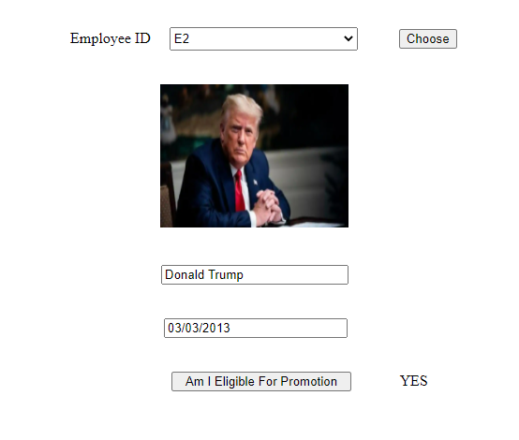

## Question 3

**Greeting.aspx**

<%@ Page Language="C#" AutoEventWireup="true" CodeBehind="WebForm1.aspx.cs" Inherits="IT_LAB_WEEK3_Q1.WebForm1" %>

<!DOCTYPE html>

<html xmlns="http://www.w3.org/1999/xhtml">

<head runat="server">

<title></title>

</head>

<body>

<form id="form1" runat="server">

<div style="height: 672px">

<asp:TextBox ID="messageTextBox" runat="server" OnTextChanged="TextBox1_TextChanged" style="margin-left: 148px; margin-top: 46px" Width="152px">Type message</asp:TextBox>

<br />

<br />

<br />

<asp:Label ID="Label2" runat="server" Text="Choose font"></asp:Label>

<asp:DropDownList ID="fontDropDown" runat="server" Height="50px" style="margin-left: 58px; margin-top: 31px" Width="203px">

</asp:DropDownList>

<br />

<br />

<br />

<br />

<asp:Label ID="Label3" runat="server" Text="Choose size"></asp:Label>

&nbsp;&nbsp;&nbsp;&nbsp;&nbsp;&nbsp;&nbsp;&nbsp;&nbsp;&nbsp;&nbsp;&nbsp;&nbsp;&nbsp;&nbsp;

<asp:DropDownList ID="fontSizeDropDown" runat="server" Height="24px" style="margin-left: 0px" Width="203px">

<asp:ListItem>14</asp:ListItem>

<asp:ListItem>16</asp:ListItem>

<asp:ListItem>18</asp:ListItem>

<asp:ListItem>20</asp:ListItem>

<asp:ListItem>22</asp:ListItem>

</asp:DropDownList>

<br />

<br />

<br />

<br />

<asp:Label ID="Label4" runat="server" Text="Choose color"></asp:Label>

&nbsp;&nbsp;&nbsp;&nbsp;&nbsp;&nbsp;&nbsp;&nbsp;&nbsp;&nbsp;&nbsp;

<asp:DropDownList ID="colorDropDown" runat="server" Height="24px" Width="212px">

</asp:DropDownList>

<br />

<br />

<asp:Label ID="bgColor" runat="server" Text="Choose background"></asp:Label>

&nbsp;&nbsp;&nbsp;

<asp:DropDownList ID="backgroundColor" runat="server" Height="16px" Width="200px">

</asp:DropDownList>

<br />

<br />

&nbsp;<asp:Label ID="Label5" runat="server" Text="Upload image"></asp:Label>

&nbsp;&nbsp;&nbsp;&nbsp;&nbsp;&nbsp;&nbsp;&nbsp;&nbsp;&nbsp;&nbsp;

<asp:TextBox ID="imageLocal" runat="server"></asp:TextBox>

<br />

<br />

<br />

&nbsp;&nbsp;&nbsp;&nbsp;&nbsp;&nbsp;&nbsp;&nbsp;&nbsp;&nbsp;&nbsp;&nbsp;&nbsp;&nbsp;&nbsp;&nbsp;&nbsp;&nbsp;&nbsp;&nbsp;&nbsp;&nbsp;&nbsp;&nbsp;&nbsp;&nbsp;&nbsp;&nbsp;&nbsp;&nbsp;&nbsp;&nbsp;&nbsp;&nbsp;&nbsp;&nbsp;&nbsp;&nbsp;&nbsp;

<asp:Button ID="generateButton" runat="server" OnClick="generate" Text="Generate" />

</div>

<asp:Panel ID="magazine" runat="server" style="position: absolute; margin-left: 598px; top: 32px; left: -86px; width: 554px; height: 405px;">

<asp:Label ID="titleLabel" runat="server" Text="Label"></asp:Label>

<asp:Image ID="coverImage" runat="server" Height="200px" style="margin-left: 149px; margin-top: 119px" Width="250px" />

</asp:Panel>

</form>

</body>

</html>

**Greeting.aspx.cs**

using System;

using System.Collections.Generic;

using System.Linq;

using System.Web;

using System.Web.UI;

using System.Drawing;

using System.Web.UI.WebControls;

namespace IT_LAB_WEEK3_Q1

{

public partial class WebForm1 : System.Web.UI.Page

{

protected void Page_Load(object sender, EventArgs e)

{

if(!IsPostBack)

{

// Set font options.

fontDropDown.Items.Add("Times New Roman");

fontDropDown.Items.Add("Arial");

fontDropDown.Items.Add("Verdana");

fontDropDown.Items.Add("Tahoma");

colorDropDown.Items.Add("White");

colorDropDown.Items.Add("Red");

colorDropDown.Items.Add("Green");

colorDropDown.Items.Add("Blue");

colorDropDown.Items.Add("Yellow");

backgroundColor.Items.Add("White");

backgroundColor.Items.Add("Red");

backgroundColor.Items.Add("Green");

backgroundColor.Items.Add("Blue");

backgroundColor.Items.Add("Yellow");

}

}

protected void TextBox1_TextChanged(object sender, EventArgs e)

{

titleLabel.Text = messageTextBox.Text;

}

protected void generate(object sender, EventArgs args)

{

magazine.BackColor = Color.FromName(backgroundColor.SelectedItem.Text);

string selectedFont = fontSizeDropDown.SelectedValue;

titleLabel.Font.Size = FontUnit.Point(Int32.Parse(selectedFont));

titleLabel.BackColor = Color.FromName(colorDropDown.SelectedItem.Text);

titleLabel.Text = messageTextBox.Text;

coverImage.ImageUrl = imageLocal.Text;

}

}

}

**Output**

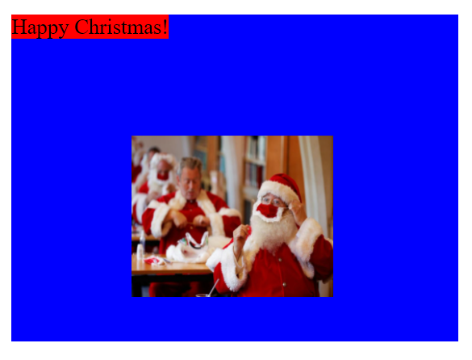

## Question 4

**Captcha.aspx**

<%@ Page Language="C#" AutoEventWireup="true" CodeBehind="Captcha.aspx.cs" Inherits="Captcha.Captcha" %>

<!DOCTYPE html>

<html xmlns="http://www.w3.org/1999/xhtml">

<head runat="server">

<title></title>

</head>

<body>

<form id="form1" runat="server">

<div>

<img runat="server" id="CaptchaImage" alt="Captcha Image" style="width:180px; height:30px" />

<br /><br />

<asp:Button runat="server" ID="Reload" Text="Reload this Captcha" />

<br />

<br />

<asp:TextBox ID="CaptchaText" runat="server" />

<asp:Button runat="server" ID="Submit" Text="Submit Captcha" OnClick="Check_Captcha" />

</div>

<br />

<asp:Label Text="Waiting for Verification..." runat="server" ID="VerifiedStatus" />

</form>

</body>

</html>

**Captcha.aspx.cs**

using System;

using System.Collections.Generic;

using System.Linq;

using System.Web;

using System.Web.UI;

using System.Web.UI.WebControls;

namespace Captcha

{

    public partial class Captcha : System.Web.UI.Page

    {

        public List<String> captchas;

        public List<String> values;

        public static int currentShow;

        public static int oldShow;

        public static int tries = 3;

        public void Initialize_Lists()

        {

            captchas = new List<String>();

            captchas.Add("https://captcha.com/images/captcha/botdetect3-captcha-ancientmosaic.jpg");

            captchas.Add("https://captcha.com/images/captcha/botdetect3-captcha-blackoverlap.jpg");

            captchas.Add("https://captcha.com/images/captcha/botdetect3-captcha-meltingheat.jpg");

            captchas.Add("https://captcha.com/images/captcha/botdetect3-captcha-negative.jpg");

            values = new List<String>();

            values.Add("W93BX");

            values.Add("RBSKW");

            values.Add("JA3V8");

            values.Add("459CT");

        }

        protected void Page_Load(object sender, EventArgs e)

        {

            if (tries > 0)

            {

                CaptchaText.Enabled = true;

                Submit.Enabled = true;

            }

            else

            {

                VerifiedStatus.Text = "Max Attempts Exceeded.";

                CaptchaText.Enabled = false;

                Submit.Enabled = false;

            }

            Random random = new Random();

            oldShow = currentShow;

            currentShow = random.Next(0, 4);

            Initialize_Lists();

            CaptchaImage.Src = captchas[currentShow];

        }

        protected void Check_Captcha(object sender, EventArgs e)

        {

            String captchaEntered = CaptchaText.Text.Trim().ToUpper();

            if (captchaEntered.Equals(values[oldShow]))

            {

                VerifiedStatus.Text = "Successfully Verified.";

            }

            else

            {

                tries--;

                VerifiedStatus.Text = "Failed. Remaining Attempts: " + tries;

            }

        }

    }

}

**Output**

