Internet Technology Lab

# Week 4

Name: Harshavardhan K

Roll No: 06, CSE D

Reg No: 170905022

# Question 1

Webform1.aspx

<%@ Page Language="C#" AutoEventWireup="true" CodeBehind="WebForm2.aspx.cs" Inherits="CarManufacture.WebForm2" %>

<!DOCTYPE html>

<html xmlns="http://www.w3.org/1999/xhtml">

<head runat="server">

<title>One</title>

</head>

<body>

<form id="form1" runat="server">

<div style="height: 393px">

Car Name:<br />

<asp:DropDownList ID="DropDownList1" runat="server" Height="16px" Width="207px">

</asp:DropDownList>

<br />

<br />

Car Model:-<br />

<asp:DropDownList ID="DropDownList2" runat="server" Height="25px" Width="209px">

</asp:DropDownList>

<br />

<br />

<br />

<asp:Button ID="Button1" runat="server" OnClick="Button1_Click" Text="Next Page" Width="173px" />

</div>

</form>

</body>

</html>

WebForm1.aspx.cs

using System;

using System.Data;

using System.Configuration;

using System.Collections;

using System.Web;

using System.Web.Security;

using System.Web.UI;

using System.Web.UI.WebControls;

using System.Web.UI.WebControls.WebParts;

using System.Web.UI.HtmlControls;

namespace CarManufacture

{

public partial class WebForm2 : System.Web.UI.Page

{

protected void Page_Load(object sender, EventArgs e)

{

if (!IsPostBack)

{

DropDownList1.Items.Add("Audi");

DropDownList1.Items.Add("Jaguar");

DropDownList1.Items.Add("Maruti");

DropDownList2.Items.Add("First");

DropDownList2.Items.Add("Second");

DropDownList2.Items.Add("Third");

}

}

protected void Button1_Click(object sender, EventArgs e)

{

string url = "WebForm1.aspx?";

url += "Car=" + Server.UrlEncode(DropDownList1.SelectedItem.Text) + "&";

url += "Model=" + Server.UrlEncode(DropDownList2.SelectedItem.Text);

Response.Redirect(url);

}

}

}

Webform2.aspx

%@ Page Language="C#" AutoEventWireup="true" CodeBehind="WebForm1.aspx.cs" Inherits="CarManufacture.WebForm1" %>

<!DOCTYPE html>

<html xmlns="http://www.w3.org/1999/xhtml">

<head runat="server">

<title>Two</title>

</head>

<body>

<form id="form1" runat="server">

<p>

<asp:Label ID="Label1" runat="server"></asp:Label>

</p>

</form>

</body>

</html>

Webform2.aspx.cs

ing System;

using System.Data;

using System.Configuration;

using System.Collections;

using System.Web;

using System.Web.Security;

using System.Web.UI;

using System.Web.UI.WebControls;

using System.Web.UI.WebControls.WebParts;

using System.Web.UI.HtmlControls;

public partial class QueryStringRecipient : System.Web.UI.Page

{

protected void Page_Load(object sender, EventArgs e)

{

lblInfo.Text = "Item: " + Request.QueryString["Item"];

lblInfo.Text += "<br />Show Full Record: ";

lblInfo.Text += Request.QueryString["Mode"];

}

}

**Output**

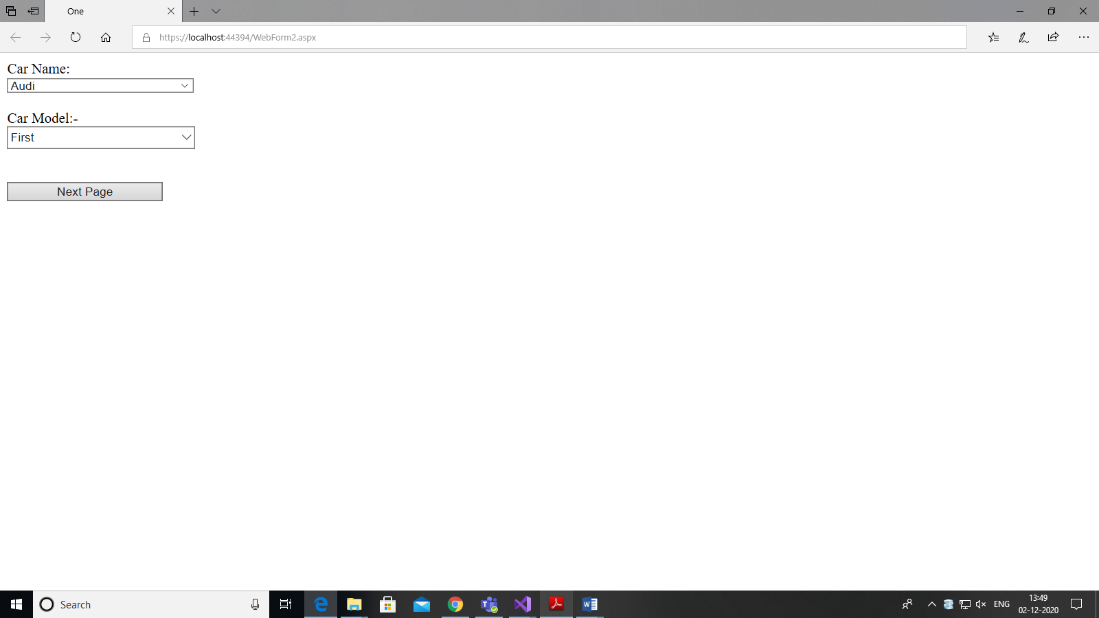

## Question 2

firstForm.aspx

<%@ Page Language="C#" AutoEventWireup="true" CodeBehind="firstFrom.aspx.cs" Inherits="Lab4Q2.WebForm1" %>

<!DOCTYPE html>

<html xmlns="http://www.w3.org/1999/xhtml">

<head runat="server">

<title></title>

</head>

<body>

<form id="form1" runat="server">

<div style="height: 357px">

Name:<br />

<asp:TextBox ID="TextBox1" runat="server"></asp:TextBox>

<br />

<br />

Roll No:<br />

<asp:TextBox ID="TextBox2" runat="server"></asp:TextBox>

<br />

<br />

Subjects:<br />

<asp:DropDownList ID="DropDownList1" runat="server" Height="16px" Width="194px">

</asp:DropDownList>

<br />

<br />

<asp:Button ID="Button1" runat="server" OnClick="Button1_Click" Text="Next" />

</div>

</form>

</body>

</html>

firstForm.aspx.cs

using System;

using System.Collections.Generic;

using System.Linq;

using System.Web;

using System.Web.UI;

using System.Web.UI.WebControls;

namespace Lab4Q2

{

public partial class WebForm1 : System.Web.UI.Page

{

protected void Page_Load(object sender, EventArgs e)

{

if (!IsPostBack)

{

DropDownList1.Items.Add("Hindi");

DropDownList1.Items.Add("English");

DropDownList1.Items.Add("Maths");

TextBox1.Text = "";

TextBox2.Text = "";

}

}

protected void Button1_Click(object sender, EventArgs e)

{

Session["Subject"] = DropDownList1.Items[DropDownList1.SelectedIndex];

Session["Name"] = TextBox1.Text;

Session["RollNo"] = TextBox2.Text;

Response.Redirect("secondForm.aspx");

}

}

}

SecondForm.aspx

<%@ Page Language="C#" AutoEventWireup="true" CodeBehind="secondForm.aspx.cs" Inherits="Lab4Q2.secondForm" %>

<!DOCTYPE html>

<html xmlns="http://www.w3.org/1999/xhtml">

<head runat="server">

<title></title>

</head>

<body>

<form id="form1" runat="server">

<div style="height: 166px">

Info:-<br />

<asp:Label ID="Label1" runat="server"></asp:Label>

<br />

<br />

Counter:-<br />

<asp:Label ID="Label2" runat="server"></asp:Label>

<br />

<br />

<asp:Button ID="Button1" runat="server" OnClick="Button1_Click" Text="Counter" />

</div>

</form>

</body>

</html>

SecondForm.aspx.cs

using System;

using System.Collections.Generic;

using System.Linq;

using System.Web;

using System.Web.UI;

using System.Web.UI.WebControls;

namespace Lab4Q2

{

public partial class secondForm : System.Web.UI.Page

{

protected void Page_Load(object sender, EventArgs e)

{

if (!IsPostBack)

{

string text = Session["Name"] + ":" + Session["RollNo"] + ":" + Session["Subject"];

Label1.Text = text;

}

}

protected void Button1_Click(object sender, EventArgs e)

{

int counter;

if (ViewState["Counter"] == null)

{

counter = 1;

}

else

{

counter = (int)ViewState["Counter"] + 1;

}

ViewState["Counter"] = counter;

Label2.Text = "Counter: " + counter.ToString();

}

}

}

**Output**

