Internet Technology Lab

# Week 5

Name: Harshavardhan K

Reg No: 170905022

Roll No: 6, CSE D

**Question 1**

**ELectionForm.aspx**

<%@ Page Language="C#" AutoEventWireup="true" CodeBehind="ElectionForm.aspx.cs" Inherits="IT_LAB_WEEK5_Q1.WebForm1" %>

<!DOCTYPE html>

<html xmlns="http://www.w3.org/1999/xhtml">

<head runat="server">

<title></title>

</head>

<body>

<form id="form1" runat="server">

<div style="margin-left: 6px">

<asp:Label ID="Label1" runat="server" Text="Choose a Candidate"></asp:Label>

<br />

<br />

<asp:DropDownList ID="candidateList" runat="server" Height="16px" Width="129px">

</asp:DropDownList>

<asp:RequiredFieldValidator ID="candidateValidator" runat="server" ControlToValidate="candidateList" ErrorMessage="Please choose a candidate"></asp:RequiredFieldValidator>

<br />

<br />

<br />

<br />

<asp:Label ID="Label2" runat="server" Text="Student Details"></asp:Label>

<br />

<br />

<asp:RadioButtonList ID="houseList" runat="server">

</asp:RadioButtonList>

<asp:RequiredFieldValidator ID="RequiredFieldValidator1" runat="server" ControlToValidate="houseList" ErrorMessage="Please select a house"></asp:RequiredFieldValidator>

<br />

<asp:TextBox ID="classText" runat="server" Width="202px">Enter class</asp:TextBox>

<asp:RequiredFieldValidator ID="RequiredFieldValidator2" runat="server" ControlToValidate="classText" ErrorMessage="Please enter a class"></asp:RequiredFieldValidator>

&nbsp;&nbsp;&nbsp;

<asp:RangeValidator ID="classRangeValidator" runat="server" ControlToValidate="classText" ErrorMessage="Enter class from 6 to 9" MaximumValue="9" MinimumValue="6"></asp:RangeValidator>

<br />

<br />

<asp:TextBox ID="emailText" runat="server" Width="205px">Enter Email</asp:TextBox>

&nbsp;<asp:RequiredFieldValidator ID="RequiredFieldValidator3" runat="server" ControlToValidate="emailText" ErrorMessage="Please enter an email ID"></asp:RequiredFieldValidator>

&nbsp;<br />

&nbsp;&nbsp;

<asp:RegularExpressionValidator ID="emailRegExValidator" runat="server" ControlToValidate="emailText" ErrorMessage="Enter a valid email ID" ValidationExpression="\w+([-+.']\w+)*@\w+([-.]\w+)*\.\w+([-.]\w+)*"></asp:RegularExpressionValidator>

<br />

<br />

<asp:TextBox ID="phoneText" runat="server" Width="206px">Enter Parent Phone Number</asp:TextBox>

&nbsp;&nbsp;&nbsp;

<asp:CustomValidator ID="phoneCustomValidator" runat="server" ControlToValidate="phoneText" ErrorMessage="Enter a valid phone number" OnServerValidate="phone_Custom_Server_Validator"></asp:CustomValidator>

<br />

<br />

<br />

<asp:Button ID="Button1" runat="server" style="margin-left: 38px" Text="Submit" Width="121px" />

<br />

<br />

<asp:ValidationSummary ID="ValidationSummary1" runat="server" />

</div>

</form>

</body>

</html>

**ElectionForm.aspx.cs**

using System;

using System.Collections.Generic;

using System.Linq;

using System.Web;

using System.Web.UI;

using System.Web.UI.WebControls;

namespace IT_LAB_WEEK5_Q1

{

public partial class WebForm1 : System.Web.UI.Page

{

protected void Page_Load(object sender, EventArgs e)

{

if(!IsPostBack)

{

candidateList.Items.Add("Donald Trump");

candidateList.Items.Add("Narendra Modi");

candidateList.Items.Add("Joseph R Biden");

houseList.Items.Add("Gryffindor");

houseList.Items.Add("Slytherin");

houseList.Items.Add("Ravenclaw");

}

}

protected void phone_Custom_Server_Validator(object sender, ServerValidateEventArgs args)

{

try

{

long phoneNumber;

long.TryParse(args.Value, out phoneNumber);

int count = 0;

while(phoneNumber > 0)

{

count += 1;

phoneNumber /= 10;

}

args.IsValid = (count == 10);

} catch(Exception ex)

{

args.IsValid = false;

}

}

}

}

**Output**

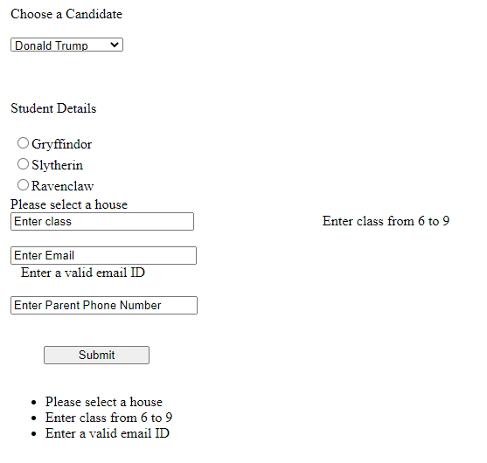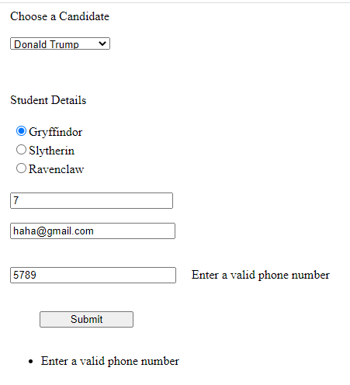

**Question 2**

**SiteMaster.aspx**

<%@ Master Language="C#" AutoEventWireup="true" CodeBehind="HomePage.master.cs" Inherits="ECommerce.HomePage" %>

<html>

<head runat="server">

<title>Amazon</title>

</head>

<body style="padding:0; margin: 0">

<nav>

<ul>

<li class="Company">Pluto's Galaxy</li>

<li>About Us</li>

<li>Contact Us</li>

</ul>

</nav>

<h1>Explore Pluto's Galaxy</h1>

<nav>

<ul>

<li class="Company">Exciting Categories for you</li>

<li><a href="/Electronics.aspx">Electronics.aspx</a></li>

<li><a href="/Baggage.aspx">Baggages</a></li>

<li><a href="/Offers.aspx">Offers</a></li>

</ul>

</nav>

<asp:ContentPlaceHolder ID="Electronics" runat="server" />

<asp:ContentPlaceHolder ID="Baggage" runat="server" />

<asp:ContentPlaceHolder ID="Offers" runat="server" />

</body>

</html>

**Baggage.aspx**

<%@ Page Title="" Language="C#" MasterPageFile="~/HomePage.master" AutoEventWireup="true" CodeBehind="Baggage.aspx.cs" Inherits="ECommerce.Baggage" %>

<asp:Content ID="Baggage_Section" ContentPlaceHolderID="Baggage" runat="server">

<img src="https://images.unsplash.com/photo-1517612228538-cefdbc2c01e7?ixid=MXwxMjA3fDB8MHxwaG90by1wYWdlfHx8fGVufDB8fHw%3D&ixlib=rb-1.2.1&auto=format&fit=crop&w=1050&q=80" style="height:100%; width:100%; margin: 0; padding:0; display:inline; position:absolute; z-index:-1" />

<div style="z-index:0; color:#fff">

<h2>

Welcome to Baggage Section.

</h2>

<h1>Look mighty good with the mighty American Tourister.</h1>

<h3>Deals raining on Polo, AT and Gucci. Visit the nearest Pluto's Galaxy today!</h3>

<img class="options" src="https://images.unsplash.com/photo-1475312775467-159e03aaa7cd?ixid=MXwxMjA3fDB8MHxwaG90by1wYWdlfHx8fGVufDB8fHw%3D&ixlib=rb-1.2.1&auto=format&fit=crop&w=1050&q=80" style="height:106px; width:160px" />

<img class="options" src="https://images.unsplash.com/photo-1525103504173-8dc1582c7430?ixid=MXwxMjA3fDB8MHxwaG90by1wYWdlfHx8fGVufDB8fHw%3D&ixlib=rb-1.2.1&auto=format&fit=crop&w=1053&q=80" style="height:106px; width:160px" />

</div>

</asp:Content>

**Electronics.aspx**

<%@ Page Title="" Language="C#" MasterPageFile="~/HomePage.master" AutoEventWireup="true" CodeBehind="Electronics.aspx.cs" Inherits="ECommerce.Electronics" %>

<asp:Content ID="Electronics_Section" ContentPlaceHolderID="Electronics" runat="server">

<img src="https://images.unsplash.com/photo-1518770660439-4636190af475?ixid=MXwxMjA3fDB8MHxwaG90by1wYWdlfHx8fGVufDB8fHw%3D&ixlib=rb-1.2.1&auto=format&fit=crop&w=1050&q=80" style="height:100%; width:100%; margin: 0; padding:0; display:inline; position:absolute; z-index:-1" />

<div style="z-index:0; color:#fff">

<h2>

Welcome to Electronics Section.

</h2>

<h1>

Bag an exciting deal on iPhone 12 Mini! Visit our store near you now!

</h1>

<h3>

Be your best: with a durable OS, you remain safe in a world of constant threats to your privacy. <a href="google.com">Read More</a>

</h3>

<img class="options" src="https://images.unsplash.com/photo-1510557880182-3d4d3cba35a5?ixid=MXwxMjA3fDB8MHxwaG90by1wYWdlfHx8fGVufDB8fHw%3D&ixlib=rb-1.2.1&auto=format&fit=crop&w=1050&q=80" style="height:106px; width:160px" />

<img class="options" src="https://images.unsplash.com/photo-1591122947157-26bad3a117d2?ixid=MXwxMjA3fDB8MHxwaG90by1wYWdlfHx8fGVufDB8fHw%3D&ixlib=rb-1.2.1&auto=format&fit=crop&w=1050&q=80" style="height:106px; width:160px" />

<img class="options" src="https://images.unsplash.com/photo-1582227108289-44a0f0dd993d?ixid=MXwxMjA3fDB8MHxwaG90by1wYWdlfHx8fGVufDB8fHw%3D&ixlib=rb-1.2.1&auto=format&fit=crop&w=1050&q=80" style="height:106px; width:160px" />

<img class="options" src="https://images.unsplash.com/photo-1505616784093-32fb4f9b1bf7?ixid=MXwxMjA3fDB8MHxwaG90by1wYWdlfHx8fGVufDB8fHw%3D&ixlib=rb-1.2.1&auto=format&fit=crop&w=1050&q=80" style="height:106px; width:160px" />

</div>

</asp:Content>

**Offers.aspx**

<%@ Page Title="" Language="C#" MasterPageFile="~/HomePage.master" AutoEventWireup="true" CodeBehind="Offers.aspx.cs" Inherits="ECommerce.Offers" %>

<asp:Content ID="Offers_Section" ContentPlaceHolderID="Offers" runat="server">

<img src="https://images.unsplash.com/photo-1515606378517-3451a4fa2e12?ixlib=rb-1.2.1&ixid=MXwxMjA3fDB8MHxwaG90by1wYWdlfHx8fGVufDB8fHw%3D&auto=format&fit=crop&w=1100&q=80" style="height:100%; width:100%; margin: 0; padding:0; display:inline; position:absolute; z-index:-1" />

<div style="z-index:0; color:#000">

<h2>

Welcome to Offers Section.

</h2>

<h1>You want it? Then buy it and save loads of money!</h1>

<h3>Deals raining on iPhones, Galaxies, Zara, and Titan. Visit the nearest Amazon Go Store today!</h3>

<img class="options" src="https://images.unsplash.com/photo-1510557880182-3d4d3cba35a5?ixid=MXwxMjA3fDB8MHxwaG90by1wYWdlfHx8fGVufDB8fHw%3D&ixlib=rb-1.2.1&auto=format&fit=crop&w=1050&q=80" style="height:106px; width:160px" />

<img class="options" src="https://images.unsplash.com/photo-1591122947157-26bad3a117d2?ixid=MXwxMjA3fDB8MHxwaG90by1wYWdlfHx8fGVufDB8fHw%3D&ixlib=rb-1.2.1&auto=format&fit=crop&w=1050&q=80" style="height:106px; width:160px" />

<img class="options" src="https://images.unsplash.com/photo-1582227108289-44a0f0dd993d?ixid=MXwxMjA3fDB8MHxwaG90by1wYWdlfHx8fGVufDB8fHw%3D&ixlib=rb-1.2.1&auto=format&fit=crop&w=1050&q=80" style="height:106px; width:160px" />

<img class="options" src="https://images.unsplash.com/photo-1505616784093-32fb4f9b1bf7?ixid=MXwxMjA3fDB8MHxwaG90by1wYWdlfHx8fGVufDB8fHw%3D&ixlib=rb-1.2.1&auto=format&fit=crop&w=1050&q=80" style="height:106px; width:160px" />

<img class="options" src="https://images.unsplash.com/photo-1475312775467-159e03aaa7cd?ixid=MXwxMjA3fDB8MHxwaG90by1wYWdlfHx8fGVufDB8fHw%3D&ixlib=rb-1.2.1&auto=format&fit=crop&w=1050&q=80" style="height:106px; width:160px" />

<img class="options" src="https://images.unsplash.com/photo-1525103504173-8dc1582c7430?ixid=MXwxMjA3fDB8MHxwaG90by1wYWdlfHx8fGVufDB8fHw%3D&ixlib=rb-1.2.1&auto=format&fit=crop&w=1053&q=80" style="height:106px; width:160px" />

</div>

</asp:Content>

**All .cs files are empty. Hence, did not include in the file**

**Output**

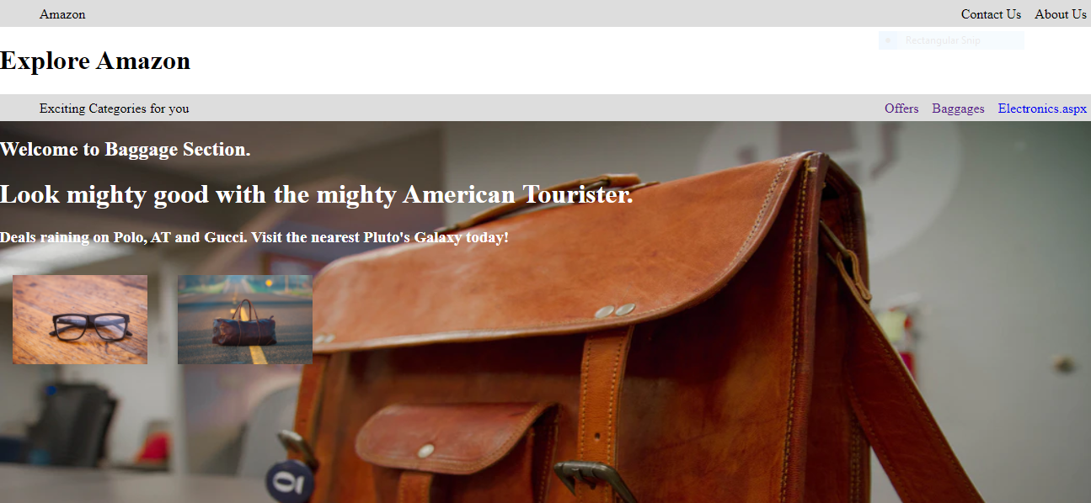

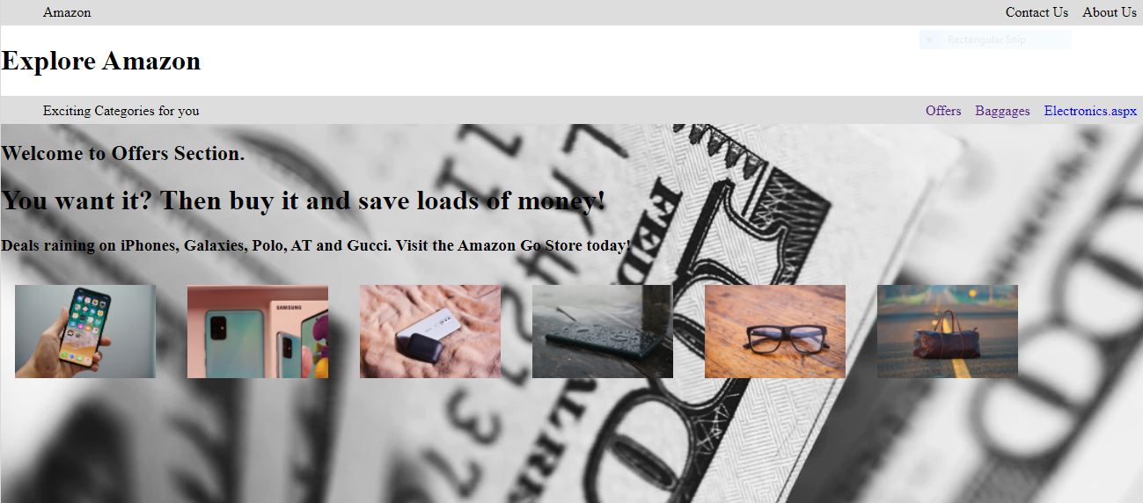

**Question 3**

**WebForm1.aspx**

<%@ Page Language="C#" AutoEventWireup="true" CodeBehind="WebForm1.aspx.cs" Inherits="SummerMonsoon.WebForm1" %>

<!DOCTYPE html>

<html xmlns="http://www.w3.org/1999/xhtml">

<head runat="server">

<title></title>

<style type="text/css">

.auto-style1 {

height: 478px;

}

</style>

</head>

<body>

<form id="form1" runat="server">

<div class="auto-style1">

<asp:DropDownList ID="DropDownList1" runat="server" Height="17px" Width="142px" AutoPostBack="true" OnSelectedIndexChanged="ChangedContent">

</asp:DropDownList>

<br />

<h2>Type Anything:</h2><br />

<asp:TextBox ID="TextBox2" runat="server" Height="22px" Width="137px"></asp:TextBox>

<br />

<br />

<asp:Label ID="Label1" runat="server" BorderColor="#FFCC00" BorderStyle="Solid"></asp:Label>

</div>

</form>

</body>

</html>

**WebForm1.aspx.cs**

using System;

using System.Collections.Generic;

using System.Linq;

using System.Web;

using System.Web.UI;

using System.Web.UI.WebControls;

namespace SummerMonsoon

{

public partial class WebForm1 : System.Web.UI.Page

{

protected void Page_Load(object sender, EventArgs e)

{

if (!IsPostBack)

{

DropDownList1.Items.Add("Monsoon");

DropDownList1.Items.Add("Summer");

if(Session["Theme"] != null)

{

DropDownList1.Items.FindByText(Session["Theme"].ToString()).Selected = true;

}

}

Label1.Text = "'" + TextBox2.Text + "'";

}

protected void Page_PreInit(object sender, EventArgs e)

{

if(Session["Theme"] != null)

{

Page.Theme = Session["Theme"].ToString();

}

}

protected void ChangedContent(object sender, EventArgs e)

{

Session["Theme"] = DropDownList1.SelectedValue;

Server.Transfer(Request.FilePath);

}

}

}

**Output**

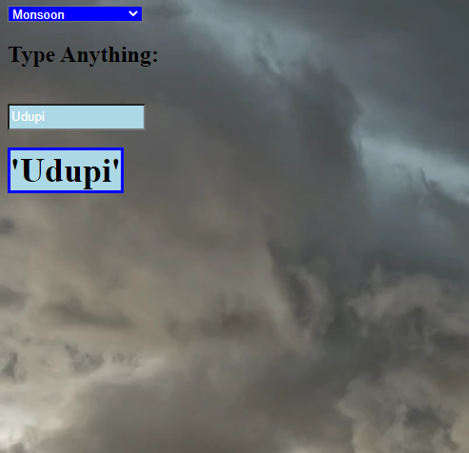

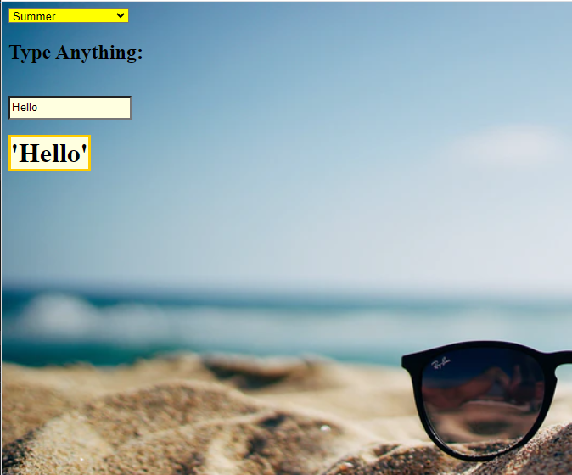

**Question 4**

**HomeMaster.aspx**

<%@ Master Language="C#" AutoEventWireup="true" CodeBehind="Home.master.cs" Inherits="MobileSpecs.Home" EnableTheming="true" %>

<!DOCTYPE html>

<html>

<head runat="server">

<title></title>

<asp:ContentPlaceHolder ID="head" runat="server">

</asp:ContentPlaceHolder>

</head>

<body>

<form id="form1" runat="server">

<div>

<asp:ContentPlaceHolder ID="LeftPane" runat="server">

</asp:ContentPlaceHolder>

<asp:ContentPlaceHolder ID="MainPane" runat="server">

</asp:ContentPlaceHolder>

</div>

</form>

</body>

</html>

**First.aspx**

<%@ Page Title="" Language="C#" MasterPageFile="~/Home.Master" AutoEventWireup="true" CodeBehind="First.aspx.cs" Inherits="MobileSpecs.First" %>

<asp:Content ID="Content1" ContentPlaceHolderID="head" runat="server">

</asp:Content>

<asp:Content ID="Content2" ContentPlaceHolderID="MainPane" runat="server">

<asp:DropDownList ID="Mobile_Names" runat="server" AutoPostBack="true" OnSelectedIndexChanged="Mobile_Names_SelectedIndexChanged" /><br /><br />

<asp:Button ID="Submit_Choice" runat="server" Text="Check Specs" OnClick="Next" />

</asp:Content>

<asp:Content ID="Content3" ContentPlaceHolderID="LeftPane" runat="server">

<asp:Label ID="Mobile_Name" runat="server" style="display:block; background:#ddd; padding:16px; margin-bottom:16px"/>

</asp:Content>

using System;

using System.Collections.Generic;

using System.Linq;

using System.Web;

using System.Web.UI;

using System.Web.UI.WebControls;

namespace MobileSpecs

{

public partial class First : System.Web.UI.Page

{

List<String> mobiles;

private void Initialize_List()

{

mobiles = new List<String>();

mobiles.Add("iPhone 12 Mini");

mobiles.Add("Galazy Z Flip");

mobiles.Add("OnePlus 8T Pro");

}

protected void Page_Load(object sender, EventArgs e)

{

Initialize_List();

foreach (String item in mobiles)

Mobile_Names.Items.Add(new ListItem(item, item));

}

protected void Mobile_Names_SelectedIndexChanged(object sender, EventArgs e)

{

Mobile_Name.Text = Mobile_Names.Items[Mobile_Names.SelectedIndex].Value;

}

protected void Next(object sender, EventArgs e)

{

Response.Redirect("/Second?index=" + Mobile_Names.SelectedIndex);

}

}

}

**Second.aspx**

<%@ Page Title="" Language="C#" MasterPageFile="~/Home.Master" AutoEventWireup="true" CodeBehind="Second.aspx.cs" Inherits="MobileSpecs.Second" %>

<asp:Content ID="Content1" ContentPlaceHolderID="head" runat="server">

</asp:Content>

<asp:Content ID="Content2" ContentPlaceHolderID="MainPane" runat="server">

<asp:Button ID="Back" runat="server" Text="Back" OnClick="Back_Click" /> <br /><br />

<asp:Table runat="server">

<asp:TableRow>

<asp:TableCell>RAM:</asp:TableCell>

<asp:TableCell ID="RAM">12 Gb</asp:TableCell>

</asp:TableRow>

<asp:TableRow>

<asp:TableCell>Battery:</asp:TableCell>

<asp:TableCell ID="Battery">5000 mAH</asp:TableCell>

</asp:TableRow>

<asp:TableRow>

<asp:TableCell>Display:</asp:TableCell>

<asp:TableCell ID="Display">5.7 Inch</asp:TableCell>

</asp:TableRow>

</asp:Table>

</asp:Content>

<asp:Content ID="Content3" ContentPlaceHolderID="LeftPane" runat="server">

<asp:Label ID="Mobile_Name" runat="server" style="display:block; background:#ddd; padding:16px; margin-bottom:16px"/>

</asp:Content>

using System;

using System.Collections.Generic;

using System.Linq;

using System.Web;

using System.Web.UI;

using System.Web.UI.WebControls;

namespace MobileSpecs

{

public partial class Second : System.Web.UI.Page

{

List<int> Battery_Caps, RAM_Sizes;

List<float> Display_Sizes;

List<String> mobiles;

private void Initialize_List()

{

Battery_Caps = new List<int>();

Battery_Caps.Add(3000);

Battery_Caps.Add(4000);

Battery_Caps.Add(3500);

RAM_Sizes = new List<int>();

RAM_Sizes.Add(6);

RAM_Sizes.Add(8);

RAM_Sizes.Add(12);

Display_Sizes = new List<float>();

Display_Sizes.Add(5.7f);

Display_Sizes.Add(5.3f);

Display_Sizes.Add(6.2f);

mobiles = new List<String>();

mobiles.Add("iPhone 12 Mini");

mobiles.Add("Galazy Z Flip");

mobiles.Add("OnePlus 8T Pro");

}

protected void Back_Click(object sender, EventArgs e)

{

Response.Redirect("/First");

}

protected void Page_Load(object sender, EventArgs e)

{

Initialize_List();

RAM.Text = RAM_Sizes[Convert.ToInt32(Request.QueryString["index"])] + " Gb";

Battery.Text = Battery_Caps[Convert.ToInt32(Request.QueryString["index"])] + " mAH";

Display.Text = Display_Sizes[Convert.ToInt32(Request.QueryString["index"])] + " inch";

Mobile_Name.Text = mobiles[Convert.ToInt32(Request.QueryString["index"])];

}

}

}

Output

