Internet Technologies Lab

# Week 6

Name: Harshavardhan K

Roll: 06, CSE D

Reg: 170905022

**Question 1**

**Table and Data**

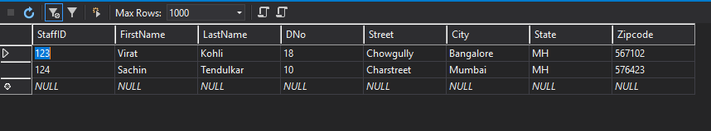

**Employee.aspx**

<%@ Page Language="C#" AutoEventWireup="true" CodeBehind="Emlpoyee.aspx.cs" Inherits="IT_LAB_WEEK6_Q1.WebForm1" %>

<!DOCTYPE html>

<html xmlns="http://www.w3.org/1999/xhtml">

<head runat="server">

<title></title>

</head>

<body>

<form id="form1" runat="server">

<div>

&nbsp;<br />

<asp:DropDownList ID="employeeDDL" runat="server" Height="28px" Width="178px">

</asp:DropDownList>

&nbsp;&nbsp;&nbsp;

<asp:Button ID="selectButton" runat="server" OnClick="employee_Selected" Text="Select" />

<br />

<asp:Label ID="detailsLabel" runat="server" Text="Label"></asp:Label>

<br />

<br />

<br />

<asp:DropDownList ID="cityDDL" runat="server" Height="20px" Width="190px">

</asp:DropDownList>

<br />

<asp:Button ID="update" runat="server" OnClick="update_City" Text="Update City" Width="89px" />

</div>

</form>

</body>

</html>

**Employee.aspx.cs**

using System;

using System.Collections.Generic;

using System.Linq;

using System.Web;

using System.Web.UI;

using System.Web.UI.WebControls;

//Database imports

using System.Data;

using System.Data.Sql;

using System.Data.SqlClient;

namespace IT_LAB_WEEK6_Q1

{

public partial class WebForm1 : System.Web.UI.Page

{

DataSet dataset = new DataSet();

protected void Page_Load(object sender, EventArgs e)

{

if(!IsPostBack)

{

SqlConnection connection = new SqlConnection();

connection.ConnectionString = @"Data Source=(localdb)\MSSQLlocalDB;Initial Catalog=it_lab_hvk;Integrated Security=True";

try

{

connection.Open();

SqlCommand command = new SqlCommand("SELECT DISTINCT StaffID from Emplopyee", connection);

SqlDataReader dataReader = command.ExecuteReader();

while(dataReader.Read())

{

employeeDDL.Items.Add(dataReader["StaffID"].ToString());

System.Diagnostics.Debug.WriteLine(dataReader["StaffID"].ToString());

}

} catch(Exception ex)

{

detailsLabel.Text = ex.Message;

} finally

{

connection.Close();

}

cityDDL.Items.Add("Melbourne");

cityDDL.Items.Add("Bangalore");

cityDDL.Items.Add("Delhi");

}

}

protected void update_City(object sender, EventArgs args)

{

using(SqlConnection connection = new SqlConnection(@"Data Source=(localdb)\MSSQLlocalDB;Initial Catalog=it_lab_hvk;Integrated Security=True"))

{

using(SqlCommand command = new SqlCommand())

{

command.CommandText = "UPDATE Emplopyee SET City=@c WHERE StaffID=@s";

command.Parameters.AddWithValue("@c", cityDDL.SelectedValue);

command.Parameters.AddWithValue("@s", employeeDDL.SelectedValue);

command.Connection = connection;

connection.Open();

command.ExecuteNonQuery();

}

}

}

protected void employee_Selected(object sender, EventArgs args)

{

detailsLabel.Text = String.Empty;

using (SqlConnection connection = new SqlConnection())

{

using (SqlCommand command = new SqlCommand())

{

command.CommandText = "SELECT * from Emplopyee WHERE StaffID = @s";

command.Parameters.AddWithValue("@s", employeeDDL.SelectedValue);

command.Connection = connection;

connection.ConnectionString = @"Data Source=(localdb)\MSSQLlocalDB;Initial Catalog=it_lab_hvk;Integrated Security=True";

connection.Open();

SqlDataAdapter adapter = new SqlDataAdapter(command);

adapter.Fill(dataset, "Emplopyee");

foreach(DataRow row in dataset.Tables["Emplopyee"].Rows)

{

detailsLabel.Text = row["StaffID"] + " " + row["FirstName"] + " " + row["LastName"] + " " + row["City"];

}

}

}

}

}

}

**Output**

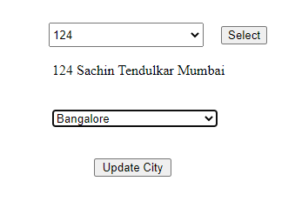

**Question 2**

**Table and Data**

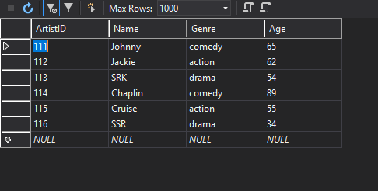

**Legends.aspx**

<%@ Page Language="C#" AutoEventWireup="true" CodeBehind="Actors.aspx.cs" Inherits="IT_LAB_WEEK_Q2.WebForm1" %>

<!DOCTYPE html>

<html xmlns="http://www.w3.org/1999/xhtml">

<head runat="server">

<title></title>

</head>

<body>

<p>

<br />

</p>

<form id="form1" runat="server">

<p>

<asp:Label ID="Label1" runat="server" Text="Choose the genre"></asp:Label>

<asp:DropDownList ID="genreDDL" runat="server" Height="22px" Width="115px">

</asp:DropDownList>

<asp:Button ID="Button1" runat="server" OnClick="choose_Genre" Text="Choose" Width="72px" />

</p>

<p>

<asp:Label ID="Label2" runat="server" Text="Choose the actor"></asp:Label>

<asp:ListBox ID="actorLB" runat="server" Width="117px"></asp:ListBox>

&nbsp;&nbsp;&nbsp;

<asp:Button ID="Button2" runat="server" OnClick="choose_Actor" Text="Choose" Width="79px" />

</p>

<p>

<asp:Label ID="actorDetails" runat="server" Text="Actor details..."></asp:Label>

</p>

<div>

</div>

</form>

</body>

</html>

**Legends.aspx.cs**

using System;

using System.Collections.Generic;

using System.Linq;

using System.Web;

using System.Web.UI;

using System.Web.UI.WebControls;

//Database imports

using System.Data;

using System.Data.Sql;

using System.Data.SqlClient;

namespace IT_LAB_WEEK_Q2

{

public partial class WebForm1 : System.Web.UI.Page

{

DataSet dataset = new DataSet();

string connectionString = @"Data Source=(localdb)\MSSQLlocalDB;Initial Catalog=it_lab_hvk;Integrated Security=True";

protected void Page_Load(object sender, EventArgs e)

{

SqlConnection connection = new SqlConnection();

connection.ConnectionString = connectionString;

try

{

connection.Open();

SqlCommand command = new SqlCommand("SELECT DISTINCT Genre from Legenda", connection);

SqlDataReader reader = command.ExecuteReader();

while(reader.Read())

{

genreDDL.Items.Add(reader["Genre"].ToString());

}

} catch(Exception ex)

{

actorDetails.Text = ex.Message;

}

}

protected void choose_Actor(object sender, EventArgs args)

{

//actorLB.Items.Clear();

using(SqlConnection connection = new SqlConnection(connectionString))

{

using(SqlCommand command = new SqlCommand())

{

command.CommandText = "SELECT Age, Name from Legenda WHERE Name=@n";

command.Parameters.AddWithValue("@n", actorLB.SelectedValue);

command.Connection = connection;

SqlDataAdapter adapter = new SqlDataAdapter(command);

connection.Open();

adapter.Fill(dataset, "Legenda");

foreach(DataRow row in dataset.Tables["Legenda"].Rows)

{

actorDetails.Text = "Name: " + row["Name"] + " Age: " + row["Age"];

}

}

}

}

protected void choose_Genre(object sender, EventArgs args)

{

using(SqlConnection connection = new SqlConnection(connectionString))

{

using(SqlCommand command = new SqlCommand())

{

command.CommandText = "SELECT Name from Legenda WHERE Genre=@g";

command.Parameters.AddWithValue("@g", genreDDL.SelectedValue);

command.Connection = connection;

SqlDataAdapter adapter = new SqlDataAdapter(command);

connection.Open();

adapter.Fill(dataset, "Legenda");

foreach(DataRow row in dataset.Tables["Legenda"].Rows)

{

actorLB.Items.Add(row["Name"].ToString());

}

}

}

}

}

}

**Output**

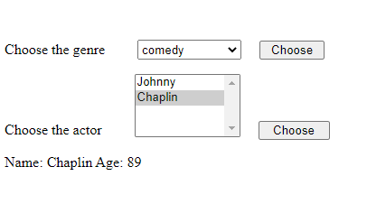

**Question 3**

**Table and data**

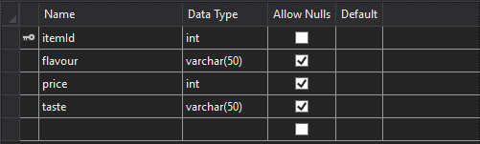

**Default.aspx**

<%@ Page Language="C#" AutoEventWireup="true" CodeFile="Default.aspx.cs" Inherits="_Default" %>

<!DOCTYPE html>

<html xmlns="http://www.w3.org/1999/xhtml">

<head runat="server">

<title></title>

</head>

<body>

<form id="form1" runat="server">

<div>

<asp:TextBox ID="txtItemid" runat="server"></asp:TextBox>

<asp:TextBox ID="txtFlavour" runat="server"></asp:TextBox>

<asp:Button ID="btnAdd" OnClick="btnAdd_Click" runat="server" Text="ADD" />

<br />

<asp:Label ID="lblDisplay" runat="server" ></asp:Label>

<asp:Button ID="btnDisplay" OnClick="btnDisplay_Click" runat="server" Text="DISPLAY" />

<br />

<asp:TextBox ID="txtVanila" runat="server"></asp:TextBox>

<asp:Button ID="updateVanilla" OnClick="updateVanilla_Click" runat="server" Text="UPDATE" />

</div>

</form>

</body>

</html>

**Default.aspx.cs**

using System;

using System.Collections.Generic;

using System.Data.SqlClient;

using System.Linq;

using System.Web;

using System.Web.UI;

using System.Web.UI.WebControls;

public partial class _Default : System.Web.UI.Page

{

protected void Page_Load(object sender, EventArgs e)

{

}

protected void btnDisplay_Click(object sender, EventArgs e)

{

lblDisplay.Text = String.Empty;

String cs = @"Data Source = (localdb)\MSSQLlocalDB; Initial Catalog = Products; Integrated Security = True; Pooling = False";

using (SqlConnection con = new SqlConnection(cs))

{

using (SqlCommand cmd = new SqlCommand())

{

cmd.CommandText = "SELECT * FROM ITEMS";

cmd.Connection = con;

con.Open();

SqlDataReader rd = cmd.ExecuteReader();

while (rd.Read())

{

lblDisplay.Text += rd["itemId"].ToString() + " " + rd["flavour"].ToString() +" "+ rd["price"].ToString() + "<br/>";

}

}

}

}

protected void btnAdd_Click(object sender, EventArgs e)

{

String cs = @"Data Source = (localdb)\MSSQLlocalDB; Initial Catalog = Products; Integrated Security = True; Pooling = False";

using (SqlConnection con = new SqlConnection(cs))

{

using (SqlCommand cmd = new SqlCommand())

{

//cmd.CommandText = "INSERT INTO Items(ItemId,flavour) VALUES ("+ txtItemid.Text + ",'"+txtFlavour.Text+"')";

cmd.CommandText = "INSERT INTO Items(ItemId,flavour) VALUES (@id,@flavor)";

cmd.Parameters.AddWithValue("@id",txtItemid.Text);

cmd.Parameters.AddWithValue("@flavor",txtFlavour.Text.ToString());

cmd.Connection = con;

con.Open();

cmd.ExecuteNonQuery();

txtItemid.Text = String.Empty;

txtFlavour.Text = String.Empty;

}

}

}

protected void updateVanilla_Click(object sender, EventArgs e)

{

String cs = @"Data Source = (localdb)\MSSQLlocalDB; Initial Catalog = Products; Integrated Security = True; Pooling = False";

using (SqlConnection con = new SqlConnection(cs))

{

using (SqlCommand cmd = new SqlCommand())

{

cmd.CommandText = "UPDATE Items SET price=@pri WHERE flavour = 'Vanila'";

cmd.Parameters.AddWithValue("@pri", txtVanila.Text);

// cmd.Parameters.AddWithValue("@flavor", txtFlavour.Text.ToString());

cmd.Connection = con;

con.Open();

cmd.ExecuteNonQuery();

txtVanila.Text = String.Empty;

}

}

}

}

**Output**

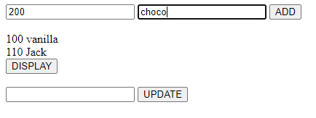

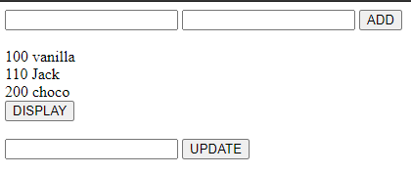

**Question 4**

**Default.aspx**

<%@ Page Language="C#" AutoEventWireup="true" CodeFile="Default.aspx.cs" Inherits="_Default" %>

<!DOCTYPE html>

<html xmlns="http://www.w3.org/1999/xhtml">

<head runat="server">

<title></title>

</head>

<body>

<form id="form1" runat="server">

<div>

<asp:TextBox ID="pname" runat="server"></asp:TextBox>

<asp:TextBox ID="cname" runat="server"></asp:TextBox>

<asp:TextBox ID="sal" runat="server"></asp:TextBox>

<asp:Button ID="Button1" OnClick="Button1_Click" runat="server" Text="INSERT" />

<br />

<asp:TextBox ID="txtCname" runat="server"></asp:TextBox>

<asp:Button ID="Button2" OnClick="Button2_Click" runat="server" Text="DISPLAY" />

<br />

<asp:Label ID="Label1" runat="server" ></asp:Label>

</div>

</form>

</body>

</html>

**Default.aspx.cs**

using System;

using System.Collections.Generic;

using System.Configuration;

using System.Data.SqlClient;

using System.Linq;

using System.Web;

using System.Web.UI;

using System.Web.UI.WebControls;

public partial class _Default : System.Web.UI.Page

{ static string connectionString;

static _Default()

{

string connectionString = ConfigurationManager.ConnectionStrings["ProductDb"].ConnectionString;

}

protected void Page_Load(object sender, EventArgs e)

{

}

protected void Button1_Click(object sender, EventArgs e)

{

String cs = @"Data Source = (localdb)\MSSQLlocalDB; Initial Catalog = Products; Integrated Security = True; Pooling = False";

using (SqlConnection con = new SqlConnection(cs))

{

using (SqlCommand cmd = new SqlCommand())

{

cmd.CommandText = "INSERT INTO WORKS(person_name,company_name,salary) VALUES (@a,@c,@s)";

cmd.Parameters.AddWithValue("@a", pname.Text);

cmd.Parameters.AddWithValue("@c", cname.Text);

cmd.Parameters.AddWithValue("@s", sal.Text);

cmd.Connection = con;

con.Open();

cmd.ExecuteNonQuery();

pname.Text = String.Empty;

cname.Text = String.Empty;

sal.Text = String.Empty;

}

}

}

protected void Button2_Click(object sender, EventArgs e)

{

String cs = @"Data Source = (localdb)\MSSQLlocalDB; Initial Catalog = Products; Integrated Security = True; Pooling = False";

using (SqlConnection con = new SqlConnection(cs))

{

using (SqlCommand cmd = new SqlCommand())

{

cmd.CommandText = "SELECT w.person_name,city from WORKS w,LIVES l where company_name=@company and w.person_name=l.person_name;";

cmd.Connection = con;

cmd.Parameters.AddWithValue("@company", txtCname.Text);

con.Open();

SqlDataReader rd = cmd.ExecuteReader();

while (rd.Read())

{

Label1.Text += rd["person_name"].ToString() + " " + rd["city"].ToString() + "<br/>";

}

}

}

}

}

**Output**