PPS LAB 1 – DATE: 21/08/2019

Problem Statement 1:
Write a c program to print following output.

*** Welcome***
To
*** PPS LAB***

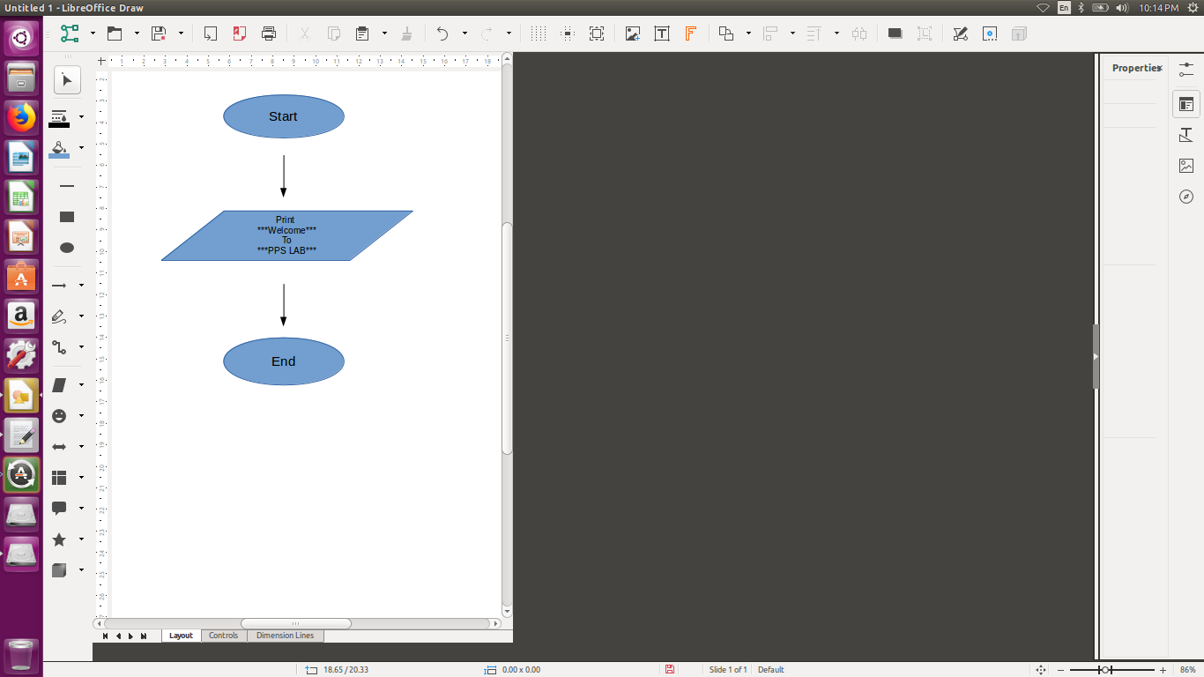
Design:

Implementation:

#include <stdio.h>
int main(){
printf("***Welcome***\n To\t\n***PPS LAB***\n");
return 0;
}

Input / Output:

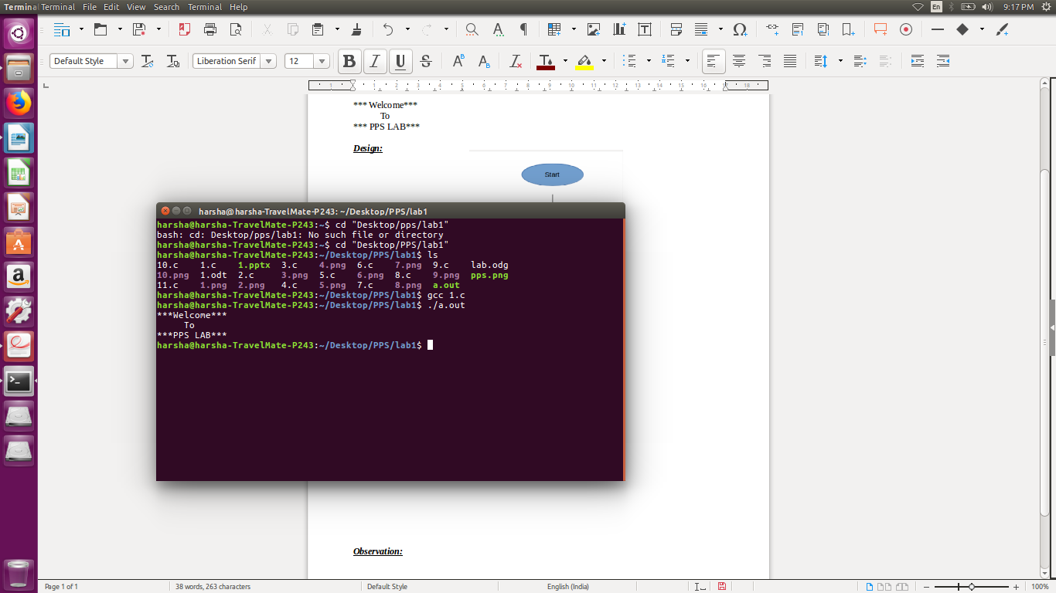

Observation:

