PPS LAB 1 – DATE: 21/08/2019

Problem Statement 10:

Write a C program to convert given Centigrade units to Fahrenheit.
Formula : C=( F-32)/1.8.

Design:

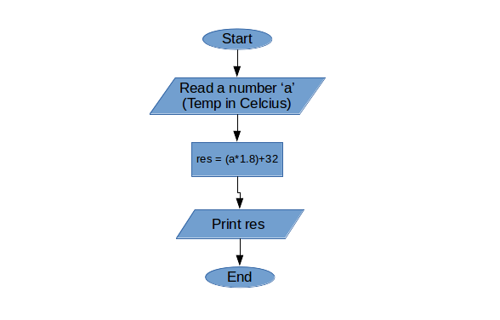

Implementation:
#include <stdio.h>
int a;
void main(){
printf("Enter Celcious:");
scanf("%d",&a);
printf("Fahrenheit = %4f\n",(a*1.8)+32);
}

Input / Output:

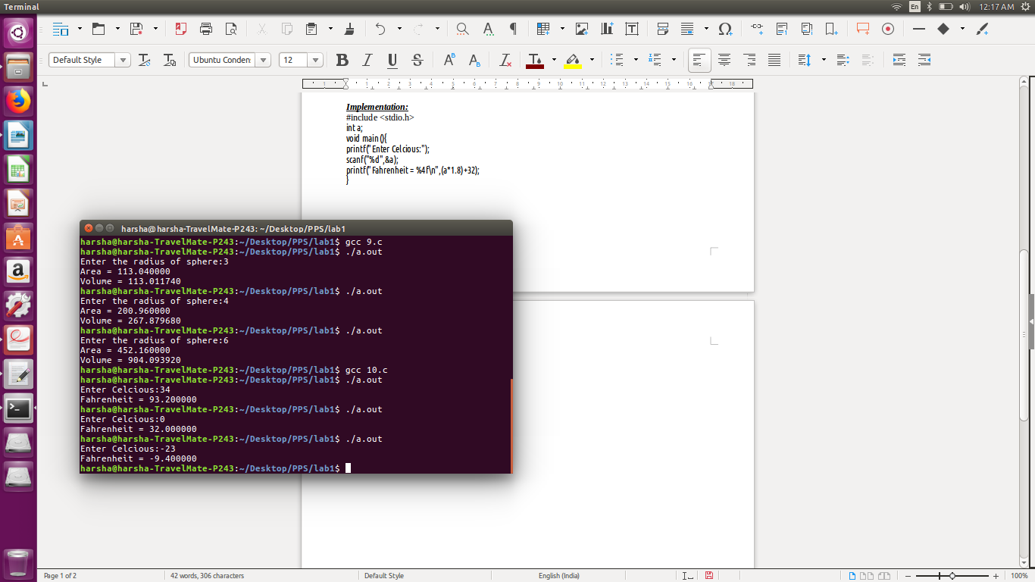

Observation:

