PPS LAB 1 – DATE: 21/08/2019

Problem Statement 11:

Write a C program to read in two integers and display one as a percentage of the other.
Typically your program should look like 20 is 50.00% of 40 assuming that the input numbers
were 20 and 40. Display the percentage correct to two decimal places.

Design:
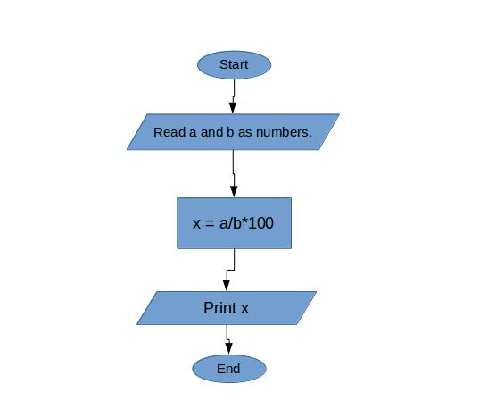
Implementation:
#include <stdio.h>
int a,b;
float x;
void main(){
printf("Enter any 2 numbers:");
scanf("%d%d",&a,&b);
x=(float)a/b*100.0;
//printf("%f",x);
printf("%2f is percentage of %d in %d.\n",x,a,b);
}
}

Input / Output:

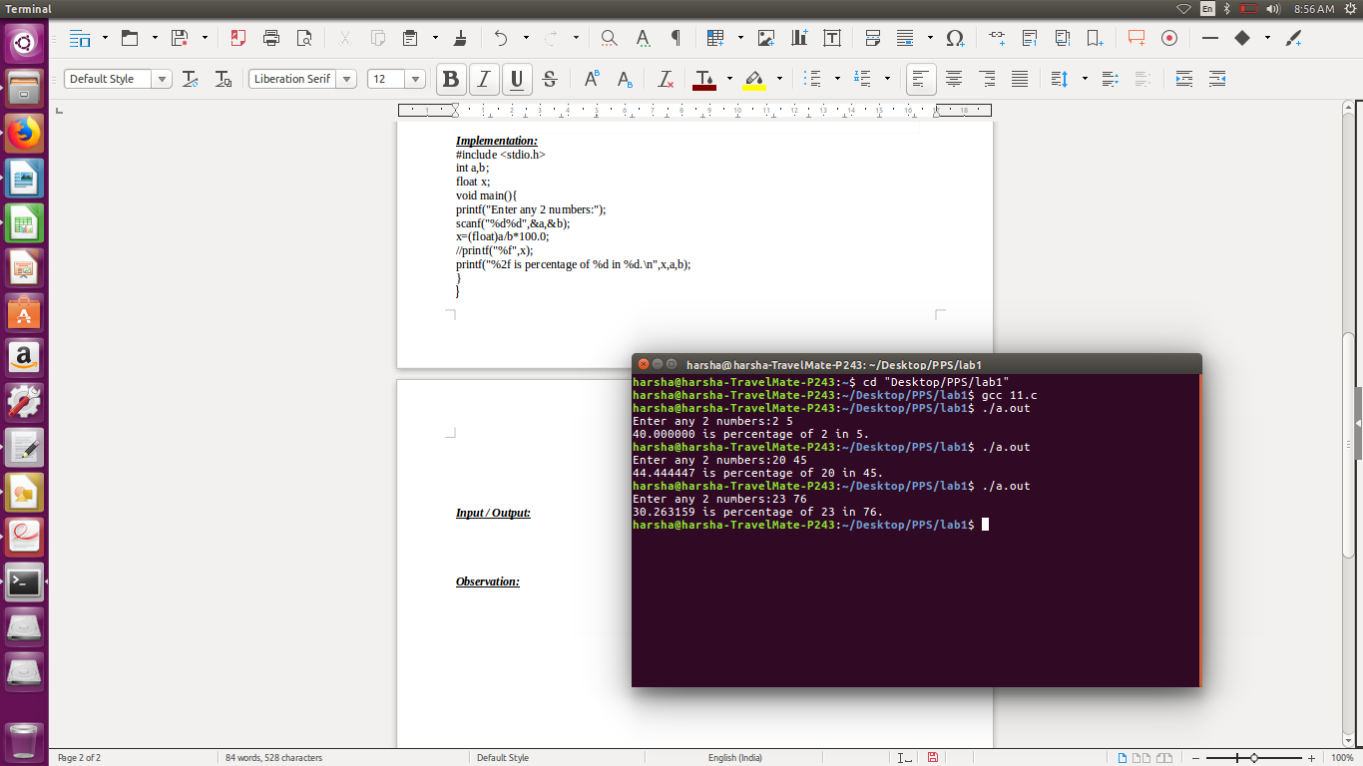

Observation:

