PPS LAB 1 – DATE: 21/08/2019

Problem Statement 2:

Write a C program to print addition, subtraction, multiplication and division of any two
given integers.

Design:

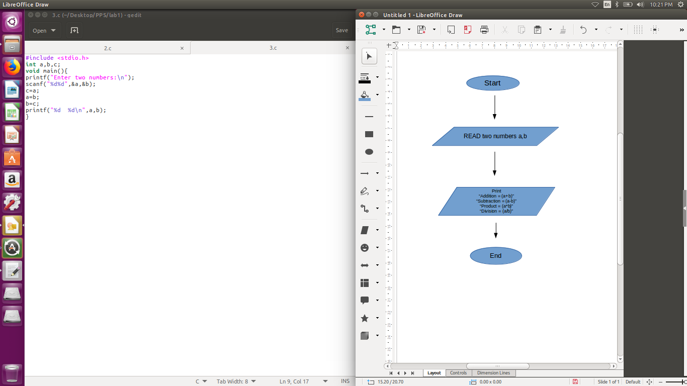

Implementation:

#include <stdio.h>
int a,b;
void main(){
printf("Enter two numbers:\n");
scanf("%d%d",&a,&b);
printf("Addition: %d\n",a+b);
printf("Subtraction: %d\n",a-b);
printf("Multiplication: %d\n",a*b);
printf("Division: %d\n",a/b);
}

Input / Output:

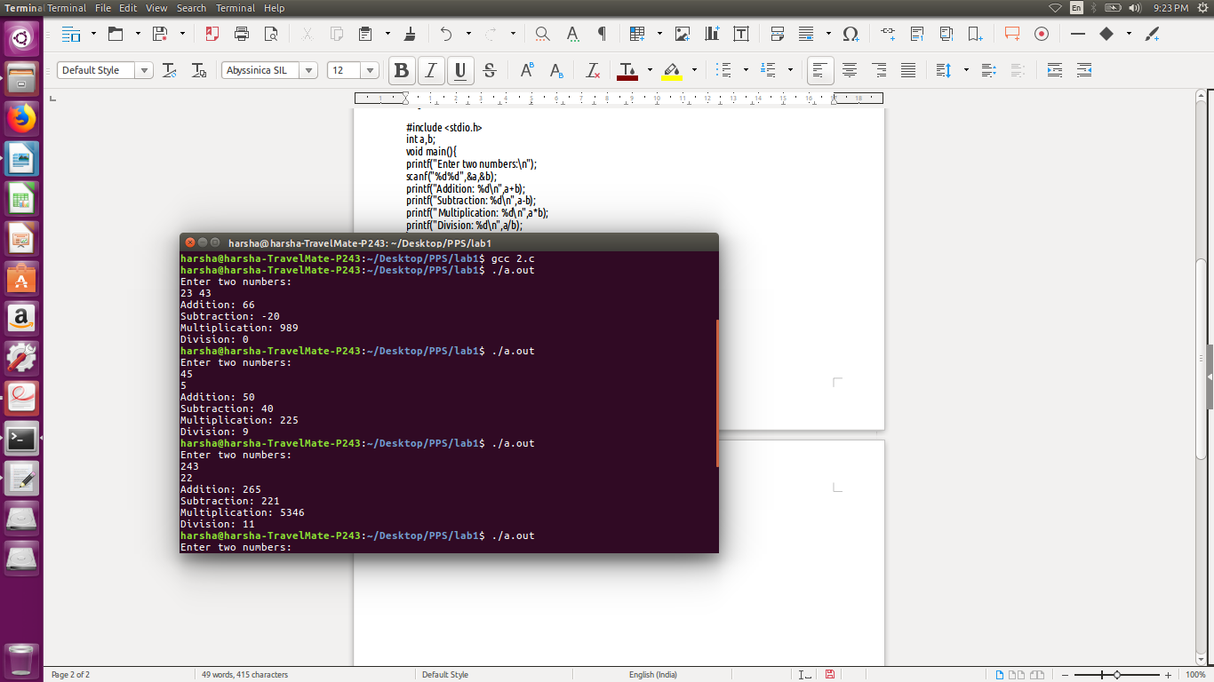

Observation:

