PPS LAB 1 – DATE: 21/08/2019

Problem Statement 3:

Write a C program to swap two given integers.

Design:

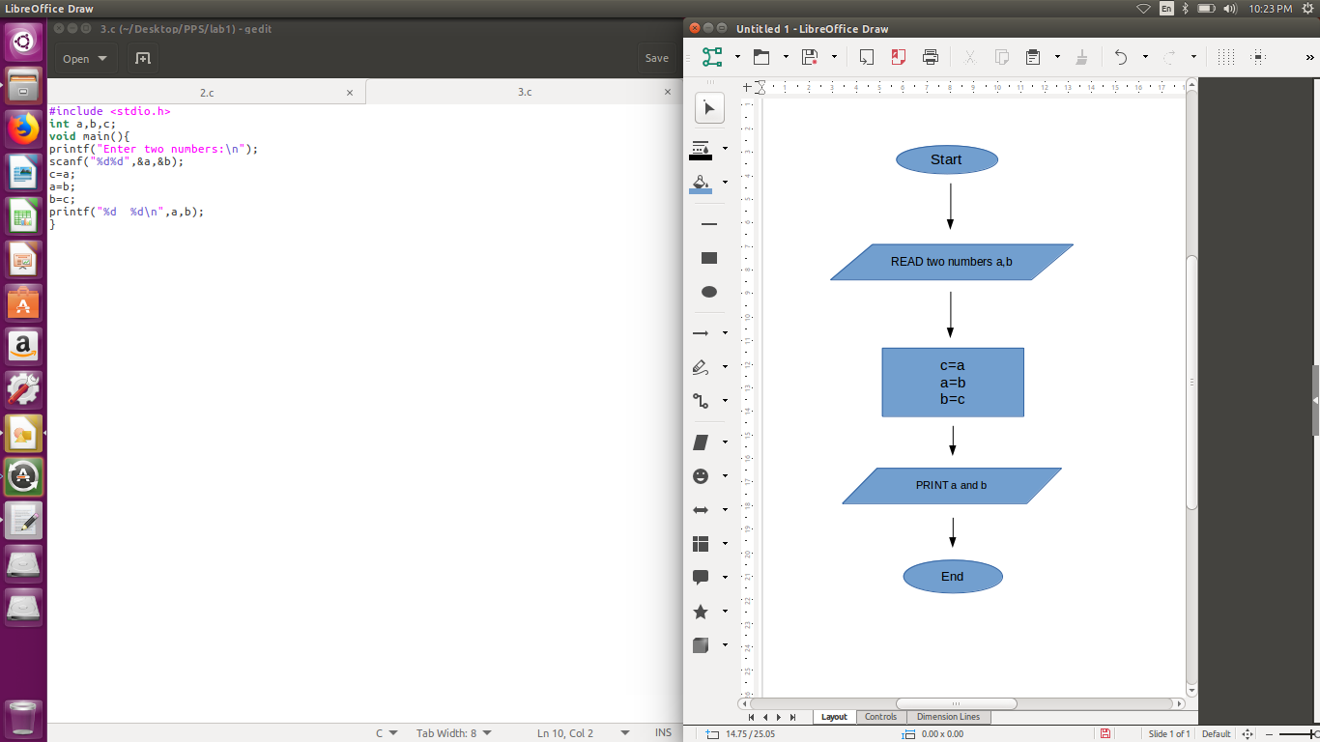

Implementation:

#include <stdio.h>
int a,b,c;
void main(){
printf("Enter two numbers:\n");
scanf("%d%d",&a,&b);
c=a;
a=b;
b=c;
printf("%d %d\n",a,b);
}

Input / Output:

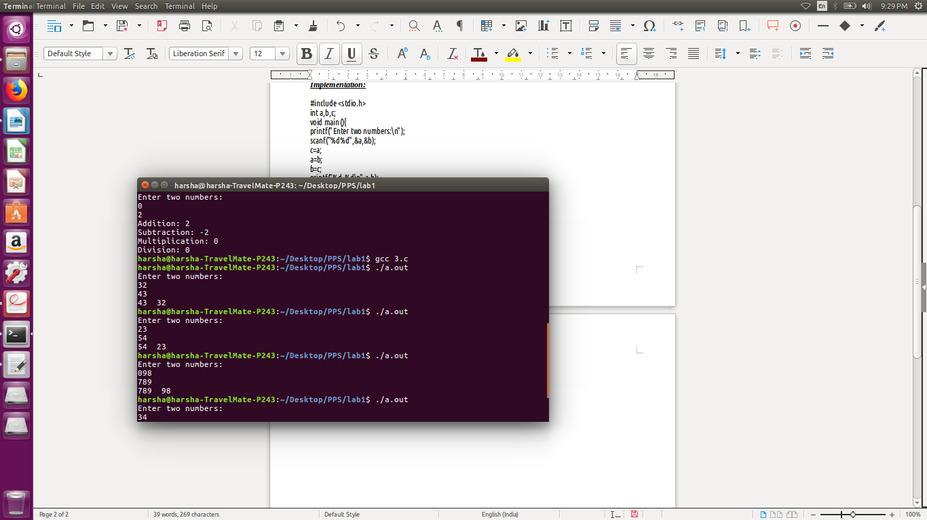

Observation:

