PPS LAB 1 – DATE: 21/08/2019

Problem Statement 4:

Write a C program to read a character as Input and display the character case.
Sample output: Input : a Output : Lower case

Design:

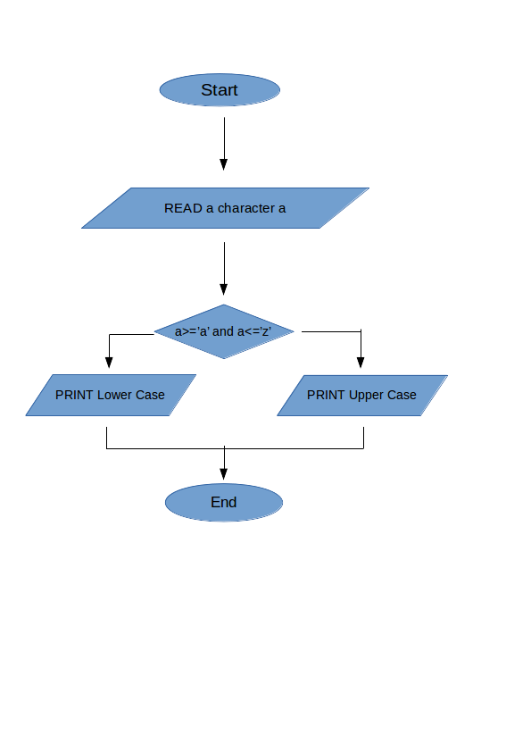

Implementation:

#include <stdio.h>
char a;
void main(){
printf("Enter any single character:");
scanf("%c",&a);
(a>='a' && a<='z') ? printf("Lower Case\n") : printf("Upper Case\n") ;
}

Input / Output:

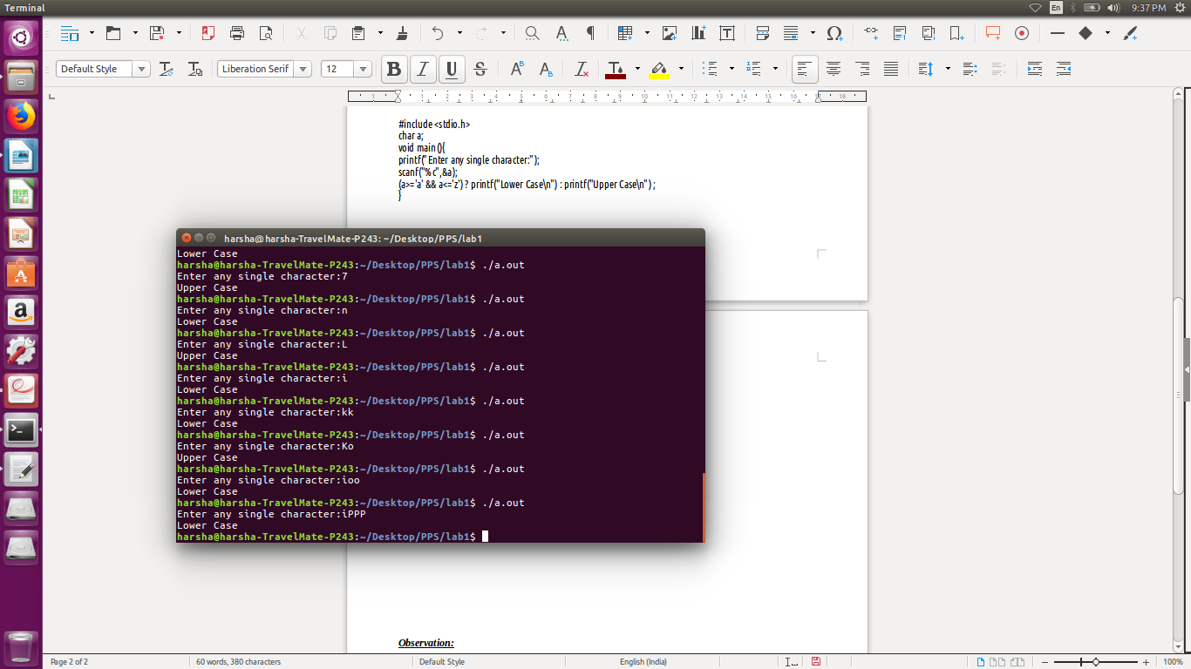

Observation:

