PPS LAB 1 – DATE: 21/08/2019

Problem Statement 6:

Write a C program to print mulitplication and Division Table of any given numbers using
left shift(<<) and right shift(>>) operators.

Design:

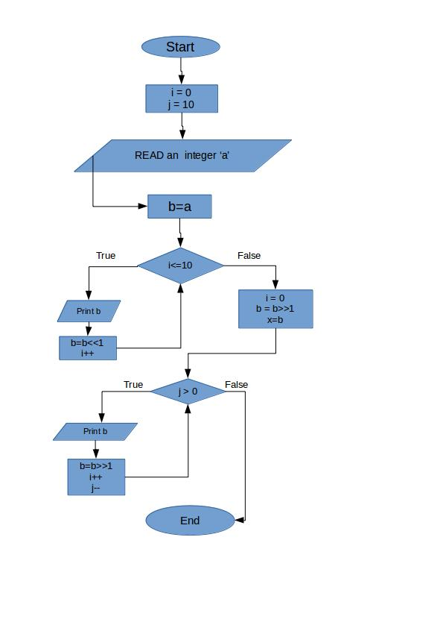

Implementation:
#include <stdio.h>
int a,i=0,b,j=10,x;
void main(){
printf("Enter a number:");
scanf("%d",&a);
b=a;
while(i<=10){
printf("%d * 2 ^ %d = %d\n",a,i,b);
b=b<<1;
i++;
}
printf("\n");
i=0;
b=b>>1;
x=b;
while(j>0){
printf("%d / %d^%d = %d\n",x,a,i,b);
b=b>>1;
i++;
j--;
}}

Input / Output:
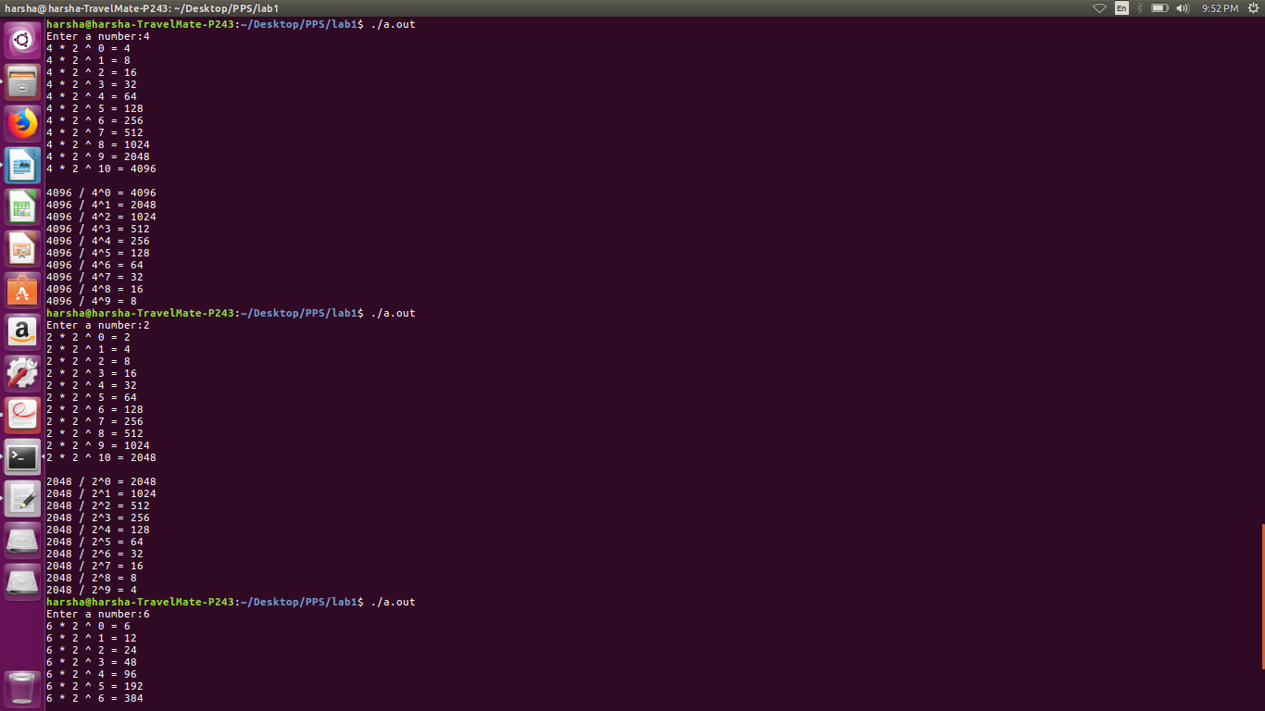

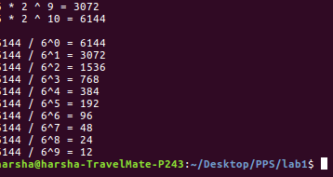

Observation:

