PPS LAB 1 – DATE: 21/08/2019

Problem Statement 8:

Write a C program to display the area of a Circle.
Note : Area of a circle: PI * r * r .

Design:

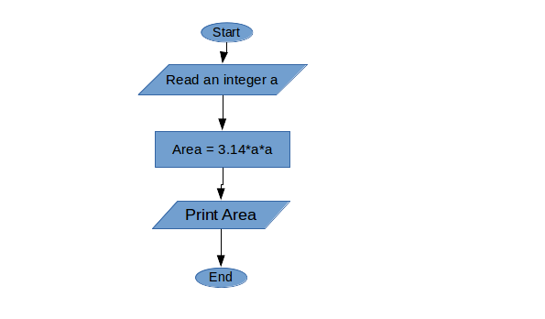

Implementation:
#include <stdio.h>
int a;
void main(){
printf("Enter the radius of the triangle:");
scanf("%d",&a);
printf("Area = %2f\n", 3.14*a*a);
}

Input / Output:

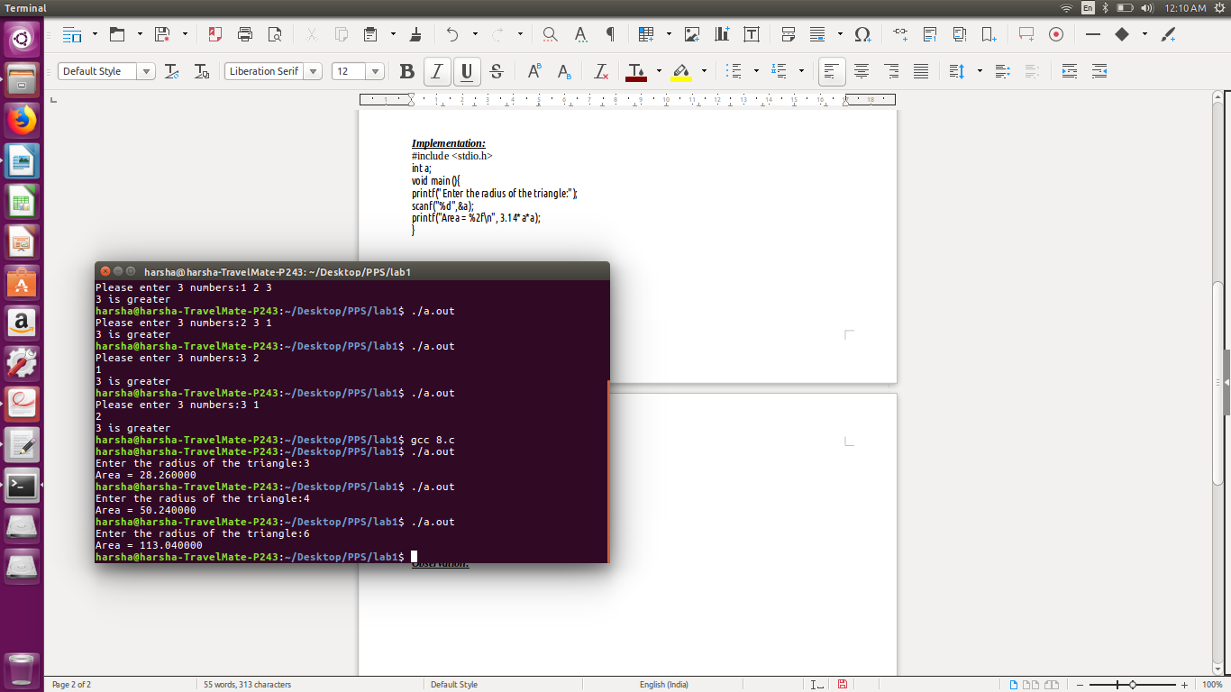

Observation:

