PPS LAB 1 – DATE: 21/08/2019

Problem Statement 9:

Write a C program to find the area of a circle and volume of a sphere.
Note : Area = 4*PI*r*r
Volume = (4/3) * PI * r * r * r .

Design:

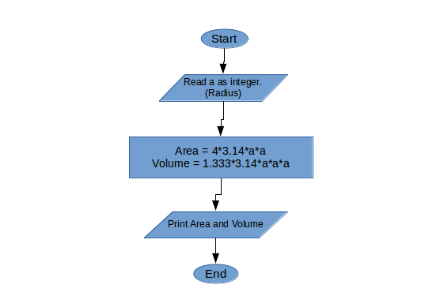

Implementation:
#include <stdio.h>
int a;
void main(){
printf("Enter the radius of sphere:");
scanf("%d",&a);
printf("Area = %6f\n", 4*3.14*a*a);
printf("Volume = %6f\n",1.333*3.14*a*a*a);
}

Input / Output:
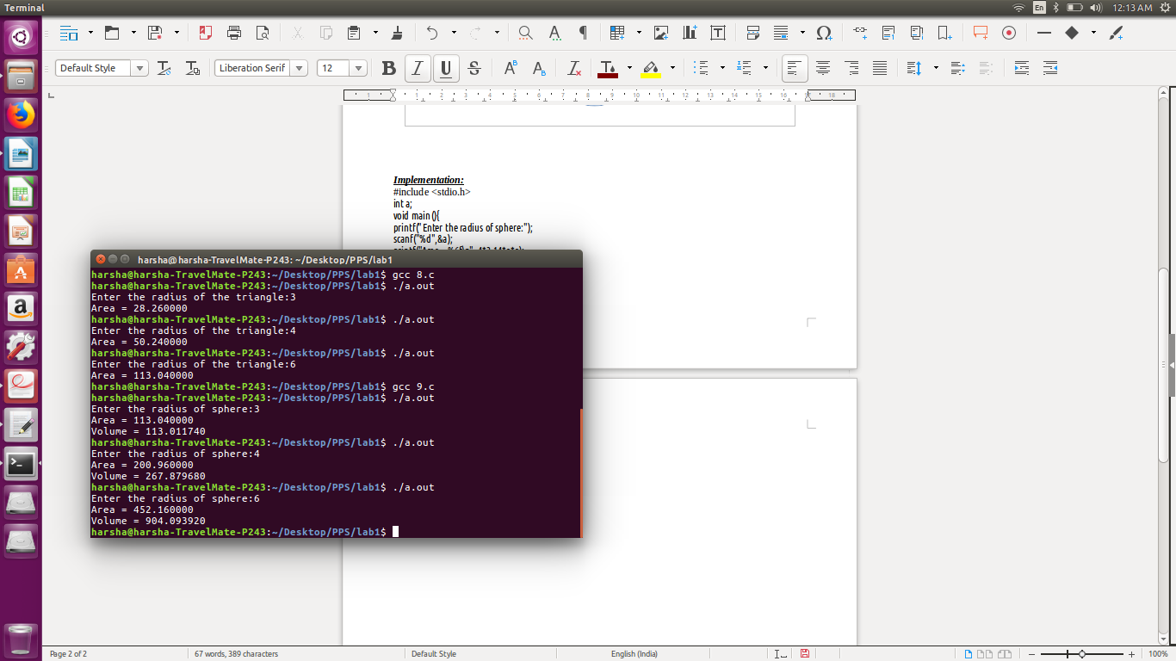

Observation:

