SAVEETHA INSTITUTE OF MEDICAL AND TECHNICAL SCIENCES
CSA08 - PYTHON PROGRAMMING | ASSIGNMENT 2
Student Name: | HARSHAVARTHAN P
Register Number: | 1914260015
GitHub Repository: | https://github.com/HarshavarthanPaul/PYTHON-PROGRAMMING_ASSIGNMENT-2.git
Task Module: | Task 01: Decisions with Many Boundaries - Electricity Subsidy Eligibility

Task 01: Decisions with Many Boundaries - Electricity Subsidy Eligibility

Problem & Decision Boundary Analysis
State Electricity Subsidy Eligibility evaluates household electricity consumption (in units) against three tariff slabs: 100 units or less (Full Subsidy), 101 to 200 units (Partial Subsidy with Ration Card), and above 200 units (No Subsidy, unless a member is above 80 years). Boundary testing covers 0, 100, 101, 150, 200, 201, and 350 units.

Control Flow Analysis: Independent IF vs if-elif-else
When a developer writes eligibility rules using independent 'if' statements, Python evaluates every condition sequentially. For example, a household with 50 units satisfies both 'units <= 200' and 'units <= 100', triggering duplicate outputs and multi-subsidy bugs. Conversely, an 'if-elif-else' ladder guarantees mutual exclusivity by short-circuiting as soon as a True branch is matched.

Design Decision: Nested IF vs Combined Boolean Conditions
Combined Boolean conditions using chained range syntax (e.g., 0 <= units <= 100) are selected over deeply nested IF statements. Chained comparisons eliminate the 'arrow anti-pattern' of deep indentation, improve code readability, clean up boundary edge case checks, and match mathematical interval notation.

Alternative Concept & Complexity Analysis
Alternative implementations include match-case pattern matching (Python 3.10+) or lookup tables indexed by unit buckets.
- if-elif-else Ladder: Time Complexity = O(1), Space Complexity = O(1). Fast, readable, and handles non-uniform boundary logic natively.
- Lookup Table / Dictionary: Time Complexity = O(1), Space Complexity = O(1). Provides constant time lookup but requires uniform slab bucket arithmetic.

Program Execution Screenshot
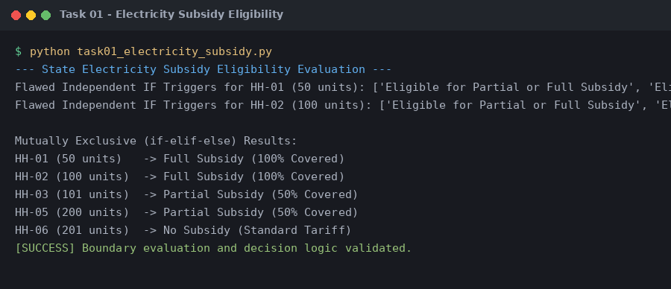
Figure 1.1: Execution output verification for Task 1 (Electricity Subsidy Eligibility).

