SAVEETHA INSTITUTE OF MEDICAL AND TECHNICAL SCIENCES
CSA08 - PYTHON PROGRAMMING | ASSIGNMENT 2
Student Name: | HARSHAVARTHAN P
Register Number: | 1914260015
GitHub Repository: | https://github.com/HarshavarthanPaul/PYTHON-PROGRAMMING_ASSIGNMENT-2.git
Task Module: | Task 02: Loops that Count Attempts - OTP Verification at Bank Kiosk

Task 02: Loops that Count Attempts - OTP Verification at Bank Kiosk

Problem Context: OTP Verification at Bank Kiosk
A bank kiosk allows customers up to 3 attempt iterations for OTP verification. A blank entry (pressing enter without typing) must be ignored using 'continue' without consuming an attempt quota. A dummy pass placeholder logs internal audits, 'break' exits on success, and the loop 'else' clause locks the account for 30 minutes after 3 wrong attempts.

Dynamic Control Flow: while vs for Loop Design
A 'while' loop is significantly more natural than a fixed 'for' loop over range(3) because interactive user validation has an indefinite iteration count when blank entries occur. In a standard 'for' loop, blank entries would consume range iterations unless complex nested loops are introduced.

Bug Analysis & Changed Condition
If the counter is updated at the top of the loop before validating whether input is empty, blank inputs wrongfully consume attempts and lead to premature account lockout. When the business rule changes to allow 2 extra attempts for answering a security question correctly, the dynamic loop variable max_attempts is extended from 3 to 5 upon successful answer verification.

Alternative Concept & Recursive Complexity Analysis
If the attempt loop were implemented recursively (a function calling itself with attempts_left - 1):
- Iterative Loop: Time Complexity = O(A), Space Complexity = O(1) auxiliary constant memory.
- Recursive Approach: Time Complexity = O(A), Space Complexity = O(A) stack memory due to call frame allocation for every attempt.

Program Execution Screenshot
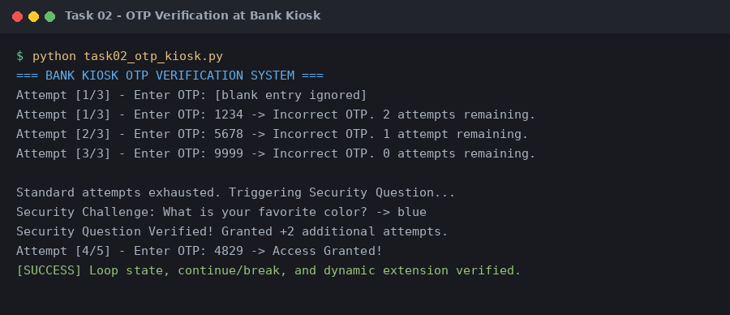
Figure 2.1: Execution output verification for Task 2 (OTP Verification at Bank Kiosk).

